"Made an expensive drug out of sugar!" Development of high value-added eco-friendly catalyst

- Developed ‘cofactor protein swing arm’ that can be used for a long time without additional consumption of expensive cofactors
-Supplying sugar and converting it into an extremely expensive drug... expected to create high value-added products such as drugs and energy

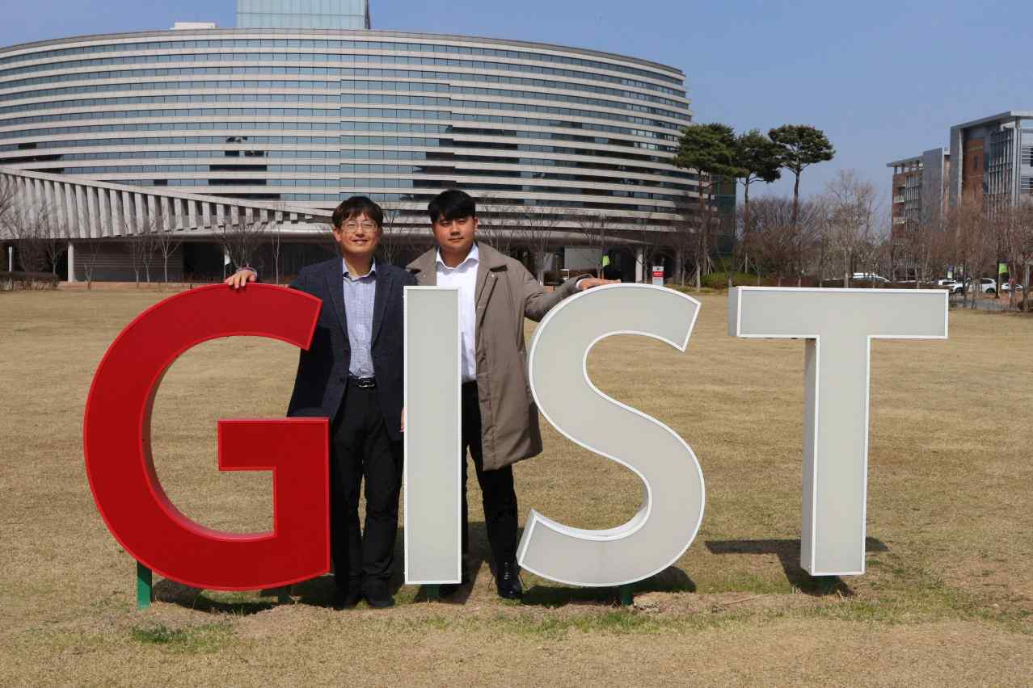
▲ (From left) GIST School of Materials Science and Engineering Professor Inchan Kwon and integrated student Jaehyun Cha

As environmental protection and sustainable development are emphasized worldwide, eco-friendly technologies that produce useful compounds such as drugs by utilizing enzymes*, which are biocatalysts, are attracting attention. In particular, oxidation-reductase is an enzyme involved in the oxidation-reduction reaction of compounds and is widely used in drugs, food raw materials, and energy production.

* Enzymes: Enzymes are mainly composed of proteins and require cofactors, which are non-protein components. Cofactors include coenzymes composed of organic substances (organic substances with low molecular weight, such as NAD, NADP, and FAD) and prosthetic groups mainly composed of metal ions. Enzymes cannot function properly if cofactors are insufficient.

To separate the enzyme from the product and reuse it multiple times, the enzyme must be immobilized on a specific carrier*. NAD, NADP*, etc., which are essential cofactors for the oxidase reaction, are very expensive and cannot be immobilized, so they are additionally consumed each time. Since this process requires high costs, it is necessary to develop a system capable of continuously producing drugs by regenerating cofactors.

* carrier: A medium that provides an attachment surface to allow microorganisms to proliferate and grow well inside the bioreactor.

* cofactor: Refers to an organic compound or metal ion that binds to a catalyst so that the enzyme can be activated as a catalyst. During the reaction of the oxidoreductase, substances such as NAD(P) and FAD are continuously consumed as cofactors. Most of the auxiliary factors are very expensive and require reuse technology. Mobility to move between oxidoreductases is essential for cofactor operation.

* NAD: about 10 million won per 1 kg, NADP: about 50 million won per 1 kg

GIST (Gwangju Institute of Science and Technology, Acting President Raekil Park) GIST School of Materials Science and Engineering Professor Inchan Kwon's research team developed an eco-friendly biocatalytic reaction system that regenerates cofactors as a platform technology that can be used in various ways for oxidation-reduction reactions.

The research team developed the world's first cofactor protein swing arm* by combining a cofactor with a flexible protein called elastin-like polypeptide (ELP)*.

The cofactor swing arm fabricated a microreactor by immobilizing two oxidoreductases (glucose dehydrogenase and mannitol dehydrogenase) on a micro-sized porous bead thinner than a human hair on a solid support.

* elastin-like polypeptide (ELP): An artificial protein derived from a protein called elastin. It is flexible and has the advantage of being easily adjustable through design, so it is usefully used in various fields of biomedicine.

* swing arm: A support having a length of several to several tens of nanometers (nm) for immobilizing the cofactor on a solid support while ensuring fluidity.

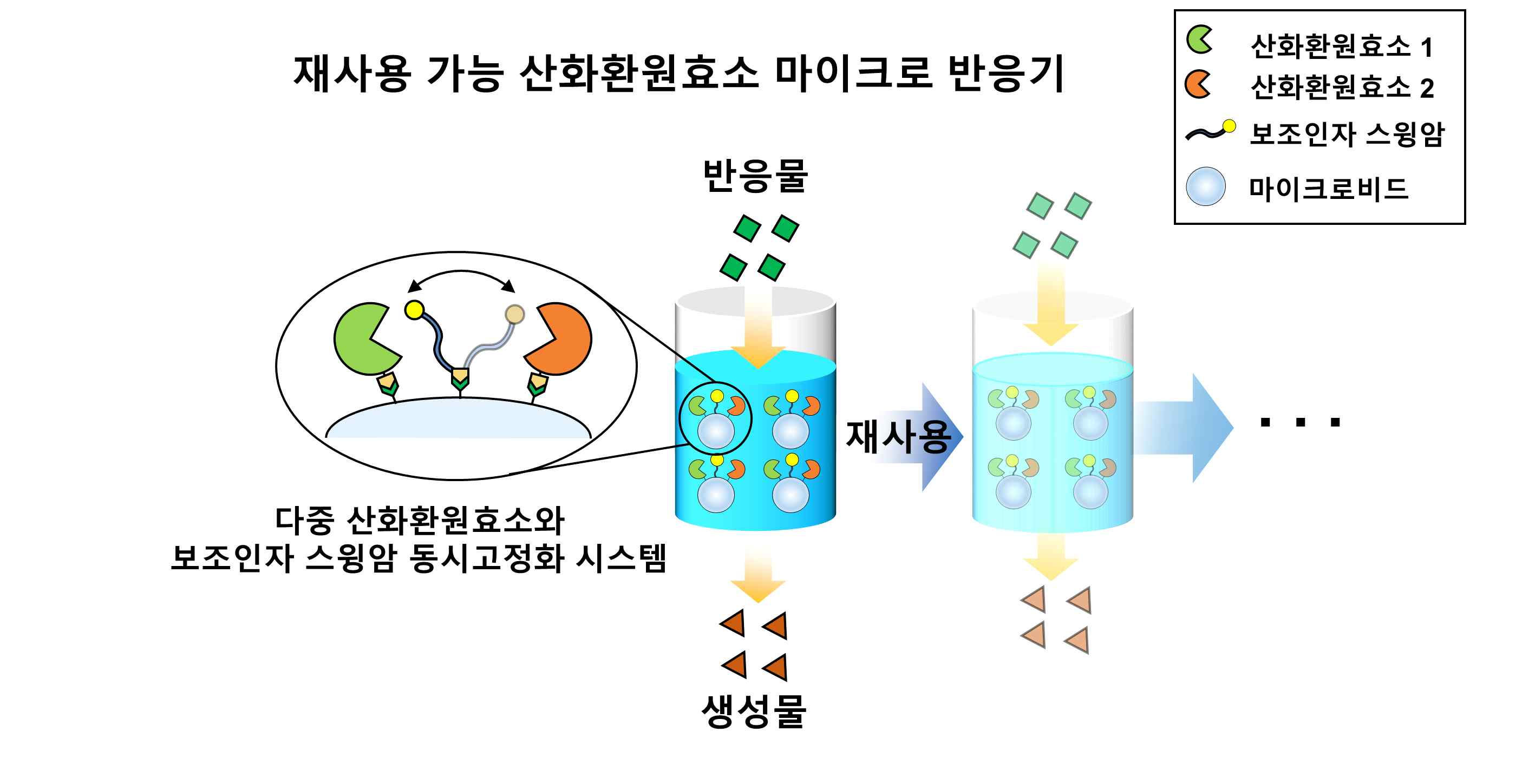
▲ Reusable redox enzyme microreactor. Multiple oxidoreductases and cofactor swing arms are co-immobilized on microbeads, so products can be easily separated and reused several times.

When glucose and fructose, which constitute sugar (1), are supplied to the microreactor as raw materials, glucose dehydrogenase (2) reduces cofactors using glucose (about 700 won/kg), and reduced cofactor (3) supplies reducing power to mannitol dehydrogenase. By doing so, it is possible to produce high added value by converting (4) fructose (about 1,300 won/kg) into D-mannitol* (about 100,000 won/kg), which is an extremely expensive drug.

* D-mannitol: a drug that reduces intraocular and intracranial pressure

The resulting microreactor system was confirmed to repeatedly produce more than 1.6 mM D-mannitol without the supply of expensive enzymes and cofactors, and it can be used to make various other drugs.

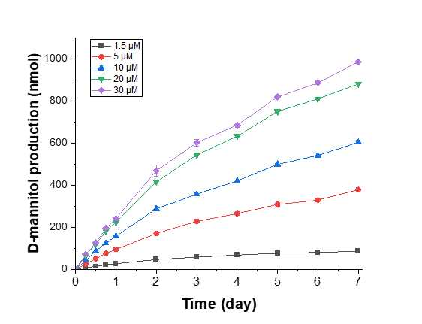
▲ Production of D-mannitol through a microreactor. The product, D-mannitol, can be identified through a microreactor in which glucose dehydrogenase, mannitol dehydrogenase and cofactor swing arm are co-immobilized.

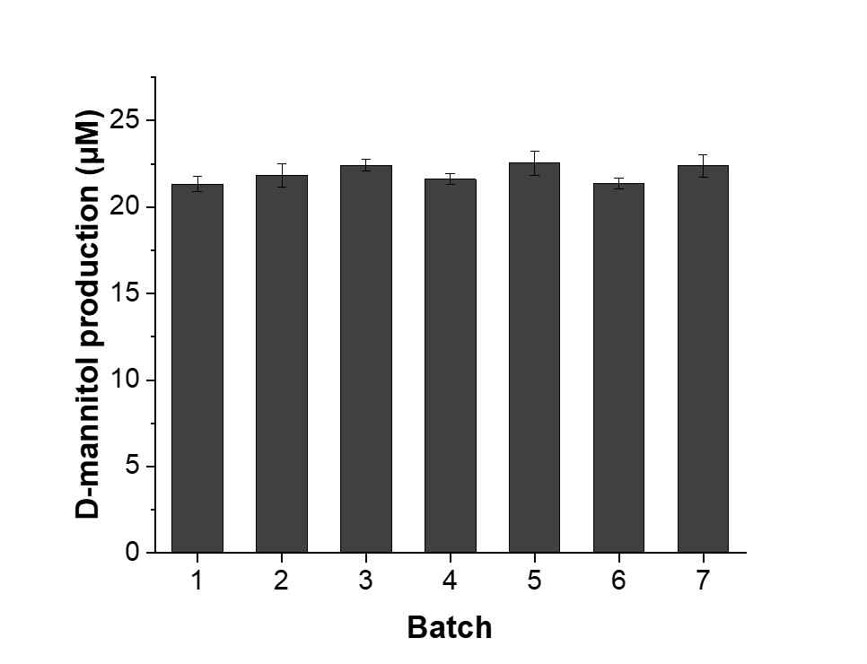
▲ Maintain microreactor reuse yield. Reusability can be confirmed by maintaining D-mannitol productivity during 7 repeated uses of the microreactor.

In particular, the produced D-mannitol is easily separated from the reactor through simple filtration, and there is no need to additionally recover the cofactor, which is expected to significantly reduce the cost of separating and recovering the cofactor from the product.

Professor Inchan Kwon said, "The results of this research show the possibility of developing drugs using oxidoreductases, which have been an obstacle to commercialization due to expensive cofactors, as well as new carbon resource conversion and carbon-neutral high value-added eco-friendly technologies that is expected to convert by-product gases or greenhouse gases into useful compounds."

This research was conducted with the support of the C1 Gas Refinery Project, a leading research center promoted by the Ministry of Science and ICT and the National Research Foundation of Korea, was published online on February 14 in 'ACS Sustainable Chemistry & Engineering', a top international academic journal in the field of chemical engineering and was selected as the cover paper.

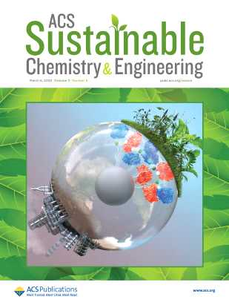
▲ Journal cover image. Eco-friendly production is possible through the simultaneous immobilization of oxidoreductase and cofactor.



