Development of hydrogel-based bio-implantable electrode with reduced side effects and increased utilization

- Adjust the rate of decomposition by injection... Development of highly utilized implantable electrodes
- Professor Jae Young Lee's team from School of Materials Science and Engineering published in the prestigious journal 'Small' in the material field

▲ (From left) GIST Professor Jae Young Lee and GIST Researcher Junggeon Park

GIST (Gwangju Institute of Science and Technology, Acting President Raekil Park) School of Materials Science and Engineering Professor Jae Young Lee's research team has produced a bio-implantable conductive hydration gel* that can be injected and whose lifespan can be controlled.

The research team developed a hydrogel-based bio-implantable electrode and injected it without incision to minimize side effects such as the risk of infection and can control the lifespan of the electrode by adjusting the decomposition rate.

Implantable bioelectrodes can measure precise biosignals as well as deep brain stimulation for the treatment of Parkinson's disease, and selective electrical stimulation such as spinal cord stimulation for chronic pain relief is possible. It can be used as a composite electrode that delivers target drugs to specific tissues by monitoring physiological signals in real time.

On the other hand, conventional implantable bioelectrodes* may cause side effects such as wounds and infections due to incision procedures, tissue damage, or severe inflammatory reactions when implanted with conductive biomaterials such as gold and platinum. In addition, surgery is required for implantation and removal.

* conductive hydrogel: Conductive hydrogel is made by mixing a hydrogel backbone polymer and a conductive material. The conductive hydrogel produced in this way has excellent electrical properties and is soft and flexible, so it is applied to various fields such as cell scaffolds, various electronic devices, and bioelectrodes.

The research team designed the bioelectrode to be implanted using a click chemical reaction*. In the case of injectable conductive hydrogels, conformal contact is possible on curved surfaces or inside dense tissue. The degree of biodegradability was adjusted according to the type of polymer skeleton of the hydrogel, and a polymer and a stable polymer were used to enable hydrolysis in vivo.

* click chemical reaction: A term coined by K. Barry Sharpless, who won the Nobel Prize in Chemistry in 2001, and it is an efficient and selective chemical reaction that can be used for molecular bonding. In this study, Michael addition reaction, which is a representative click chemical reaction and shows high yield under physiological conditions, was used for injectable biomaterials.

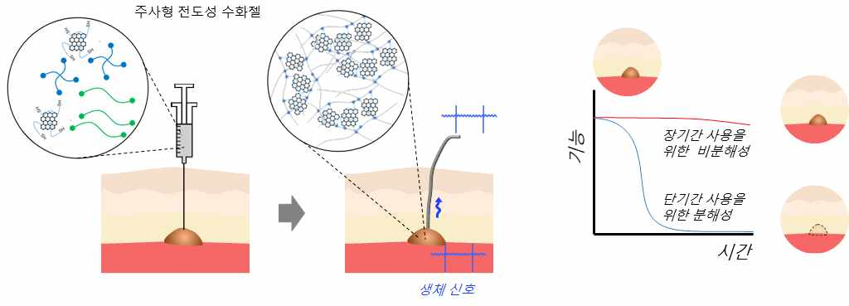
▲ Degradability and stability schematic diagram of bio-signal electrode utilization of injectable conductive hydrogel: Injectable conductive hydrogel using click chemical reaction is an implantable bioelectrode that spontaneously gels after being easily injected into the body by injection. In addition, since the degradability in vivo can be adjusted, the hydrogel electrode can be applied temporarily or permanently according to the purpose.

Compared to existing metal-based bioelectrodes, this hydrogel can be injected without incision, and it is more advantageous for biosignal measurement in terms of high performance and biocompatibility, enabling EMG signals to be measured with more than three times higher sensitivity.

It shows mechanical properties of 30 kPa and conductivity of about 20 mS/cm* and has soft properties similar to living tissue and electrical properties at a level that can efficiently measure vital signals.

* S (Siemens): The Siemens (symbol S) is the international unit of electrical conductance and is equal to the reciprocal of the ohm. One siemens (S) is the conductivity that allows a current of 1 ampere (A) to pass when a voltage of 1 volt (V) is applied. (1 S/cm = 1,000 mS/cm)

The hydrogel developed by the research team can adjust the decomposition rate. 1) In the case of the degradable hydrogel, the EMG could be measured in real time with high sensitivity immediately after injection, but the signal was not measured after it was degraded in the body. It was also confirmed that it completely decomposed within 7 days. 2) The non-degradable hydrogel maintained structural stability and remained unchanged in the body for a long time, functioning as a bioelectrode for up to 3 weeks.

* electromyography (EMG): With electrical signals generated from nerves and muscles, it is possible to examine diseases, muscle diseases, and peripheral nerve diseases.

Professor Jae Young Lee said, "A conductive hydrogel with controllable degradability, stability, and injectability that goes beyond the limitations of existing implantable bioelectrodes was fabricated. In the future, it is expected to replace metal-based electrodes and use them as more efficient bio-implantable electrodes that can be used in the human body or as smart electrodes for tissue regeneration."

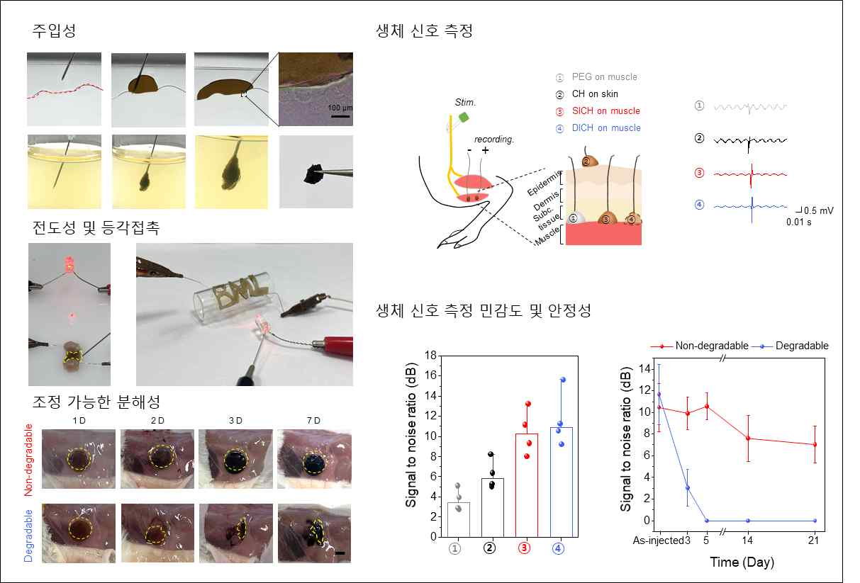
▲ Degradability and stability result of characterization of injectable conductive hydrogel (injectability, conductivity, degradability and biosignal measurement): Injectability, conductivity and degradation controllability of injectable conductive hydrogel. Bio-signal diagram of injectable conductive hydrogel and possibility of application as temporary or permanent bio-electrode according to tunable degradability.

This research, conducted by Professor Jae Young Lee's team at GIST, was carried out with the support of the National Research Foundation of Korea-Nano and Materials Technology Development Project and the National Research Foundation of Korea Basic Research Laboratory Project funded by the Ministry of Science and ICT and was published online on February 24, 2023, in Small, an international academic journal in the field of materials.



