Development of platform technology that maintains the effect of protein drugs for a long time

- Simple application regardless of the type of drug or drug delivery system... Contributing to the development of protein drugs


▲ (From left) GIST Professor Inchan Kwon, Sungkyunkwan University Professor Jaeyun Kim, GIST Dr. Seoungkyun Kim, Sungkyunkwan University student Dong Hee Kim

A Korean research team has developed a groundbreaking platform technology that can easily control the duration of effects of protein drugs.

The National Research Foundation of Korea (Chairman Kwang-bok Lee) announced that the research team of Professor Inchan Kwon of the School of Materials Science and Engineering at the Gwangju Institute of Science and Technology designed charge-amplifying peptide fragments that regulate the charge interaction between protein drugs and drug carriers through joint research with Professor Jaeyun Kim of the School of Chemical Engineering at Sungkyunkwan University.

Protein drugs* are used for the treatment of many diseases due to their excellent matrix properties, but they are rapidly decomposed when injected into the body, making it difficult to sustain the medicinal effect, so there is a problem of repeated and excessive administration.

Accordingly, hydrogel*** is widely used as a drug delivery system**. Depending on the type of drug, if the interaction between protein and hydrogel is weak, the drug release rate in the body is fast, so the drug effect does not last as long as expected. Therefore, it was necessary to develop a platform technology that can strengthen these interactions.

* protein drug (pharmaceutical): A drug that mass-produces therapeutic protein components that are difficult to obtain in vivo.

** drug delivery system: A formulation that binds to a protein drug to prolong its efficacy.

*** hydrogels: A three-dimensional cross-linked structure containing a lot of water, which is used as a drug delivery material such as capsules.

Professor Inchan Kwon's research team tried to control the charge of the drug and the charge interaction between the drug and the drug carrier with a peptide* that can be easily fused to protein drugs. To this end, positive charge amplification peptides and negative charge amplification peptides were designed respectively. As a result of testing the protein drug for gout treatment with the designed charge-amplifying peptide, it was fused to the drug and the charge of the protein drug could be greatly increased or decreased without additional chemical reaction.

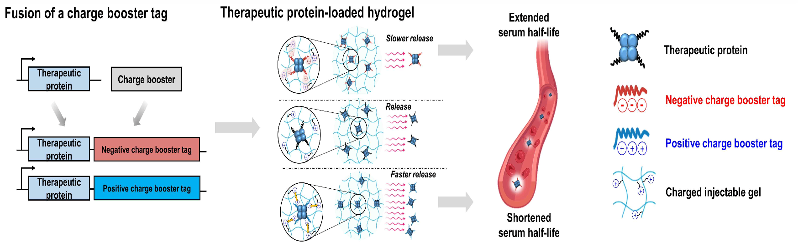▲ A technology that adjusts the rate at which protein drugs are released from a hydrogel for drug delivery and the half-life in the body by fusing charge-amplifying peptides. In particular, in the case of peptides that amplify the charge opposite to hydrogel, the protein drug is slowly released, allowing the drug's efficacy to last for a long time in the body.

As a result of confirming the release rate by injecting these protein drug variants into a hydrogel having a positive charge, it was confirmed that the drug release rate changes according to the size of the protein drug charge.

As a result of animal experiments under the same conditions, it was confirmed that the half-life in the body was significantly increased from 3 hours to 4 days or more, and that the main drug effect was maintained even after 4 days of drug injection.

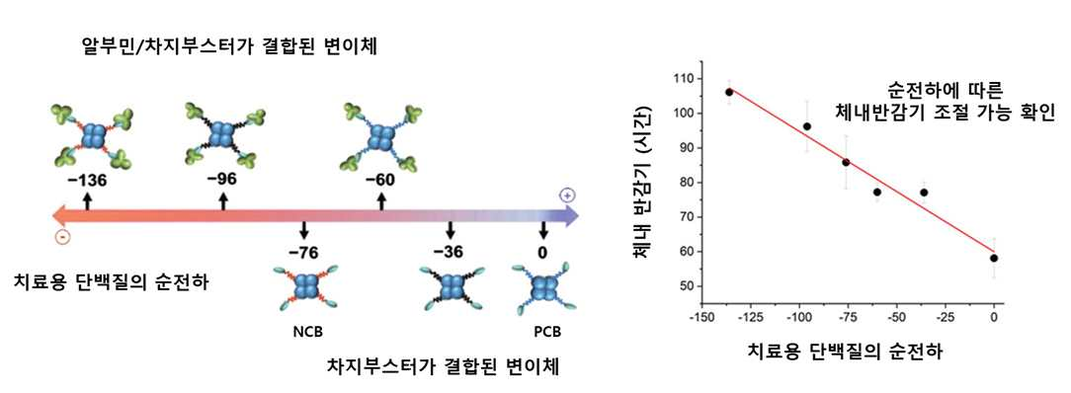
▲ It was confirmed that the half-life in the body can be adjusted according to the size of the negative charge imparted through the charge-amplifying peptide/albumin. It was confirmed that the protein drug can last for a long time in the body when the charge is amplified.

The developed charged peptide fragments are recombinant protein technology** and can be used without additional reaction or purification when preparing drugs. As in the above experiment, the possibility of a platform technology that can be applied to various types of protein drugs and drug delivery systems was also confirmed.

* peptide: A short chain of amino acids linked by peptide bonds.

** protein recombination technology: Transplanting and culturing the gene of a protein that can be useful in human life so that a large amount of protein can be purified and used with simple manipulation.

Professor Inchan Kwon said, "The peptide fragments developed this time are expected to contribute to the commercialization of various protein drugs by enabling control of the half-life of protein drugs in the body through simple fusion."

The results of this research, which were conducted with the support of the mid-sized research, leading research center, and C1 Refinery Project promoted by the Ministry of Science and ICT and the National Research Foundation of Korea, were published in 'Advanced Functional Materials', an international academic journal in the field of materials. It was published online on December 27th, and is scheduled to be published in the next issue after being selected as the cover story.



