Development of core technologies for longer lasting electric vehicles

- Domestic joint research team replaces copper thin film anode material of lithium metal battery with carbon fiber paper
- Durability improved by more than 3 times... High energy density and light weight


▲ (From left) GIST Professor KwangSup Eom, KIST Center Director Sungho Lee, KIST Student Researcher Youn-Ki Lee

As the demand for secondary batteries explodes due to the expansion of the supply of electric vehicles, the need for next-generation secondary batteries that can be rapidly charged and that has a larger capacity than the current most popular lithium-ion battery is growing.

A lithium metal battery that replaces graphite, an anode material* of lithium ion with lithium metal, can theoretically realize a capacity 10 times higher than that of a lithium ion battery. However, since crystal protrusions* are generated on the surface of lithium during charging and discharging, the separator* is torn, which has problems with durability and safety, so it has not been commercialized.

* anode material: Stores and releases lithium ions from the anode to allow current to flow, playing an important role in the charging speed and lifespan of the battery.

* Lithium dendrite: In the process of charging a lithium metal battery, lithium is unevenly deposited on the electrode and grows into protrusions.

* Separator: A thin film of insulating material that prevents contact between the positive and negative electrodes inside the battery. Regarding the safety of the battery.

GIST (Gwangju Institute of Science and Technology, Acting President Raekil Park) School of Materials Science and Engineering Professor KwangSup Eom's team, together with a research team led by Carbon Composite Materials Research Center Director Sungho Lee, Director of the Carbon Convergence Materials Research Center at the Carbon Composite Materials Research Center (Branch Director Jin-sang Kim) at the Jeonbuk Branch of the Korea Institute of Science and Technology (KIST, President Seok-jin Yoon) announced that they had developed a technology that improved the durability of lithium metal batteries by more than three times by using carbon fiber paper as an anode material.

The research team replaced the copper thin film coated with lithium metal, which is used as an anode material for lithium metal batteries, with thin carbon fiber paper containing lithium metal. The developed carbon fiber paper was surface-treated with inorganic nanoparticles of amorphous* carbon and sodium carbonate on short carbon fibers to have lithium-friendly characteristics and prevent sharp growth of lithium dendrites.

* amorphous: Minerals that do not form regular crystals because the arrangement of atoms or ions that make up the mineral is irregular.

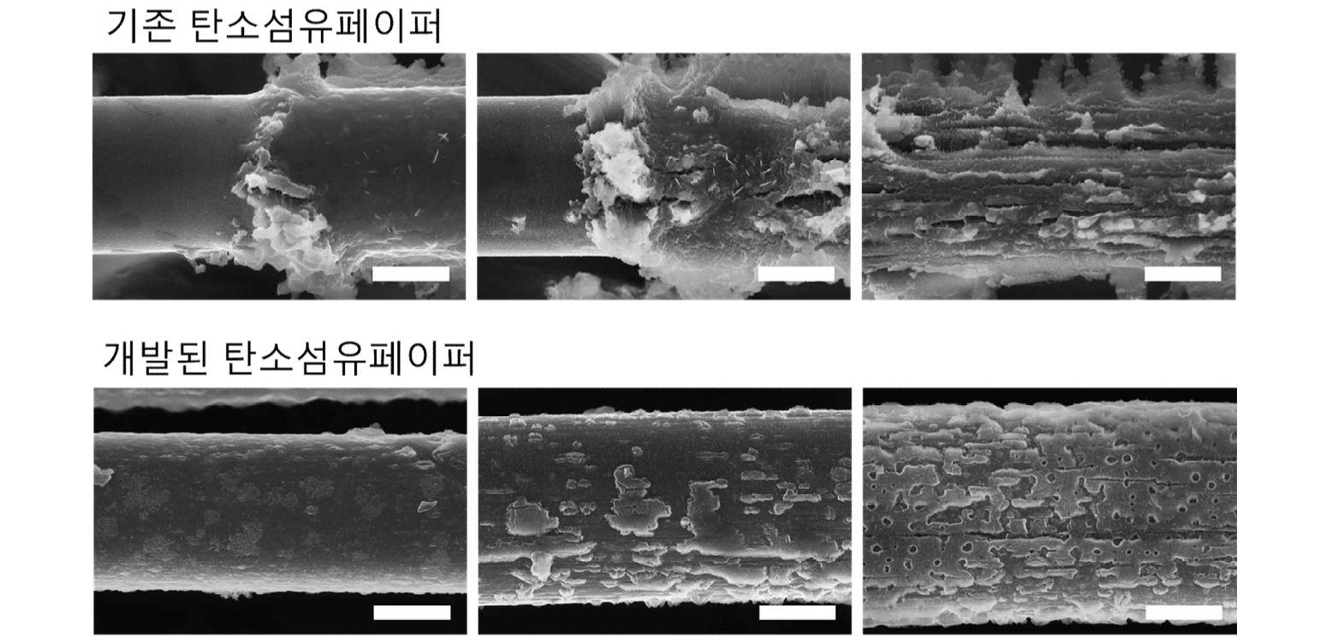▲ Shape according to lithium plating amount of carbon fiber paper with hierarchical structure compared to existing carbon fiber paper

As a result of using the developed carbon fiber paper anode material, the joint research team was able to manufacture a lithium metal battery with durability three times higher than copper thin film. The copper thin film suffered a short circuit* after about 100 charge/discharge cycles, but the newly developed carbon fiber paper showed stable performance even after 300 cycles or more.

In addition, the energy density* of lithium metal batteries using copper thin films was increased by about 1.8 times from 240 Wh/kg to 428 Wh/kg. Furthermore, it is expected that the electrode manufacturing process can be simplified because the melted lithium is quickly absorbed into the carbon fiber paper.

* short circuit: short circuit. A phenomenon in which two parts on a circuit having a potential difference are in electrical contact. Excessive current flows at the contact point, causing heat generation, fire or explosion.

* energy density: Energy stored in unit volume or unit weight. An indicator of battery efficiency.

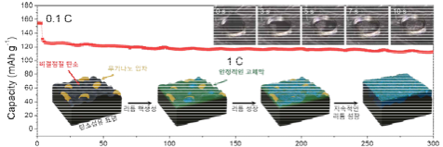
Cycle numbers
▲ A schematic diagram showing the effect of suppressing lithium dendrites on the surface of carbon fiber, where a hierarchical structure is formed by the formation of amorphous carbon and inorganic nanoparticles through carbonization of polymers, and the melted lithium is quickly absorbed into the carbon fiber paper.

Professor KwangSup Eom said, "This research achievement has the greatest significance in that sufficient stability can be secured as a current collector for a lithium metal anode even with a simple surface treatment of carbon fiber, which is much lighter than copper. It is expected to contribute to the commercialization of high-energy lithium metal batteries in the future."

This research was supported by the Ministry of Science and ICT (Minister Jong-ho Lee) and was carried out as a KIST major project and nano material technology development project, and the research results were published in the January issue of ‘Advanced Energy Materials’ (IF=29.698, JCR top 2.464%), an international academic journal.



