The place you want to see... "Make it clearer!" Development of high-contrast and high-resolution cameras that resemble the eyes of a cuttlefish

- Overcoming unfavorable visual environment by mimicking cuttlefish's W-shaped pupil and retinal structure
- Expected to be used as a camera for self-driving cars, robots, and drones... published by Science Robotics


▲ Photographs of researchers (counterclockwise from top left): GIST Professor Young Min Song, Seoul National University Professor Dae-Hyeong Kim, Pusan National University Professor Gil Ju Lee, Seoul National University Researcher Minsu Kim, GIST Researcher Sehui Chang, Northwestern University Doctor Minsung Kim

A Korean joint research team including GIST (Gwangju Institute of Science and Technology, President Kiseon Kim) has developed a camera that can obtain high-contrast and high-resolution images even under irregular lighting conditions by imitating the eyes of cuttlefish that catches prey even in unfavorable conditions underwater.

The cuttlefish's pupils form a W-shape to adjust the light conditions in order to block the upper light and receive the lower light. In the retina, photoreceptors are densely concentrated in the area where light enters from below, so that high-resolution vision is realized downward as prey passes.

By mimicking the pupil of a cuttlefish, the research team made the aperture in front of the spherical lens into a W-shape like the pupil of a cuttlefish to effectively reduce strong light coming from above and prevent overexposure of the photodiode.

In addition, photodiode pixels are concentrated in the area where the region of interest is formed as an image, such as the retina of a cuttlefish, to efficiently obtain high-resolution images. If only the region of interest is viewed at high resolution, power consumption can be reduced and image processing speed can be increased.

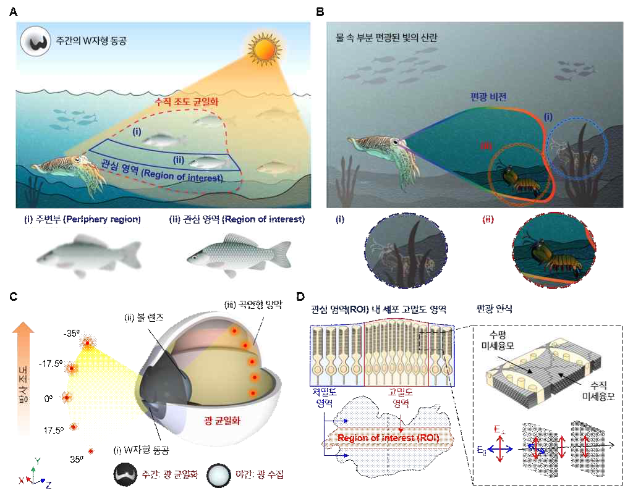
▲ Visual characteristics and eye structure of cuttlefish in water: (A) Cuttlefish equalize uneven vertical illumination through daytime W-shaped pupils and form a high-resolution field of view in the region of interest. (B) A cuttlefish forms a high-contrast field of view by removing scattered light through partial polarization and recognizing polarized light reflected from the body of a prey creature. (C) Illustration of cuttlefish's eye structure (D) Illustration of cuttlefish's polarization recognition through the cell-dense region of the retina where the region of interest is imaged and the microvillus alignment structure

Unlike the existing camera system, which was a post-processing method in which images were acquired under irregular light conditions and then improved with software, this system can collect high-quality images by adjusting the lighting conditions in the hardware itself, enabling efficient image processing.

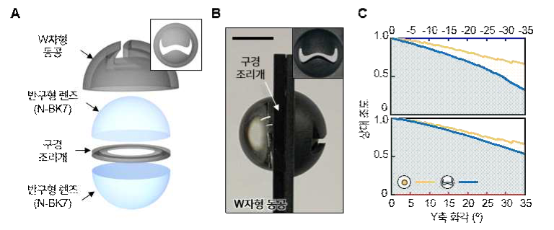
▲ Optical system imitating a cuttlefish eye: (A) Illustration of an optical system mimicking a cuttlefish eye (B) Photo of the optical system imitating a cuttlefish eye and a W-shaped pupil (C) Comparison of vertical relative illumination of the optical system according to the shape of the pupil

In particular, by producing a carbon nanotube-based flexible polarizing film that flexibly adheres to the cylindrical photodiode array, light is absorbed and transmitted according to the polarization* direction, enabling clearer images to be obtained with increased contrast.

* polarization phenomenon: Sunlight originally vibrates in all directions, but when it hits a specific surface, the electric field vibrates only in a specific direction.

This study proposes a non-uniform lighting environment and efficient high-contrast image processing technology, which can be used as a camera system to obtain high-quality images in autonomous vehicles, mobile robots, and drones that must be used in visually changing environments. If installed in an autonomous vehicle, it will be possible to see ahead clearly even when driving in a situation where the sunlight is irregularly shining in broad daylight.

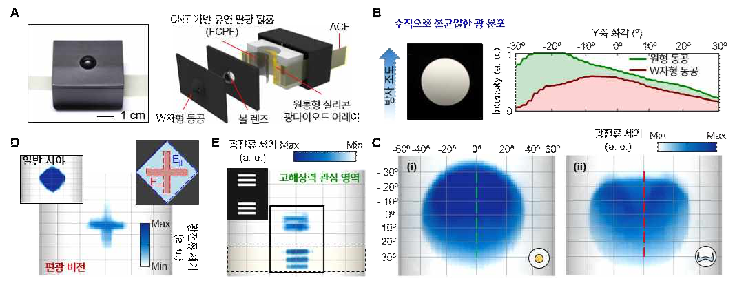
▲ Cuttlefish eye imitation camera structure and image processing results: (A) Cuttlefish eye imitation camera photo and exploded view illustration (B-C) Vertical illumination improvement evaluation graph and image result of non-uniform incident light of the manufactured cuttlefish eye imitation camera (D) Polarization recognition image processing result of the fabricated cuttlefish eye imitation camera (E) High resolution ROI image processing result of the fabricated cuttlefish eye imitation camera

If a variable pupil that can be changed to a circular pupil with a large area is produced using the results of this study, it is expected that a high-quality camera system that can be used not only during the daytime but also at night when the amount of light is low can be realized.

Professor Song said, "This study is the first case of developing a high-contrast and high-resolution camera system by mimicking the unique W-shaped pupil and retinal structure of cuttlefish, which is characterized by acquiring improved images in unfavorable visual environment by using the hardware itself without complicated software processing."

Professor Song continues his research on visual structures based on nature, which started with insect eye simulation, developing a wide-angle camera that mimics fish eyes, and an omnidirectional amphibious camera that mimics the eye structure of a sea crab.

This research was conducted by GIST School of Electrical Engineering and Computer Science Professor Young Min Song, Seoul National University School of Chemical and Biological EngineeringProfessor Dae-Hyeong Kim, Pusan National University Department of Electronics Engineering Professor Gil Ju Lee, GIST Researcher Sehui Chang, and Northwestern University Doctor Minsung Kim with support from the Future Materials Discovery Project promoted by the Ministry of Science and ICT and the National Research Foundation of Korea and was published on February 15, 2023, in the world-renowned academic journal Science Robotics.



