Development of a new cryopreservative in the form of nanoparticles that restores ‘hard’ frozen cells to health

- Discovery of nanoparticles that restore frozen cells to health by controlling the interface between ice and water
- School of Materials Science and Engineering Professor Eunji Lee’s team selected as the cover paper of JACS Au, an internationally renowned academic journal in the field of chemistry


▲ (From left) Master's Nayeong Jeon, Professor Eunji Lee, and integrated student Ilhyung Choi

A research team in Korea has developed a cryopreservative in the form of nanoparticles that can be mass-produced and exhibits better recovery ability than existing chemical preservatives when cells are frozen at cryogenic temperatures and is non-toxic even when used at high concentrations.

When using a very small amount (1/2200) compared to the conventional chemical cryopreservation agent, dimethyl sulfoxide (DMSO), the corresponding cell recovery rate (average 70%) and cell proliferation efficacy (4 times within 48 hours) were shown. It is expected to be used in various fields such as rare cell storage and organ transplantation due to its excellent biocompatibility.

* cell recovery rate: ratio of the number of viable cells upon thawing to the total number of frozen cells

* cell proliferation efficacy: degree of proliferative ability of living cells among thawed cells

To minimize cell damage caused by ice crystals when freezing cells, a preservative solution is used for storage. Recently, as interest in personalized medical technology has increased, interest in high value-added biological sample cryopreservation technology such as stem cells, umbilical cord blood, reproductive cells, cell therapy products, and organs, which are aggregates of cells, is growing.

Existing cryopreservatives such as dimethyl sulfoxide, sodium phosphate, and glycerol are cytotoxic at high concentrations, destroying cells. Repeated freezing and thawing has fatal disadvantages such as damaging cell membranes and causing genetic modification during cell restoration.

GIST (Gwangju Institute of Science and Technology, President Kiseon Kim) School of Materials Science and Engineering Professor Eunji Lee’s research team developed nano-sized metal-organic skeletal particles combined with anti-freezing protein-derived peptides that can effectively control the freezing phenomenon that occurs when cells are frozen and thawed and secured the original technology for synthesizing preservatives that have better cell resilience than existing cryopreservatives.

* freezing: the process of changing the phase of water from a liquid state to a solid state when the temperature of the water is sufficiently low

* metal-organic framework (MOF): a type of coordinating polymer as a porous material in which clusters containing metal ions or metals are connected by organic ligands

The research team paid attention to the instability principle of the ice-water interface and the site of chemical bonding on the ice surface. Synthesis of zirconium metal-organic framework nanoparticles having the same framework lattice size as the ice crystal lattice and having excellent biocompatibility. Three types of nanoparticles (10/30/250 nm) were prepared by binding anti-icing protein-derived peptides to the surface of the nanoparticles through a chemical reaction.

After adding the nanoparticles developed by the research team to water, the ice recrystallization phenomenon was observed during freeze-thaw. It was confirmed that the small-sized nanoparticles effectively prevent the entry, lower the freezing point by increasing the fine curvature of the ice-water interface, and inhibit the growth of ice very effectively.

The growth of small ice crystals formed by freezing into larger ice crystals when thawing is called ice recrystallization. The nanoparticles developed by the research team effectively bind to the ice surface and exhibit excellent freezing control effects, effectively preserving cells when frozen and restoring them to health when thawing.

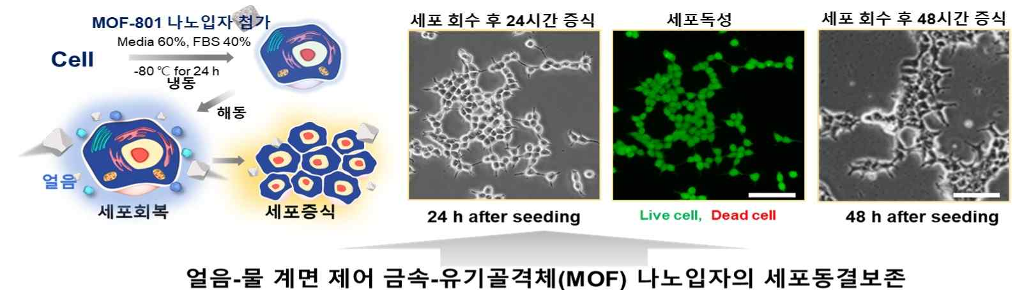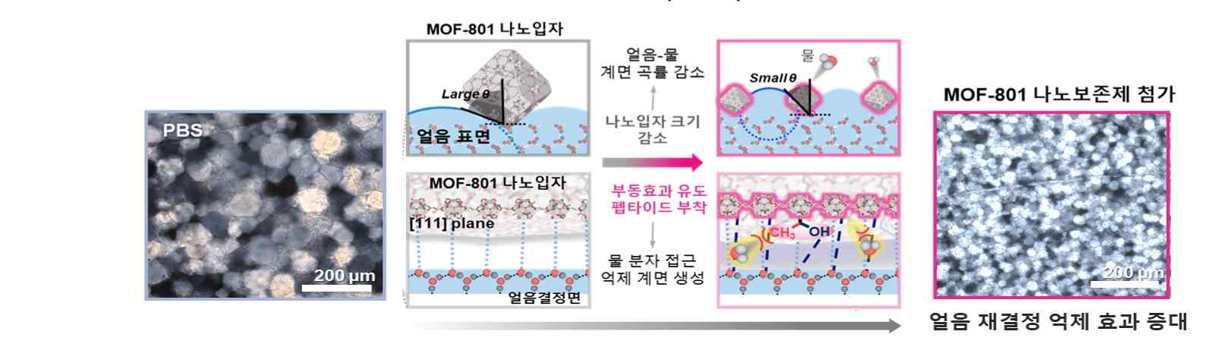
▲ A nano-sized metal-organic framework cryopreservative with high biocompatibility and cell recovery rate that can be mass-produced is driven and applied. Nanoparticle cryopreservatives modified with peptides that mimic anti-icing proteins show high cell recovery rates comparable to commercial chemical preservatives.

Compared to existing cryopreservatives, these nanoparticles showed excellent biocompatibility even at high concentrations, and despite the use of a very small amount (50 ug/mL), kidney cells. When applied to various cell lines such as cancer cells and stem cells, it was possible to confirm the cell recovery rate that is comparable to or higher than that of existing cryopreservatives and the proliferation efficiency of the recovered cells.

Professor Eunji Lee said, "This study is significant in that it suggests the possibility of developing an economical frozen nanopreservative that can be mass-produced with excellent biocompatibility. In particular, it overcomes the fatal disadvantages of existing chemical preservatives, has almost no toxicity even at high concentrations, and preserves rare cells as it can expect results comparable to existing preservatives even when used in extremely small amounts. This is expected to have a great ripple effect in related biomedical fields such as organ transplantation."

Master's student Nayeong Jeon, who led the research and produced a series of thesis and patent results, said, "Based on the understanding of the chemical and physical properties of ice, specific experiments were designed, and we realized the importance of convergence research through active exchanges with the joint research team. I want to focus on more in-depth research for the development and commercialization of cryopreservatives with greater added value."

The research was conducted by GIST Professor Eunji Lee, Korea Institute of Materials Science Dr. Hee Jung Lee, and University of Ulsan College of Medicine Professor Lee Chang-hwan Lee's joint research team with support from the National Research Foundation of Korea's individual basic research project (mid-level), Future Materials Discovery Project, and the GIST Commercialization Project and was published online on January 23, 2023, (Tuesday) as a cover paper in the American Chemical Society Gold Paper (JACS Au), an international academic journal published by the American Chemical Society (ACS).

In addition, an evaluation platform for anti-icing protein-derived nanopreservatives was developed and published on October 4, 2022, in ACS Applied Nano Materials, an international journal published by the American Chemical Society, and patents were registered in the United States and Japan in 2022.

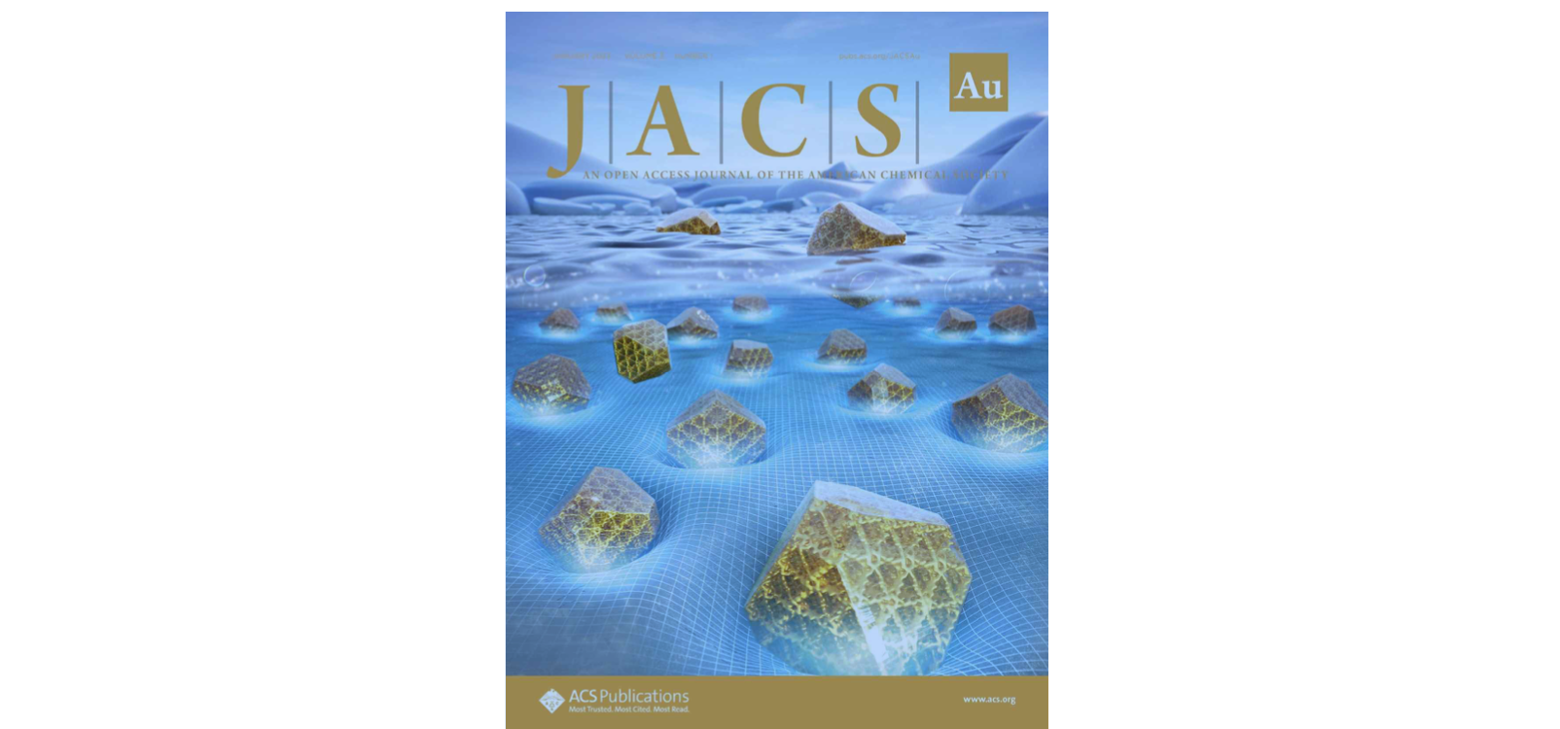▲ Selected as the cover paper of JACS Au, an internationally renowned academic journal



