GIST and Korea University jointly develop a fiber-type power generation system that bends and stretches by applying a zebra pattern

- Utilizing the difference between black and white color... Can be implemented on textiles with a simple horizontal structure
- 24-hour electricity production using thermoelectric phenomenon with a temperature difference of up to 22 degrees, published in Science Advances


▲ (From left) GIST Professor Young Min Song, Korea University Professor Suk-Won Hwang, GIST Ph.D. student Se-Yeon Heo

GIST (Gwangju Institute of Science and Technology, President Kiseon Kim) and Korea University researchers developed a bending and stretching fiber-type power generation system by applying the horizontal power generation mechanism inspired by the zebra pattern to biodegradable nanofilm material.

It uses the ‘thermoelectric phenomenon*’ that generates electricity with the temperature difference caused by the color difference (black-white) on the surface of the film material. Unlike conventional complex thermoelectric materials, it is expected to be used in various environments that require flexibility and elasticity by applying a simple horizontal structure such as a zebra pattern.

In addition, it can generate electricity 24 hours a day without a break, and it is expected to be used as a next-generation eco-friendly energy source by using biodegradable materials that dissolve in physiological saline.

The results of this research were published online on February 1, 2023, in 「Science Advances」, a sister journal of the world-renowned academic journal Science.

* thermoelectric phenomenon: A phenomenon in which a potential difference is generated from a difference in temperature (thermal energy) and current flows. When there is a temperature difference (heat) between the inside and outside of the material, the power to flow the charges is generated. It is similar to the principle that the higher the height (drop) of a waterfall in hydroelectric power generation and the more water flows, the more electricity is produced.

The research team focused on the zebra pattern with distinct heating (black) and cooling (white) areas even on a flat surface due to the color difference. A zebra pattern was applied on a biodegradable nanofiber film, and a structure that absorbs and releases heat most efficiently was designed through optical calculation. As a result of spectral analysis, a constant temperature difference was maintained for 24 hours in both the heating and cooling zones.

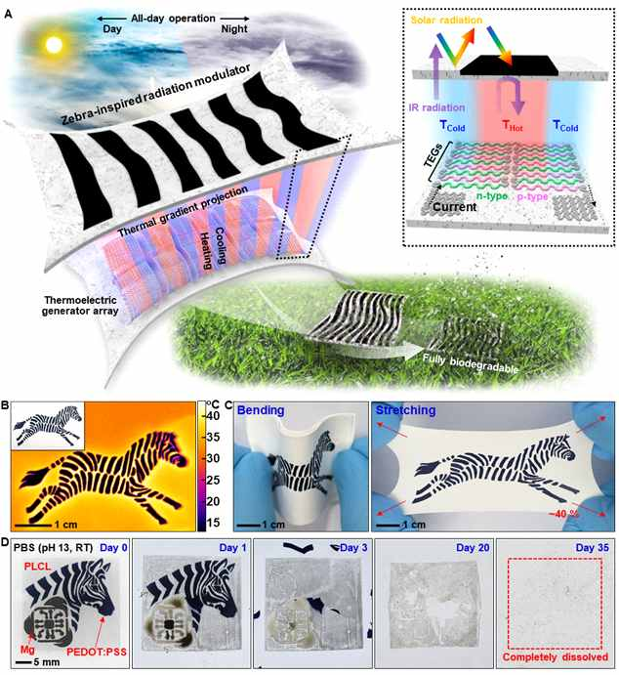
▲ A. Schematic diagram of a biodegradable flexible/stretchable temperature control system capable of 24-hour power generation. The radiant heating zebra-patterned stretchable radiant cooling nanofiber film forms a horizontal temperature difference, and the biodegradable silicon nanomembrane thermoelectric element converts this thermal energy into electrical energy. B. Thermal infrared image of a film patterned in a zebra pattern. The white nanofiber film shows high solar reflectance and emissivity to the window area of the atmosphere, while the black zebra pattern shows high solar absorbance and reflectivity to the window area to the atmosphere. C. High strain on bending and stretching of the film of the developed system. D. Observation of biodegradability in physiological saline for major components of the power generation system.

As a result of the experiment under various weather conditions outdoors, the white part was lowered by up to about 8° C above the ambient air temperature, and the black part rose up to 14° C above the ambient air temperature, resulting in a temperature difference of up to 22 degrees, and succeeded in converting this temperature difference into electric energy of up to about 6 μW/m².

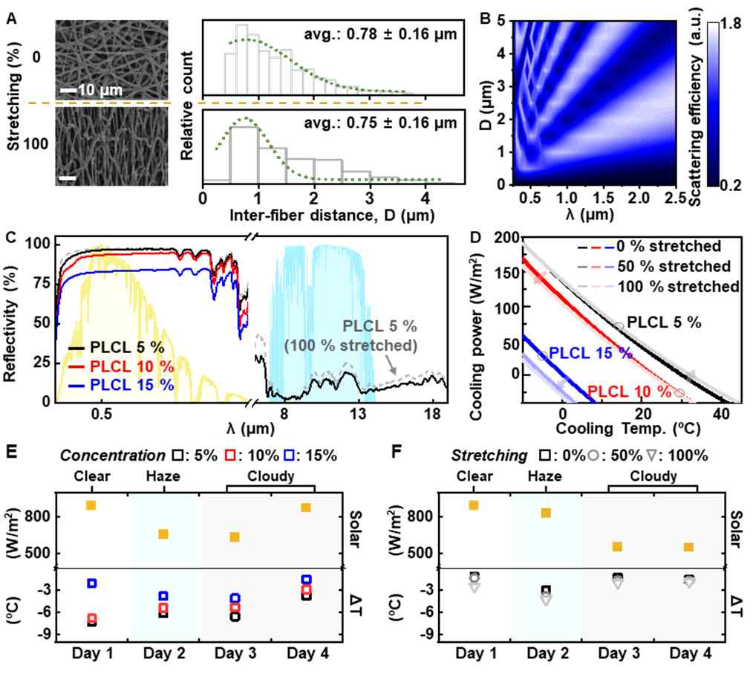
▲ A. Distribution of pores before and after stretching of radiant-cooled nanofiber film. B. Scattering efficiency for sunlight according to pore distribution. This means that films with various pore distributions have high reflectivity in the full range of the solar spectrum. C. Optical analysis results showing high solar light (yellow area) reflectance and emissivity in the window area (blue area) of the nanofiber film according to the concentration of the polymer. D. Calculated cooling performance based on optical analysis. E, F. Evaluation of the cooling performance of the films under various weathers and strains. It shows cooling performance of up to about 8°C, and the cooling performance is maintained even under deformation.

This is a level that can drive low-power sensors, which is a wearable for measuring biosignals in the future, and is expected to be used in high-temperature detection sensors in industrial sites and distance detection sensors for autonomous driving without batteries.

In particular, it is noteworthy that the power generation performance is maintained even when the square-shaped film is pulled from the four corners and stretched about 1.3 times, so that it can be applied in various environments in the future.

It is an innovative system that can be applied not only to flat surfaces, but also to stably generate electricity in the face of physical deformation such as bending and stretching and is expected to dramatically increase the utilization of thermoelectric materials. In the past, heat was released from the upper layer and absorbed from the lower layer, which was inefficient and difficult to commercialize.

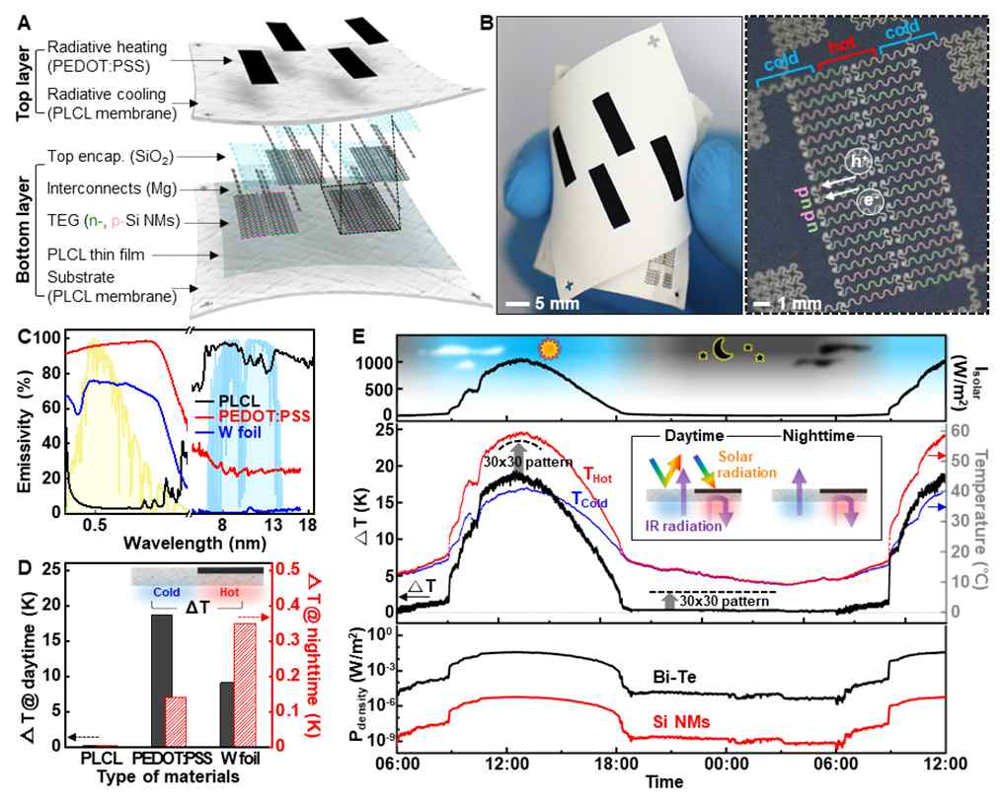
▲ A. Development of the biodegradable flexible/flexible power generation system. It is divided into an upper surface that forms a temperature difference by controlling the window area of sunlight and air, and a lower surface with a silicon nano-film-based thermoelectric element that converts thermal energy into electrical energy. B. Photo of the fabricated power generation system (left) and enlarged photo of the thermoelectric element composed of n-type and p-type silicon nanofilms (right). C. Optical analysis results of radiant cooling polymer and radiant heating material (PEDOT:PSS, W foil). Unlike radiation-cooled polymers, radiation-heated materials have high solar emissivity (=absorption) and low atmospheric window area emissivity. D. Results of night and day temperature difference formation of zebra patterns according to radiant heating materials. E. Measurement of real-time generation performance in the external environment. The top shows the amount of sunlight, the middle shows the temperature difference, and the bottom shows the amount of electricity converted into electrical energy.

Professor Young Min Song said, "This research is the result of research on the convergence of engineering and optics to realize flexible electronic devices, and it is significant that it succeeded in controlling the temperature in the horizontal direction, which was difficult to implement, and produced a power generation system with flexibility and elasticity."

GIST School of Electrical Engineering and Computer Science Professor Young Min Song and Korea University KU-KIST Graduate School of Convergence Professor Suk-Won Hwang led the research conducted by GIST Ph.D. student Se-Yeon Heo and Korea University Won Bae Han, and Dr. Donghak Kim with the support of the Korea Research Foundation's basic research lab follow-up project, Nanomaterial Technology Development Project, Promising Convergence Technology Pioneer Project, and Future Material Discovery Project.



