Increase hydrogen generation of cheap metal catalyst to platinum level!

- Efficiency close to that of platinum achieved by simple surface treatment of existing nickel compound catalysts
- School of Materials Science and Engineering Professors KwangSup Eom and Joo-Hyoung Lee's research team published a paper in a renowned academic journal in the field of chemical engineering


▲ (From left) Professor KwangSup Eom, Professor Joo-Hyoung Lee, Ph.D. student Seunghyun Jo, and Ph.D. student Byeol Kang

GIST (Gwangju Institute of Science and Technology, President Kiseon Kim) researchers improved the hydrogen generation efficiency of nickel-based compound catalysts by more than 40% through electrochemical surface treatment.

‘Hydrogen generation efficiency’ determines the required power consumption per volume of generated hydrogen fuel. If the catalyst developed in this research is used for water electrolysis, it is expected to contribute to lowering the price of hydrogen fuel by reducing power consumption by about 30% when producing hydrogen fuel.

‘Water electrolysis’ is a device that generates hydrogen gas and oxygen gas from water by generating a potential difference using a hydrogen generating catalyst and an oxygen generating catalyst at the anode. It is attracting attention as a key technology for eco-friendly hydrogen fuel production because it does not generate greenhouse gases such as carbon dioxide in the hydrogen fuel generation process.

Currently, most of the materials used as catalysts for generating hydrogen are noble metal catalysts, including platinum. Because these noble metal catalysts are expensive, they are a major cause of increasing the price of hydrogen fuel, so research on developing non-noble metal catalysts such as nickel, cobalt, and iron are being conducted.

However, non-noble metal catalysts are less efficient than platinum and require a lot of power. Since this increases the price of hydrogen fuel, research is needed to increase the hydrogen generation reaction rate of non-noble metal catalysts.

The School of Materials Science and Engineering Professors KwangSup Eom and Joo-Hyoung Lee's joint research team developed a catalyst that can increase hydrogen generation efficiency by about 44% compared to existing non-precious metal catalysts by forming a structure suitable for hydrogen generation reaction through electrochemical surface treatment of nickel compounds.

The nickel compound catalyst material has a disadvantage in that it is difficult to meet the conditions optimized for the hydrogen generation reaction due to the standardized composition and structure between nickel and additives.

To solve this problem, the research team modified the composition and crystal structure of the surface where the actual catalytic reaction takes place through an electrochemical process to form conditions for the fastest hydrogen generation reaction rate.

The surface treatment method is characterized by high utilization because it can be used by flexibly changing the conditions of the electrochemical process according to the acidity and ion concentration of the electrolyte.

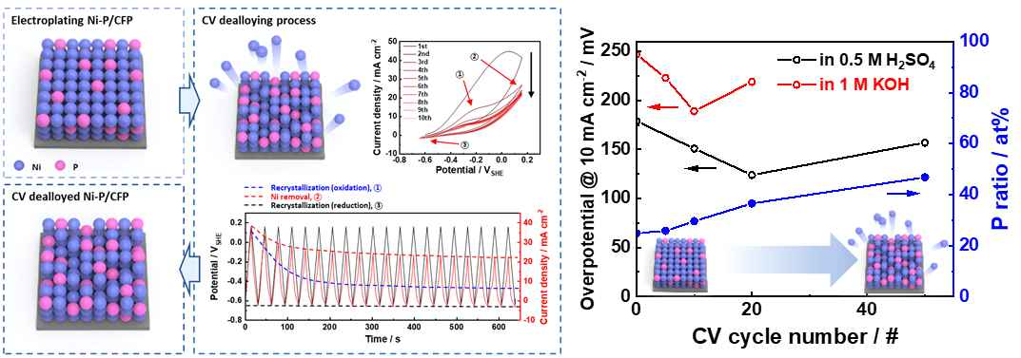
▲ A mimetic diagram showing the surface treatment process of nickel compound catalysts and a comparison of catalytic activity according to the degree of surface treatment.

The schematic diagram shows the significantly improved electrochemical performance of nickel phosphide during the surface treatment of the prepared nickel phosphide catalyst and after surface treatment. Since the developed nickel phosphide catalyst material has a different hydrogen generation mechanism depending on the acidity of the electrolyte, the number of repetitions of the surface treatment was adjusted to have a suitable structure according to the acidity. As a result, the ratio of phosphorus to nickel on the surface increased and the crystal structure changed. These changes balance the rate of adsorption and desorption of hydrogen cations on the surface of the catalyst so that the hydrogen evolution reaction can occur quickly.

The research team analyzed the factors affecting the change and rate of the reaction process according to the acidity of the electrolyte through computer calculations.

Based on the above analysis, the surface treatment conditions were modified and the hydrogen generation reaction of the nickel compound catalyst was analyzed under acidic and basic conditions. Compared to the existing nickel compound, the efficiency was 1.44 and 1.30 times, respectively.

The hydrogen generation efficiency of the surface-treated nickel compound is about 77% compared to that of the platinum catalyst. Considering the cost, it seems to be sufficiently usable as a substitute for platinum catalysts.

In addition, the research team succeeded in improving the durability of the developed nickel compound catalyst. As a result of the surface treatment developed by the research team, the corrosiveness of the catalyst is reduced, and the lifespan is 8 times longer than that of the existing nickel compound catalyst in a strong acid solution.

Transition metals, including nickel, are not commercially available in acidic water electrolysis because a corrosion reaction occurs simultaneously with a hydrogen generation reaction in an acidic solution, shortening the lifespan of the catalyst.

The surface-treated nickel compound has a relatively stable structure as the bond between nickel and additives is strengthened. This greatly reduced the rate of the corrosion reaction.

The nickel compound catalyst developed by the research team had a lifespan of about 3,000 hours under strong acid conditions (pH 0.3). Compared to the lifespan of the existing nickel compound (about 375 hours), very excellent durability was confirmed.

Professor KwangSup Eom said, "While most previous studies have focused on the development of new materials, this study is significant in that it has sufficiently improved the performance and stability of catalysts by simply modifying the surface of the material."

The was led by GIST School of Materials Science and Engineering Professors KwangSup Eom and Joo-Hyoung Lee and conducted by Seunghyun Jo and Byeol Kang with support from the Institute for Science and Technology Job Promotion's R&D project and the GIST-MIT AI Convergence International Cooperation project and the results were published on February 1, 2023, in the 「Chemical Engineering Journal」 (2021 citation index: 16.744, 2.79% by JCR field), a world-renowned academic journal in the field of materials.



