Professor Hyunseob Lim's research team investigates the synthesis mechanism of next-generation semiconductor materials that surpass silicon

- Securing the economic feasibility of the synthesis process by developing a synthesis method that dramatically reduces interface defects
- Professor Hyunseob Lim's team published a thesis in ACS Nano, a renowned international journal in the field of materials science and chemistry

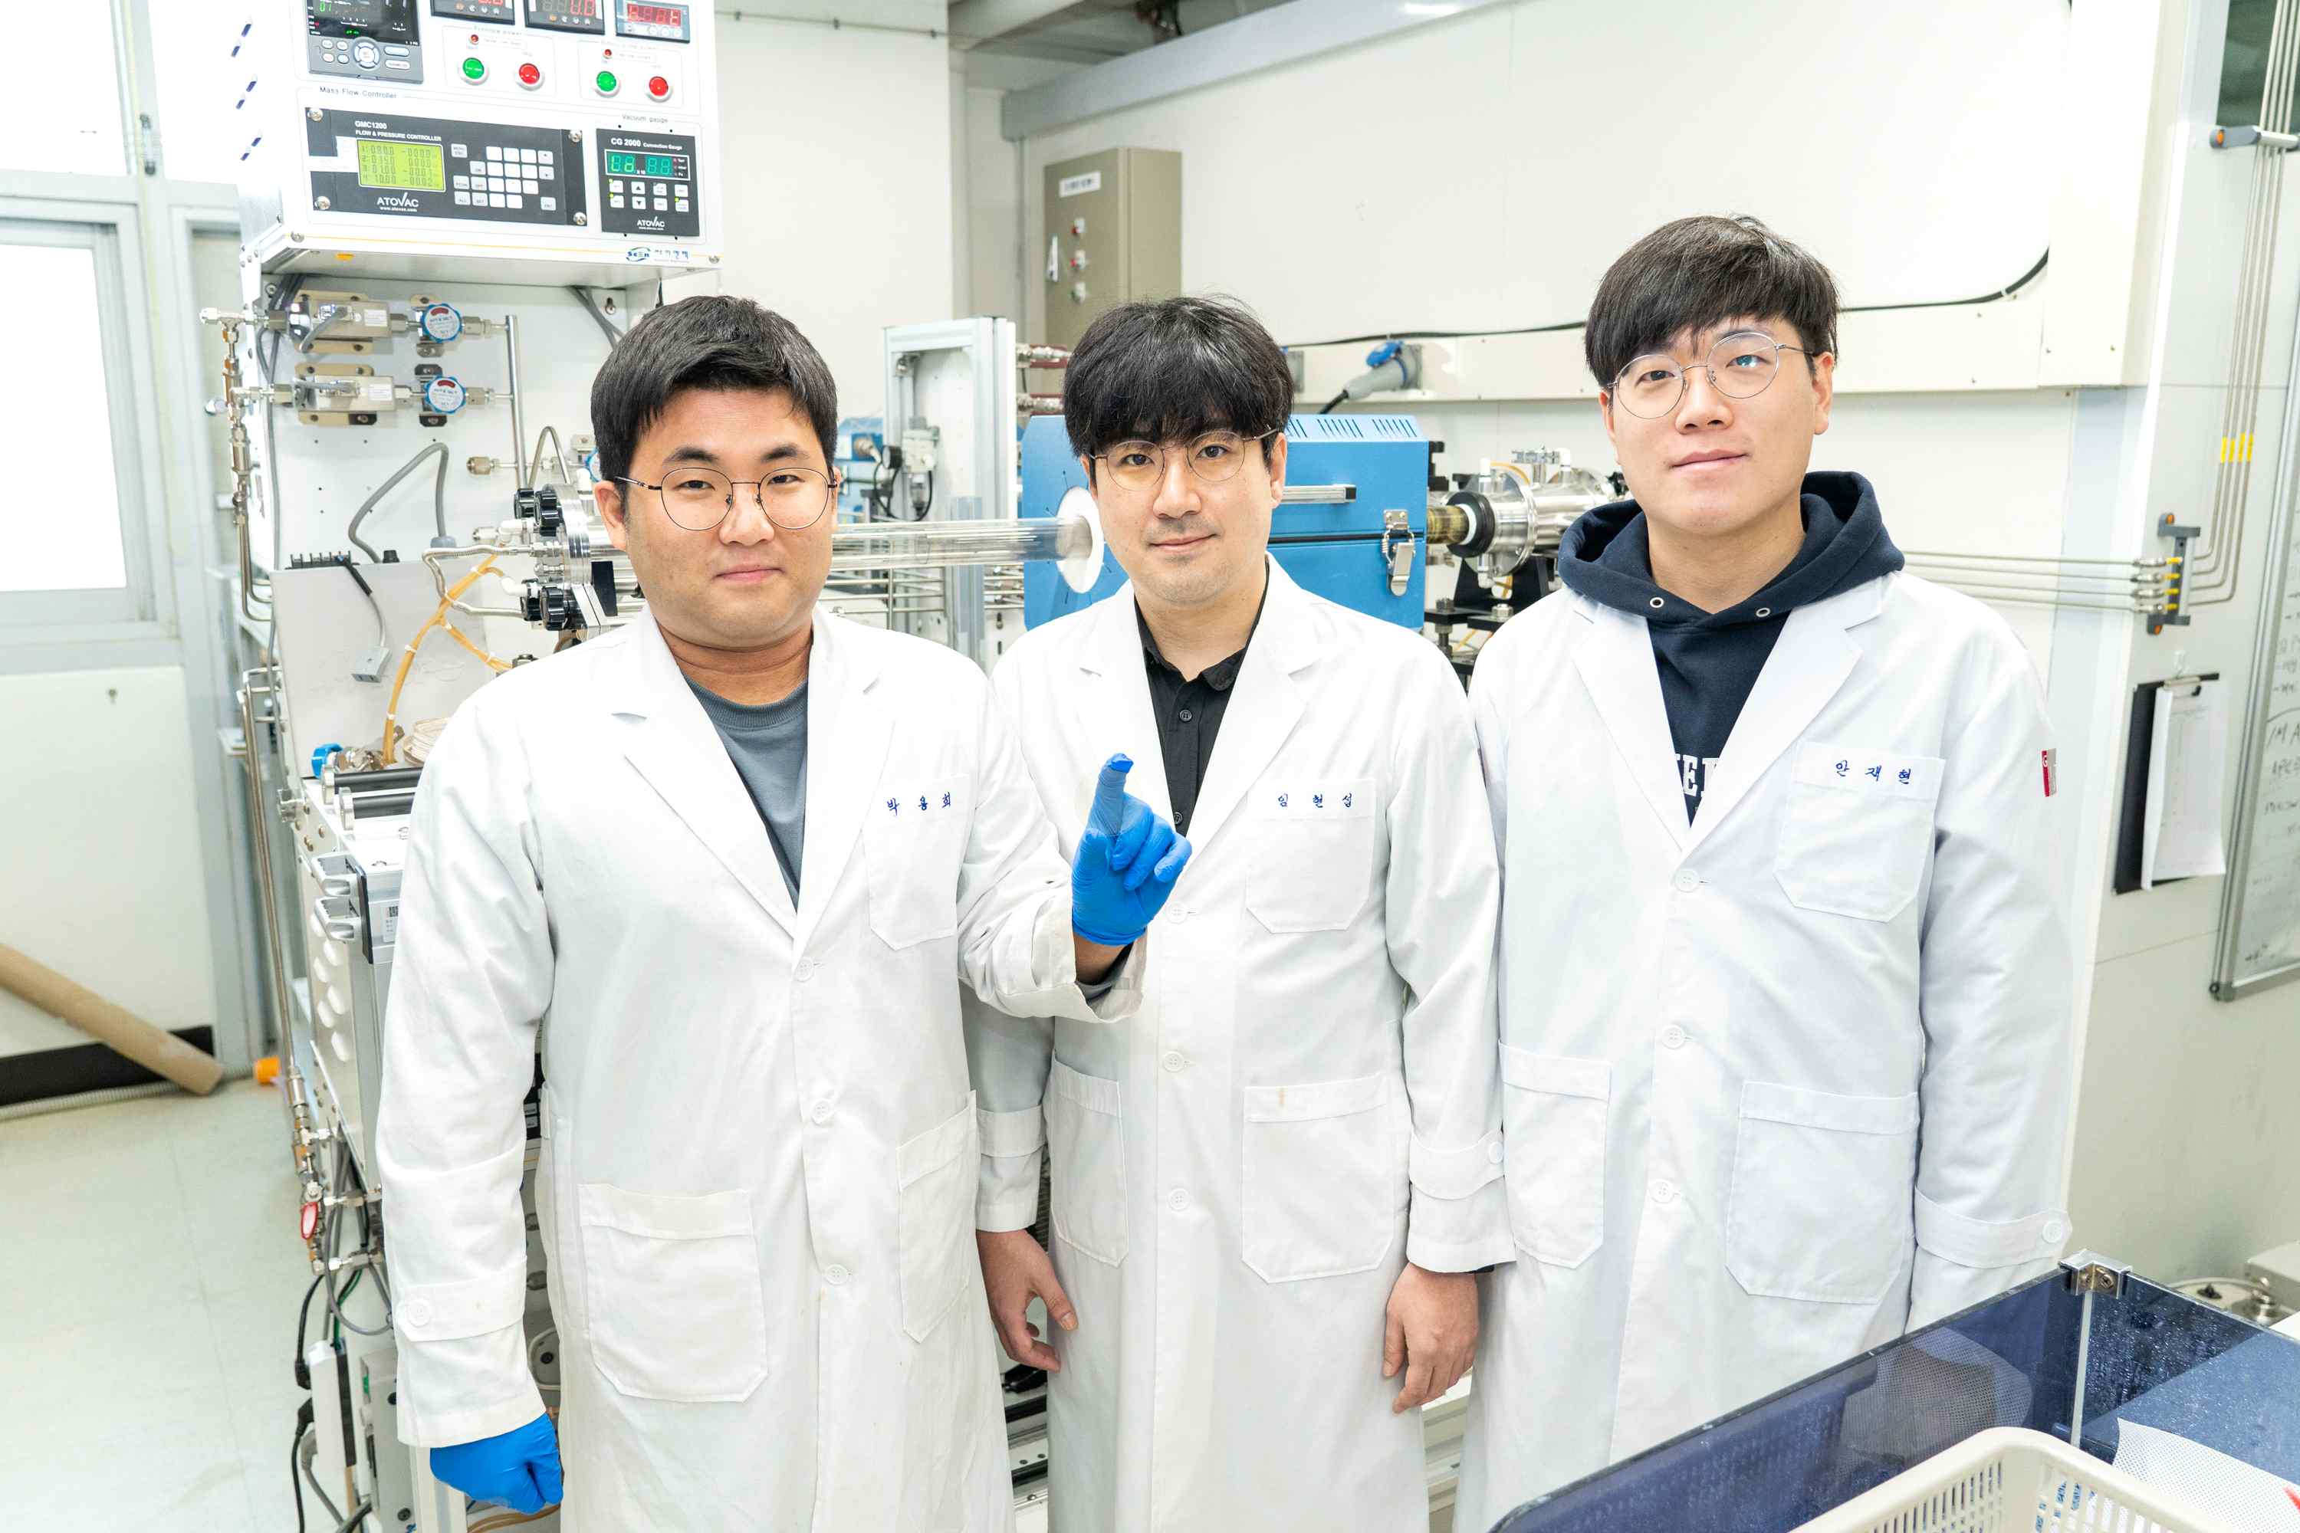
▲ (From left) Ph.D. student Younghee Park, Professor Hyunseob Lim, and Ph.D. student Chaehyeon Ahn

A Korean research team developed a method for synthesizing a two-dimensional semiconductor material thinner than 1 nm (nanometer) and confirmed the possibility of using it as a next-generation semiconductor material that surpasses silicon.

GIST (Gwangju Institute of Science and Technology, President Kiseon Kim) Department of Chemistry Professor Hyunseob Lim's research team developed a large-area single crystal synthesis method that dramatically reduces the boundaries between crystal grains by improving the two-dimensional molybdenum disulfide (MoS2) synthesis process.

This is expected to solve the disadvantage of slow charge mobility due to the presence of interfaces between crystal grains in existing polycrystalline molybdenum disulfide.

* mobility: The speed at which electrons or holes move inside a material. If a semiconductor is made of a material with low charge mobility, the problem of slowing down the electrical signal transmission occurs.

* molybdenum disulfide: A type of transition metal dichalcogenide with a two-dimensional structure, which has a band gap between energy bands and generates strong fluorescence in a single layer.

* large-area single crystal synthesis: This technology prevents defects that occur when numerous crystals that make up a material grow in different directions. At the atomic level, the direction of crystal growth must be aligned in the same direction.

Molybdenum disulfide is attracting attention as a next-generation two-dimensional nanomaterial because it can overcome the limitations of graphene*, which is called a dream material. In the process of synthesizing single crystals, it was difficult to utilize in the semiconductor industry due to the boundaries between crystal grains, and the synthesis efficiency was low, resulting in lack of economic feasibility.

* graphene: A new material with excellent thermal conductivity and durability but cannot be used as a semiconductor material because it has metallic properties.

The research team improved synthesis efficiency by replacing the existing solid precursor used in the synthesis of two-dimensional molybdenum disulfide with an inorganic molecular precursor and developed a new technology that can synthesize two-dimensional molybdenum disulfide as a single layer and single crystal on a sapphire substrate.

In addition, the role of the terminal functional group of the sapphire substrate, which had been shrouded in a veil, was identified in ‘epitaxial growth’, a key technique of single crystal synthesis.

* epitaxial growth: A growth technique in which the similarity of the lattice structure of the substrate and the thin film is maintained when growing a thin film on a substrate

* functional group: A specific substituent or part in a molecule that is responsible for the characteristic chemical reactions of molecules, and the same functional group undergoes the same or similar chemical reactions.

A sapphire substrate composed of aluminum and oxygen may have a hydroxyl group or an aluminum group as a terminal functional group depending on the air temperature. Among them, a new mechanism that aluminum end-functional groups play a key role in the growth of two-dimensional molybdenum disulfide single crystals was proposed through surface crystal structure analysis and quantum calculations.


▲ Two-dimensional molybdenum disulfide wafer: To utilize molybdenum disulfide in the semiconductor industry, large-area synthesis at the wafer level is essential.

Professor Hyunseob Lim said, "Through this research, it is expected that the timing of using molybdenum disulfide, a two-dimensional semiconductor nanomaterial, as a next-generation semiconductor material will be advanced. In particular, the newly discovered mechanism will contribute to the development of large-area single crystal synthesis processes for other 2D nanomaterials."

This research was conducted by GIST Professor Hyunseob Lim's team with support from the National Research Foundation of Korea's Excellent Young Research Project, Basic Science Lab, and Future Materials Discovery Project and was published online on January 12, 2023, in 「ACS Nano」, a renowned international academic journal in the field of materials science and chemistry.



