Greenhouse gas in industrial waste gas, made with ‘formic acid’! Development of new enzyme combination technology

- Development of eco-friendly technology that uses hydrogen in waste gas as fuel and converts CO2 into formic acid
- Confirmation of the possibility of producing formic acid through a combination reaction of two enzymes with oxygen resistance

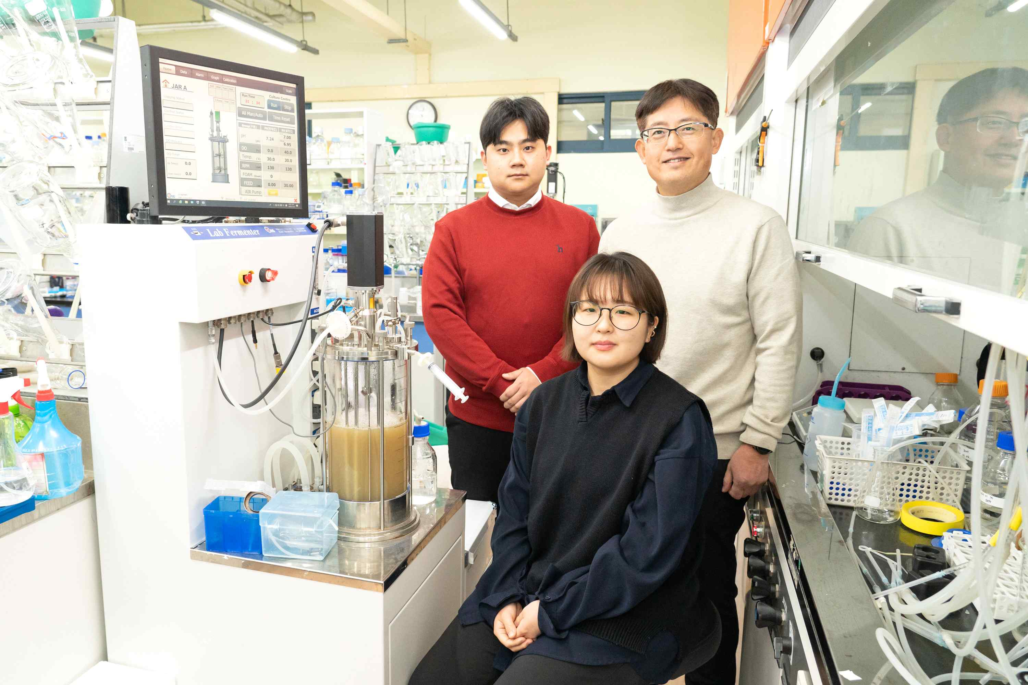
▲ (Back row from left) integrated course student Jaehyun Cha, Professor Inchan Kwon, and integrated course student Hyeonseon Bak (front row)

A research team at GIST (Gwangju Institute of Science and Technology, President Kiseon Kim) discovered an enzyme that easily converts carbon dioxide in waste into “formic acid” using hydrogen contained in industrial waste.

It is a technology that can produce ‘formic acid’, which has recently been attracting attention as a material used in the development of hydrogen storage systems and fuel cells, using industrial waste gas without additional energy supply. It is expected to attract attention as a new eco-friendly carbon neutral technology.

Industrial waste gas, such as by-product gas* generated from steel mills and petrochemical plants, contains a large amount of carbon dioxide and is known to have a large impact on climate warming.

* by-product gas: Gas generated as a by-product in addition to chemical raw materials required in the product production process

A lot of research has been conducted to convert these carbon dioxide into useful chemical fuels. The key is to develop a process that is not affected by other gases contained in industrial waste gas and does not require a separate energy supply such as electricity.

In particular, formic acid is a chemical raw material that can store hydrogen and can be made by combining hydrogen with carbon dioxide using a catalyst. There is an urgent need to develop an effective catalyst that can store hydrogen quickly and efficiently and can be used in mixed gas sources such as by-product gases (unlike synthetic catalysts).

GIST 1School of Materials Science and Engineering Professor Inchan Kwon's research team developed an enzyme combination that can use hydrogen contained in byproduct gas to convert carbon dioxide contained in industrial waste such as byproduct gas into useful formic acid.

The research team selected a combination of ‘hydrogenase*’ and ‘formate dehydrogenase*’ that had oxygen resistance through screening. The combination of these enzymes succeeded in converting carbon dioxide into formic acid in the presence of oxygen without a separate energy supply.

* hydrogenase: An enzyme that catalyzes the oxidation-reduction of hydrogen

* formate dehydrogenase: An enzyme that catalyzes the oxidation-reduction reaction between formic acid (formic acid) and carbon dioxide

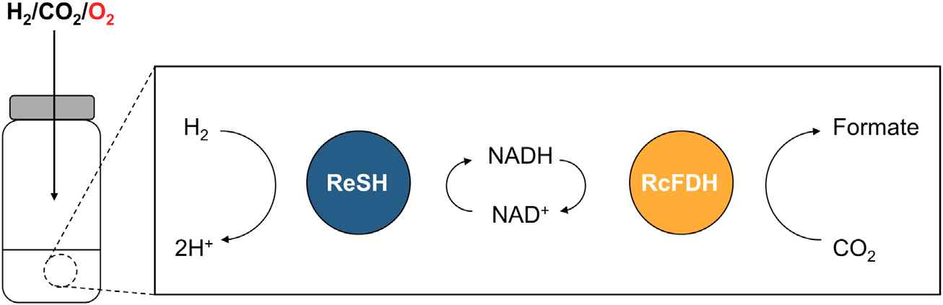
▲ Bienzyme complex reaction of hydrogenase (ReSH) and formate dehydrogenase (RcFDH): Conversion process from hydrogen to formic acid through the bienzyme complex reaction of ReSH and RcFDH under oxygen conditions

The research team confirmed for the first time that the activity of the selected enzyme combination was not inhibited even under the oxygen condition present in by-product gas. After confirming that formic acid could be produced from hydrogen through a complex reaction of these two enzymes that are resistant to oxygen, they succeeded in producing formic acid in the presence of oxygen.

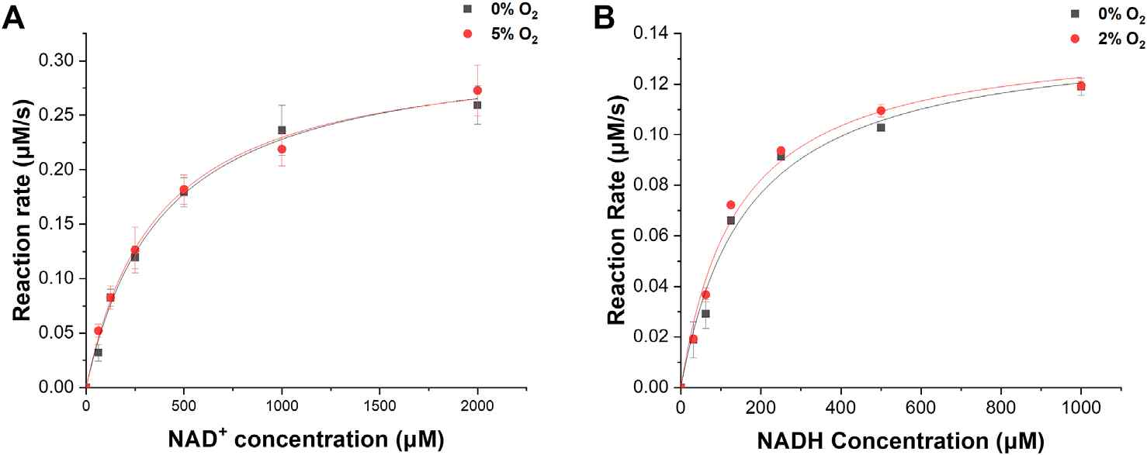
▲ Comparison of enzyme activities according to the presence or absence of oxygen: hydrogenase (ReSH) and formate dehydrogenase (RcFDH), oxygen resistance of each enzyme confirmed

Normally, a thermochemical reaction is required in the process of making formic acid industrially using sodium hydroxide, etc. For this, when burning fossil fuels to create heat, carbon dioxide is generated and greenhouse gases are emitted. However, the technology developed by the research team does not require additional energy supply in the process of converting carbon dioxide into formic acid, so it is expected to contribute to the realization of carbon neutrality when applied to actual industrial waste gas.

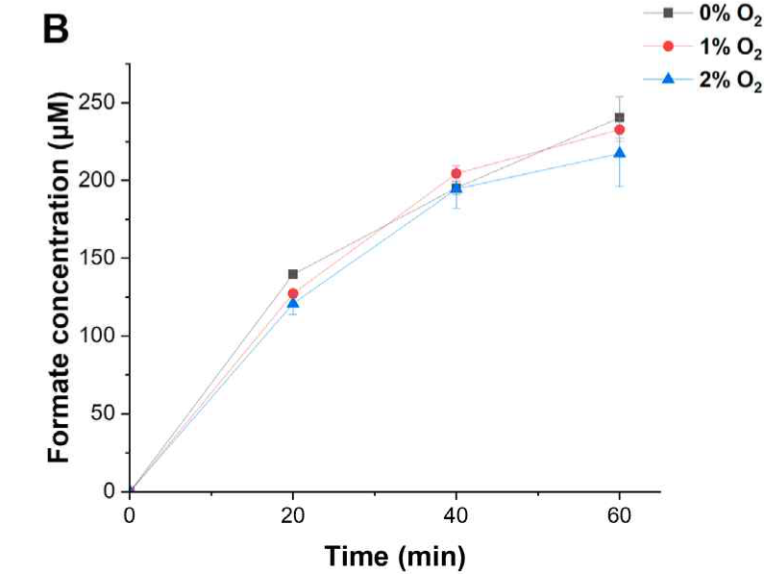
▲ Comparison of formic acid production through double enzyme complex reaction under oxygen conditions: It was confirmed that the conversion of hydrogen energy into formic acid by double enzyme complex reaction under oxygen conditions was not inhibited.

Professor Inchan Kwon said, "Through the results of this research, the possibility of an eco-friendly carbon-neutral technology that converts carbon dioxide in industrial waste gas containing oxygen into a useful chemical raw material without additional energy supply was confirmed. Through follow-up research, it is expected to develop technologies that are applied to actual industrial waste gas and contribute to the realization of carbon neutrality."

This research, conducted by Professor Inchan Kwon's team at GIST, was conducted under the project of the Ministry of Science and ICT's 'Urban Municipal Waste Gasification Material Innovative Conversion Research Center (ERC)' and was published in Frontiers in Bioengineering and Biotechnology, an international journal in the field of biotechnology. Published online on January 5, 2023.



