Warm continental air is closely related to high concentration of fine dust! Korean and American researchers identify changes in fine dust according to weather patterns

– Analysis of 30 years of data confirms that continental warm and tropical air masses increase the concentration of fine dust on the Korean peninsula


▲ School of Earth Sciences and Environmental Engineering Professor Jin-Ho Yoon

A study has found that warm continental air has a greater influence on increasing the concentration of fine dust around the Korean Peninsula, making air quality worse than cold air.

This is the result of an analysis of the relationship between seasonal weather patterns and fine dust concentrations over the past 30 years by a Korean-American joint research team in which GIST (Gwangju Institute of Science and Technology, President Kiseon Kim) participated is expected to contribute to the use of weather forecasts for fine dust prediction.

Although the concentration of fine dust is gradually decreasing according to the air quality improvement policy, cases of high concentration of fine dust still occur. The exact cause of this has not yet been identified, and scientific debate is ongoing.

In previous studies, many studies have been conducted on changes in fine dust concentration due to changes in fine dust emissions or long-distance transport. Regarding the role of the weather pattern, which is pointed out as a major factor, interest has been so great that the phrase “Samhansami (three days cold and four days fine dust)” has been talked about instead of Samhansaon, but systematic research is lacking.

A joint research team from the University of Maryland and others classified the variability of fine dust according to seasonal weather patterns and identified the mechanism, including School of Earth Sciences and Environmental Engineering Professor Jin-Ho Yoon's research team, Dasom Lee, a senior researcher at the Advanced Institute of Convergence Technology (Director Kim Jae-young, Lee Ha-Kwon), National Institute of Environmental Research Air Quality Forecast Center, Seoul Institute of Technology, South and Pukyong National University, and the US National Oceanic and Atmospheric Administration (NOAA).

The research team found and confirmed that among the various synoptic weather patterns affecting the Korean Peninsula, the continental warm air mass (DM) and the continental tropical air mass (DT), which create relatively warm weather, increase the concentration of fine dust around the Korean peninsula and deteriorate air quality.

* Synoptic meteorology: Meteorological conditions (atmospheric pressure, cyclones, fronts, typhoons, etc.) that have a spatial scale of 1000km x 1000km or more and a time scale of several days and are important meteorological factors in mid-latitudes including the Korean peninsula.

Continental warm air masses cause warm dry weather, and continental tropical air masses cause warmer weather conditions than continental warm air masses.

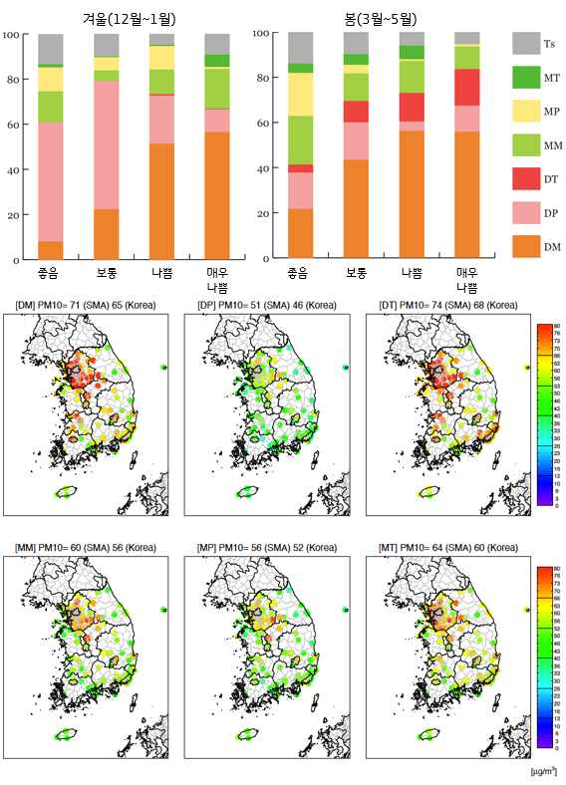
▲ (Top) Frequency of Spatial Synoptic Classification (SSC) occurrence according to fine dust concentration ranges in winter and spring. Through this, cases of low/high concentration fine dust occurrence according to the frequency of occurrence of synoptic weather patterns by season are explained. (Bottom) Spatial distribution of fine dust concentration according to SSC in the Korean Peninsula from 1988 to 2018. Through this, it is explained that continental warm and tropical air masses provide favorable meteorological conditions for the generation of high-concentration fine dust.

The research team systematically classified the relationship between synoptic weather patterns and fine dust concentrations by season using Spatial Synoptic Classification (SSC) data for about 30 years since 1988. It was confirmed that cases of high-concentration fine dust in winter are closely related to the development of anticyclonic circulation and continental warm air masses that weaken boreal winds, and cases of low-concentration fine dust are closely related to continental cold air masses that strengthen boreal winds.

On the other hand, cases of high-concentration fine dust in spring are related to continental warming and tropical air masses that enhance anticyclonic circulation development and atmospheric stability. In particular, it was confirmed that the continental tropical air mass developed a very strong atmospheric stability and was related to the generation of very high concentrations of fine dust.

Professor Jin-Ho Yoon said, "Through the analysis of past data, the relationship between weather and fine dust was systematically identified, and it was confirmed why certain weather patterns aggravated fine dust in winter and spring. The results of this study suggest that daily weather forecasts can be used to predict the concentration of fine dust."

The research was led by School of Earth Sciences and Environmental Engineering Professor Jin-Ho Yoon and Senior Researcher Dasom Lee, a Ph.D. graduate from the School of Earth Sciences and Environmental Engineering, with support from the National Institute of Environmental Research, the National Research Foundation of Korea, and the Korea Environmental Industry and Technology Institute.

The research results were published online on December 15, 2022, in the Journal of Geophysical Research: Atmosphere, an internationally renowned academic journal in the field of atmospheric science.



