Poetically difficult poetry solved again with physics!

- 「Architecture Infinite Hexagon - Diagnosis 0:1」 is an expression of time and space that is periodically repeated and an insight into a morbid society
- A literary attempt that is more innovative than European art movements such as dimensionalism


▲ (From left) Professor Soo Jeong Lee and University of California Merced Ph.D candidate Sang-Hyun Oh

A thesis interpreting the esoteric poem Diagnosis 0:1, one of the works of the genius poet Lee Sang (1910-1937)'s series of poems, "Architecture Infinite Hexahedron," from a physics point of view, was published in an academic journal published by the Lee Sang Literary Society.

GIST Division of Liberal Arts and Sciences Professor Lee Soo-jung and University of California, Merced (UC Merced) Ph.D. studentSang-Hyun Oh (GIST graduate, physics major) recently published a dissertation recently published a paper on the above poem "Diagnosis 0:1" about time and space and explained it.

In 2021, the research team drew attention by analyzing Lee Sang's representative esoteric poems, 「Triangle Design Blueprint」 and 「Architecture Infinite Hexahedron Prism」 from a 4-dimensional geometrical and physical point of view.

「Diagnosis 0: 1」 is a short poem featuring a number table in 11 rows and 11 columns with a dot (•) in the middle crossing the diagonal and the expression ‘diagnosis 0: 1’ (see [Figure 1]). Existing interpretations of this include a geometric sequence that is multiplied by 1/10 every time a row changes, or a description of a confrontation with a diagonal line in between.

The research team broke away from the existing interpretation and proposed a new interpretation from a physics point of view. The research team reports the numbers in the number table as space-time coordinates and explained that ‘diagnosis 0:1’ is a statement that connects and repeats the boundaries of space and time, as if rolling paper to form a cylinder with both ends connected.

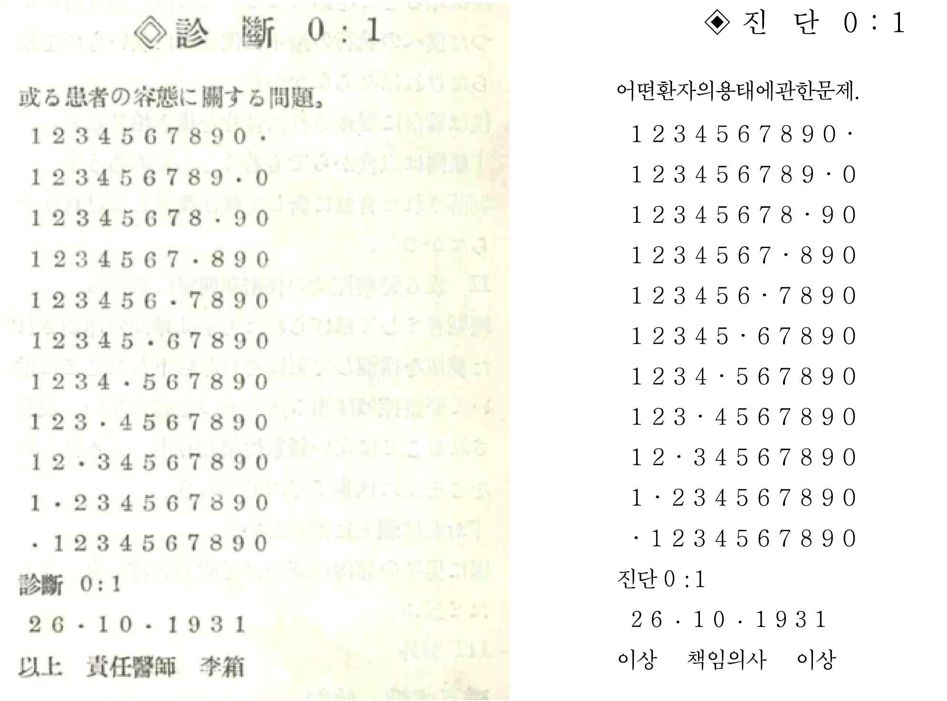
▲ [Picture 1] (Left) Japanese original text of 「Architecture Infinite Hexagon - Diagnosis 0:1」, (Right) Korean translation of the same work.

In addition, 「Diagnosis 0: 1」 is a poem that establishes the spatial and temporal background of 「Architecture Infinite Hexahedron」, and the theme of connection and repetition of space and time (periodic boundary condition motif) was presented. It was revealed that it has a close relationship with other motifs in Lee Sang's literature, such as repetition, infinity, fear, boredom, and ego division.

In addition, the research team interpreted the sequence '1234567890' appearing in the number table based on Lee Sang's other work 「Triangle Plan – Memorandum on Line 6」 as a cyclic node of an infinitely repeating sequence and implying space-time coordinates that are periodically repeated.

The research team named this idea as ‘periodic boundary condition motif’ (see [Figure 2] and terminology at the bottom for an explanation of ‘periodic boundary condition’).

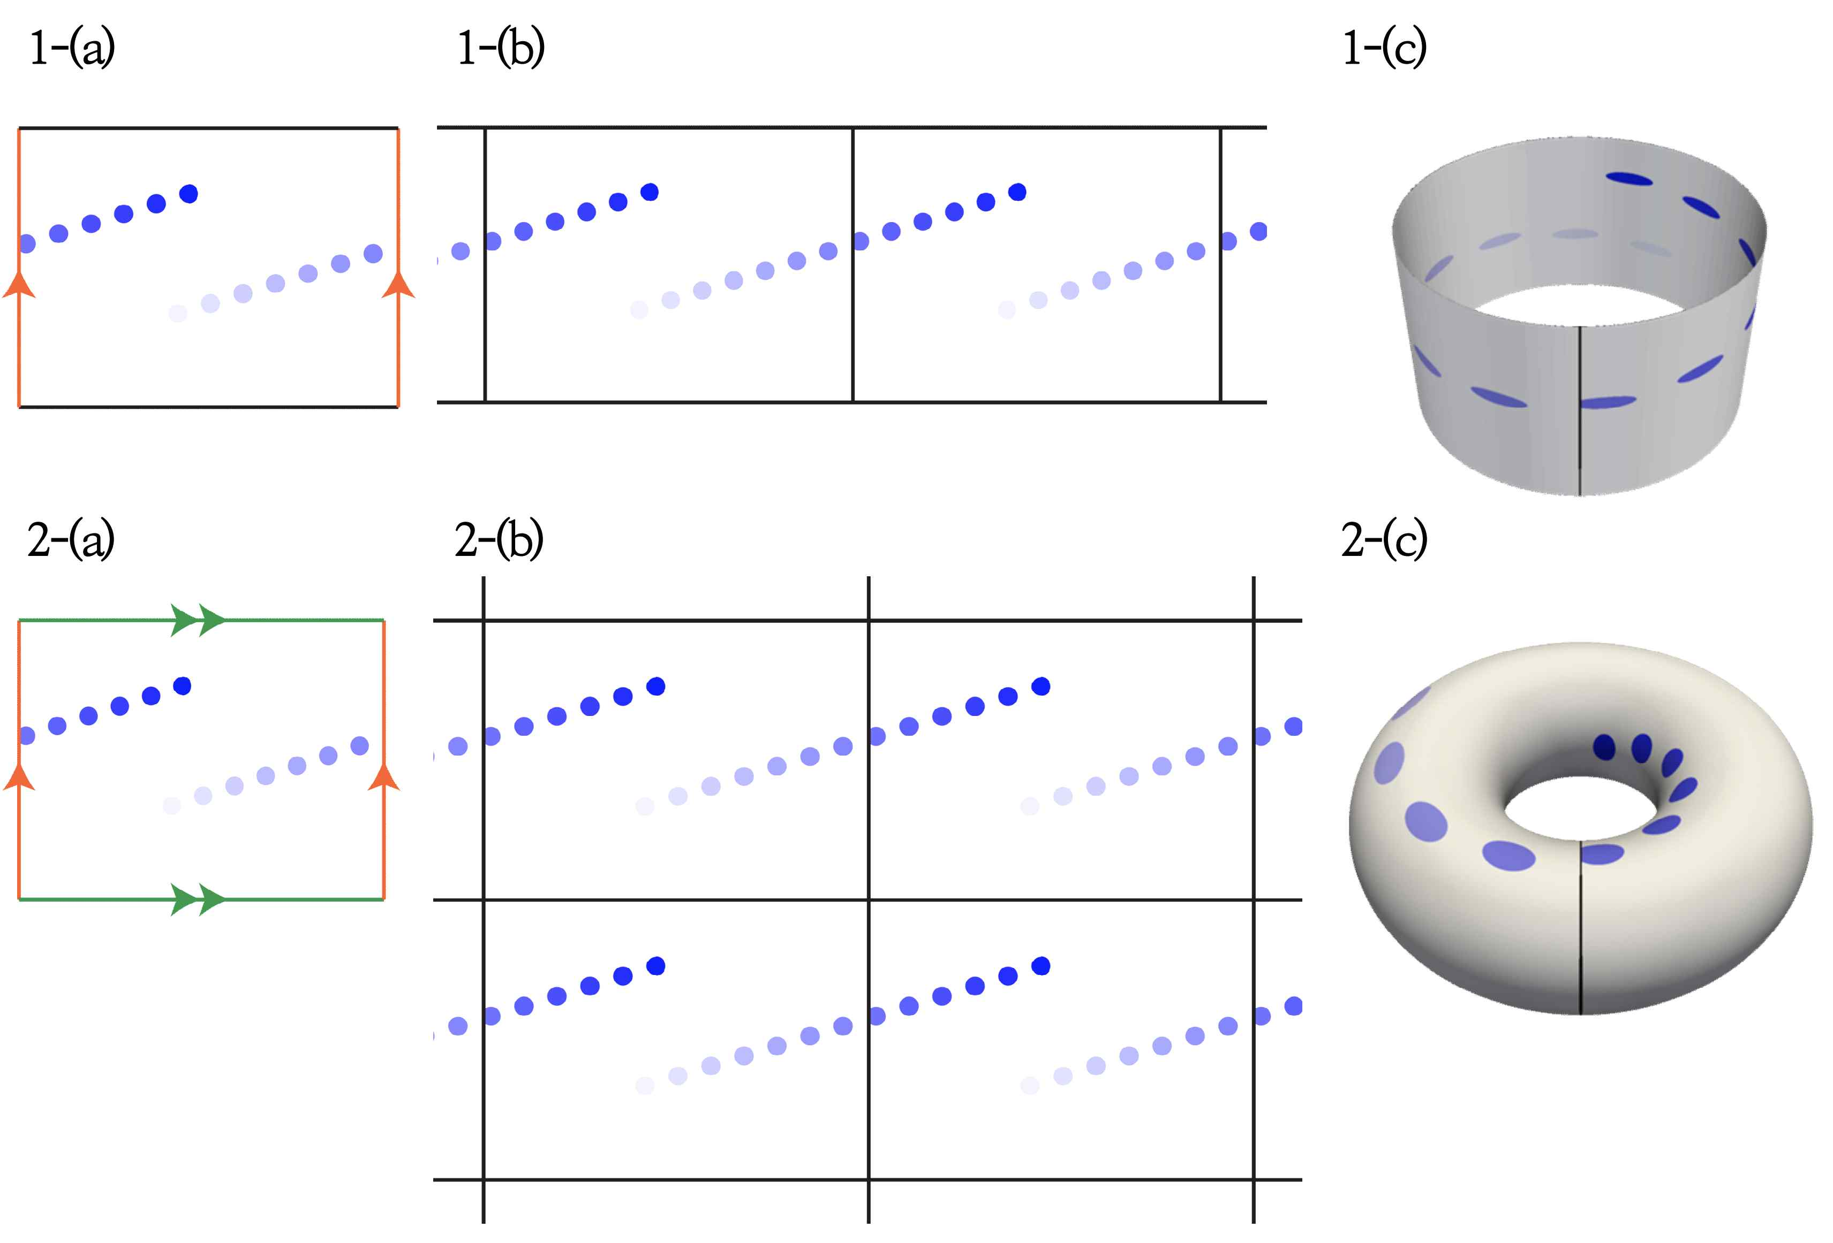
▲ [Figure 2] The periodic boundary condition refers to the condition in physics that connects the boundaries of space so that space has periodic properties. The figure above is a pictorial representation of various methods of expressing periodic boundary conditions. Blue dots are shown together for clarity.
(1) When periodic boundary conditions are assumed for left and right (red), (2) When periodic boundary conditions are assumed for left and right (red) and top and bottom (green). (a) Basic polygonal figure. The edges of the spaces to be connected are marked with different colors/symbols. (b) Repeated figure. List and connect multiple identical spaces. (c) Co-topological mapping. Rolling or transforming space to connect the boundaries of space.

If you connect the number tables of 「Diagnosis 0: 1」 based on the ‘periodic boundary condition motif’, you can see the discontinuity of the number arrangement at the boundary of the number table (see [Figure 3]). This means that space-time has an inappropriate periodicity. It can be solved by moving the upper half of the connected number table one space to the left and down and attaching them on top of each other (see [Figure 4]).

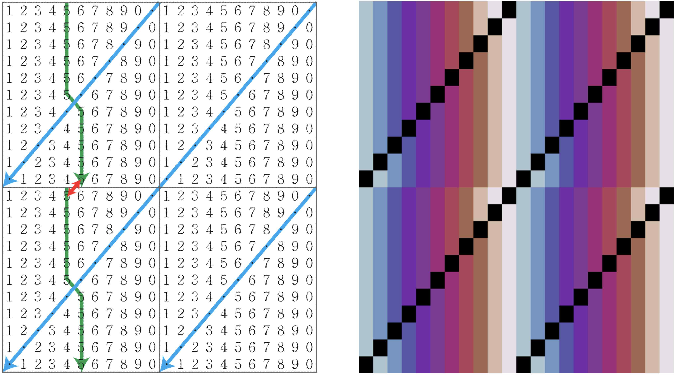
▲ [Picture 3] (Left) Number table expanded with inappropriate cycles. You can see discontinuities (red) in the number array at the boundaries of the number table. (Right) Extended color table with inappropriate cycles made by matching colors to numbers on the left. Discontinuities can be better identified.

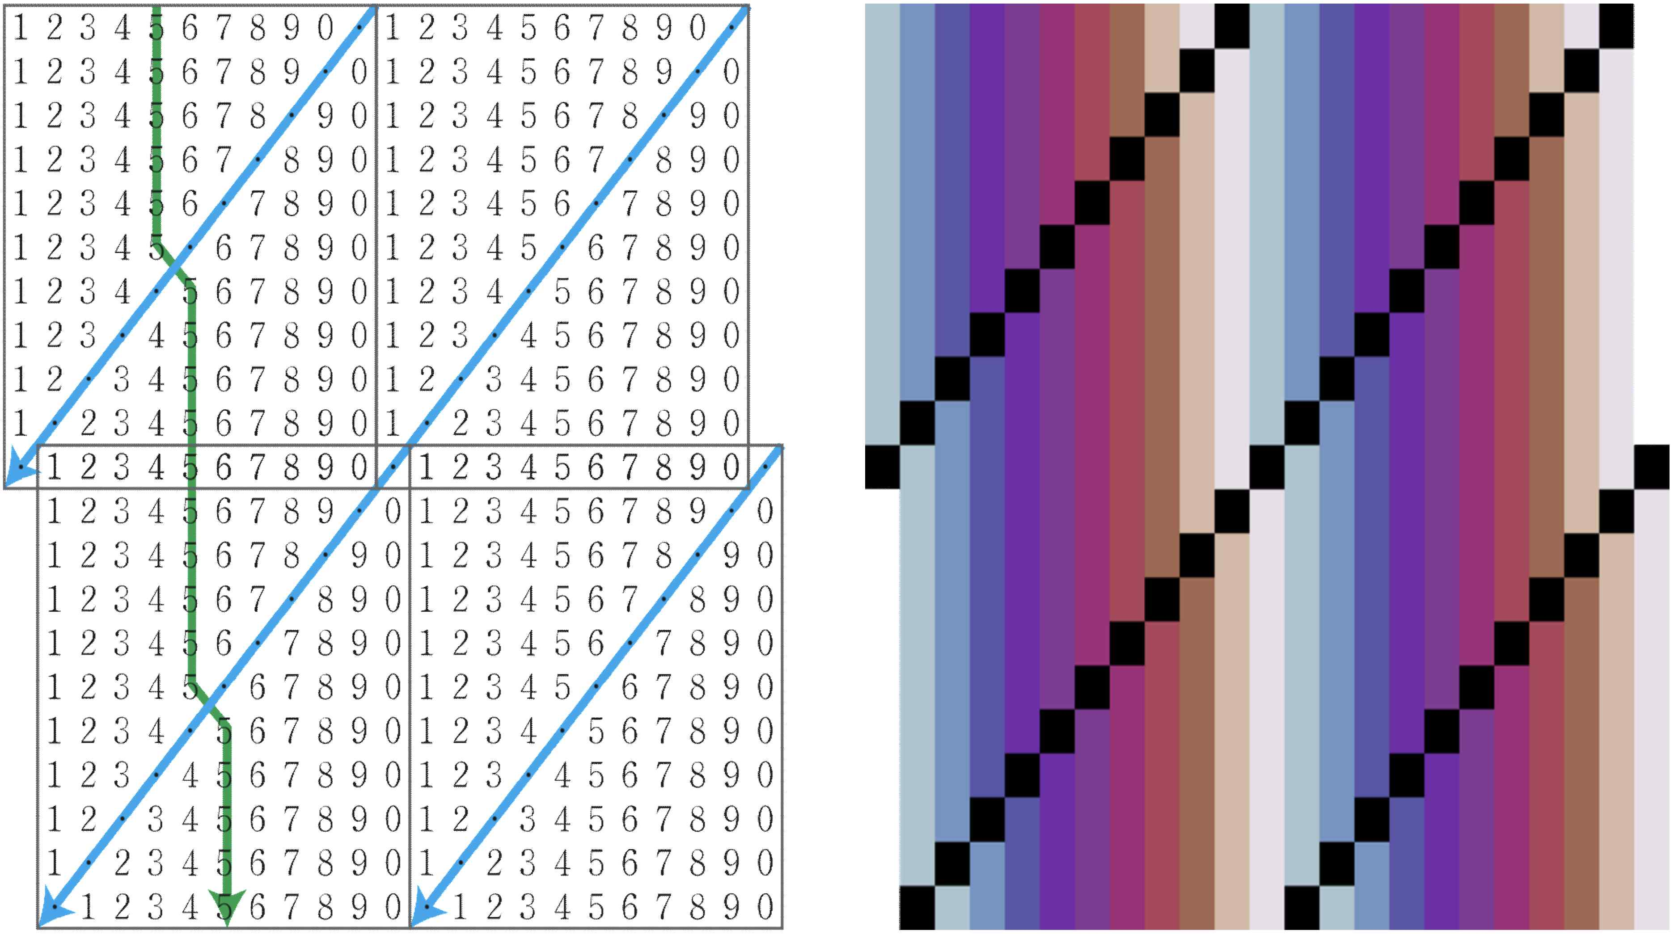
▲ [Picture 4] (Left) Number table expanded at appropriate intervals. You can see the continuity of the number array at the border of the number table. (Right) Extended color table at appropriate intervals. Continuity can be better checked.

‘0:1’ means this ‘move and overlap’. When the upper half of the number table is moved and attached, if you pay attention to the middle part, you can see that 0 and 1 and the center dot (•) move as follows.

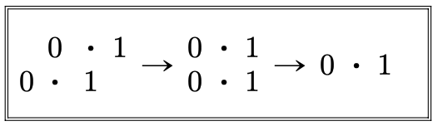

First of all, ' : ' in '0 : 1' corresponds to the first step of moving the upper '0 • 1' to the left to align the two middle points (⦁⦁) that were previously placed diagonally in a line ( : ). do. Next, '0' and '1' are overlapped by moving the upper '0 • 1' downward to make the pair of 0 and 1 (, ) placed above and below into one 0 and 1.

At this time, ‘diagnosis 0: 1’ is a diagnosis that requires manipulation expressed as ‘0: 1’ in the given number table when interpreted narrowly. When interpreted more broadly, it can be seen as an insightful judgment that it is repeated pathologically through examination of time and space (or the world and society).

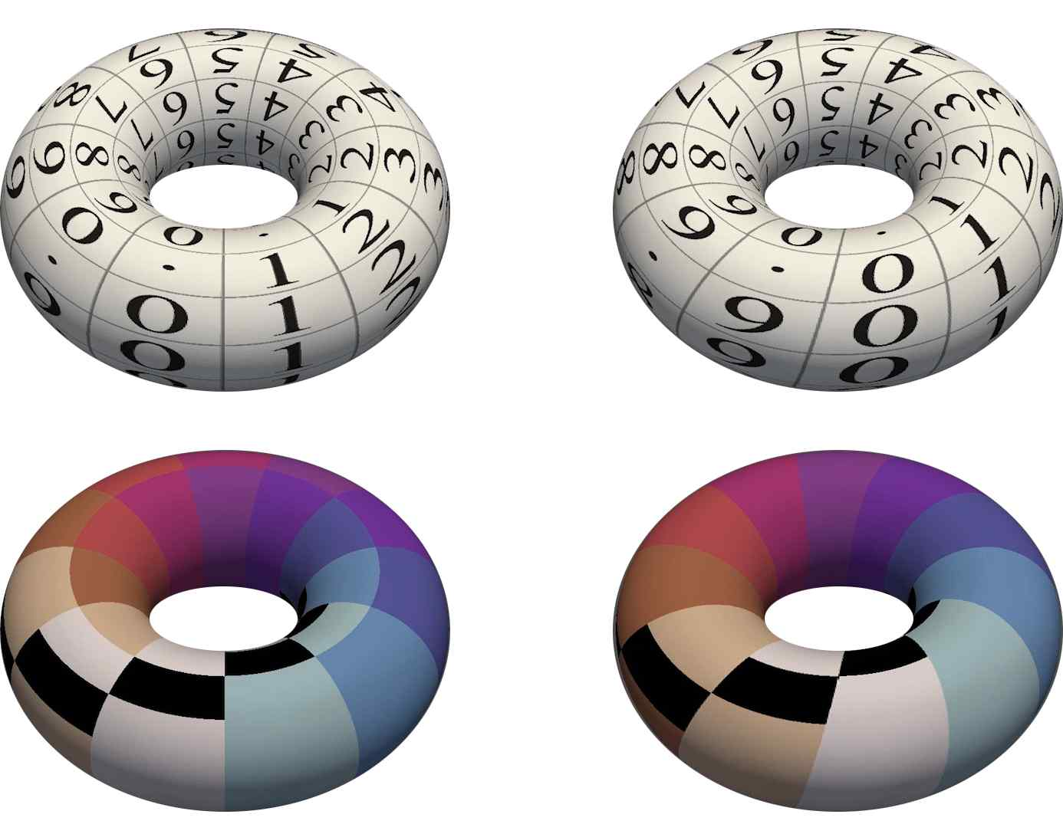
▲ [Picture 5] Graphical representation of the number table and color table of 「Diagnosis 0:1」 (co-topological figure mapping).
(Left) Numeral/color table with inappropriate cycles. You can see that numbers/colors are unnaturally cut off at the top of the border of the table. (Right) Numeric/color tables in appropriate intervals. Even at the top of the border of the table, you can see that numbers/colors are naturally connected.

Professor Soo Jeong Lee and Sang-Hyun Oh said, "This study not only proposed a new and innovative interpretation of 「Diagnosis 0:1」, but also raised the understanding of Lee Sang's literary originality and avant-garde in that periodic space-time was used as the material and background of literature. This is a more innovative literary attempt than European artistic movements such as dimensionalism."

And added, "The periodic boundary condition motif will function as a new framework and paradigm for interpreting Lee Sang's works."

This paper is the first publication in the paper series ‘Periodic Boundary Conditions for Ideal Times’. Subsequent papers in the series plan to deal with periodic boundary condition motifs and their interpretations revealed in 「Trigonal Design Diagram」, 「Infinite Hexagonal Architecture」, and 「Five Senses」.

This research was carried out with the support of the 2022 GIST development project. It was published on December 30, 2022 in the 18th issue of <Lee Sang Review> published by the Lee Sang Literary Society as a thesis titled ‘Periodic Boundary Condition 1 of Yi Sang’s Poetry – Destruction of 「Architectural Infinite Hexahedron – Diagnosis 0:1」.

Information on the paper can be searched on the Korean Journal Citation Index (KCI), and can be viewed free of charge at the link below.

https://www.kci.go.kr/kciportal/ci/sereArticleSearch/ciSereArtiView.kci?sereArticleSearchBean.artiId =ART002919857

The thesis introduction video (26 minutes), which summarizes and introduces the main concepts and points of the thesis, can be found at the following link.

https://www.youtube.com/watch?v=VT7J85OtCFc



