Development of ‘ultra-low dielectric capacitor’, a core component of next-generation electronic devices

- Expected to be applied to high-voltage and flexible devices such as semiconductors and broadband antennas


▲ (From left) Professor Bong-Joong Kim and Dr. Min-Woo Kim

A Korean research team has developed a metastructured capacitor* that can be stably used in supercomputers, broadband wireless communication, and high-voltage devices.

* capacitor: An electrical component that temporarily stores a large amount of charge in a conductor.

The Korea Research Foundation (Chairman Lee Kwang-bok) announced that Professor Bong-Joong Kim (Gwangju Institute of Science and Technology) and Professor Julia Greer (California University of Technology) developed a capacitor that maintains ultra-low dielectric constant** and continuously recovers dielectric breakdown strength*** even in repeated compressive strain by using a 3D-nano lattice* structure.

* 3D-nanolattice: A metamaterial in which ceramic nanotubes are regularly arranged in a unit cell form using 3D laser etching and atomic layer deposition technology.

** ultra low-k dielectric: low dielectric constant of 1.5 or less

*** dielectric breakdown strength: the voltage at the moment when the electrical resistance between electrically insulated materials is reduced and a lot of current flows at the metal level

As many next-generation electronic devices use high-voltage wiring and evolve into a flexible form that maintains reliability even under mechanical deformation, the development of capacitors using low dielectric materials with high electrical and dielectric stability is required.

Existing low-k materials have increased porosity* to lower dielectric constant. However, materials with high porosity have limitations in that mechanical strength and dielectric breakdown strength are weakened and thermal stability is lowered.

Through previous research, the research team has developed a nano lattice capacitor with a porosity of 99% that is capable of dielectric breakdown and recovery of ultra-low dielectric properties even under mechanical compression. However, commercialization was difficult as performance could be recovered only after 5 compression cycles and a small deformation of 25%.

* porosity: The ratio of the volume of the porous material to the total volume of the porous material

Accordingly, the research team solved the problem by improving the existing nano lattice, which consists of a single density and unit layer, into a heterogeneous structure in which two layers of low density and high density are mixed. As a result of the test, when stress is applied to the nanolattice, the low-density layer starts to deform first, and the high-density layer is completely protected from the stress until 50% of the entire lattice is deformed.

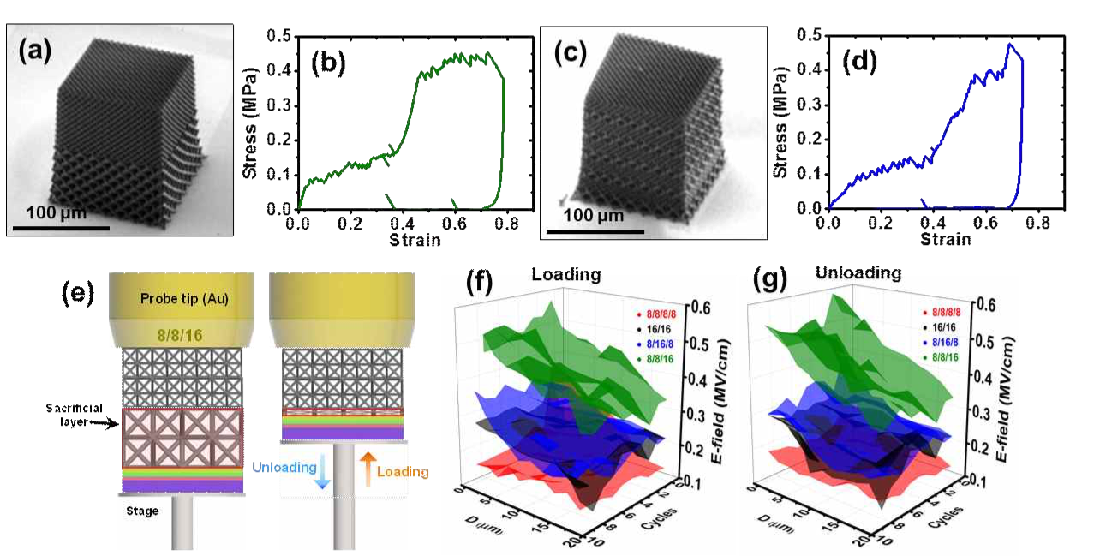
▲ Ultra-low dielectric capacitors and their mechanical stress-strain relationship and self-healing dielectric strength results for compressive strain. (a,b) Images of ultra-low-k capacitors with bisected density distribution and stress-strain relationship (c,d) Images of ultra-low-k capacitors with repetitive density distribution and stress-strain relationship (e) Schematic diagram for measuring electrical/insulation properties against compressive strain (f) Leakage current density according to the degree of compression and the number of stress cycles during compression deformation (g) Leakage current density according to the degree of compression and the number of stress cycles when compression strain is removed

In addition, dielectric breakdown and ultra-low dielectric properties were stably recovered during 62.5% strain and 100 compression cycles. It recorded a breakdown strength up to 3.3 times higher than single-density nanolattises.

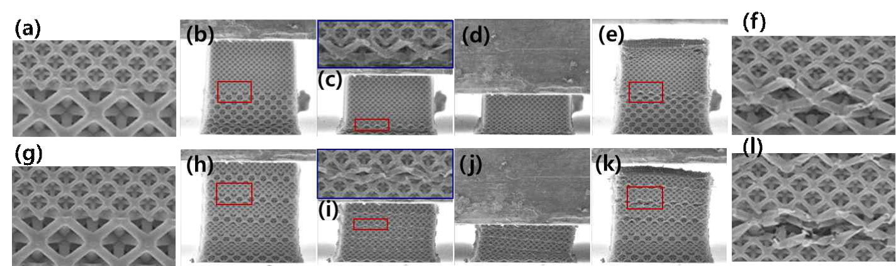
▲ Deformation that occurs when compressive stress is applied to nanolattices in which low/high density layers are bisected and nanolattices in which low/high density layers are repeated. (a-f) Deformation that occurs sequentially from before stress application to stress relief in nanolattices with low/high density layers bisected, (g-l) from before stress application to stress relief in nanolattice with low/high density layers repeated Transformation that occurs sequentially

Professor Bong-Joong Kim said, "This research is significant in that it has developed an ultra-low dielectric material that has mechanical resilience and thermal and electrical stability at the same time. In the future, it is expected to be used in flexible electronic device systems, electric vehicles, and high-voltage systems in space and aviation."

The results of this research, conducted as a mid-level research support project supported by the Ministry of Science and ICT and the National Research Foundation of Korea, were published as a cover page on November 15th in the online edition of Advanced Materials, an international academic journal in the field of materials.



