Lithium-free anode material increases electric vehicle mileage by 1.5 times!

- Supported by Hyundai Motor Company, etc...Use of high-capacity vanadium oxide as cathode material, realization of lithium battery with 50% increase in energy capacity
- School of Materials Science and Engineering Professor KwangSup Eom's team published a cover paper in 「Small」, a renowned academic journal in the field of materials

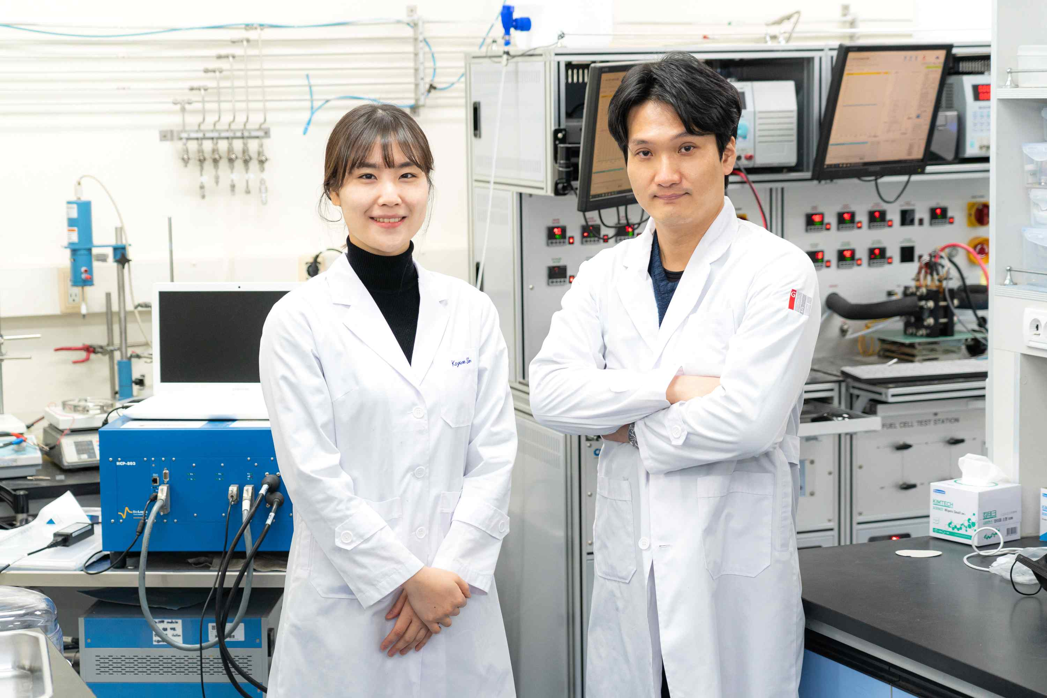
▲ (From left) Doctoral student Kiyeon Sim and Professor KwangSup Eom

A research team at GIST (Gwangju Institute of Science and Technology, President Kiseon Kim) used high-capacity vanadium oxide as the anode material of a lithium battery to realize a high-performance lithium metal battery with an energy storage capacity that increased by about 50% compared to the previous one.

‘Energy storage capacity’ determines the driving distance of an electric vehicle on a single charge, and it is expected that the driving distance of an electric vehicle will increase by about 50% (about 1.5 times compared to the previous one) on a single charge.

* cathode materials: As an energy source for lithium-ion batteries, it is a key material that determines the capacity and output of a battery, and determines the performance of the battery. As transition metals are oxidized/reduced, lithium ions and electrons are released/inhaled, and batteries use the difference in reactivity between metals to convert chemical energy into electrical energy.

The ‘lithium battery’ used in electric vehicles is a battery in which the existing graphite anode is replaced with a lithium metal anode. It is lightweight, has a large capacity of a lithium metal anode, and has a low oxidation-reduction potential, so it is in the spotlight as a next-generation battery.

Currently, in many studies, oxides of cobalt (Co), nickel (Ni), manganese (Mn), and iron (Fe) are used as cathode materials for lithium batteries. Since the increase in capacity of existing anode materials has already reached its limit, there is a limit to improving the energy of lithium batteries to increase the mileage when charging an electric vehicle once.

Therefore, in order to realize high-energy lithium batteries, it is necessary to develop new high-capacity cathode materials. For commercialization, it is necessary to ensure that the performance of the cathode material is maintained even in thick electrodes.

Although it is possible to store more energy in a smaller battery by making the electrodes thicker. The thicker the electrode, the greater the resistance, resulting in deterioration in performance such as output. Therefore, it is necessary to secure a fast electrochemical reaction rate at the anode.

Professor KwangSup Eom's research team in the Department of Materials Science and Engineering developed a lithium battery with approximately 1.5 times higher capacity than conventional batteries using vanadium oxide by using vanadium oxide, a lithium-free material in which lithium does not exist, as an anode material.

The vanadium oxide anode material has a theoretical capacity of 294 mAh/g, which is about 1.5 to 2 times higher than that of conventional transition metal oxide anode materials (140 mA/g to 200 mA/g). It has fatal disadvantages such as low stability due to the collapse of the structure during the charging and discharging process of the battery and slow electrochemical reaction rate due to low ionic and electronic conductivity, so it has not been commercialized.

To solve this problem, the research team developed a layered nanostructured vanadium oxide anode material in which nanoplates are stacked using a new synthesis method in which a crystal growth inhibitor is added to the existing hydrothermal synthesis method* and subsequent heat treatment is performed.

The developed vanadium oxide material effectively provides a fast lithium ion movement path inside the structure. By reducing the moving distance of lithium ions, it is possible to secure high capacity even under fast charging/discharging current conditions. In addition, the rigid hierarchical nanostructure allows the structure to be stably maintained during the charging and discharging process.

* hydrothermal synthesis: Synthesis of materials using water or aqueous solution under high temperature and high pressure. It is a simple liquid phase synthesis method that does not require complicated processes such as high temperature heat treatment or transfer process.

The anode material developed by the research team showed an increased energy storage capacity of 1.5 to 2 times compared to the existing one-dimensional nanostructured vanadium oxide. In addition, large resistance is generated under the condition of normally fast charging and discharging current, and the capacity rapidly decreases. The developed cathode material showed a smaller reduction in storage capacity even at fast charge/discharge rates thanks to the reduced diffusion distance and increased diffusion rate of lithium ions inside the material.

The lithium battery made with the developed anode material has been confirmed to have a capacity retention rate of about 80% even after 100 charge and discharge cycles. It maintained very good performance compared to the capacity retention rate (average of 60% or less) of vanadium oxide in most existing nanobelt structures.

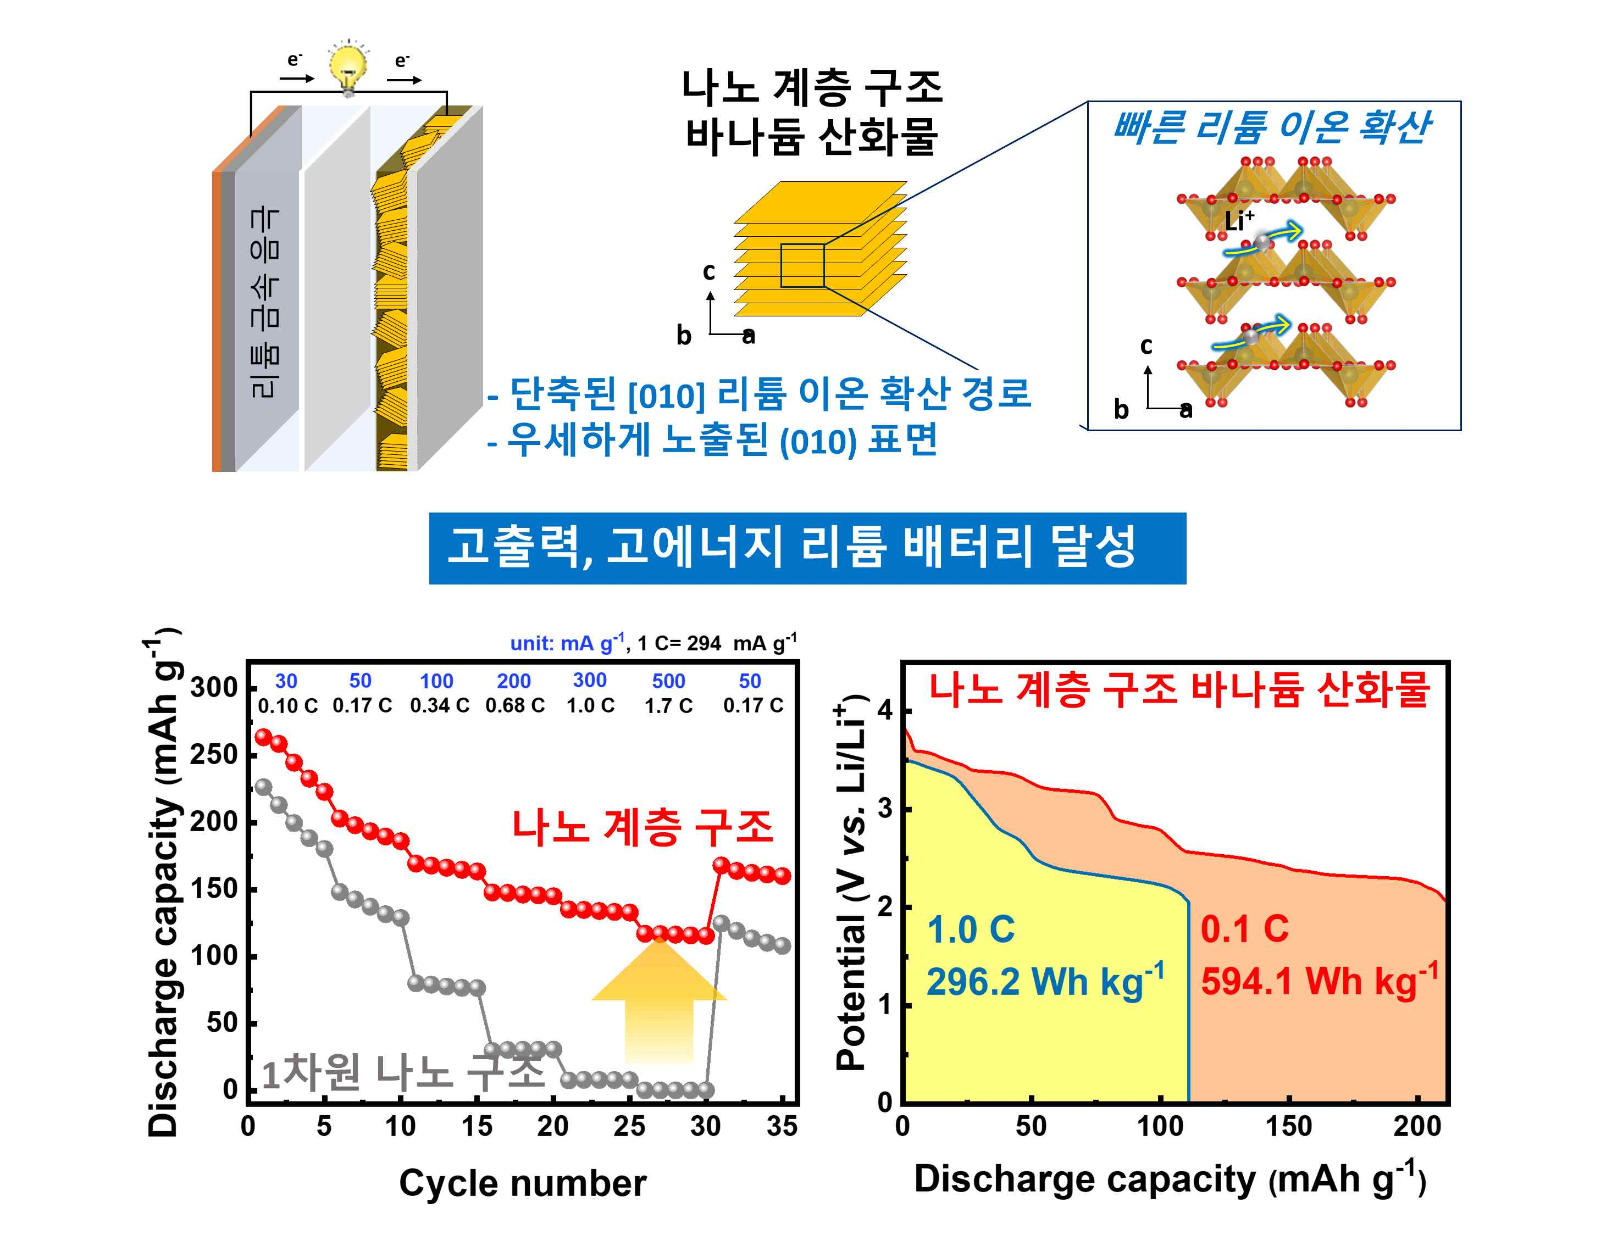
[Figure] Comparison of rate characteristics and energy storage capacity according to the anode structure of a lithium battery composed of a vanadium oxide anode and a lithium metal cathode. The schematic diagram shows the significantly improved electrochemical performance of the vanadium anode oxide with a nano-hierarchical structure in which nanoplates are stacked compared to a one-dimensional nanostructure. In the developed cathode material, crystal growth was controlled in a direction favorable to lithium ion diffusion through the newly proposed synthesis method in this study, and a stable hierarchical structure was formed. This structure minimizes the lithium ion diffusion distance so that the reaction can occur quickly. Moreover, the hierarchical structure prevents structural collapse of the active material or aggregation between particles during charge/discharge, enabling stable driving. Therefore, thanks to the improved electrochemical performance of the nano-hierarchical vanadium oxide, the lithium battery employing the nano-hierarchical vanadium anode has maximized energy densities of 594.1 Wh/kg and 296.2 Wh/kg at current densities of 0.1C and 1C, respectively.

In particular, the research team succeeded in realizing a high-performance lithium battery by composing the developed anode material and lithium metal cathode into a full cell. This battery was able to maintain performance even with the increased electrode thickness thanks to the unique structure of the cathode material, and showed a high density per weight of 592 Wh/kg based on the weight of both electrodes.

This is a result of 50% (1.5 times) improvement in terms of electrode compared to existing lithium-ion batteries. Therefore, it is expected that in the future, through optimization of electrolyte and battery packing materials, it will be possible to generate more than 400 Wh/kg, which is 140 to 150% of 280 Wh/kg, which is the highest cell specific energy (energy per weight) of existing lithium-ion batteries.

Professor KwangSup Eom said, "The results of this research are expected to suggest the importance of high-capacity lithium-free cathode materials in the development of next-generation high-energy lithium metal batteries and new possibilities for securing electrochemical reaction rate performance through nano-structuring of cathode materials."

This research was led by GIST School of Materials Science and Engineering Professor KwangSup Eom of the Department of Materials Science and Engineering at GIST and conducted by doctoral student Kiyeon Sim with support from the National Research Foundation of Korea, Hyundai Motor Company, and GIST Research Institute for Solar and sustainable Energies was selected as a cover paper published on January 4, 2023, in Small, a world-renowned academic journal in the field of materials.



