Professor Tae-Young Kim's research team easily and accurately discovers high value-added raw materials in rice straw through an analysis method using 'acetic acid', a vinegar ingredient!

- Used to detect ‘lignin’ in plant biomass... up to 13 times higher analysis sensitivity than before
- School of Earth Sciences and Environmental Engineering Professor Tae-Young Kim's team published a thesis in an international journal in the field of chromatography


▲ (From left) Professor Tae-Young Kim, postdoctoral researcher Woo-Young Song, researcher Hyejin Park

A research team at GIST (Gwangju Institute of Science and Technology, President Kiseon Kim) developed a new highly sensitive analysis method that effectively detects lignin*, a high value-added raw material, from plant biomass*, which is attracting attention as an eco-friendly resource.

* biomass: Organisms that can be used as energy sources or raw materials and organic matter obtained from them. Plant-derived biomass includes agricultural by-products such as cornstalks and rice straw, and waste wood. Since plants absorb and consume carbon dioxide in the process of growing, ‘plant biomass’ is in the limelight as an eco-friendly resource that can replace fossil fuels.

Using the analysis method developed by the research team, it is expected to help extract more types of fossil raw material alternatives from lignin by more accurately identifying the types and contents of 'lignin' decomposition products, which are attracting attention as eco-friendly resources among the chemical components that make up biomass. In addition, this analysis method is expected to be used to find trace amounts of harmful ingredients that may be included in household chemical products.

‘Lignin’ is a ring-shaped polymeric compound that accounts for 20 to 30% of cotton plants such as wood, bamboo, and straw and gives off a scent, and is used as a raw material for bioplastics, pharmaceuticals, and cosmetics. It is attracting attention as an eco-friendly raw material that creates high added value of about 900 million dollars (as of 2021) worldwide.

There are mainly two methods for isolating lignin from plants: ▴ leaving lignin as an insoluble residue by decomposing and removing other components in plants, and ▴ eluting lignin by making it soluble. The small amount of lignin contained in biomass is difficult to detect effectively because it exists as a very complex mixture.

Therefore, in order to utilize various types of lignin degradation products contained in biomass as raw materials for chemical products, an analytical method is required to determine each lignin component as accurately as possible.

Professor Tae-Young Kim's research team in the School of Earth Sciences and Environmental Engineering developed a highly sensitive analysis method that can effectively analyze the mass and structure of various lignins contained in biomass even in very small amounts using liquid chromatography-electrospray ionization mass spectrometry*.

* liquid chromatography-electrospray ionization mass spectrometry: The liquid component dissolved in the solvent separated through liquid chromatography is sprayed under high voltage conditions to form charged droplets, which gradually become smaller as the solvent evaporates under high temperature conditions. As it is broken into fine droplets of the same size, molecular ions are finally generated. Afterwards, the chemical composition can be found by measuring the mass of the molecular ion in a mass spectrometer, and the molecular structure of the component can be identified through serial mass spectrometry, which analyzes the fragment ions generated after breaking the molecular ion.

The research team compared and analyzed various liquid chromatography solvent additives to find the optimal conditions for biomass analysis. As a result, it was found that the signal of lignin was improved by an average of 4 times and a maximum of 13 times when acetic acid, the main component of vinegar, was used instead of ammonium salt, which is mainly used in the existing liquid chromatography analysis method.

Thanks to the improved sensitivity due to the acetic acid additive, the research team was able to discover the chemical raw material candidate by identifying the exact structure of the lignin molecule, which could not be identified by conventional methods.

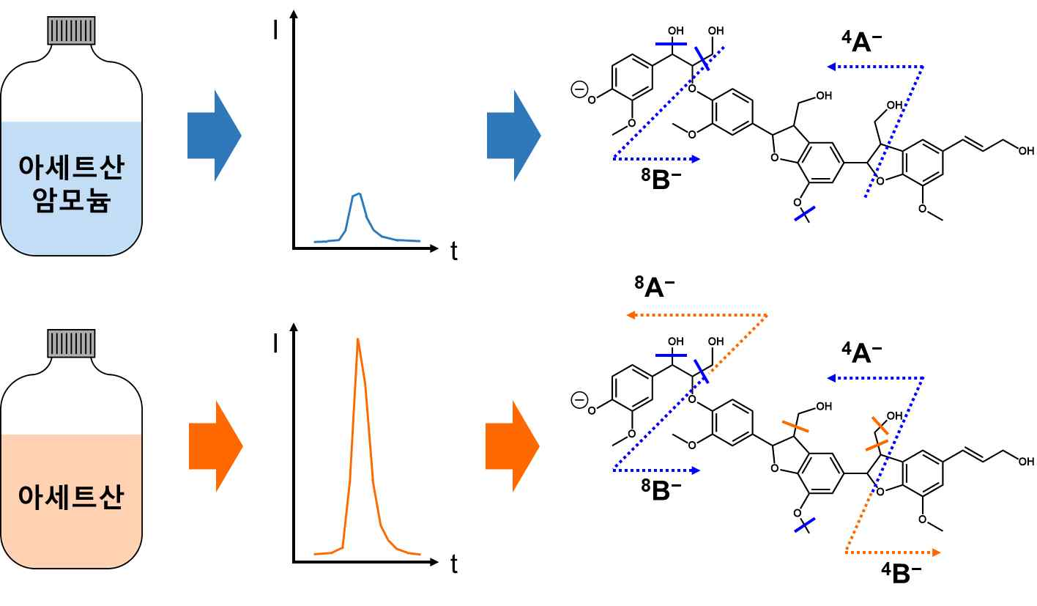
▲ Improved sensitivity and accuracy of biomass analysis using acetic acid additives. When acetic acid was used instead of ammonium acetate, which was previously used, high analysis signal strength (average 4 times, up to 13 times improvement) was obtained. As a result, it can be confirmed that the structure of the lignin molecule can be identified more accurately.

In addition, the research team found that the newly developed analysis method can be effectively used to identify degradation products of lignin extracted from rice straw. Among the components obtained from the decomposition of rice straw, the types and contents of a total of six lignins, including vanillin, a vanilla flavor, were identified.

Professor Tae-Young Kim said, "The newly developed analytical method not only contributes to the development of various eco-friendly raw materials by more accurately determining the type and content of lignin, a high value-added raw material in plant biomass. It can also be used to find trace amounts of harmful ingredients that may be included in household chemical products. After the humidifier disinfectant incident, public interest in hazardous substances in household chemical products is increasing. It is expected to contribute to improving public health by detecting harmful chemicals that can be exposed to the human body with high sensitivity."

This research, led by Professor Taeyoung Kim and conducted by postdoctoral researcher Woo-Young Song and graduate student Hyejin Park with the support of the Korea Environmental Industry and Technology Institute's Household Chemical Product Safety Management Technology Development Project and was published online on Sunday, October 23, 2022, in the Journal of Chromatography A, an authoritative journal in the field of chromatography.



