GIST College student publishes a paper in an SCI-level journal in the field of physical chemistry

– Participated in the Department of Chemistry’s ‘Undergraduate Research Program’ and published a paper in the Journal of Molecular Liquids


▲ (From left) Professor Jun-Ho Choi and undergraduate student Jiwon Seo

A research paper in the field of physical chemistry* led by an undergraduate student at GIST (Gwangju Institute of Science and Technology, President Kiseon Kim) as the first author was published in an SCI*-registered international journal.

* physical chemistry: the study of various chemical phenomena using physical laws

* SCI: journals listed in the Science Citation Index (SCI) database

Currently enrolled GIST College student Jiwon Seo (chemistry major, senior) and her advisor, Department of Chemistry Professor Jun-Ho Choi, with the support of the National Research Foundation of Korea's basic research project, conducted research on the subject of 'computational chemistry research on the distribution of molecules in mixtures'. The results were published online on December 1 in the Journal of Molecular Liquids, an SCI-registered international academic journal in the field of physical chemistry.

During the second semester of the 2022 school year, Ms. Seo took the research subject ‘Bachelor Thesis Research’ and participated in the undergraduate research program of the Department of Chemistry and conducted related research.

Professor Jun-Ho Choi and Ms. Seo presented a new hypothesis about the aggregation of solute molecules by introducing molecular dynamics simulation and graph theory through research on the properties of solutions that change when substances such as salt and sugar dissolve in water.

Various attempts have been made to explain how well a substance mixes with water when dissolved in water (miscibility) and what structure the molecules in the mixture are distributed in. Solubility due to difficult experiments on structure determination in the liquid state and complex interactions between molecules. Even basic phenomena such as phase separation and boiling point are difficult to understand. Also, there was no way to quantitatively measure the overall distribution of various dissolved substances.

The research team performed molecular dynamics simulations* for three mixtures (methanol/dichloromethane/butanol) at various concentrations and temperatures. A measurement method called h value* was introduced to measure the spatial heterogeneity of molecules. In addition, graph theory analysis was applied to quantitatively examine mixtures with different miscibility.

* molecular dynamics simulations: A theoretical method of studying the behavior of atoms or molecules using Newton's equations of motion. It is a very efficient method for investigating the structure, dynamics, and thermodynamics of molecules over time, and is widely used in studying the hydrogen bond structure and motion of water in real time, which is difficult to study experimentally.

* h value: This is a measurement method used in the field of wireless network research, which quantifies and measures the spatial distribution of given points. In this study, the center of mass of water and molecules dissolved in water was treated as a point and their spatial distribution was calculated.

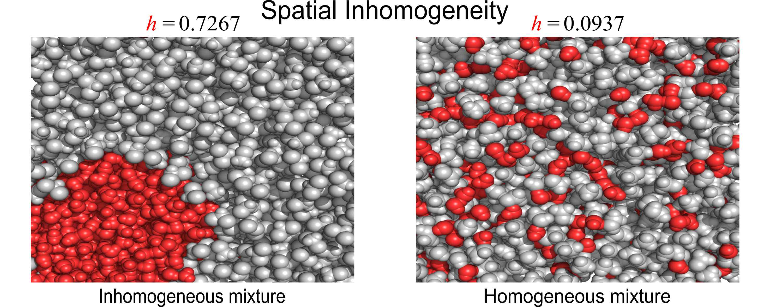
▲ Aggregation form of water and water-dissolved molecules in the mixture: The h value written in the figure is a quantitative calculation of the spatial distribution of molecules in each mixture. In the state on the left, dichloromethane (grey) is separated from water (red) in an aqueous solution of dichloromethane. In the state on the right, methanol (grey) is well mixed with water (red) in aqueous methanol solution. In the condition on the left, the h value was measured very high, whereas in the condition on the right, it was measured very low.

Methanol is miscible with water regardless of temperature and concentration, dichloromethane is separated from water regardless of temperature and concentration, and butanol is miscible depending on concentration and temperature. The research team found that this difference in mixing properties was related to the form of aggregation of molecules, and, through calculation of the h value, the form of aggregation also affected the spatial distribution of molecules.

Also, the spatial distribution of molecules in the three materials is clearly distinguished. In other words, a methanol solution that is miscible with water has an h-value close to zero. A water immiscible dichloromethane mixture shows a relatively large value of 0.7.

This study is significant in that it quantified and explained the spatial distribution of molecules by introducing a new measurement method and is expected to make an important contribution to understanding the effect of ions and osmotic substances on the hydrogen bond structure of water and the properties of solutions, which have been considered difficult in the field of basic science.

Furthermore, quantitative analysis studies on the aggregation structure and mixing degree of these solutes are the physicochemical properties of the solution. Beyond the elucidation of mechanisms for phenomena such as liquid-liquid phase separation of intracellular proteins, extraction of specific substances, and increase in solubility and stability of proteins. It can have various applications in the industrial aspect, such as increasing the solubility of drug candidates.

Jiwon Seo said, "Through this study, it was possible to quantitatively explain the spatial distribution of molecules when substances with different miscibility were dissolved in water, and it established the relationship between the aggregation behavior and spatial distribution of molecules in aqueous solution. In the future, this is expected to expand research on the effect of various molecules, such as osmotic substances and proteins, on the structure of water and the distribution of molecules when dissolved in water."



