Development of quantum ring laser gyro theory with at least 3 times higher resolution than existing ones

– Application of wave quantum sensing based on coherence de Broglie wave (CBW) to ring laser gyroscope


▲ School of Electrical Engineering and Computer Science Professor Byoung S. Ham

Theories on principles and structures that can dramatically improve the resolution of ring laser gyroscopes, which are essential for geodesy and seismometers, as well as inertial navigation, which are essential for robots, drones, guided weapons, and submarines, have been developed.

* ring laser gyroscope: By arranging a laser medium inside an optical resonator, two independent bi-directional frequency modes compete to create a frequency difference by the Sagnac effect and measure it to determine the accuracy of the object. An angular acceleration optical sensor with the highest phase resolution that measures angular velocity.

GIST (Gwangju Institute of Science and Technology, President Kiseon Kim) School of Electrical Engineering and Computer Science Professor Byoung S. Ham presented the theory of quantum ring laser gyroscopes by applying 'coherence de Broglie wave (CBW)', a result of wave quantum science, to existing ring laser gyroscopes.

Professor Byoung S. Ham is the first to propose the principle and structure of a ‘quantum ring laser gyroscope’ that exceeds the resolution of existing ring laser gyroscopes by at least three times.

A gyroscope was first developed as a tool for measuring the rotation of an object and is widely used in mobile phones, guided weapons, drones, airplanes, submarines, and spacecraft. Recently, microelectromechanical system (MEMS) technology is applied to produce microelectronic parts.

For high resolution, it is necessary to move to ring laser gyroscopes, but unlike microelectromechanical systems or fiber optic gyroscopes, size is a key challenge.

The best existing gyro sensor is a Sagnac-based ring laser gyroscope that creates a phase difference between the split lights as the interferometer rotates while the light splits in the interferometer. The square optical resonator structure with a length of several tens of meters can measure the rotation of the earth with an accuracy of less than 1/10 million.

However, despite such high resolution, ring laser gyroscopes are large in size from several meters to several tens of meters in square structure, so there is a limitation that they cannot be applied to drones, guided weapons, and autonomous vehicles.

The quantum ring laser gyroscope proposed by Professor Byoung S. Ham has the same optical resonator structure as the existing ring laser gyroscope, but it is characterized by the addition of a light splitter for the application of 'coherence de Broglie wave (CBW)' based on superposition Mach-Zehnder interferometry. In interferometry, the application of phase quantized infinite series ground state generation is the key to quantum sensing of 'coherence de Broglie wave (CBW)'. Unlike the existing quantum sensing technology based on high-order entangled photon pairs, CBW quantum sensing can be applied to existing technologies virtually as it is because laser light is applied as it is.

* Coherent de Broglie (CBW) quantum sensor: unlike the existing quantum sensing principle based on higher-order entangled photon pairs, quantum sensing using phase-based quantization based on quantum superposition of interferometric pairs was first proposed by Professor Byoung S. Ham in 2020.

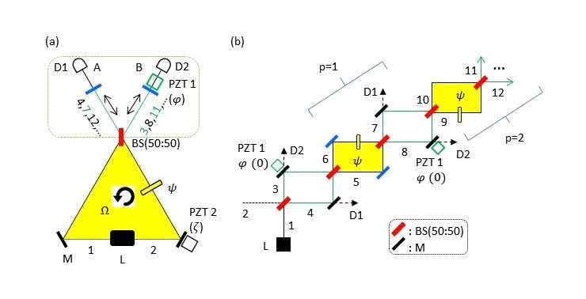
▲ (a) Quantum ring laser gyroscope structure. (b) Infinite series of CBW as a group of friends

Professor Byoung S. Ham said, "The basic concept and structure of the quantum ring laser gyroscope were proposed by applying the CBW quantum sensor based on the wave nature of quantum mechanics to the existing optical resonator structure to the quantum sensor, which was virtually impossible to apply to the quantum sensor. The Sagnac interferometer automatically satisfies the basic principle of CBW, in which the phase superpositions of successive Mach-Zehnder interferometers must operate in opposite directions, and can be easily applied to the ring laser gyroscope structure."

This research was carried out with the support of the GIST GRI/GTI R&D project and the ITRC Quantum Internet Project of the Ministry of Science and ICT and was published online on November 10, 2022, in the international journal Sensors.



