Succeeded in domestic development of ‘Hollow Fiber Membrane for Hemodialysis’, dependent on imports

- Supported by the Ministry of SMEs and Startups, TIPS, published papers in top 4% internationally renowned journals in the field of chemical engineering
- Inosep Co., Ltd., founded by Professor In S. Kim, prepares for mass production of prototypes... “Challenge to supply domestic blood filters”

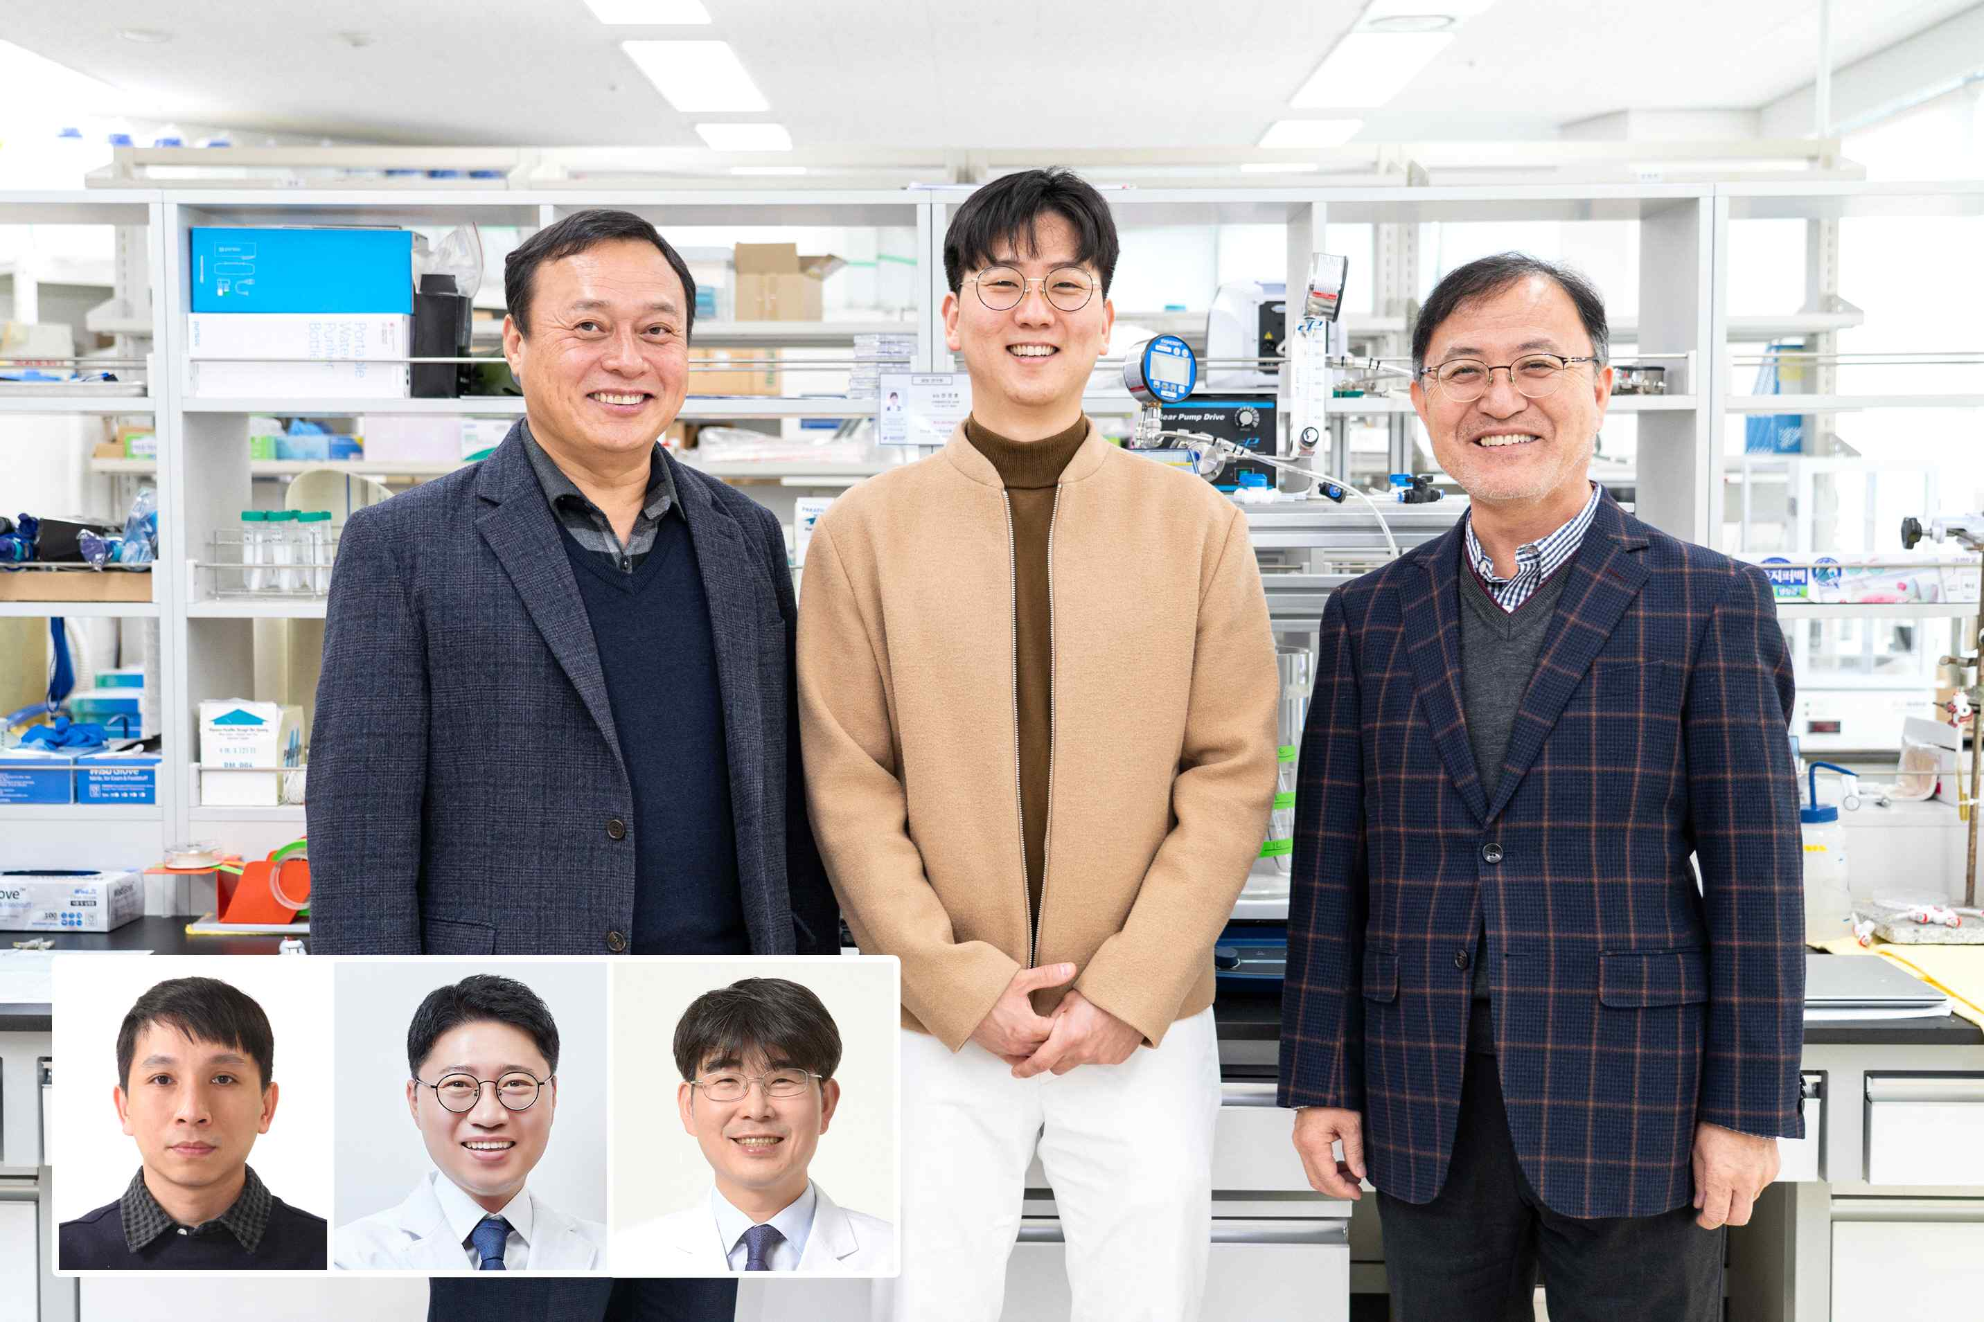
▲ (Counterclockwise from bottom left) Senior Inosep Researcher Thanh-Tin Nguyen, Chonnam National University Professor Chang Seong Kim, Chonnam National University Professor Soo Wan Kim, Professor In S. Kim, Ph.D. student Kyunghoon Jang, GIST Research Professor Namguk Her

A research team at GIST (Gwangju Institute of Science and Technology, President Kiseon Kim) succeeded in improving the performance of hollow fiber membranes for hemodialysis, a key part of blood filters that play a role in the kidneys of patients with end-stage renal failure.

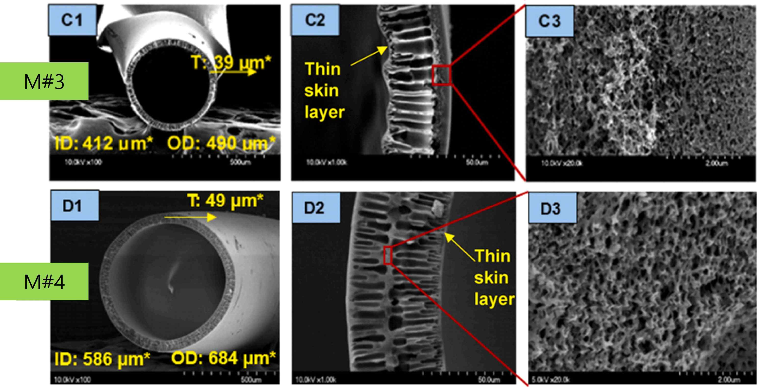
[Figure 1] Cross-section of the developed hemodialysis membrane. It includes cross-sectional photographs of the developed hemodialysis membranes, information on the inner diameter, outer diameter, and thickness of the membrane.

School of Earth Sciences and Environmental Engineering Professor In S. Kim, who led this research, is promoting 100% localization of hollow fiber membranes for hemodialysis through his start-up company, Inosep. It is expected to contribute to the localization of blood filters, which are entirely dependent on imports.

A blood filter is a medical device that replaces the kidneys of patients with end-stage renal failure. It filters out urinary substances and waste products from the blood using a very thin membrane.

Currently used blood filters are effective in removing low-molecular-weight uremic substances with a molecular weight of 1,000 or less, but it has limited effectiveness in the elimination of medium molecule uremic and protein bound uremic toxin (PBUT)*.

When unremoved heavy molecules and protein-binding urea accumulate in the blood, cardiovascular complications occur, and when the pore size of the hollow fiber membrane is increased to a size similar to that of the protein needed by the human body, albumin, an essential protein, is removed.

In particular, protein-bound uremia is associated with an increased risk of developing and dying from cardiovascular disease, although increasing clearance efficiency is important. Clinical results using existing commercial products as well as research on the development of separation membranes for the removal of protein-bound uremic toxins are scarce.

* uremia: Toxicity that occurs when waste products that should be excreted in urine through the kidneys are not excreted and accumulate in the blood. In a healthy kidney, it is removed from the blood through glomerular-tubular filtration-reabsorption-secretion processes. There are low-molecular uremics with a molecular weight of less than 1,000 Daltons (Da), medium-molecular uremics with a molecular weight between 1,000 and 60,000 Daltons (Da), and protein-bound uremics.

* protein-bound uremic: uremic that has the property of binding to proteins in the body. It exists in the blood in a state bound to proteins in the body with a molecular weight of 66,000 Daltons (Da) or more.

GIST Professor In S. Kim's team and Chonnam National University School of Medicine's Nephrology Department Professor Soo Wan Kim's team developed polyethersulfone (PES), a material with excellent biocompatibility. The research team identified the principle of removing protein-bound urea, which must be removed during hemodialysis, and fabricated a new hollow fiber membrane for hemodialysis.

When manufacturing a membrane for hemodialysis, it is important to increase the residual molecular weight (MWRO)* as much as possible while making the molecular weight cutoff (MWCO)* less than the required protein molecular weight. (Refer to [Figure 2])

* residual molecular weight (MWRO): The molecular weight at which the concentration ratio of the solute passing through the membrane in the direction from the supply section to the permeation section starts to fall below 90%. In other words, it can be seen that uremic components in the blood begin to remain.

* molecular cutoff (MWCO): Molecular weight at which the removal rate filtration coefficient starts to be less than 10% when solutes are removed through a membrane. Solutes with molecular weights below the MWCO result in loss of solute from the feed solution.

The two types of hollow fiber membranes developed by the research team were able to easily remove low- and medium-molecular urea with residual molecular weights of 16,773 Daltons (Da) and 13,998 Daltons (Da), respectively, and at the same time have a molecular weight of 66,000 Daltons (Da) or more. Both types of hollow fiber membranes have secured a molecular weight fraction of around 50,000 Daltons (Da) at a level that can prevent leakage of essential proteins in the body. (Refer to [Figure 2])

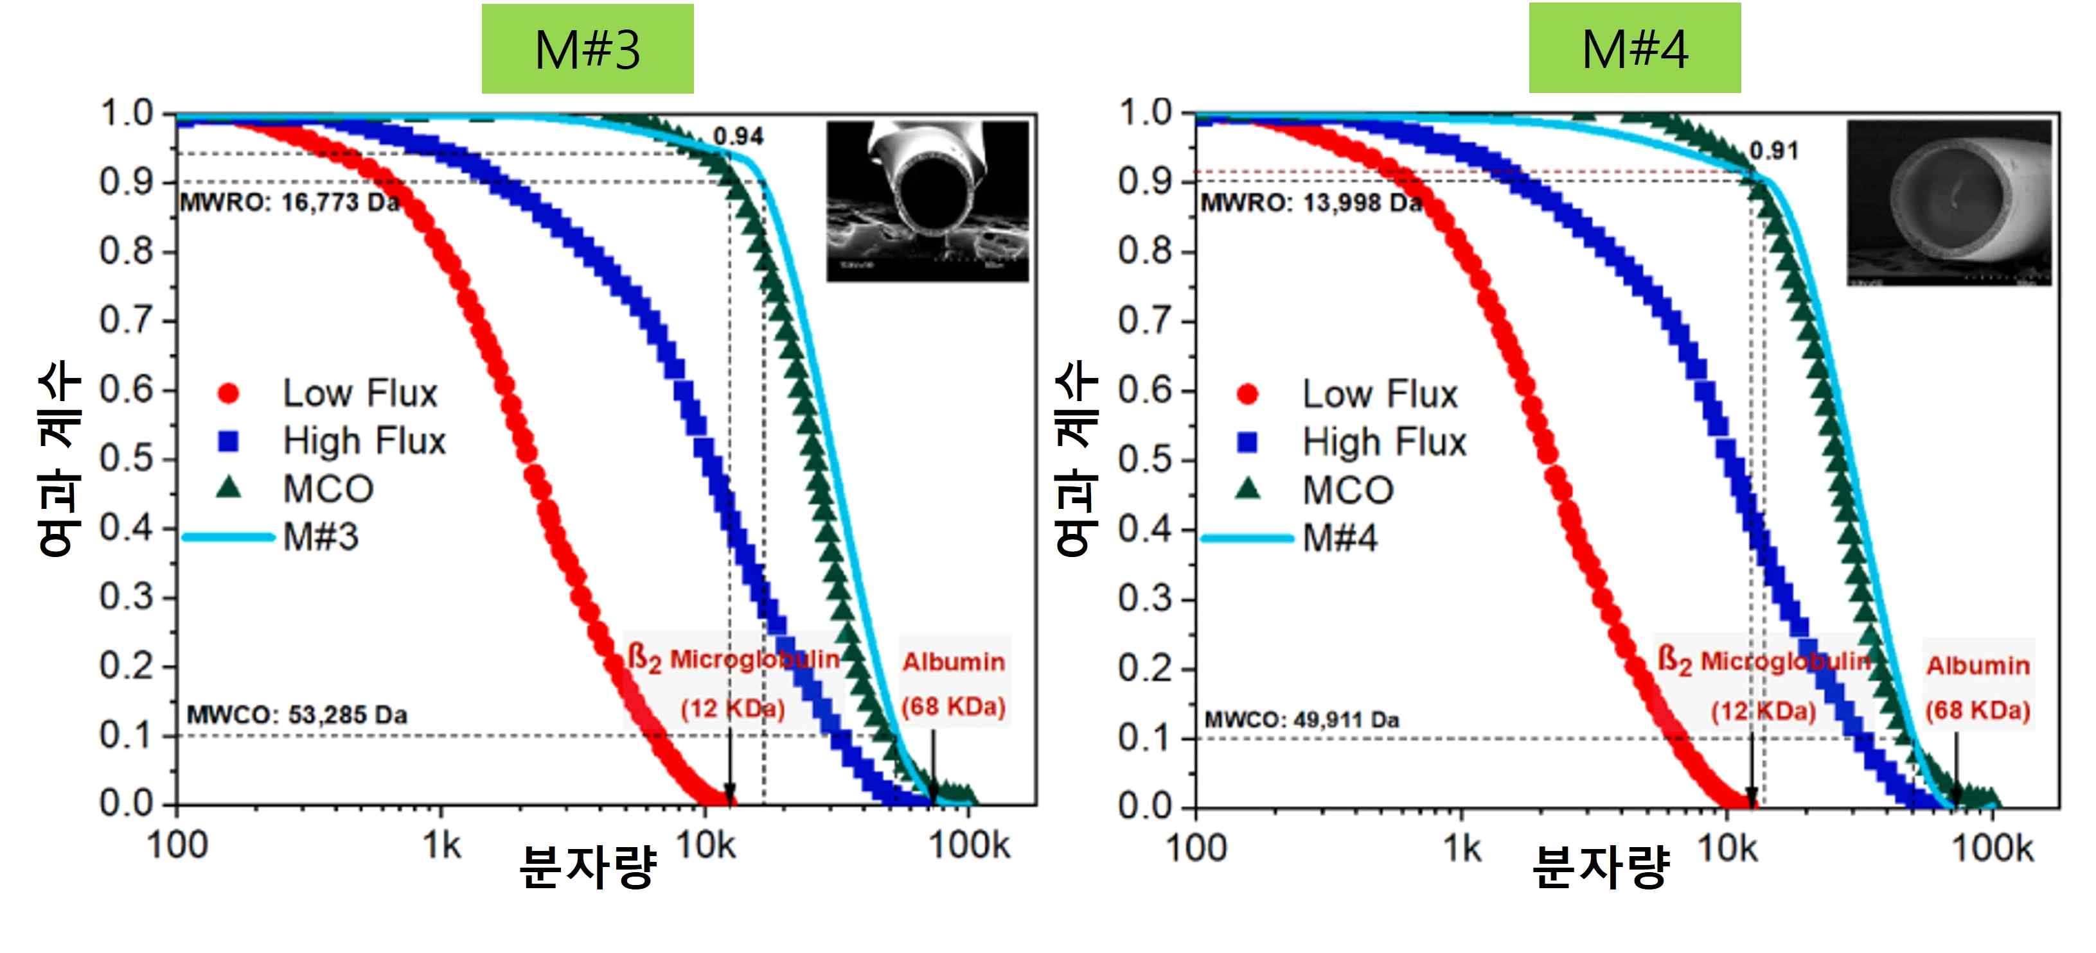
[Figure 2] Measurement results of filtration coefficient according to molecular weight of developed hollow fiber membranes and comparison with commercial membranes: The two developed hollow fiber membranes (M#3 and M#4) have MWROs of 16,773 Da and 13,998 Da, respectively, Proteins with molecular weight cutoff (MWCO) of 53,285 Da and 49,911 Da, respectively, at a level that can easily remove low- and medium-molecular urinary toxins lower than the residual molecular weight (MWRO) by diffusion and at the same time prevent leakage of essential proteins with a molecular weight of 66 kDa or more in the body.

The removal rate of hippuric acid, indoxyl sulfate, and p-cresol urea poisoning using the hollow fiber membrane developed by the research team showed much better removal performance compared to previously reported world-class research results*.

* Separator developed in 2020 by researchers at the University of Twente in the Netherlands

Professor In S. Kim said, "It is expected that the development of the hollow fiber membrane for hemodialysis will be the cornerstone for the development of domestic blood filters. If domestic blood filters are supplied, fuel costs and additional costs incurred when importing will be saved, domestic economy will be revitalized, and Korea will be able to contribute to becoming a medical powerhouse."

Based on the results of this research, the research team is preparing for the pilot stage (preliminary test stage with mass production conditions) for mass production of blood filter prototypes.

This research was carried out with the support of the TIPS program (private investment-driven technology start-up support project) of the Ministry of SMEs and Startups and was published on October 5, 2022, in the international academic journal 'Journal of Membrane Science' (Scientific Theory and Methods of Chemical Engineering) with world-renowned authority in the field of separators (JCI top 4%, impact index 10.530).



