What FDA drug made the thighs of 'sarcopenia' rats thicker?

- Increased muscle thickness and weight after administering ‘Malotylate’… confirming the possibility of ‘eating pill’ rather than an injection
- Prof. Darren Williams' research team published a paper in the Journal of Geriatrics... “Expected to shorten the development of sarcopenia treatment”

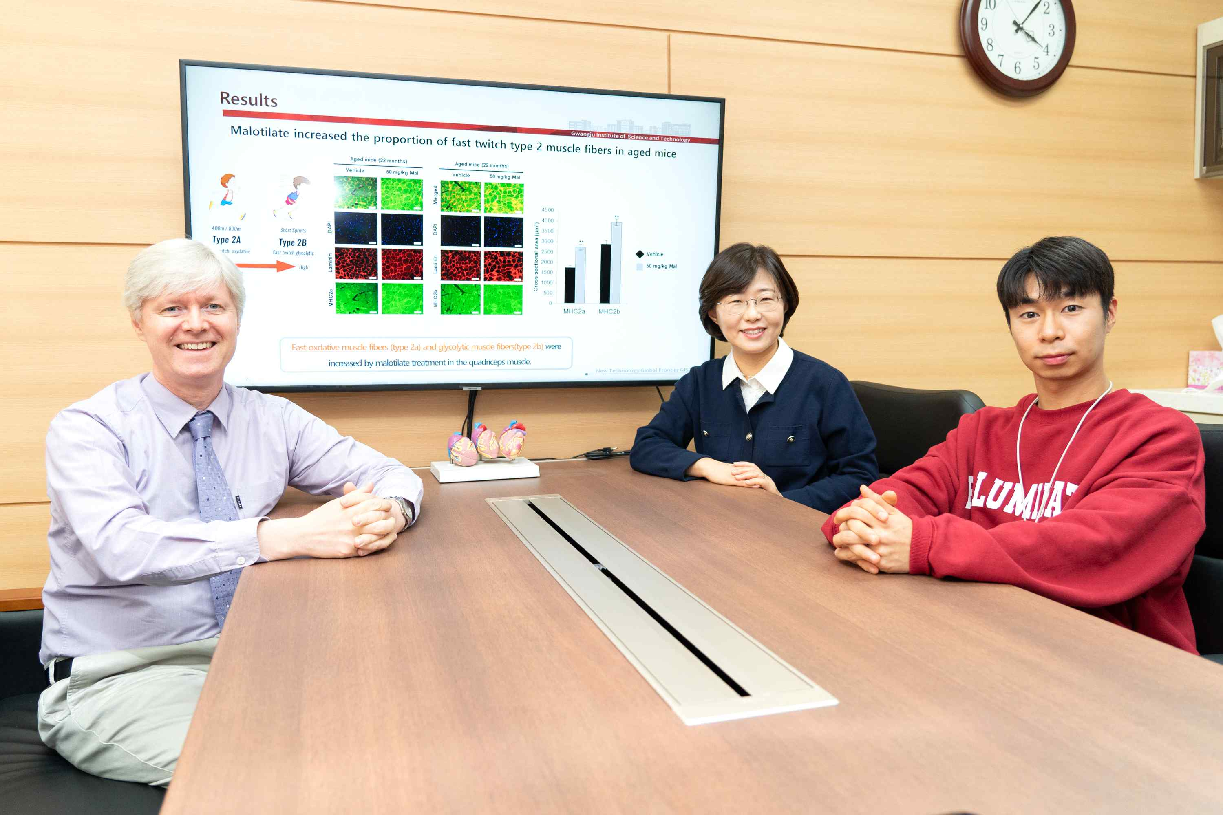
▲ (From left) Professor Darren Williams, Research Professor Da-Woon Jung, and student Hyun-Jun Kim

A research team at GIST (Gwangju Institute of Science and Technology, President Kiseon Kim) has discovered a drug approved by the US Food and Drug Administration (FDA) that is effective in the treatment of sarcopenia, a representative musculoskeletal disease caused by aging.

In the absence of a commercially available treatment, this achievement is expected to contribute to the development of a safe and highly effective sarcopenia treatment in a short period of time and at low cost through the “drug re-creation” method.

* sarcopenia: A disease in which muscles are abnormally reduced or weakened as aging progresses, resulting in poor physical activity. In 2016, the World Health Organization (WHO) and the U.S. Centers for Disease Control and Prevention assigned a disease code (M62.84), and in Korea, a disease code for sarcopenia was assigned in the 8th revision of the Korean Standard Disease Classification in 2021.

* drug re-creation: It is a method of developing new drugs that can be used as a treatment for a new disease for drugs that have already been marketed and proven to be safe or drugs whose safety has been verified in clinical trials but failed in clinical trials due to problems in efficacy.

Looking at the prevalence of sarcopenia reported in 2019, 15.7% of men and 15.2% of women over the age of 65 in the United States suffered from sarcopenia. As the aging society accelerates, the number of patients is showing a rapid increase. In addition, it has been reported that the mortality rate of patients with sarcopenia increases by more than 2 times worldwide and by up to 9.5 times in domestic studies.

The current treatment for sarcopenia includes diet control, resistance exercise, and administration of hormone regulators. However, drugs to treat sarcopenia are urgently needed for patients with inconvenient movement or difficult dietary control, or for patients who do not benefit from existing treatment therapies.

The research team led by Professor Darren Williams of the GIST School of Life Sciences screened FDA-approved drugs and succeeded in selecting ‘Malotylate’ as a drug with the efficacy of reducing muscle fiber atrophy.

Malotylate is a drug that has been used as a treatment for liver cirrhosis and liver damage, and the research team found that this drug reduces the activity of an enzyme in the body called '5-lipoxygenase', which increases during the process of skeletal muscle atrophy, and it was revealed that it inhibits the action of FoxO3, a substance (transcription factor) that plays a key role in muscle loss by lowering the concentration of LTB4 (leukotriene B4), an inflammatory mediator in muscle cells.

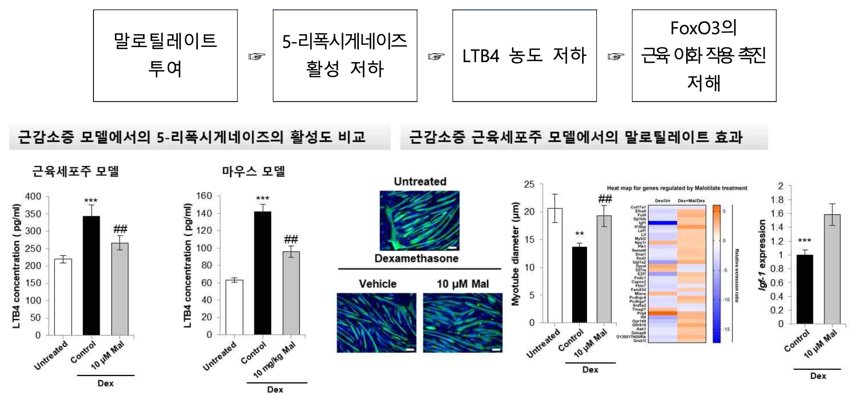▲ (Left) The activity of 5-lipoxygenase was indirectly compared by measuring the concentration of LTB4 (leukotriene B4) in an experimentally designed sarcopenia model. (Right) It was confirmed that the diameter of the muscle fiber was restored when the 5-lipoxygenase inhibitor malotylate was subsequently treated in the sarcopenia muscle cell line model, and Igf-1, a key material for muscle protein assimilation, was confirmed through transcriptome analysis It was confirmed that the expression amount of increased.

The research team conducted an experiment using laboratory rats induced with sarcopenia and aged laboratory rats, and when malotylate was administered, the average diameter of muscle fibers, which is the most important criterion for determining the increase or decrease in muscle mass, was increased 46.9% on average compared to the control group. The rate of muscle protein synthesis was also confirmed to increase. In addition, the expression of IGF-1 (insulin-like growth factor), a hormone in the body involved in the process of muscle protein assimilation, also increased.

In addition, it was found that the weight of the anterior thigh muscle (quadriceps femoris) increased by 21.58% in the group administered with malotylate compared to the control group without administration of malotylate. The muscle performance, which was quantitatively evaluated by measuring how hard the rats could pull the handle of the measuring instrument (grip strength), also increased by 39.31% compared to the control group.

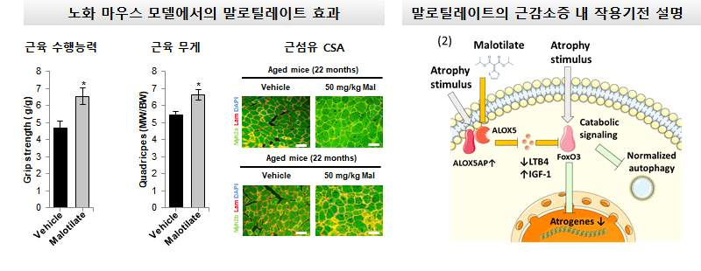
▲ (Left) Muscle strength between groups after oral administration of malotylate for 28 days in an aging mouse model aged 21 months or older and weight and tissue analysis of sampled leg muscles. In addition, it was confirmed that the large diameter of the muscle fiber increased regardless of the type of muscle fiber. (Right) Investigated that the activity of 5-lipoxygenase in the sarcopenia environment was inhibited by malotylate treatment to alleviate the mechanism of muscle protein degradation and promote the expression of Igf-1, which is important for muscle protein synthesis.

In particular, the research team confirmed the sarcopenia alleviation effect through oral administration of malotylate in an aging mouse model experiment. This can be an advantage that patients can more easily accept the treatment because they can take the drug not only by injection but also by eating.

Professor Darren Williams said, "Through this study, new drugs and targets for the treatment of sarcopenia were presented, and the drug re-creation strategy is expected to advance the development of safe sarcopenia drugs that can be eaten."

This research was carried out with support from the National Research Foundation of Korea's mid-career researcher support project, biomedical technology development project, information and communication planning and evaluation institute, and GIST GRI project and was published online on October 17, 2022, in the Journal of Cachexia Sarcopenia and Muscle, a top 3% paper in the journal of geriatric medicine.



