Confirmation of ‘peptide supplement’ for COVID-19 treatment

- ‘Apelin’ binds and degrades the receptor for the corona 19 virus to penetrate the lungs
- Prof. Chang-Myung Oh’s team published a thesis in 「QJM: International Medical Journal」...Pre-clinical trial scheduled

▲ (From left) Department of Biomedical Science and Engineering Professor Oh Chang-myeong and master’s student Ji Won Park

Amid the emergence of various new mutations of the COVID-19 virus, a research team at GIST (Gwangju Institute of Science and Technology, President Kiseon Kim) announced the results of a study that discovered the possibility of developing a treatment for COVID-19 through peptide supplements.

It was discovered that the peptide ‘Apelin-13’ can degrade the body receptor that the COVID-19 virus binds to enter lung cells. If preclinical trials on animals such as laboratory rats are successful in the future, it is expected to attract attention as a new treatment method for COVID-19.

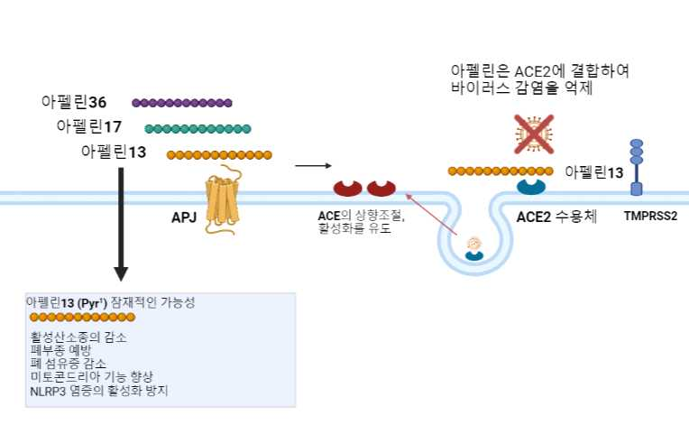
▲ Overview of the proposed beneficial role of apelin in the lung in SARS-CoV-2 pathogenesis: Spiking of ACE2 and SARS virus induces infection upon endocytosis. Apelin binds to the APJ receptor. This complex inhibits viral infection by blocking the binding of ACE2 to spike.

Like the SARS virus, the COVID-19 virus is known to use ACE2, a protein in the human body, as a receptor to enter lung cells and cause infection.

* ACE2: Angiotensin Converting Enzyme (ACE), pulmonary epithelial cells, vascular endothelial cells, airway epithelial cells, and the surface of macrophages in the lungs is expressed in various ways in the intestine and is known to play an essential role in viral binding.

Apelin is a peptide consisting of 77 amino acids involved in various physiological processes in the heart, lungs and other peripheral organs. Among them, ‘apelin-13’ in the form of pyroglutamic acid is known to bind to and degrade ACE2.

The GIST Department of Biomedical Science and Engineering Professor Chang-Myung Oh's research team used a human lung cell line in an experiment to confirm that apelin-13 directly binds to ACE2 in lung cells. The role of apelin as a practical treatment target for COVID-19 was demonstrated through experiments using experiments and public data.

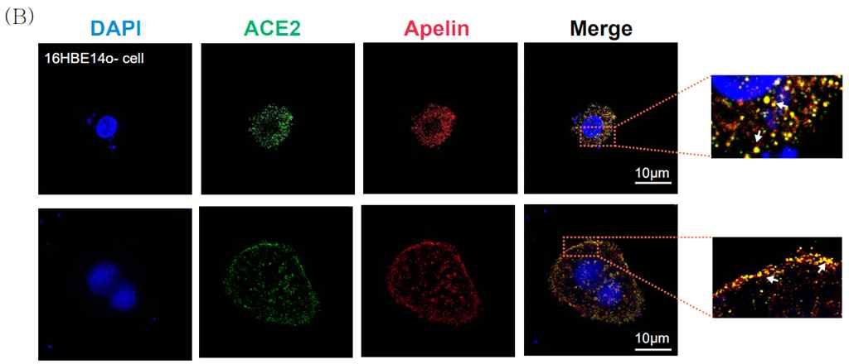
▲ Colocalization of ACE2 and Apelin in human lung cell lines. Representative images showing friendly and direct binding of ACE2 and apelin. Dapi (blue): nuclear staining, ACE2 (green), Apelin (red), Merge (yellow)

First, the research team infected human lung cell lines with a similar virus (pseudovirus) into which the spike of the SARS virus was inserted, injected apelin at different concentrations (0, 2, 5, and 10 micromol (μM)), and then expressed the spike protein. As a result, it was confirmed that the spike protein was expressed 80% less in the cell line injected with 10 micromolar (μM) than in the group not injected with apelin-13.

The research team conducted an additional transcriptome analysis using public data from an existing study using lung tissues of laboratory mice from which apelin was removed. As a result, genes that are mediators of lung inflammation and carcinogenesis increased in the group in which apelin was removed.

In addition, transcriptome analysis using lung autopsy data of the deceased due to actual COVID-19 virus infection showed that immune response genes related to viral infection increased in the group with high apelin expression.

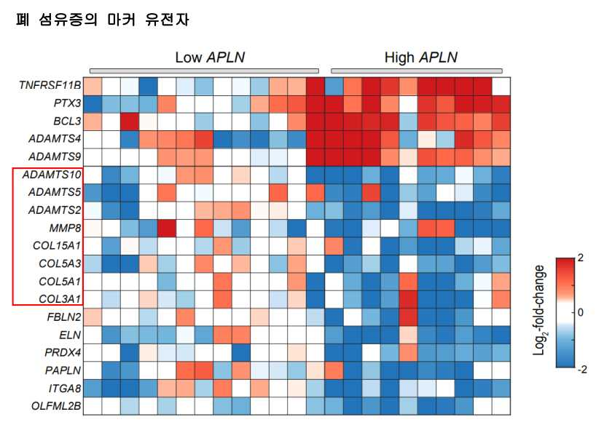
▲ Downregulation of fibrosis biomarkers in the group with high viral load among COVID-19 deaths (squares are marker genes)

In addition, as a result of analysis using public data of 24 patients (14 males and 10 females) infected with the SARS virus, the expression level of apelin was about 1.5 times higher in the patient group with high viral load, and it was associated with the formation of pulmonary fibrosis. The expression of genes was reduced.

The results of these experiments and analysis can be expected to improve immunity and inflammatory responses when apelin is present and suggests that apelin has a protective effect when the amount of virus increases.

Professor Chang-Myung Oh said, "Through transcriptome analysis and several experimental data, it was confirmed that apelin can be used as an effective treatment that can inhibit infection of COVID-19 and reduce tissue damage caused by infection. If the preclinical trial currently being prepared is successfully completed, it is expected to be a groundbreaking treatment for COVID-19."

This research, conducted by Professor Chang-Myung Oh's research team at GIST, was conducted with support from the Joint Research Project of the National Institute of Science and Technology, the Excellent New Research Project of the National Research Foundation of Korea, and the GIST Biomedical Science Convergence Research Institute and was published online on October 6, 2022 in QJM: An International Journal of Medicine, an international academic journal in the field of medicine.



