Increased durability of non-precious metal catalysts for eco-friendly ‘green hydrogen’! Korea-India joint research team develops water electrolysis catalyst with 70 times improved lifespan

- Generating 126L of hydrogen per hour for 100 hours, stable use as a key part of water electrolysis electrode
- A research team led by Professor Jaeyoung Lee Lee of the School of Earth Sciences and Environmental Engineering published a cover thesis on 「Ankevante Chemie」, a world-renowned academic journal in the field of chemistry

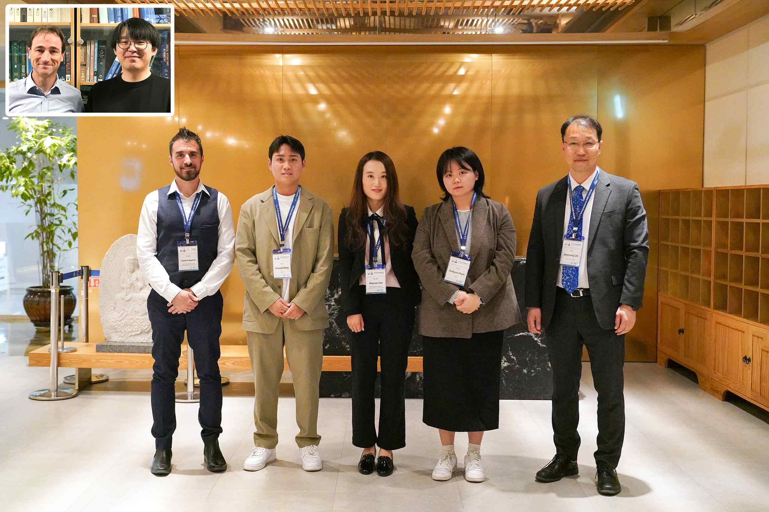
▲ (From top left) Professor Timo Jacob (co-author, Ulm University), Changbin Im (co-author, Ulm University), Dr. Ioannis Spanos (co-author, Max Planck Institute), Sinwoo Kang (first author, GIST), Ahyoun Lim (co-author, Max Planck Institute), Kahyun Ham (co-author, GIST), Professor Jaeyoung Lee (corresponding author, GIST)

A joint research team from Korea and Germany succeeded in improving the lifespan of a non-precious metal catalyst required for the water electrolysis process to obtain hydrogen by electrolysis of water by 70 times, which is expected to contribute to accelerating the commercialization of the water decomposition 'green hydrogen' production process.

As a technology to enter a carbon-neutral society, water electrolysis technology that obtains hydrogen by electrolyzing water is attracting attention. In the water electrolysis process using a catalyst, an oxygen generation reaction occurs and the active metal of the catalyst is lost from the electrode, reducing the efficiency of the entire water electrolysis system.

Iridium (Ir) and ruthenium (Ru) are evaluated as the most suitable catalysts, but as noble metal catalysts, their high price is an obstacle to commercialization. Therefore, it is important to develop high-performance and high-durability non-noble metal catalysts for use in oxygen evolution reactions.

GIST (Gwangju Institute of Science and Technology, President Kiseon Kim) School of Earth Sciences and Environmental Engineering Professor Jaeyoung Lee (Ertl Catalyst Research Center) research team along with German researchers such as Professor Robert Schlegel of the Max Planck Institute for Chemical Energy Conversion (MPI CEC) and Professor Timo Jakob of the University of Ulm, Germany, have developed a nickel-iron-based non-noble metal water electrolysis catalyst that improved durability.

Through real-time metal dissolution analysis*, the research team confirmed that iron escape is the main deterioration of the nickel-iron catalyst and minimized iron leakage by applying a protective film made of tetraphenylporphine (TPP, hereinafter referred to as porphyrin protective film). Based on molecular dynamics* simulation, it was found that a protective film and a reinforcing film were formed due to the difference in iron polarity.

* real-time metal dissolution analysis: An analysis technique that can quantify in real time the amount of dissolution of a metal forming a catalyst under potential.

* molecular dynamics: Using computers to describe the motion of molecules. Molecules are allowed to interact for a period of time and the resulting motion is predicted by numerical calculation.

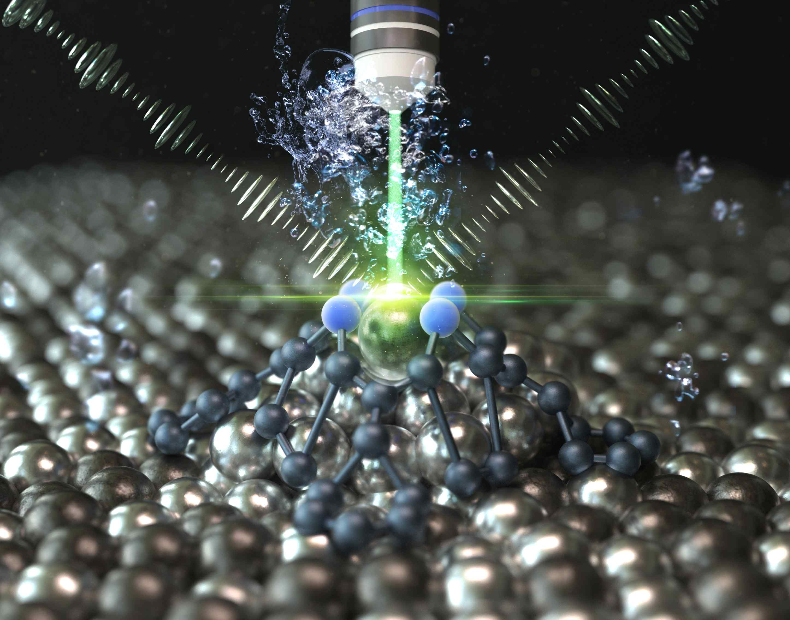
▲ A highly durable nickel-iron anode catalyst for water electrolysis cells that stably generates 126 L of green hydrogen per hour for more than 100 hours has been developed. Iron loss was found to be the main cause of performance degradation, and a non-polar protective film (TPP) layer was applied to slow it down. The role of the protective film was demonstrated through real-time metal quantitative analysis and molecular dynamics simulation.

The iron lost in the aqueous phase immediately interacts with water and is hydrated. On the other hand, it was confirmed that the non-polar porphyrin protective film acts as a buffer to prevent the complete release of eluted iron from the electrode interface.

This causes a lifespan improvement of about 70 times compared to the existing catalyst, and it was confirmed that it acts as a key component of a stable water electrolysis electrode that generates 126 L of hydrogen per hour for 100 hours.

Professor Jaeyoung Lee said, "The results of this research are expected to present a new direction to solve the durability problem in the design of water electrolysis catalysts for hydrogen generation."

GIST School of Earth Sciences and Environmental Engineering Professor Jaeyoung Lee (corresponding author) and doctoral student Sinwoo Kang (first author) jointly conducted this research with two German researchers with the support as an institutional joint research project and was published online on October 23 of Angewandte Chemie-International Edition, a world-class academic journal in the field of chemistry, and was selected as a front cover article in recognition of its excellence.



