Identification of novel mechanisms of peptide transport proteins

- Identification of three structures of the peptide transport protein TAPL through cryogenic electron microscopy
- Professor Mi Sun Jin's team confirms the world's first ability to transport phospholipids of TAPL... Nature Comm. publication

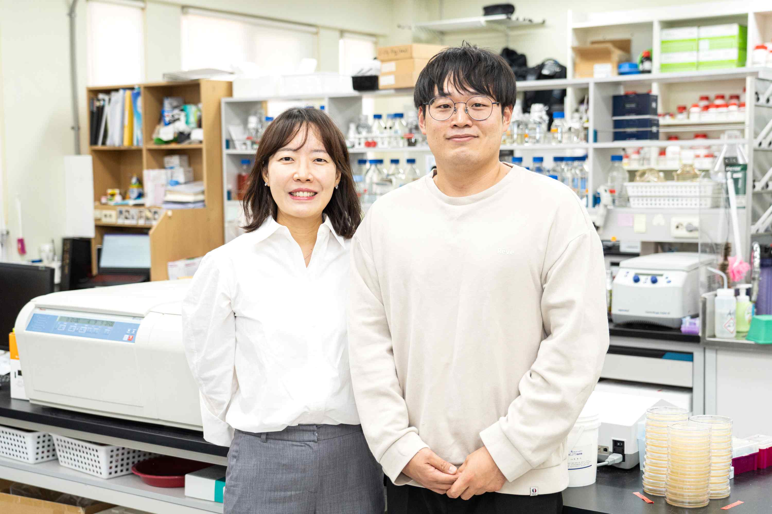
▲ (From left) Professor Mi Sun Jin, research director, and student Jun Gyou Park, first author

GIST (Gwangju Institute of Science and Technology, President Kiseon Kim) Professor Mi Sun Jin's research team has identified for the first time in the world that TAPL, a protein that transports unnecessary peptides in cells, is involved in the onset of degenerative brain diseases and metabolic diseases, and has an intracellular lipid transport function.

This achievement is expected to provide key information necessary to discover new drug candidates targeting TAPL.

TAPL is a type of ‘ABC transporter’ (48 in total), a protein that transports various substances (eg, sugar, vitamins, hormones, metabolites, antibiotics, anticancer drugs, etc.) in and out of cell membranes in the body. Mutations or dysfunction of the ABC transporter have been reported as major causes of various intractable diseases (cancer, metabolic disease, degenerative brain disease, hypoglycemia, etc.).

TAPL is a transporter that transports peptides to the lysosome*, where the transported peptides are broken down into amino acids by various enzymes and reused for energy generation and protein synthesis [Figure 1]. This dysfunction of TAPL causes excessive accumulation of intracellular peptides, which can affect the onset of various cancers, metabolic diseases, and degenerative brain diseases.

* Lysosome: The inside of the lysosome is acidified (pH4.5-5.0) and is an unnecessary protein in the cell because it has various degrading enzymes and functions to remove substances introduced from outside the cell and damaged organelles.

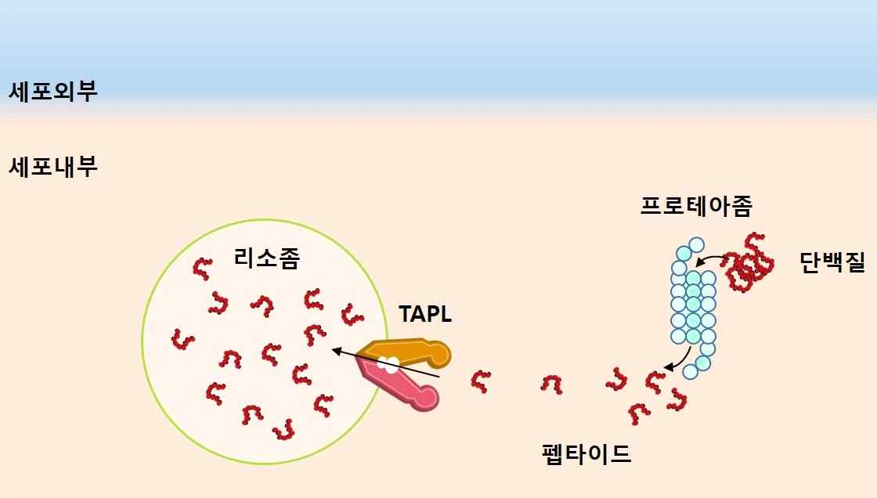
[Figure 1] Schematic diagram of TAPL peptide transport

Because of this importance, numerous studies have been conducted since the existence of TAPL was first known. The process of protein crystallization*, which is essential to understand the protein structure of TAPL, is very difficult, which has been a major obstacle in the study of intracellular peptide transport mechanisms.

* crystallization: When a protein is placed in a specific solution and a certain period of time elapses, the protein particles are arranged regularly. This is called ‘protein crystallization’. The crystals thus formed use X-ray crystallography using a radiation accelerator, which has been the main method for elucidating the molecular structure of proteins for a long time. Through this method, numerous important discoveries and developments have been made over the past 60 years since 1957, but there was also a disadvantage that the crystallization process of the protein was absolutely necessary. In addition, the possibility that the structure of the protein obtained in the crystalline state may be different from that of the protein in the cell has always been raised.

The research team led by GIST School of Life Sciences Professor Mi Sun Jin has succeeded in elucidating the various structures of TAPL during the transport cycle using a cryogenic electron microscope* that can identify the protein structure without the need for crystallization. Through this, it was identified for the first time in the world that TAPL is involved in the transport of phospholipids as well as peptides.

The cell membrane is composed of a double membrane of an outer membrane and an inner membrane. The transport of lipids from the outer membrane to the inner membrane or the lipids from the inner membrane to the outer membrane is called ‘phospholipid transport’. If this transport function is abnormal, degenerative brain diseases such as Alzheimer's disease or metabolic diseases such as obesity and fatty liver may occur.

* cryogenic electron microscopy (cryo-EM): It rapidly freezes biological samples (proteins, microorganisms, cells, etc.) to keep them in their natural state as much as possible and analyzes the three-dimensional structure after observation through a transmission electron microscope (TEM). Cryo-EM technology, which won the Nobel Prize in Chemistry in 2017, is an innovative protein structure analysis technology that is rapidly spreading around the world, providing structural information of important biomolecules such as virus structures and cell receptors related to COVID-19.

The research team confirmed the increase in ATP degradation activity by phospholipids as well as the difference in transport capacity according to the peptide length of TAPL [Figure 2].

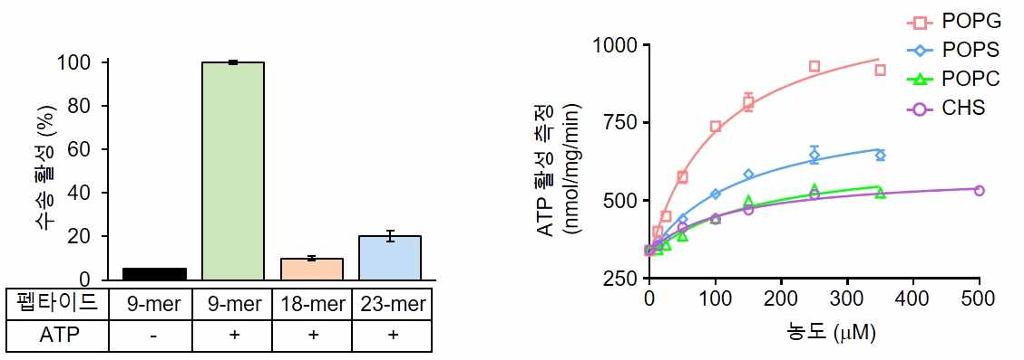
[Figure 2] Measurement of transport activity according to the peptide length of TAPL and ATP hydrolysis activity according to the addition of phospholipids. (A) TAPL showed the highest transport activity when the peptide consists of 9 amino acids. (B) Confirmation of increase in ATP decomposition activity of TAPL in various phospholipids.

As a result of structural analysis of TAPL, the substrate-binding site is divided into two parts, a part with mainly hydrophobic residues (top) and a part with mostly hydrophilic residues (bottom), and it was confirmed that phospholipids and peptides are bound to each other [Fig. 3].

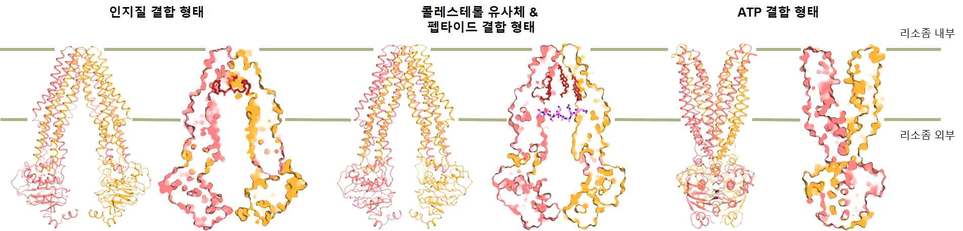
[Figure 3] Structural change of TAPL according to substrate and ATP binding during the transport cycle. (A) TAPL-phospholipid binding structure. (B) TAPL-cholesterol & peptide bond structure. (C) TAPL-ATP binding structure.

In addition, when ATP is bound, the structure of the substrate-binding site of TAPL is changed from the cytoplasm (inward-facing) to the lysosome outward-facing (outward-facing), confirming that the substrate is transported [Figure 4].

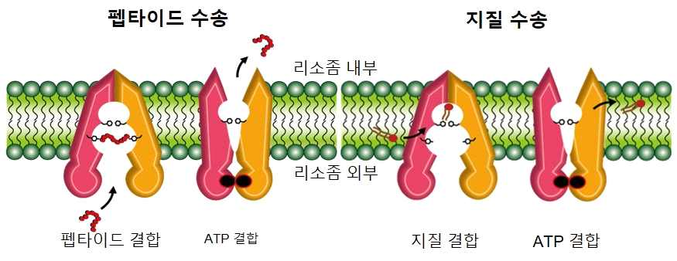
[Figure 4] Schematic diagram of the substrate transport mechanism of TAPL. As a result of the structural analysis of TAPL, the substrate binding site is divided into two parts, a part with mainly hydrophobic residues (top) and a part with mainly distributed hydrophilic residues (bottom), confirming that phospholipids and peptides are bound to each other. When ATP binds, the structure of the substrate binding site of TAPL is changed from the inside (inward-facing) to the outside (outward-facing) direction of the cell, and substrate transport is expected. After that, when ATP hydrolysis occurs, the substrate-binding site is directed back into the cell, enabling subsequent transport.

Through this study on the structure and function of TAPL, the research team proved the hypothesis that (1) TAPL is involved in peptide as well as phospholipid transport through two different mechanisms of action, and (2) TAPL due to substrate and ATP binding during the transport cycle, (3) suggested the possibility that TAPL could be considered as a target protein for the treatment of cancer, metabolic disease, and degenerative brain disease in the future.

Professor Mi Sun Jin said, "This study was able to provide new insights into the functional diversity of TAPL and is expected to provide key information needed to discover new drug candidates targeting TAPL in the future."

This research was conducted with the support of the Biomedical Technology Development Project of the Ministry of Science and ICT and was published online on October 4, 2022 (Tuesday) in the international academic journal Nature Communications.



