Overcome degradation of perovskite performance with non-conjugated polymer thin film

- Providing a clue for the development of high-quality and high-efficiency next-generation solar cells


▲ (From left) GIST Professor Kwanghee Lee Lee, GIST Professor Hee Joo Kim, Pusan National University Professor Hong-seok Seo , GIST Dr. Joo-hyun Kim, Swansea University Dr. Yong-yun Kim

The National Research Foundation of Korea (Chairman Kwangbok Lee), Professor Kwanghee Lee and Hee Joo Kim (Gwangju Institute of Science and Technology), Professor Hong-seok Seo (Pusan National University) announced that their joint research team has developed a high-performance and high-stability solar cell by suppressing non-radiative recombination**, a factor that degrades the performance of perovskite* solar cells.

* perovskite: The crystal structure of a mineral discovered in the Ural Mountains of Russia in 1839. The perovskite structure attracts attention as a leader in next-generation solar cells due to its high charge transfer and light absorption.

** non-radiative recombination: A phenomenon in which holes and electrons generated during solar cell operation fail to move to each electrode and are not converted to electrical energy but are released as thermal energy during recombination with each other.

Non-radiative recombination, which impairs the stability and efficiency of solar cells, is a phenomenon in which energy is lost as thermal energy while the solar cell absorbs light and operates. It is caused by defects in the perovskite material itself and by minority charge carriers* pooled between the electrode and the solar cell during solar cell operation.

Although research to solve this problem has been actively conducted around the world, there is still no way to solve one of the problems caused by defects in the material itself or the minority charge carriers and suppress the entire problem through complex processes such as deposition* and high-temperature heat treatment.

* charge carrier: Particles (electrons, holes) that move with an electric charge

** evaporation: A method of manufacturing a strong thin film by heating and evaporating a material to a high temperature.

Accordingly, the research team developed a new non-conjugated polymer* and fundamentally solved the non-radiative recombination by grafting it to the lower layer of the perovskite thin film through a simple solution process.

The new non-conjugated polymer layer does not interfere with the absorption of sunlight by the perovskite material, and the internal defects were effectively reduced by inducing the growth of high-quality perovskite crystals.

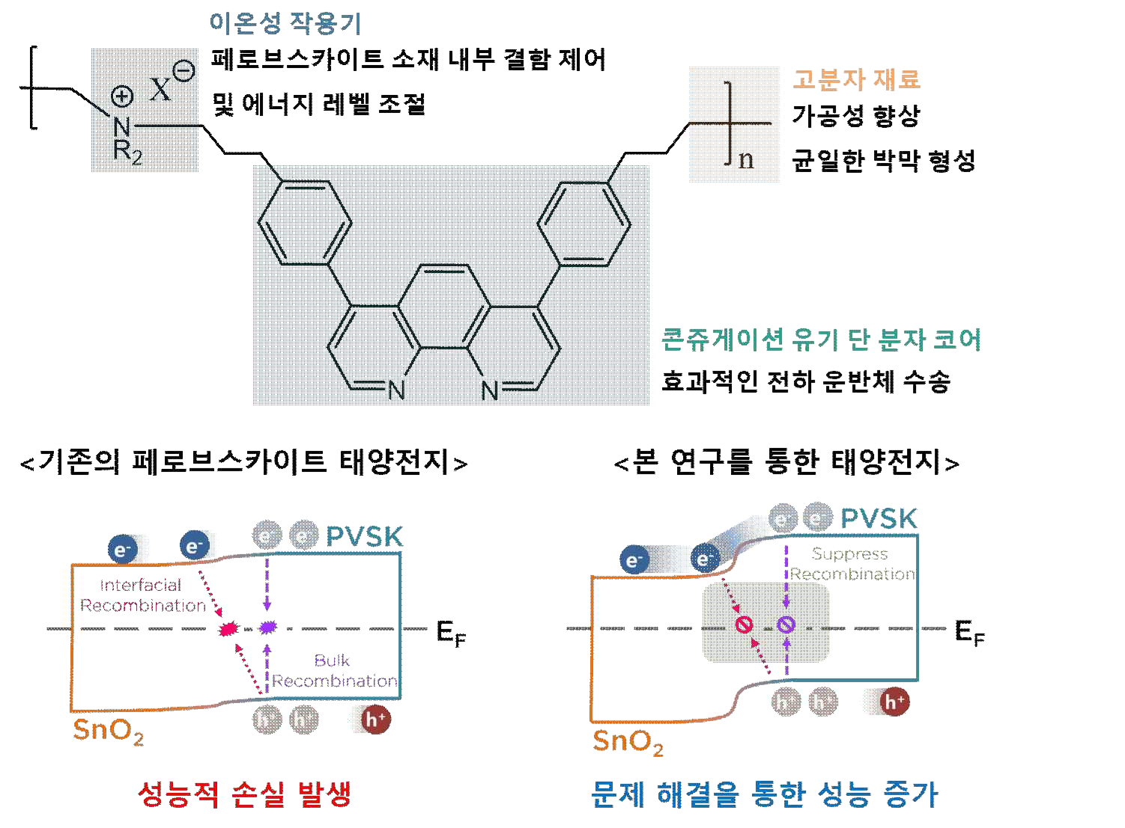
▲ The structure and characteristics of the non-conjugated polymer developed in this study (above), and the performance increase of the perovskite solar cell using it. Organic monomolecules, which are widely used in semiconductor devices, were used as the core of the material, and ionic functional groups were grafted for more efficient charge transport. Furthermore, for the processability of the material, the material was designed in the form of a non-conjugated polymer, and when the actually developed polymer material is applied between the charge transport layer and the perovskite photoactive layer, the existing performance loss is solved and the charges moved smoothly without loss.

In addition, by introducing an ionic functional group, the charge generated from the perovskite material was effectively extracted to the lower electrode, and the performance of the solar cell was improved due to the improved charge transport ability.

* non-conjugated polymer: A polymer in which a single bond is linked between units constituting a polymer material. Electrons are not unorganized and generally have insulator properties.

The research team recorded an energy conversion efficiency of 24.4% with the new device structure showing higher open-circuit voltage and photocurrent than the perovskite solar cell of the existing structure. In the 700-hour solar exposure experiment, it was confirmed that only 7% of the initial efficiency was reduced, indicating excellent photostability.

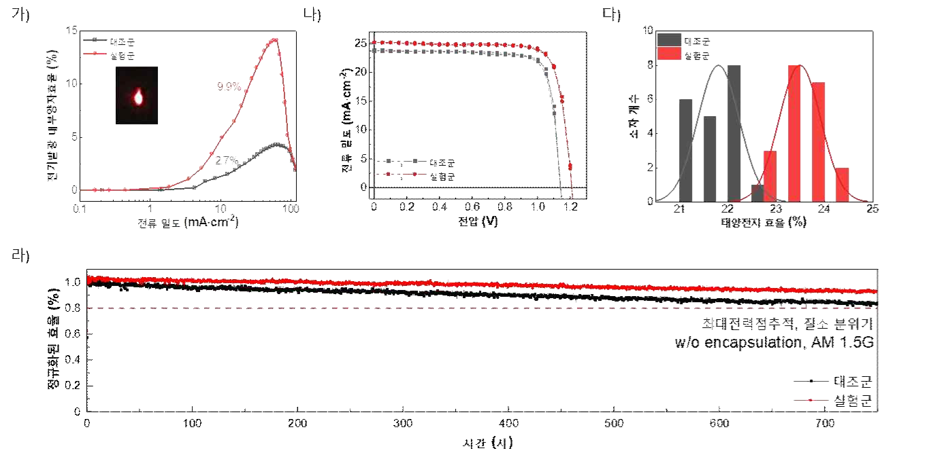
▲ Electroluminescence internal quantum efficiency graph (A), current-voltage curve (B), solar cell efficiency histogram (C), photostability graph (D): To check how much the non-radiative recombination loss was reduced when the polymer material developed in this study was applied to the perovskite solar cell, the electroluminescence internal quantum efficiency was measured. It was confirmed that the non-radiative recombination loss was effectively reduced, and through this, the solar cell efficiency and stability were remarkably increased.

Professor Kwanghee Lee said, "This study provided a clue to solve the root cause of the degradation of perovskite materials. It is expected that it can be used in various fields closely related to real life, such as the development of solar modules and building-integrated solar cells in the future."

The results of this research conducted with support from the Ministry of Science and Technology and the National Research Foundation of the Global Lab Project and Climate Change Response Technology Development Project were published in the online edition of Advanced Materials, an international academic journal in the field of materials in October. It was published on the 13th.



