Development of new material for hole transport layer of perovskite solar cell with improved stability while maintaining efficiency

- Development of a new material that can replace the existing hole transport layer material (Spiro-OMeTAD)
- Perovskite solar module achieved the world's highest efficiency of 21.35% (excluding the existing hole transport layer material)
- Prof. Hobeom Kim's joint research team, School of Materials Science and Engineering, published a paper in Angewandte Chemie


▲ (From left) Professor Hobeom Kim of GIST, Professor Nazeeruddin,
Federal Institute of Technology Lausanne

A new hole transport layer material that is essential for the production of perovskite solar cells, a next-generation solar cell, was developed by a GIST (Gwangju Institute of Science and Technology, President Kiseon Kim) research team.

It is expected to contribute to advancing the commercialization of high-efficiency, high-stability, large-area perovskite solar cells* by replacing the traditional materials (Spiro-OMeTAD, Spiro-OMeTAD) used as the hole transport layer of perovskite solar cells.

* perovskite solar cell: A solar cell using a metal-halogen perovskite material as a photoactive layer for absorbing sunlight. Recently, an efficiency equivalent to that of a silicon solar cell has been reported. Because of its advantages such as low manufacturing cost, easy production process, and flexibility, it is drawing much attention as a next-generation solar cell to succeed silicon solar cell.

The hole transport layer effectively transports and extracts charges (positive charges) generated in the light absorption layer of the perovskite solar cell, and it is a component that must be included in order to realize a high-efficiency and high-stability solar cell.

Although many studies have been conducted to improve the efficiency and lifespan of perovskite solar cells, the research on the development of the hole transport layer is largely dependent on a material called Spiro-OMeTAD.

Spiro-OMeTAD requires a doping process to mix impurities in order to achieve high efficiency of a solar cell because of its low electrical conductivity, which shortens the lifespan of the device.

Therefore, in order to increase the stagnant efficiency of perovskite solar cells and improve the short lifespan, which is a chronic problem, it is urgent to develop a new hole transport layer material that can replace existing materials.

Professor Hobeom Kim of GIST's School of Materials Science and Engineering, together with Professor Nazeeruddin's team from the Federal Institute of Technology Lausanne, Switzerland, Professor Dyson's team, and Dr. Pozzi's team from Concilio National Laboratory in Italy developed BSA50, a new material for hole transport in perovskite solar cells, and implemented high-efficiency, long-life perovskite solar cell devices and modules by using it.

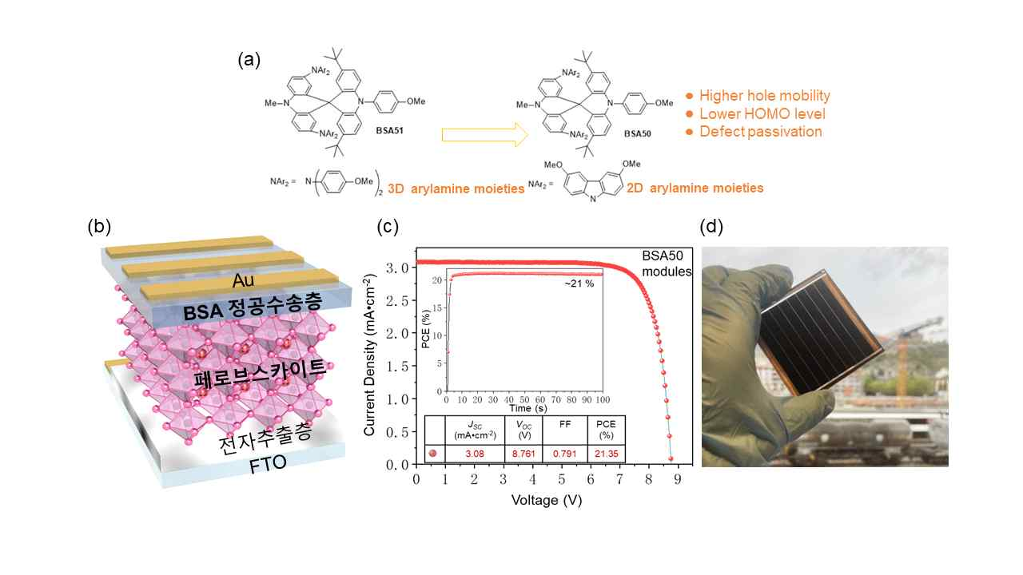
▲ New material (BSA) for hole transport layer of perovskite solar cells developed by this research team and applied to perovskite solar module. (a) Molecular structure and properties of newly developed new material for hole extraction layer: BSA51 contains a three-dimensional arylamine group, whereas BSA50 contains a two-dimensional arylamine group. Due to this molecular structure difference, BSA50 has better electrical and physical properties. (b) Structure of the developed perovskite solar cell (c) Performance of the developed perovskite solar module (d) Photo of the developed perovskite solar module

The newly developed BSA50 hole transport layer material is efficient in the extraction of holes* formed by light absorption in the perovskite layer. The oxygen atom of the arylamine in the BSA molecule can remove the defect present in the perovskite.

* Hole: A solar cell uses the property of a material that absorbs sunlight (photoactive layer) to create electrons and holes. When electrons escape from the photoactive layer, holes are created in the place where the electrons are removed.

Therefore, the perovskite solar cell to which BSA50, a new hole transport layer material was applied, has an efficiency of 22.65%, which is almost similar (97% level) to the photoelectric conversion efficiency of the device using the existing Spiro-OMeTAD hole transport layer. In terms of stability, it was shown that the initial efficiency was maintained more than 89% even after 1000 hours of operation under sunlight. This is superior to the efficiency (82%) maintained by the device applied with the existing material (Spiro-OMeTAD), showing that the BS A50 material has excellent performance and stability.

In addition, the result of the experiment by manufacturing a large-area perovskite solar module (6.5×7cm²). It achieved the world's highest efficiency of 21.35% among modules that do not use conventional materials (Spiro-OMeTAD).

Professor Hobeom Kim said, "By developing a new hole transport layer material that can significantly improve stability while maintaining the efficiency of existing devices, this is expected to greatly contribute to the commercialization of perovskite solar cells in the future."

This research, conducted by an international joint research team including Professor Hobeom Kim, was carried out with the support of the APOLO project of the European Union's Horizon 2020 Research and Innovation Programme and was published online on October 5, 2022, in Angewandte Chemie, the most prestigious journal in the field of chemistry.



