Development of new catalyst technology to obtain ‘green ammonia’ without carbon emission

- Conversion of nitrogen to ammonia using only electric energy...“Attention as a carbon-neutral technology”
- Up to 34.5% improvement in ammonia conversion efficiency...Professor Jaeyoung Lee's team published paper in 'Angevante Chemie'

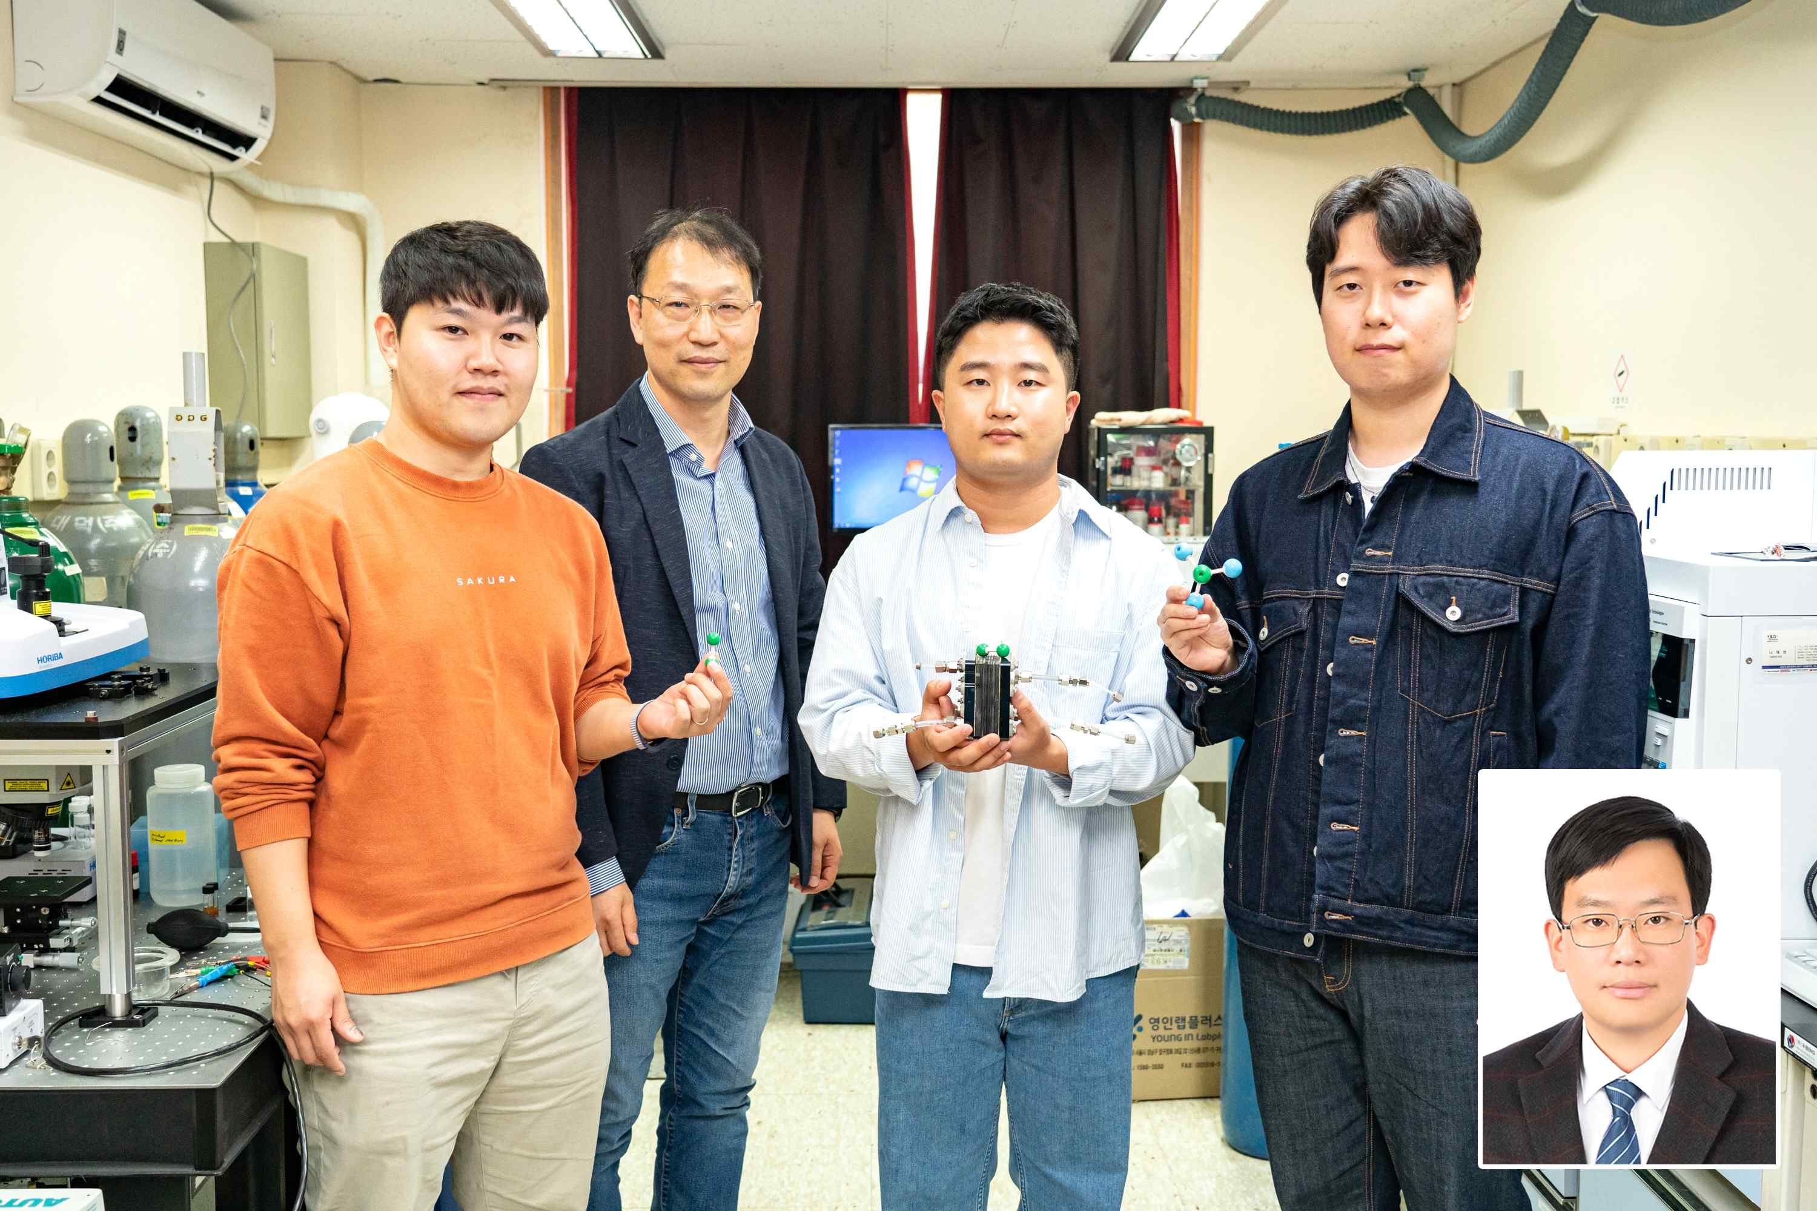
▲ (From left) Ph.D. student Minjun Choi, Professor Jaeyoung Lee, Dr. Sunki Chung, Master’s student Donghyun Yoon, Dr. Hyung-Guk Joo

GIST (Gwangju Institute of Science and Technology, President Kiseon Kim) researchers developed a catalyst that can convert nitrogen to ammonia using only electrical energy and presented a new process for the production of ‘green ammonia’ without carbon emission.

Ammonia, a compound of nitrogen and hydrogen, is an important substance used to make fertilizers and urea water*. It is considered an eco-friendly energy source without greenhouse gas and is attracting attention as a next-generation hydrogen storage material due to its high hydrogen density per mass and volume.

* urea water: As a nitrogen oxide reducing agent used in post-treatment equipment installed in diesel vehicles, it plays a role in decomposing soot emitted from diesel vehicles into nitrogen and water vapor.

Currently, the Haber-Bosch process* is widely used as the ammonia production process, but the ammonia synthesis process consumes a lot of energy and produces a significant amount of carbon dioxide. It is essential to develop an eco-friendly ammonia production process that can replace the existing Haber-Bosch method in order to use ammonia as an eco-friendly hydrogen energy carrier.

* Haber-Bosch process: Industrially, a process for producing ammonia by reacting nitrogen and hydrogen at a high temperature of 500 degrees and a high pressure of 20 MPa (megapascal). Hydrogen participating in the reaction is a fossil fuel reforming process 2.9 tons of carbon dioxide are emitted to produce 1 ton of ammonia.

The ammonia synthesis process using electrical energy is drawing attention as a new carbon-neutral technology in that it consumes less energy and can reduce dependence on fossil fuels. Since the conversion efficiency of ammonia is very low due to various competing reactions in the electrolyte, research to improve it is needed.

GIST School of Earth Science and Environmental Engineering Professor Jaeyoung Lee's research team has developed a technology that converts nitrogen (N2) into ammonia (NH3) using electrical energy as an eco-friendly ammonia production technology that does not emit carbon dioxide.

The research team developed a material with a structure in which cobalt-molybdenum is properly distributed inside carbon nanofibers through electrospinning and succeeded in converting nitrogen in the air into high value-added ammonia by using it as a nitrogen reduction reaction catalyst.

In the carbon nanofiber structure of the catalyst proposed by the research team, the adsorption and desorption strength of the reactants is properly controlled, and it was found that the water in the electrolyte participates in the nitrogen reduction reaction rather than the competitive reaction in which it is converted to hydrogen. In the electrochemical ammonia synthesis system using such a catalyst, the ammonia conversion efficiency was improved from less than 10% to a maximum of 34.5%.

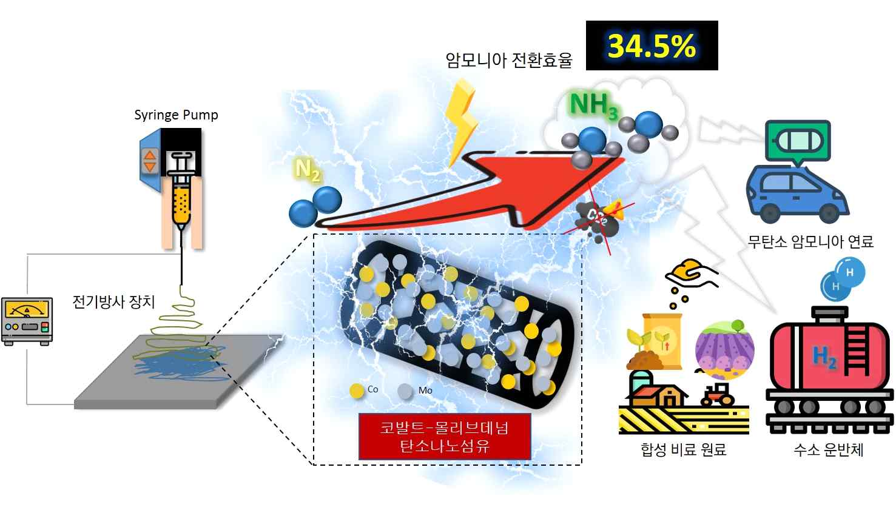
▲ Eco-friendly ammonia production and use through nitrogen reduction reaction: A carbon nanofiber catalyst containing cobalt and molybdenum was synthesized using electrospinning. Using this catalyst with high selectivity for nitrogen reduction reaction, we succeeded in producing green ammonia with high efficiency.

Professor Jaeyoung Lee said, "This research result is significant in that it presented a new, more environmentally friendly ammonia production process than the existing process and the possibility of ammonia as a hydrogen storage medium. If the reactor is optimized for mass production in the future, it is expected that the efficiency of the ammonia production process will be maximized."

This research was carried out with the support of the National Research Foundation of Korea's overseas excellent research institute cooperation hub establishment project and was published online on October 4, 2022 (Tuesday) in ‘Angewandte Chemie International Edition’ (IF=16.823), an authoritative journal in the field of chemistry.



