Predict the risk of large wildfires a week in advance with artificial intelligence!

- Verified as a case of the largest wildfire in the U.S. in 2018, predicting an increase in the wildfire weather index up to 7 days prior to the occurrence of the wildfire
- Development of AI prediction model... A Korean-American joint research team, including Professor Jin-Ho Yoon, published a paper in a renowned journal in the atmospheric field

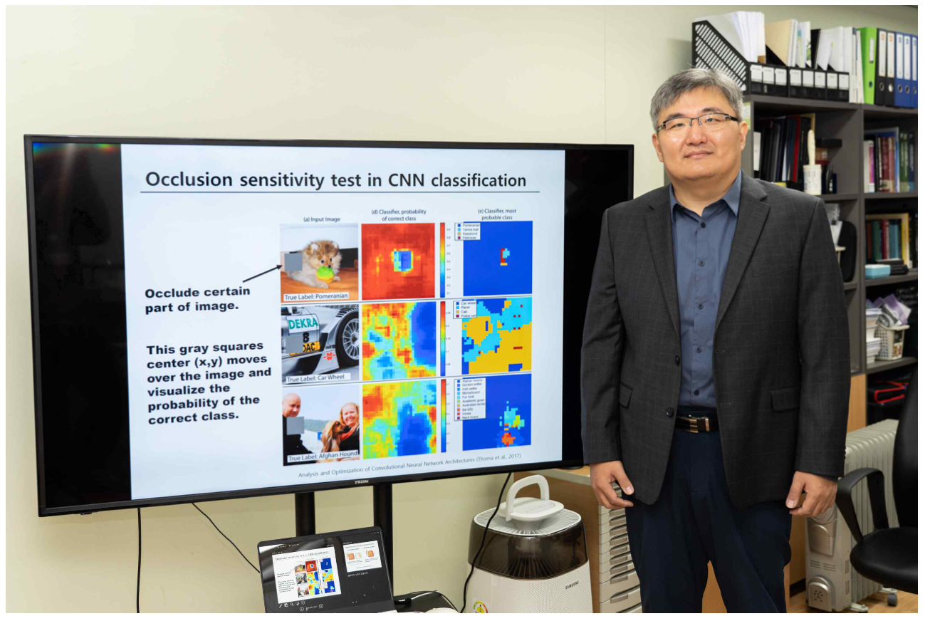

A joint research team between Korea and the United States developed a model that predicts the weather conditions with a high probability of causing a large-scale forest fire up to a week in advance using an artificial intelligence prediction model and informs the risk of forest fires.

In addition, in the prediction model developed by the research team, the horizontal resolution* of the weather prediction model for calculating the risk of forest fires was expanded from 100km to 4km, making it possible to produce forecast information in more detailed administrative district units.

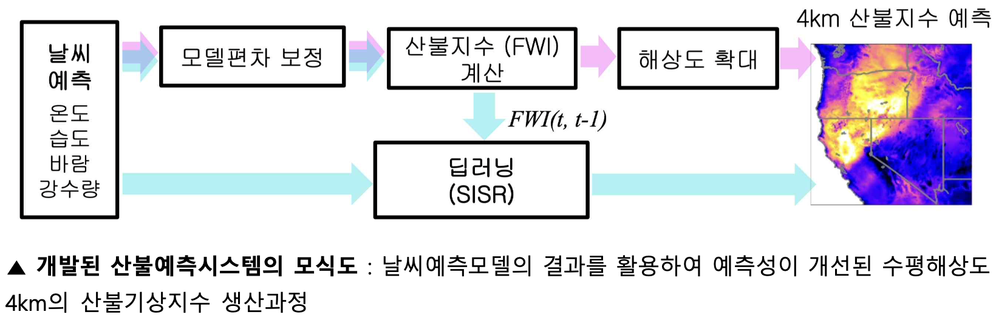▲ Schematic diagram of the developed forest fire forecasting system: The production process of the forest fire weather index with a horizontal resolution of 4km with improved predictability by using the results of the weather forecasting model

The results of this study are expected to help prepare for large-scale wildfires faster and more thoroughly.

* Horizontal resolution: 100km x 100km grid expresses 100km*2 area information as one value, 4km x 4km expresses information of 4km*2 area as a single value, and detailed regional information can be provided only with a 4km grid.

While the frequency of large-scale wildfires is increasing worldwide due to climate change, it is becoming more important to establish a predictive system that can predict the risk of a forest fire in advance by accurately measuring the ‘Fire Weather Index*’, which is considered an important prerequisite for the occurrence of a forest fire.

Until now, forest fire prediction has been attempted only on a limited scale and area due to irregularities in the occurrence and development of forest fires and limitations of predictive models. In particular, the weather prediction model used in the previous research is produced with a horizontal resolution of 100 km, and the accuracy of the forest fire weather forecast based on it is low due to the model error.

* Wildfire Weather Index (FWI): An index indicating the optimal weather conditions for wildfires. It is calculated using the temperature, humidity, wind, and accumulated precipitation near the surface of the earth. The higher the index, the higher the risk of forest fires, especially large ones. The ‘accuracy’ of forest fire prediction is defined as the deviation between the forest fire weather index calculated based on past observations and the forest fire weather index calculated based on the predicted weather conditions.

GIST (Gwangju Institute of Science and Technology, President Kiseon Kim) School of Earth Sciences and Environmental Engineering Professor Jin-Ho Yoon together with an international joint research team including the Pacific Northwest National Laboratory (a national research institute under the U.S. Department of Energy), obtained meteorological factors (temperature, humidity, precipitation, wind, etc.) from a weather prediction model and improved the predictive ability of the forest fire weather index calculated using artificial intelligence/deep learning techniques and developed an artificial intelligence model that produces high-resolution (horizontal resolution 4km) forest fire risk prediction data.

The research team developed a model using the results of the 2011-2017 weather forecasting model and high-resolution observational meteorological data, and the predictive performance of the developed method was analyzed using data from the 'Mendocino Complex' wildfires and 'Camp Fire' wildfires, which were massive wildfires in California, USA, in August and November 2018.

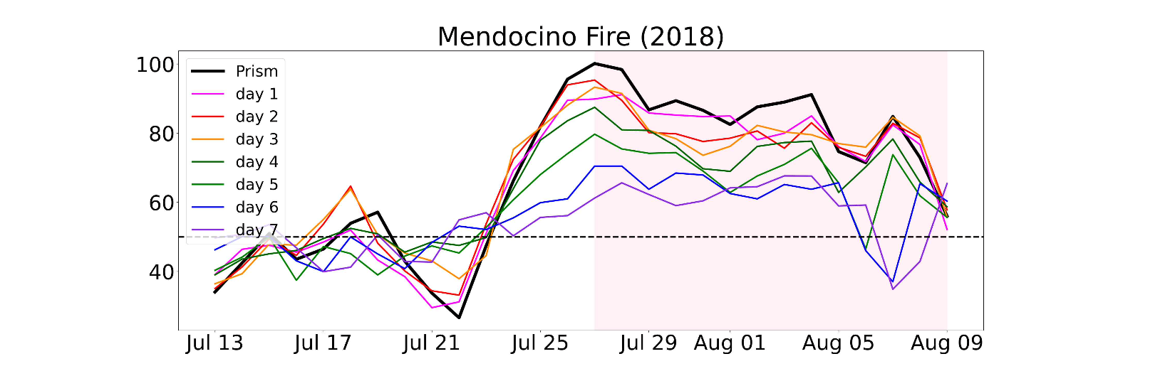▲ Predictive performance verification results for forest fires in the Mendocino area that occurred on July 27, 2018 - (black and pink sections) The wildfire weather index calculated based on the actual observed data and the days when the actual wildfire occurred (July 27 – August 9 in pink)
- (Different colored line graph) The predicted wildfire weather index from the day before the forecast up to 7 days before, and it is predicted that the forest fire weather index will rise even up to 7 days before. For example, as of July 27, it is predicted that the wildfire weather index will rise abnormally even 7 days before that day.

As a result, it was found that it was possible to predict a pattern in which the risk of forest fire rapidly increased up to 7 days before the actual wildfire occurrence date. The research team's artificial intelligence (AI) convergence prediction model was developed to expand the horizontal resolution of the prediction area up to 4 km within a short time with high accuracy.

For example, if it is possible to produce forecast information for the entire Gwangju and Jeollanam-do with 100km-level information. At 4 km, it is possible to predict even more fine-grained regional administrative units, such as specific dong units.

In addition, the research team used the Single Image – Super Resolution (SISR) technique*, which is widely used in image processing, to confirm fast processing speed and excellent performance.

* Single Image–Super Resolution (SISR) technique: Most recently, the SISR technique is used to restore old low-quality pictures to high-quality pictures in mobile phone apps. In other words, it refers to a method of increasing the resolution of a picture by learning it from various images.

The trained AI prediction model is expected to contribute to increasing the practicality of short-term prediction, which requires fast processing speed, because it can generate the final result by processing the same process in just a few seconds.

Professor Jin-Ho Yoon said, "The method applied in this study makes it possible to develop a model that predicts forest fire risk in a similar way in any region of the world. It can be applied to systems for predicting other abnormal climates and natural disasters, so it is expected to contribute to the development of applied research and prediction systems in various fields."

The study was led by Dr. Rackhun Son, a Ph.D. graduate of the GIST School of Earth Sciences and Environmental Engineering, and Professor Yoon Jin-ho and conducted with the Pacific Northwest National Laboratory (PNNL) research team, Utah State University (USU) Professor Shih-Yu (Simon) Wang, KAIST Professor Hyungjun Kim, Chonnam National University Professor Jee-Hoon Jeong, and Kyungpook National University Professor Kyo-Sun Sunny Lim with support from GIST and the Korean Meteorological Agency.

The research results were published online on September 22, 2022 (Thursday) in the Journal of Advances in Modeling Earth Systems, an international renowned scientific journal in the field of meteorology.



