Development of an antibody anticancer drug platform with more than 100-fold increase in persistence in the body

- Using ‘Deep Mind’ artificial intelligence, protein is inserted into antibody fragments to increase the duration of the body to 34 hours
- Professor Inchan Kwon's team published a thesis in Pharmaceutics, an international pharmaceutical journal... “Expected to be used as a multifunctional drug”

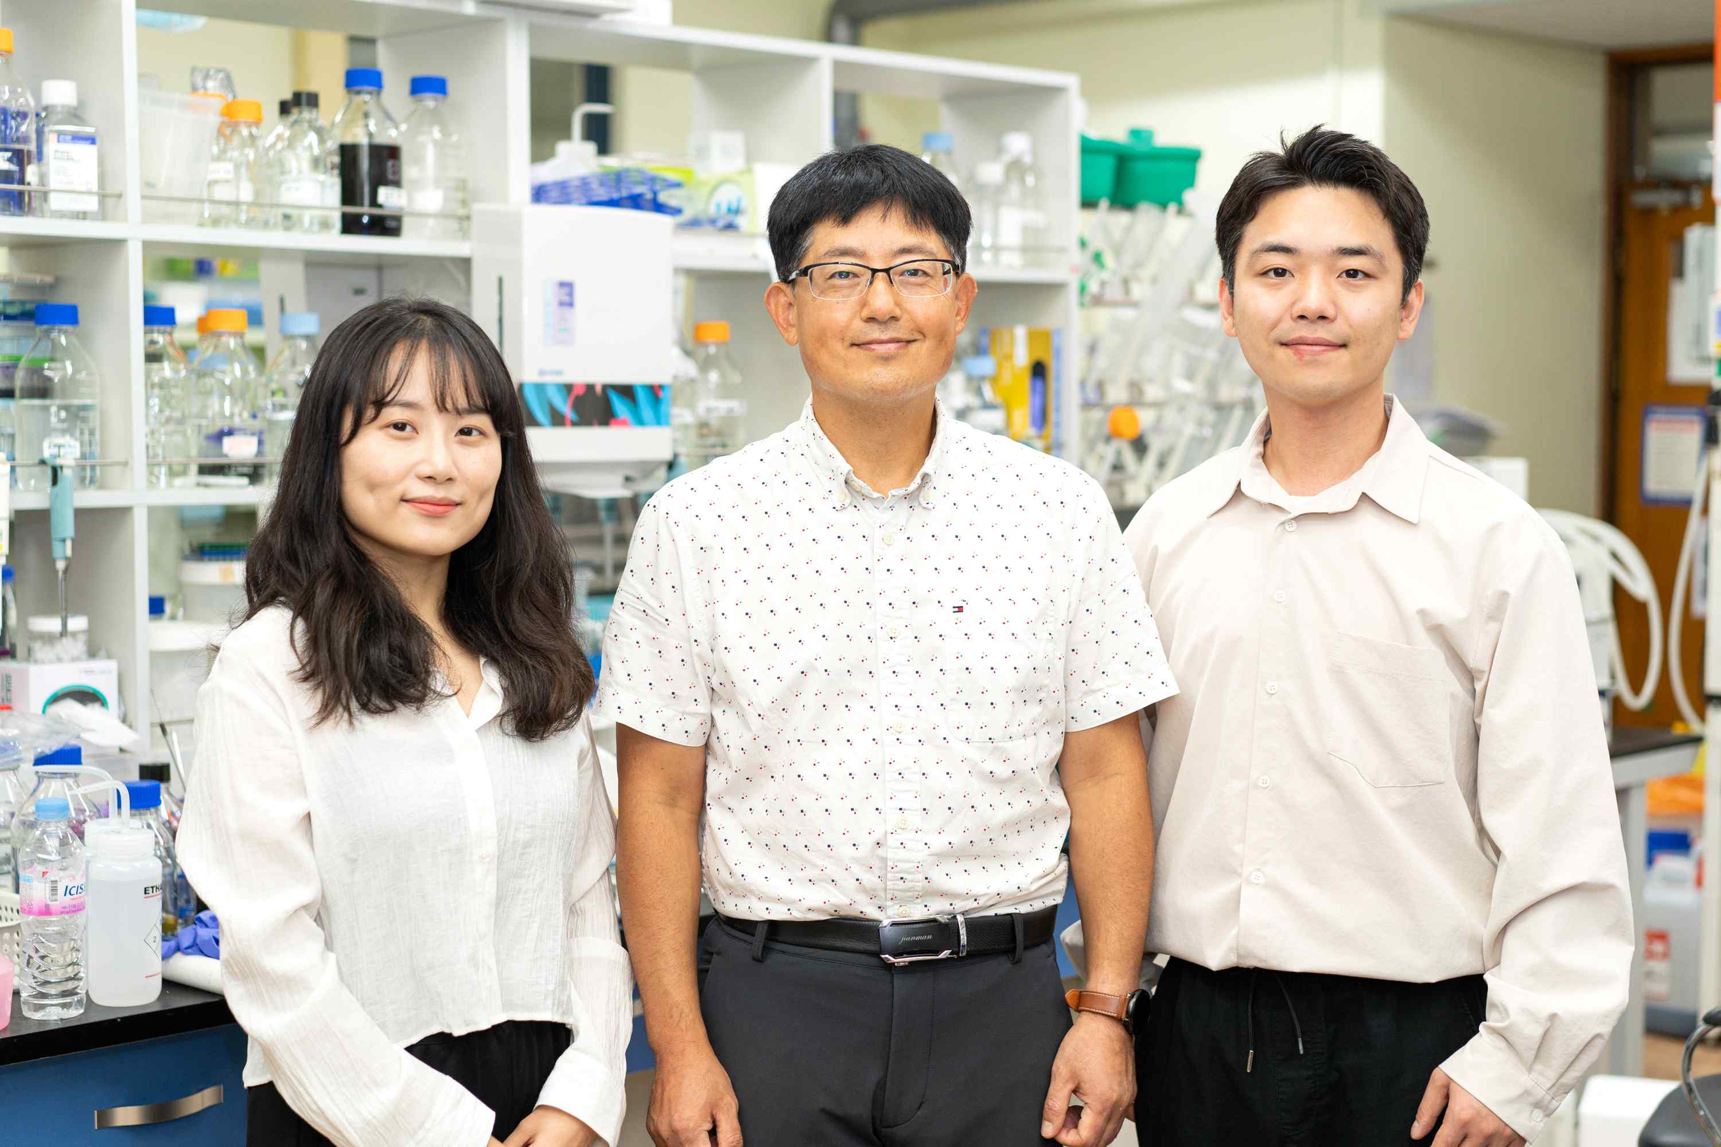
▲ (From left) Master's student Na Hyun Kwon, Professor Inchan Kwon, and Ph.D. studetn Jae Hun Lee

A research team at GIST (Gwangju Institute of Science and Technology, President Kiseon Kim) developed an antibody fragment-based anticancer drug platform that can stay in the body 100 times longer than before by using artificial intelligence (AI) to increase the efficacy.

By combining this antibody fragment with useful substances such as therapeutic agents and using it as an 'anticancer drug platform', this is expected to be widely used as a multifunctional drug with improved efficacy.

Antibodies are proteins produced by the immune system to selectively bind to foreign substances such as pathogenic bacteria or viruses when they enter the body and remove them.

An antibody fragment, a part of an antibody, is a protein composed only of a portion that binds to an external substance in an antibody. It has the advantage of being able to easily penetrate into a lump-type cancer because of its smaller size than an antibody, and it is emerging as a new anticancer drug because of its few side effects. However, it has a disadvantage that it is quickly removed from the body due to its small size, and, since such short duration in the body reduces the anticancer effect, research to increase the persistence in the body is needed to develop antibody fragments as therapeutic agents.

Professor Kwon In-chan's research team in the Department of Materials Science and Engineering has developed a new type of 'antibody fragment anticancer drug platform' by inserting a protein that extends the persistence in the body into the connection site of the two chains inside the antibody fragment.

School of Materials Science and Engineering Professor Inchan Kwon's research team has developed a new type of 'antibody fragment anticancer drug platform' by inserting a protein that extends the persistence in the body into the connection site of the two chains inside the antibody fragment.

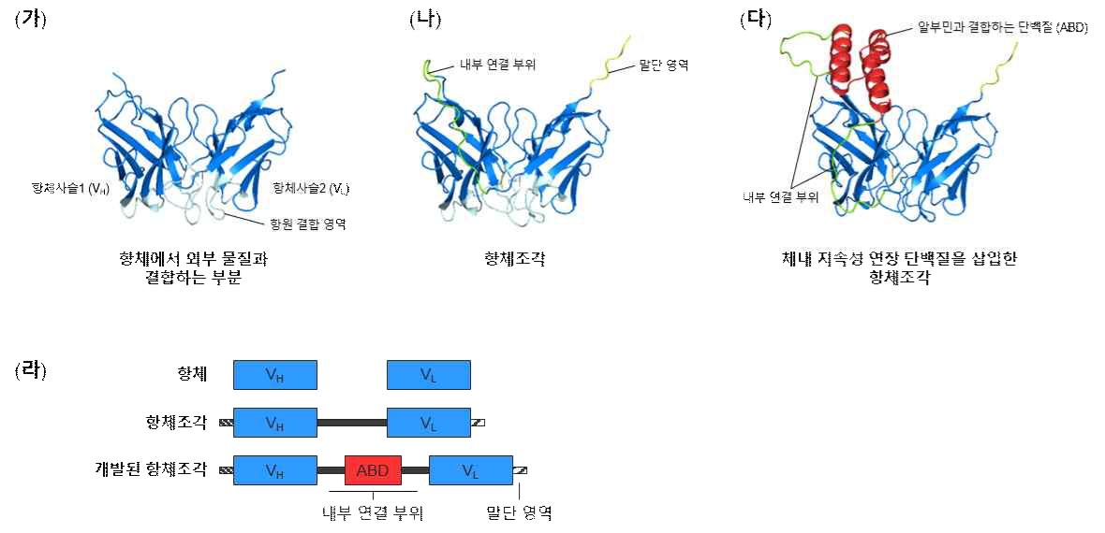
▲ Model structure of (A) part of antibody, (B) existing antibody fragment, (C) developed antibody fragment predicted by AlphaFold 2, and (D) structural schematic diagram of each protein. In the developed antibody fragment, a protein that can extend its persistence in the body is inserted into the internal linkage region. According to structural analysis of the model, a significant part of the protein structure was maintained even after insertion.

Previous studies have linked albumin*-binding proteins to the terminal regions of antibody fragments to increase persistence in the body. The research team designed a structure that inserts it into the connection site inside the antibody fragment, which has not been attempted before.

* albumin: A protein with high persistence in the body, and it is present in large amounts in the blood.

The research team used 'AlphaFold2'*, an artificial intelligence-based protein structure prediction program developed by Google's subsidiary 'DeepMind', to confirm that the structure of the antibody fragment is maintained even when the protein is introduced to improve its persistence in the body. The developed antibody fragment was confirmed to last for 34 hours (18 minutes for the existing antibody fragment), while maintaining the function of the antibody and increasing the persistence in the body by about 114 times.

* AlphaFold2: Artificial intelligence for protein structure prediction developed by Google’s subsidiary ‘DeepMind’. It is a method of predicting the structure from a new amino acid sequence based on learning the accumulated protein structure data and amino acid sequence. It succeeded in accurately predicting the three-dimensional structure of more than 365,000 proteins, including predicting 98.5% of human proteins.

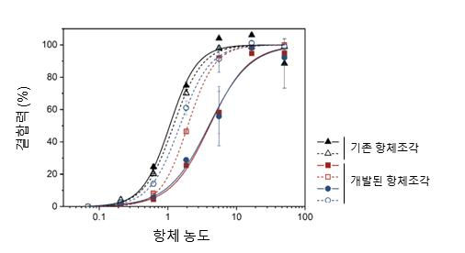
▲ The binding ability of the existing antibody fragment and the developed antibody fragment to cancer cells. There was little difference in the antigen-binding ability of the two antibody fragments, confirming that the developed antibody fragment maintained its original function.

Professor Inchan Kwon said, "The antibody fragment developed in this study is an anticancer drug platform that can be expanded into a multifunctional drug by binding other useful substances to the terminal region. This is expected to be developed into antibody-drug conjugates or double antibodies by combining substances such as therapeutic peptides, cytokines, and antibodies."

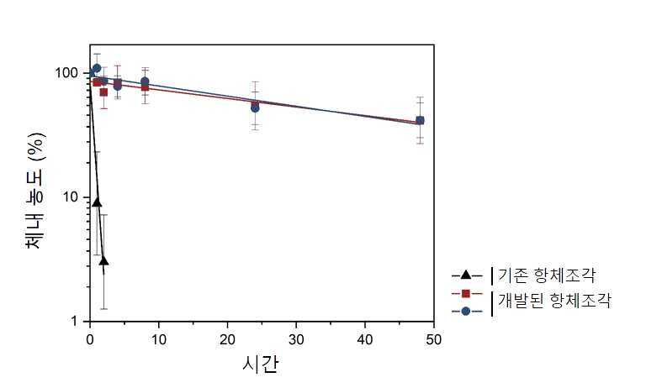
▲ Persistence of existing antibody fragments and developed antibody fragments in the body. The developed antibody fragment showed 114-fold increased persistence in the body compared to the existing antibody fragment.

This research was carried out with support from the National Research Foundation (NRF) senior researcher support project and the GIST Research Institute (GRI) climate change project. It was published online on August 24, 2022, in Pharmaceutics, an international scientific journal in the field of pharmaceuticals.



