“More shift work requires vitamin D to improve sleep disorders”

- Clinical research on vitamin D-calcium-sleep disorder for hospital shift and non-shift workers

- Two papers related to vitamin D by Professor Tae Kim's team... "Sleep disorder and dementia can be improved simultaneously with vitamin D intake"


▲ (From left) Ph.D. student Seungyeong Yu, Ph.D. student Jiseung Kang, and Professor Tae Kim

GIST (Gwangju Institute of Science and Technology, President Kiseon Kim) researchers published a series of research results in international journals that show vitamin D is effective in improving sleep disorders (Study 1) and in preventing dementia (Study 2).

In particular, the research team conducted a clinical study (Study 1) targeting shift-shift workers in a university hospital and discovered the relationship between between vitamin D and calcium in relation to improving sleep disorders.

Vitamin D is a fat-soluble hormone that is synthesized in the body when the skin is exposed to the sun's ultraviolet rays. It regulates calcium and phosphorus metabolism and is known to be involved in the expression of various genes as a transcription factor* and epigenetic regulation.

* Transcription factor: A transcriptional regulatory protein that specifically binds to the DNA of the transcriptional regulatory region of a specific gene and activates or represses the transcription of that gene. Regulates gene transcription by controlling the activity of RNA polymerase.

Studies have shown that insufficient vitamin D in the body increases the risk of cancer, autoimmune disease, and cardiovascular disease, and recent studies on the association with the central nervous system such as sleep disorders have been increasing.

(Study 1) The research team led by GIST Department of Biomedical Science and Engineering Professor Tae Kim of conducted a collaborative clinical study with Seoul National University Bundang Hospital to study vitamin D deficiency and sleep problems for shift-workers and found that vitamin D can affect sleep and circadian rhythms* by controlling blood calcium levels.

* circadian rhythms: The human body follows the circadian rhythm, which regulates various daily cycles, such as the sleep-wake rhythm, body temperature, and hormones. If the circadian rhythm is set to fall asleep later and wake up later than others due to irregular lifestyle, 'sleep phase delay syndrome' appears, in which people complain of fatigue because they cannot fall asleep on time.

The research team measured the vitamin D and calcium concentrations of 353 workers (150 shifts, 203 non-university) working at Seoul National University Bundang Hospital. The sleep pattern data were analyzed using wrist watch-type actigraphy.

As a result of the study, the lower the vitamin D level, the lower the blood calcium concentration in both the shift and non-shift group. In particular, it was found that shift-workers with low vitamin D and calcium levels had more severe sleep disorders than those of the non-shift workers. For shift-workers with low calcium levels, both the 'time from bed to actual sleep (sleep latency)' and 'time from actual sleep to waking up (total sleep time)' were found to be longer.

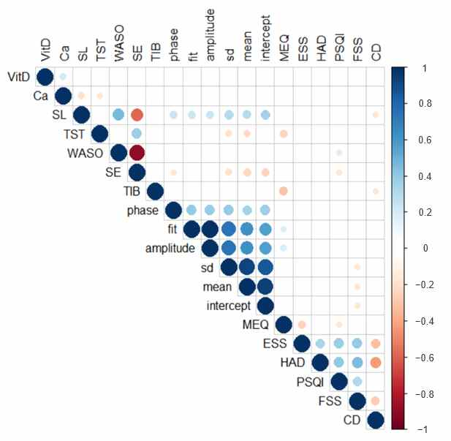
▲ Correlation analysis between shift workers' blood vitamin D and calcium levels and sleep indicators: As a result of statistical analysis of correlations between data obtained from 150 shift workers, only the relationships with P-value < 0.05 were circled (O, circle), blue color has a positive correlation, and red color has a negative correlation. For example, the light blue circle seen between the vitamin D and calcium levels means "people with low vitamin D levels in shift workers also have low calcium levels," and on the contrary, the light blue circles seen between calcium and TST (Total Sleep Time) The light red circle means "people with lower calcium levels in shift workers have higher total sleep time."

Although there was no difference in sleep time according to blood calcium concentration in the group of non-shift workers, the non-shift workers may be affected by abnormalities in their daily life due to abnormalities in the 'circadian rhythm,' in which they go to bed late and wake up late rather than having a 'sleep disorder.'

In other words, when the calcium concentration is low, the circadian rhythm is delayed, which leads to frequent drowsiness and decreased activity during the day.

Through the clinical analysis, the lower the vitamin D level, the lower the blood calcium concentration in both the shift and the non-shift workers group. It was confirmed that, even if the blood calcium concentration was within the normal range, the lower the level, the lower the sleep efficiency and the delayed circadian rhythm could affect daily life. Therefore, it can be said that the adequate intake of vitamin D is important to improve the quality of sleep.

(Study 2) In addition, the research team found that vitamin D deficiency increases the level of amyloid beta* in brain tissue, which is one of the causes of Alzheimer's disease, through pathological changes in the expression of various genes and causes memory deterioration and confirmed that vitamin D supplementation can reduce neurodegenerative changes.

* amyloid beta: Amyloid beta is a polypeptide found in the brain of Alzheimer's patients and is known as one of the causative agents of Alzheimer's disease.

Alzheimer's disease, which causes dementia, is a brain disease that shows neurodegeneration and cognitive decline due to the accumulation of amyloid beta plaques and tau protein, and the degree of expression of this enzyme is important because enzymes in the brain are involved to produce or remove amyloid beta.

The research team conducted a vitamin D deficiency test and supplementation test on an animal (mouse) model of Alzheimer's disease. In the deficient group, the transcription of amyloid beta production-related enzymes is increased. As a result, it was confirmed that amyloid beta increased and memory decreased, while vitamin D supplementation decreased amyloid beta and improved memory.

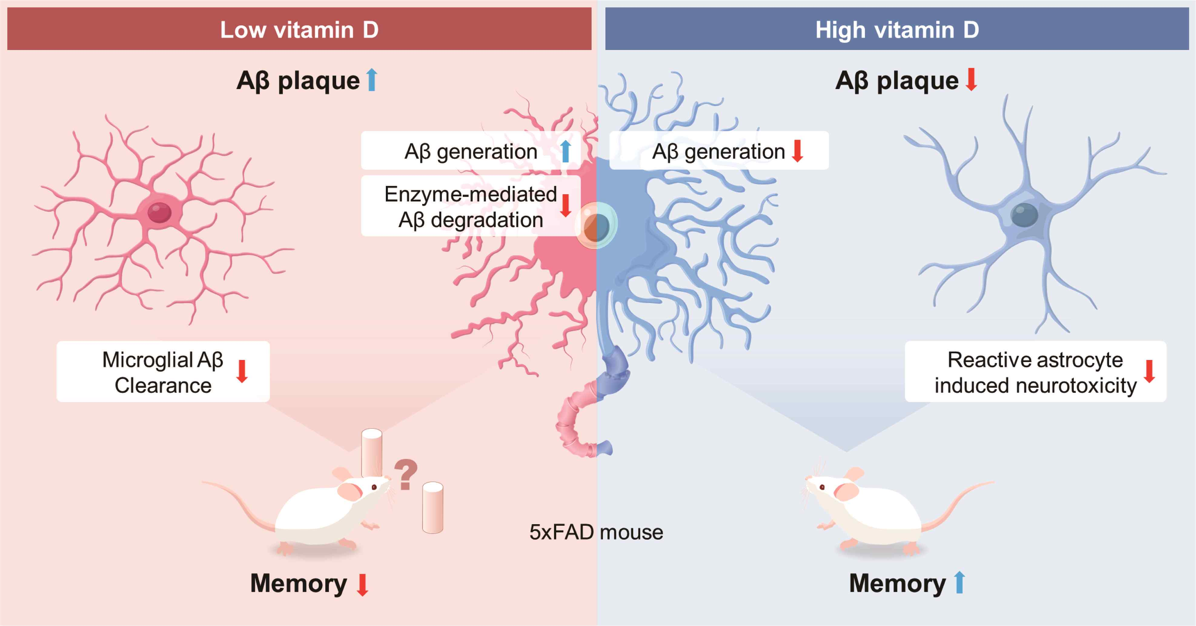
▲ Association between vitamin D and Alzheimer's disease: A low vitamin D concentration induced an increase in amyloid beta and memory deterioration, whereas a decrease in amyloid beta and improvement in memory were confirmed in the group supplemented with vitamin D.

Professor Tae Kim said, "Vitamin D deficiency is a factor that can exacerbate sleep disorders or Alzheimer's dementia, and its therapeutic potential has been discovered through clinical trials and mouse trials. Vitamin D can be an easy and safe way to achieve the effect of two birds with one stone to treat both sleep disorders and dementia that threaten the health of modern people."

The research conducted by GIST Professor Tae Kim's team was supported by the Ministry of Science and ICT and the GRI (GIST Research Institute) Life Science Convergence Research Institute. (Study 1) The research related to sleep disorders was published online on July 22, 2022, in Nutrients, an international academic journal in the field of nutrition. (Study 2) The dementia-related research was published online on July 28, 2022, in Biomedicines, an international academic journal in the field of biomedical science.



