Long-term prediction of fine dust on the Korean Peninsula using climate variables!

- Utilization of correlation between climatic factors and fine dust in the equator and arctic regions, and establishment of a foundation for seasonal forecasting of fine dust
- GIST Professor Jin-Ho Yoon's team, Chonnam National University, Seoul National University, National Institute of Environmental Research, etc. published in renowned journals in the atmospheric field


▲ GIST Professor Jin-Ho Yoon

GIST (Gwangju Institute of Science and Technology) School of Earth Sciences and Environmental Engineering Professor Jin-Ho Yoon and Korean researchers such as the National Institute of Environmental Research developed a seasonal prediction (long-term forecast) technique that can predict the concentration of fine dust on the Korean Peninsula several months in advance by using the correlation between meteorological and climatic factors.

By applying this technique, it is possible to forecast the fine dust concentration for 2 to 3 months after that instead of the fine dust concentration for 4 to 5 days from the time of prediction. (Ex. From November to December 2022, the forecast for winter fine dust concentration from December 2022 to March 2022 can be announced).

Currently, the prediction of fine dust concentration in Korea is usually focused on forecasting 1-2 days later. The forecast information produced by the weather forecast model is used together with the air quality forecast model (atmospheric chemistry model) to produce forecast information for up to 5 days.

Although the government is implementing more aggressive policies to reduce emissions, the cause of fine dust, despite the introduction of a seasonal fine dust management system*, still exists. In particular, there is a demand to accurately predict the concentration of fine dust several months in advance in various fields, but it has been difficult due to technical limitations.

* seasonal fine dust management system: A system that implements a stronger-than-usual fine dust reduction and management policy from December, when the concentration of fine dust is high, to March of the following year (refer to https://www.cleanair.go.kr/)

The research team proposed a new seasonal forecasting technique as a statistical-mechanical technique using the correlation between climate variables and fine dust concentration, and climate variables produced by climate and season prediction models.

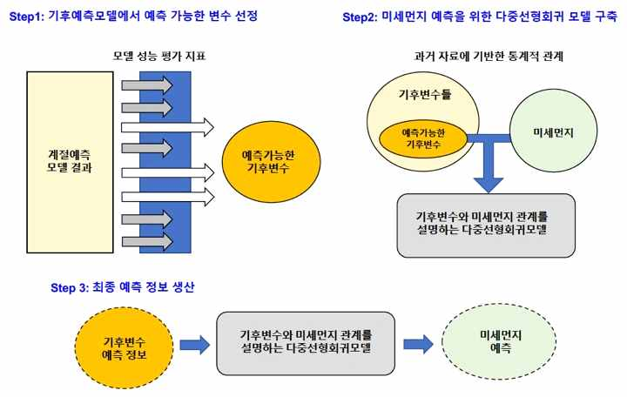
▲ Fine dust season prediction system: schematic diagram explaining the final process of predicting the concentration of fine dust after considering the performance of the climate prediction model (first process) and the relationship between climate variables and fine dust (second process)

Although multiple linear regression models are usually used in climate prediction, this research aims to improve predictability and improve stability of techniques that are difficult to obtain when using only statistical techniques by analyzing climate prediction information* with statistical models.

* climate prediction information: The climate prediction model produces climate forecast information from one month to a maximum of one year. Based on this, the Korea Meteorological Administration is currently announcing the winter forecast for November. It provides forecasts and various information on the average winter temperature and average precipitation.

Various climatic factors* such as latitude, sea level, topography, and ocean currents in the equator and arctic regions are representative climate predictors that are important for the climate of the Korean Peninsula. The research team selected the factors that can maximize the prediction performance and stability of the climate prediction model among various climate factors according to the prediction goal and the historical prediction performance of the climate prediction model and used it in the seasonal forecast.

* Climate factors: Factors that cause regional differences in the distribution of climate on Earth. Geographical climatic factors such as latitude, elevation, vegetation cover, continental distribution, topography, and ocean currents, and dynamic climatic factors such as atmospheric circulation, air masses, and front lines belong to this category. Typical examples are sea surface temperature in the equatorial Pacific, known as El Niño/La Niña, and sea ice in the Arctic.

The research team verified the model's performance by repeatedly applying the winter weather forecast information for the past 20 years to this prediction model. When the result is confirmed as a correlation coefficient, it shows about 0.7, confirming that it is a fairly good result.

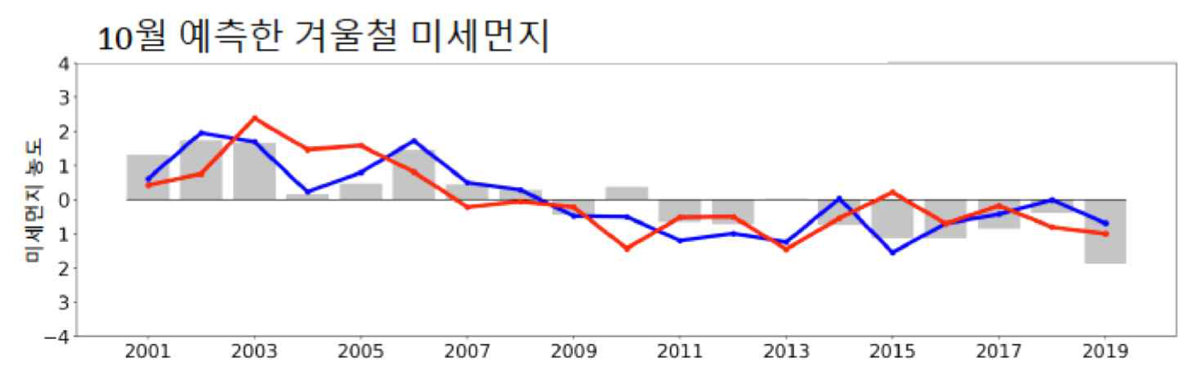
▲ Graph showing the prediction performance of the winter fine dust concentration forecast in October every year from 2001 to 2019
- (gray_bar graph) Actual observed fine dust
- (blue_line graph) Fine dust assuming perfect climate prediction, fine dust that considers the change in the concentration of fine dust due to climate variability and the continuous reduction of fine dust as a linear trend line
- (red_line graph) The concentration of fine dust predicted by the technique developed by the research team.
- The correlation coefficient between the research team's prediction method (red) and the fine dust concentration (blue) calculated by the climate variability and linear trend line is 0.7.

Professor Jin-Ho Yoon said, "This is a new technique that enables seasonal prediction of fine dust and, through continuous collaboration with academia and the National Institute of Environmental Research, has laid the foundation for the world's first fine dust season prediction. In the future, we will continue to improve the prediction accuracy through continuous supplementation so that it can be helpful to people's lives."

This research was conducted by School of Earth Sciences and Environmental Engineering Professor Jin-Ho Yoon, Chonnam National University Professor Ji-Yoon Jeong, and Seoul National University Professor Sang-Woo Kim along with researchers from the National Institute of Environmental Research with support from the National Institute of Environment Research and Korea Environment Industry & Technology Institute and published online on August 1, 2022, in Science of the Total Environment, an international renowned academic journal in the field of atmospheric environment.



