My eyes are dry and stiff, maybe dry eye syndrome?
Quantifying the loss of the eyelid meibomian glands with artificial intelligence!

- Successful verification of accuracy by comparing the patient's meibomian gland photo with the clinical diagnosis result after deep learning model
- GIST-Catholic Medical University joint research... Published in the latest issue of Ocular Surface, a prestigious journal in ophthalmology


▲ (From left) GIST Professor Euiheon Chung, Catholic University of Korea Professor Ho Sik Hwang, and Arizona State University doctoral student Ripon Kumar Saha

In the diagnosis of dry eye syndrome, one of the most common diseases in modern society, a method has been developed that can quantitatively analyze the loss of the eyelid meibomian gland with artificial intelligence.

GIST (Gwangju Institute of Science and Technology) Department of Biomedical Science and Engineering Euiheon Chung's team and Catholic University of Korea Department of Ophthalmology Professor Hwang Ho-Sik (Yeouido St. Mary's Hospital) developed a technology that uses artificial intelligence (AI) to automatically quantify images of meibomian glands (creating an oil layer) taken with infrared light.

The research team made all the data and analysis of this study available online so that researchers in related fields could try new artificial intelligence technologies and verify the results. (link: https://mgd1k.github.io/)

Dry eye syndrome is largely divided into dehydration-type dry eye syndrome, in which tears are not produced well, and over-evaporation-type dry eye syndrome due to insufficient oil layer formation. The excessive evaporation of tears is one of the most important causes of dry eye syndrome.

The meibomian gland is located on the eyelid and is the organ responsible for the formation of the oil film of the tear layer. Hyperevaporative dry eye syndrome is most often caused by the loss or deterioration of the meibomian gland. (☞ Refer to [Figure 1])

Therefore, imaging the meibomian gland to determine the degree of loss is important for accurate diagnosis and appropriate treatment of dry eye syndrome. However, there is a limitation in that the accuracy and reproducibility are low as clinicians subjectively interpret the patient's meiboscore as 0, 1, 2, or 3 points.

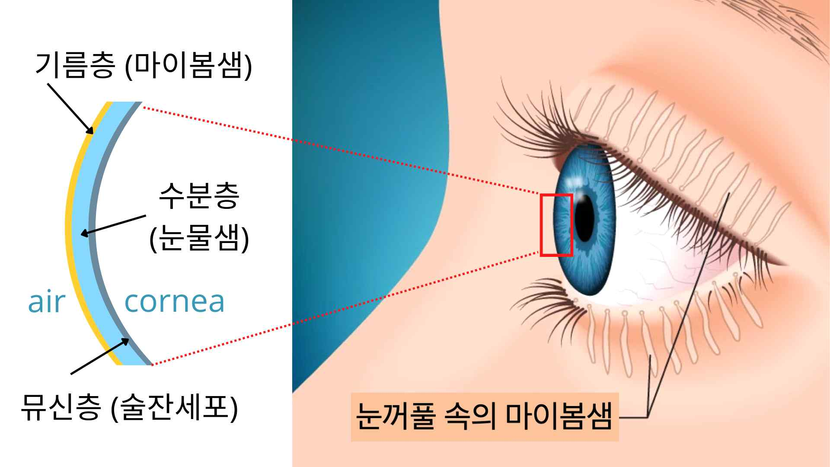
[Figure 1] Description of the meibomian gland and tear layer in the eyelid: The tear film is largely composed of a mucin layer, an aqueous layer, and a lipid layer. The most common is evaporative dry eye syndrome. This occurs because the meibomian gland in the eyelid creates an oil layer to prevent the moisture in the tear film from evaporating into the air, but this function is reduced or the meibomian gland is lost.

The research team drew faster and more accurate readings than a doctor's diagnosis by using photos of the meibomian glands of patients taken in real hospitals and a newly developed deep learning model.

First, the research team marked the eyelid area and meibomian gland area on 1000 photos of meibomian glands taken at St. Mary's Hospital in Yeouido, and then two dry eye specialists scored the loss of meibomian glands. Of these, 800 randomly selected sheets were trained by the deep learning model developed by GIST. (☞ Refer to [Figure 2]) As a result of reading the remaining 200 meibomian gland images, it showed more consistent and accurate results than those of clinicians.

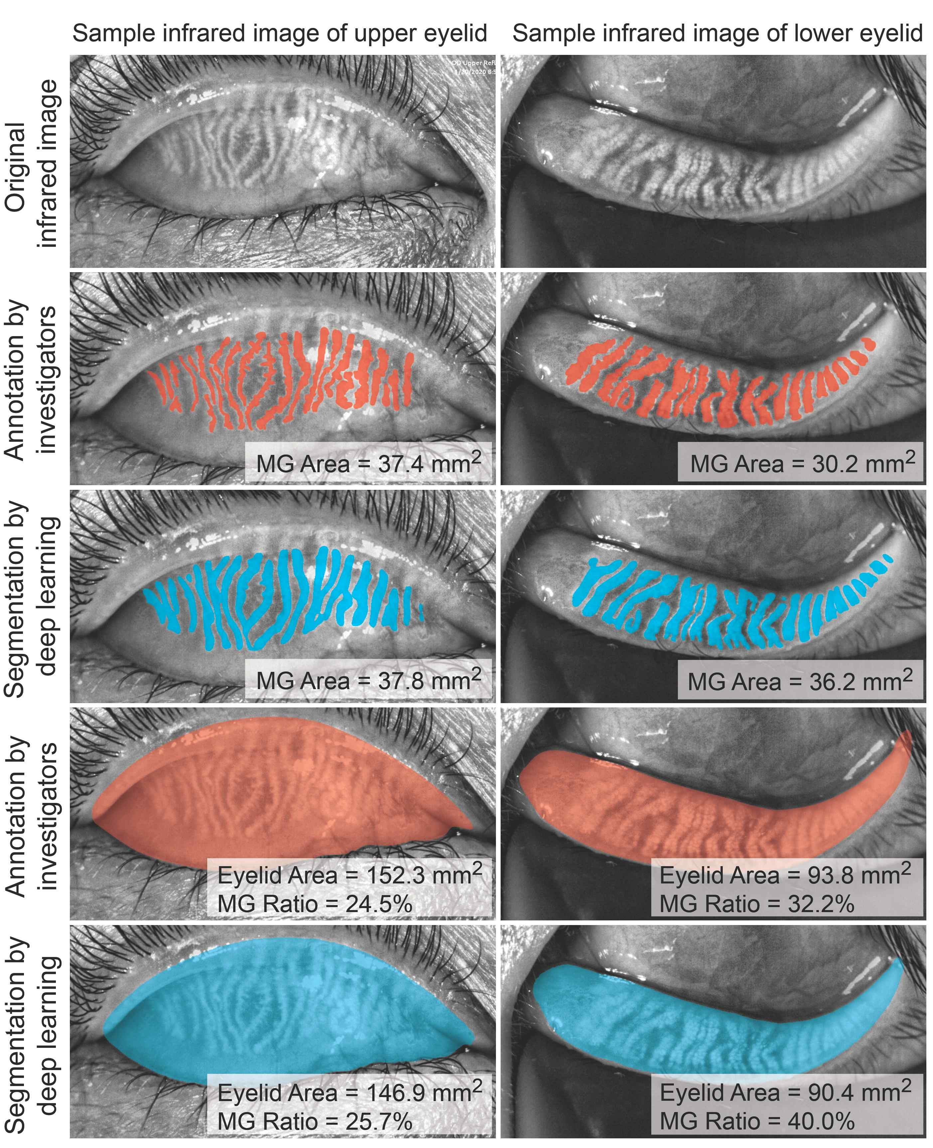
[Figure 2] Comparison of deep learning and researcher's eyelid meibomian gland area marking: Deep learning (blue) and clinician (red) mark the meibomian gland area and eyelid area of the upper eyelid (left) and lower eyelid (right). It shows that the deep learning results are consistent with expert analysis.

When the deep learning model trained in this way was applied to 600 meibomian images taken at Korea University Ansan Hospital, it was confirmed that artificial intelligence still derives faster and more accurate reading results than clinical experts.

Therefore, this study showed that meibomian gland loss can be accurately and objectively measured using a deep learning model that reads meibomian gland images with artificial intelligence. (☞ Refer to [Figure 3])

[Figure 3] Meibomian gland image analysis deep learning model: Meibomian gland (MG) image is input and the segmentation structure of the meibomian gland and the eyelid region and the meiboscore are calculated so that the meiboscore is output. It consists of three learning models including a classification structure for prediction.

GIST Professor Euiheon Chung said, "Using a deep learning model that reads the cause of meibomian gland dysfunction, which is the main cause of dry eye syndrome, with artificial intelligence, it is now possible to quickly, accurately and objectively quantify it. Prospective research to evaluate the efficacy in actual clinical practice and joint research with the goal of commercialization as a cutting-edge medical device are in progress."

Yeouido St. Mary's Hospital Professor Ho Sik Hwang said, "Since this study created a deep learning model using data from commercial equipment that takes pictures of meibomian glands, it can be easily applied to medical devices in the medical field and applied to the diagnosis and treatment of dry eye syndrome."

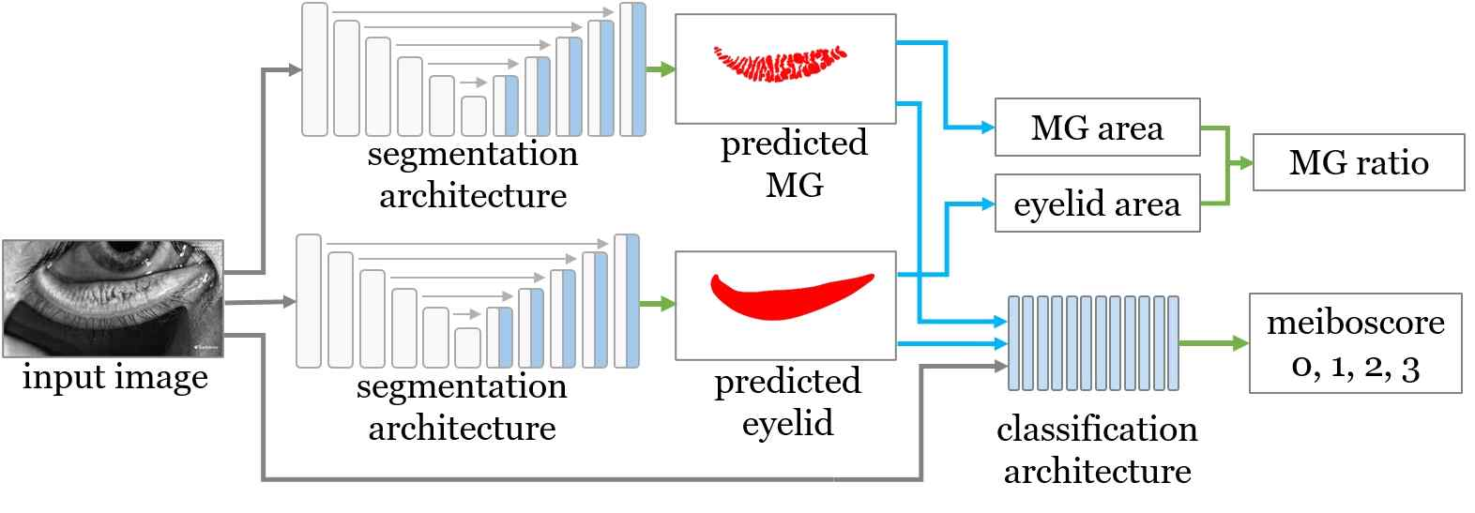
[Figure 4] Schematic diagram of artificial intelligence-based eyelid meibomian gland original and analysis data published online: The original image of the meibomian gland used in the study and various analysis data were published online, and related researchers tried new artificial intelligence technology and the results provided for verification (link: https://mgd1k.github.io/)

This research was led by GIST Professor Euiheon Chung (corresponding author) and Professor Catholic University of Korea Professor Ho Sik Hwang (corresponding author) with support from GIST GRI (Researcher at GIST) and the Health Industry Promotion Agency and was published online in the renowned international academic journal Ocular Surface in the field of ophthalmology.



