Development of real-time analysis algorithm for blood flow rate for cardiovascular disease prevention and management

- Faster calculation speed than before, low-cost system can be applied...“Blood flow analysis with low cost and high efficiency in clinical application”
- Professor Jae Gwan Kim's joint research team Published a paper in Computer Methods and Programs in Biomedicine


▲ (From left) GIST Professor Jae Gwan Kim, DGIST Professor Kijoon Lee, Nantong University in China Professor Myeongsu Seong, and GIST Ph.D. student Yoonho Oh

Researchers in Korea, including GIST (Gwangju Institute of Science and Technology), have developed an algorithm that can measure and analyze blood flow rates in real time more than 400 times faster than before to prevent and manage cardiovascular diseases such as stroke and myocardial infarction.

When the newly developed algorithm is applied to the clinical practice of cardiovascular disease*, it is expected to contribute to low-cost and high-efficiency analysis and treatment of changes in blood flow.

* cardiocerebrovascular disease: Any disease that occurs in the heart, brain and vascular system. It is known to include angina pectoris, ischemic heart disease such as myocardial infarction, cerebrovascular disease such as stroke, hypertension, heart failure, and peripheral vascular disease.

For the actual prevention and management of cardiovascular disease, it is necessary to continuously measure the blood flow of the patient. ‘Diffuse Correlation Spectroscopy*’ is one of the methods that can measure changes in blood flow rate in tissues without skin incision or damage. Compared with other measuring instruments, it is possible to measure label-free and the cost of the system is relatively low and has the advantage of having a high temporal resolution that can obtain more data within the same measurement time.

* Diffuse Correlation Spectroscopy (DCS): A system that measures changes in blood flow velocity in tissues by irradiating a near-infrared laser light source onto living tissues. By irradiating the tissue with a laser and measuring and comparing the degree of dynamic light scattering due to changes in blood flow, changes in blood flow in living tissues can be checked, and label-free measurement is possible without labels such as fluorescent substances.

However, since the existing blood flow measurement and analysis using diffusion correlation spectroscopy obtains blood flow information by comparing the measured signal with a physical model (data fitting), real-time analysis and observation are difficult. Since a considerable amount of memory is required for analysis, it was difficult to develop a diffusion correlation spectroscopy method using a low-cost processor with a small available memory capacity.

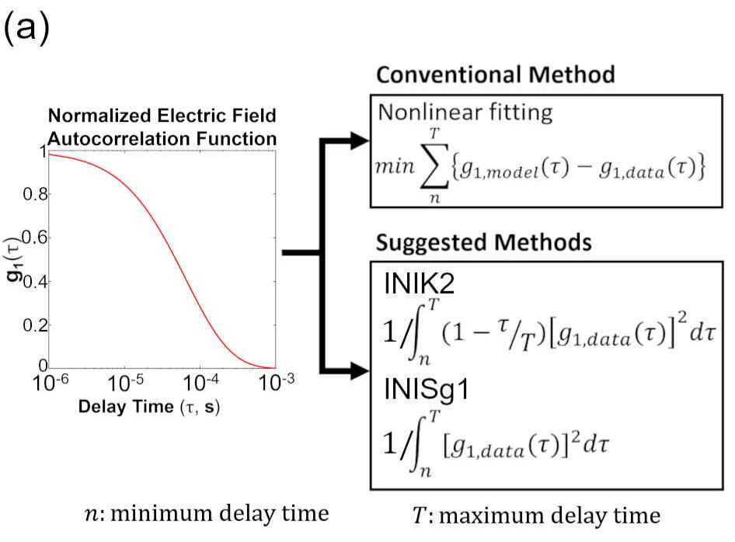
▲ The existing analysis algorithm for diffusion correlation spectroscopy (top) and the newly proposed algorithm (bottom). Whereas existing analysis algorithms involve data fitting between the autocorrelation function (g1,data) of the measured signal and the autocorrelation function based on the physical model of the tissue (g1,model). It can be seen that the newly presented algorithms directly use the autocorrelation function of the measurement signal for calculation.

The team of GIST Department of Biomedical Science and Engineering Professor Jae Gwan Kim, DGIST Professor Kijoon Lee, Nantong University in China Professor Myeongsu Seong, and GIST Ph.D. student Yoonho Oh confirmed that the time and process required for blood flow analysis can be dramatically reduced through a new algorithm based on numerical integration.

The numerical integration-based algorithm measures the blood flow change by directly applying the measured signal to the numerical integration-based equation. Therefore, the process of comparing the measured signal with the physical model is omitted, enabling quick calculation and application to a low-cost system with a low-capacity RAM.

To confirm the superiority of the developed algorithm, the research team first evaluated the effectiveness of the developed algorithm through simulation and compared the blood flow change measurement results for each algorithm of the phantom simulating living tissue and arm cuff occlusion control experiment*. Also, the applicability of the algorithm in low-cost systems was confirmed.

* arm cuff occlusion test: An experiment to occlude blood vessels with a pressure of 220 mmHg on the upper arm using a blood pressure monitor. Blood flow velocity is controlled depending on whether or not blood vessel occlusion occurs.

As a result, the research team's algorithm (average time required: 12.02 microseconds) was 400 times faster than the existing algorithm (average time required: 4960 microseconds).

In addition, the existing algorithm cannot be applied to microcomputer-based low-cost systems such as Arduino because it requires a large amount of RAM, whereas the research team's algorithm uses only 400 bytes of RAM per data, so it can be applied to low-cost systems It has been confirmed that a short computation time of up to 606 microseconds is required.

GIST Professor Jae Gwan Kim said, "It is common to obtain blood flow information by comparing the correlation function measured in the diffusion correlation spectroscopy system with the physical model. In this study, we proved that blood flow information can be obtained through the numerical integration of the correlation function, thereby reducing the computation time and overall system cost of diffusion correlation spectroscopy."

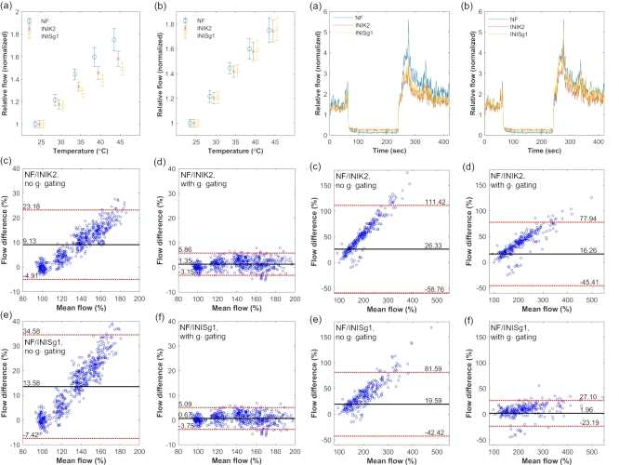
▲ Comparison graph of the results of the analysis of the existing algorithm (light blue) and the results of the new algorithm (orange, yellow) of blood flow measured in real living tissue (left: phantom test result, right: living tissue test result). Among the newly proposed algorithms, it can be seen that 'INISg1' is significantly different from the existing results.

DGIST Professor Kijoon Lee said, "The newly developed algorithm is expected to be helpful in measuring blood flow changes in the clinical field of cardiovascular disease in the future. If research continues based on this achievement, it will be possible to commercialize the development of low-cost, compact blood flow measurement equipment."

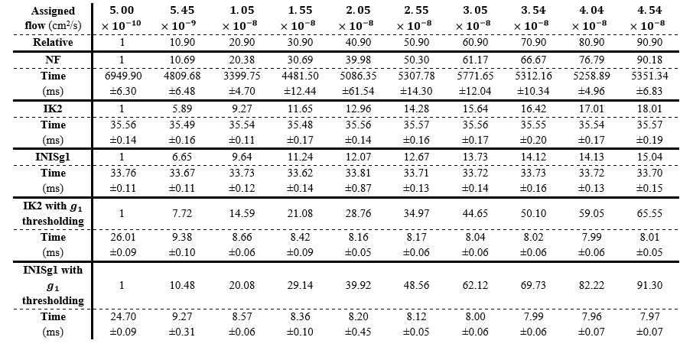
▲ It can be seen that the computation time of the newly proposed algorithm is significantly less than that of the existing algorithm.

This research was led by GIST Professor Jae Gwan Kim and DGIST Professor Kijoon Lee and conducted by Nantong University in China Professor Myeongsu Seong and GIST Ph.D. student Yoonho Oh (co-first author) with support from GIST, DIGIST, Nantong University in China, the Information and Communication Industry Promotion Agency, and the Health Industry Promotion Agency and was published online in Computer Methods and Programs in Biomedicine, an authoritative journal in the field of computer science theory and methods (top 11% in computer science theory and methods, impact factor 7.027).



