10% improvement in organic solar cell efficiency at room temperature without heat treatment

- Addition of ion catalyst to metal oxide ink... 10% photoelectric conversion efficiency, 20 times electrical conductivity, etc. performance improvement
- “Contribute to simplifying the manufacturing process and securing stability”... Advanced Functional Materials paper published


▲ From left, GIST Professor Kwanghee Lee, Dongguk University Professor Sooncheol Kwon, and GIST integrated student Taeyoon Ki

GIST (Gwangju Institute of Science and Technology) and Dongguk University's joint research team have developed a process that improves the electrical conductivity of next-generation organic solar cells* by more than 20 times by simply adding an anion catalyst without a high-temperature post process.

This achievement is expected to contribute to advancing the commercialization of organic solar cells by increasing the efficiency of converting light into electrical energy (photoelectric conversion efficiency) and simplifying and stabilizing the manufacturing process.

* organic photovoltaics (OPV): A next-generation solar cell using an organic semiconductor as a photoactive layer.

Molybdenum oxide (MoO3)*, which is used as an essential material for organic solar cells, is a compound in which an oxygen atom is bonded to a molybdenum metal atom, and it is a transparent electrically conductive thin film.

The organic sol gel synthesis method using an organic/inorganic hybrid chemical material in which molybdenum is combined with a functional organic material is a process of forming a metal oxide thin film through ink, and can replace the existing vacuum thermal deposition process. However, to derive high electrical performance from this thin film, the process of forming a network of only metal oxides is essential. This process required a high-temperature post-process of 200°C or higher, and there was a problem in its practicality.

GIST Professor Kwanghee Lee's team (School of Materials Science and Engineering) and Dongguk University Professor Sooncheol Kwon's team (Department of Energy and Materials Engineering) developed molybdenum oxide with high performance at room temperature by adding anion catalyst to metal oxide ink as a next-generation high-efficiency, long-life organic solar cell that can be mass-produced.

This room temperature process is a technology for making solar cells without heat treatment, and it is a more simplified method than the conventional printing method for manufacturing solar cells, which contributes to increasing the photoelectric conversion efficiency required for commercialization of organic solar cells.

The research team formed a dense metal oxide network by simply applying the ink at room temperature by simply adding a lithium bismide (LiTFSI) anion catalyst to the molybdenum oxide ink. Through this, the transparent electrically conductive thin film showed an improvement in electrical conductivity more than 20 times (from 8.4×10⁻⁴ S m⁻¹ to 1.8×10⁻² S m⁻¹) compared to the previous one.

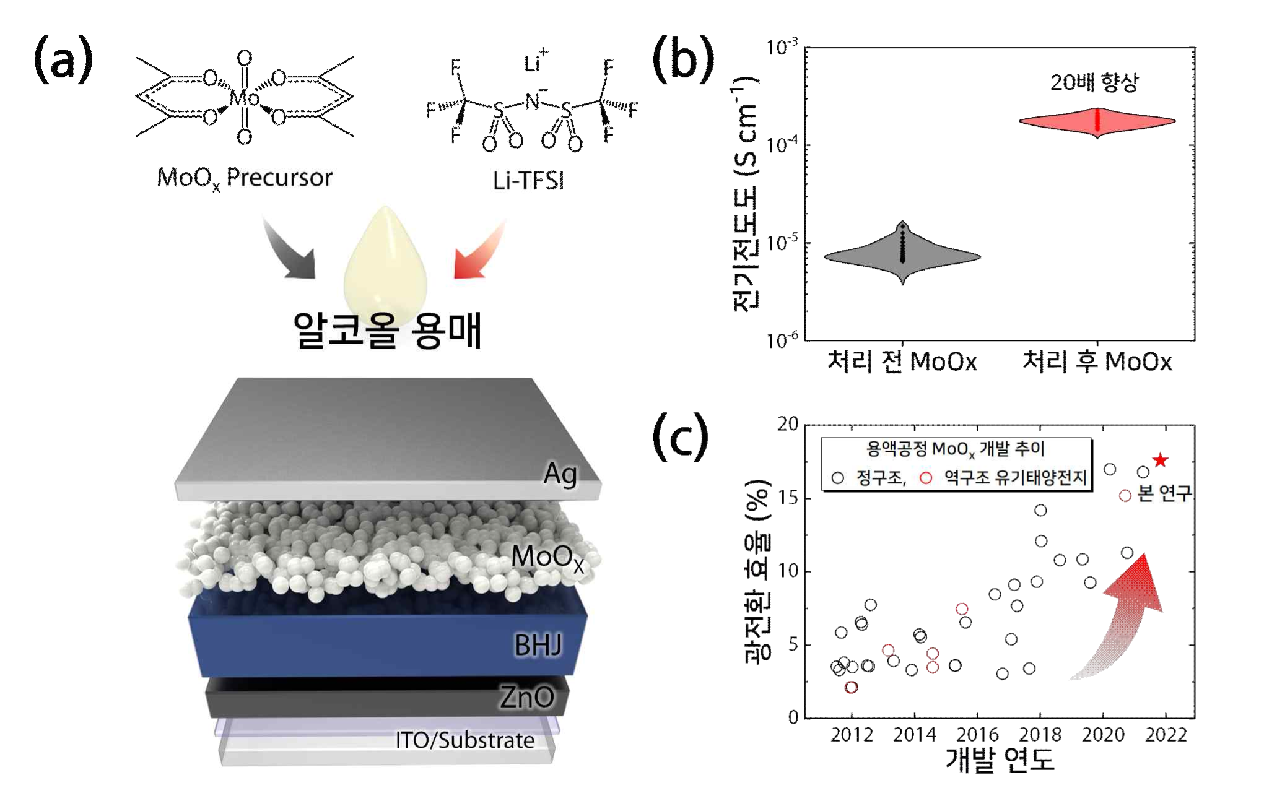
▲ Schematic diagram of the molybdenum oxide ink developed by this research team: Molybdenum oxide forms a functional layer necessary for organic solar cells through anionic catalysis in an alcohol solvent.
(a) Schematic diagram of the molybdenum oxide solution process operating at room temperature (b) Electrical conductivity of molybdenum oxide before and after anion treatment (c) Efficiency trend according to the year of molybdenum oxide in solution process

In this experiment, the research team confirmed the possibility that an anion catalyst with strong electronegativity can induce electron rearrangement in functional organic materials. The mechanism was investigated by experimentally comparing the surface shape and element distribution.

Molybdenum oxide improved the low photoelectric conversion efficiency of the existing organic solar cells by 10% (16.0% → 17.6%) through an anion catalyst method, and the dense network structure prevents the penetration of air and moisture. When exposed to sunlight for 100 hours, it was confirmed that 70% or more of the initial efficiency was maintained compared to 55% of the existing initial efficiency.

Professor Kwanghee Lee said, "This research has the greatest significance in that it developed the world's first metal oxide semiconductor that can be processed at room temperature. This is expected to energize research on mass production of transparent and flexible multifunctional electronic systems in the future."

Professor Sooncheol Kwon said, "Through this study, it was possible to develop a more dense and stable metal oxide network structure. It is expected that it can be used as a core functional layer for solar cells as well as various high-performance optoelectronic devices."

This research was led by GIST School of Materials Science and Engineering Professor Kwanghee Lee (corresponding author) and Dongguk University Department of Energy and Materials Engineering Professor Sooncheol Kwon (co-corresponding author) and conducted by GIST School of Materials Science and Engineering Professor integrated student Taeyoon Ki as first author with support from the National Research Foundation of Korea climate change response technology development project and the middle-level researcher support project and was published online on June 25, 2022 in Advanced Functional Materials, the world's most authoritative journal in the field of materials.



