Single drop of water increased efficiency of large-area organic solar cells

- Development of eco-friendly construction method that introduces small amount of water in organic active solution to realize high efficiency large area organic solar cell
- School of Materials Science and Engineering Professor Dong-Yu Kim published a cover paper for Advanced Functional Materials


▲ (From left) Professor Dong-Yu Kim, Ph.D. student Nara Han

A research team at GIST (Gwangju Institute of Science and Technology) has developed an eco-friendly method that can improve the efficiency and stability of large-area organic solar cells* using a small amount of water.

A technology that can easily control the dispersion state* in the solution during the manufacturing process of organic solar cells, including the printing process is expected to contribute to speeding up the mass production and commercialization of high-efficiency and high-stability large-area organic solar cells.

* organic solar cell: A solar cell manufactured by using an organic semiconductor material in a photoactive layer that absorbs sunlight. A current is produced through the intermediate layer and the electrode by generating an electric charge in the photoactive layer. Compared to inorganic solar cells, the low-temperature solution process is easy, and it is light and flexible and has a relatively transparent film. Recently, high photoelectric efficiency of close to 20% has been reported in small-area organic solar cells, and research for practical use is rapidly progressing.

* dispersion: One substance is suspended in the form of particles in another.

To increase the light conversion efficiency and device stability of the organic solar cell, it is very important to realize the optimal thin film shape by controlling the dispersion state of the donor-acceptor* in the photoactive layer.

* donor-acceptor: A material that forms the photoactive layer in an organic solar cell. It consists of an electron-rich 'donor' material and an electron-depleted 'acceptor'. The 'donor' receives sunlight and makes electrons and sends it, and the 'acceptor' receives the electrons from the donor and is separated, and an electric current is produced.

In particular, research on the stable generation of excitons* consisting of electron and hole pairs that can be converted into electric current at the interface between donor-acceptors and the introduction of additional processing methods such as the introduction of additives to optimize the thin film shape, etc. is actively going on.

* exciton: In an excited state, electrons and holes form a pair to form a confined state. In the case of organic solar cells, electrons and holes, which are excitons, are separated and flow to the electrode to generate current.

However, most of these methods are applied to small-area organic solar cells, and when applied equally to the printing process for the production of large-area organic solar cells, they do not exert a great effect. There is a limit in that the effect cannot be sustained due to the influence of the external environment exposed to heat, light, and air.

GIST School of Materials Science and Engineering Professor Dong-Yu Kim's research team developed a treatment method using a small amount of water to suppress excessive aggregation of donor-acceptor materials that occur during the waiting time during the manufacturing and preparation of large-area organic solar cells and to obtain an optimal active layer thin film.

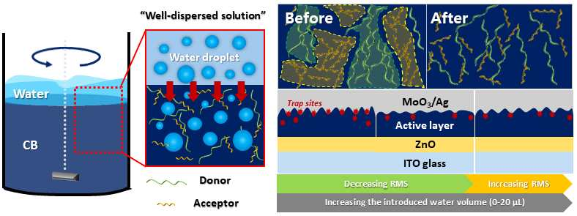
▲ Schematic diagram showing the process of the water treatment process and the result of the change in the shape of the thin film: In the water treatment process using a small amount of water, the donor and acceptor dispersion state was controlled by strongly rotating in the form of droplets that do not mix with the organic solvent. The controlled solution can affect the thin film state of the large-area organic solar cell, and it showed improved device efficiency and stability under the optimum condition with the least thin film roughness.

The water treatment method using 0-20 microliters (μL, 1 millionth of a liter) water developed by the research team penetrates the water formed as a double layer as unmixed droplets in the organic solvent. This causes a small vortex around the water droplet to inhibit the aggregation of donors and acceptors in the organic solvent.

Since the water treatment method does not use additives based on toxic organic solvents, it is an eco-friendly treatment technology for improving the efficiency and stability of large-area organic solar cells.

The research team used the slot-die printing* method to fabricate large-area organic solar cells and modules. Through this, the small-area organic solar cell (0.1 cm2) is up to 13.06%. A large-area organic solar cell module (10 cm2) achieved a maximum efficiency of 11.92%. It was confirmed that the developed technology was successfully introduced even with an increase in the active area, resulting in improved device results.

* slot-die printing: This is a method of printing a thin film of a certain thickness while maintaining the formation of droplets using a blade with a large area. It is possible to control the properties of the thin film in various shapes and thicknesses depending on the solution injection and printing speed. Recently, it has been used to fabricate large-area flexible electronic devices.

Professor Dong-Yu Kim said, "The greatest significance of this research result is that it is possible to freely control both the donor-acceptor dispersion state in the solution and film state by using the micro vortex generated during the water treatment process. This is expected to greatly contribute to the practical use of mass production technology by securing the original technology for the production and commercialization of large-area solar cells with roll-to-roll process in the future."

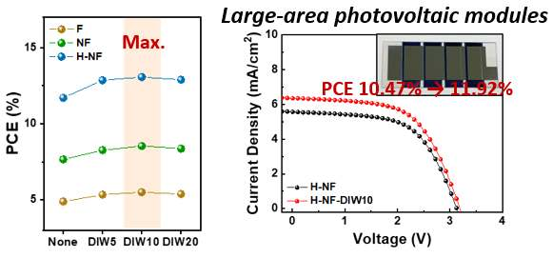
▲ Performance of organic solar cells and large-area modules manufactured by applying the water treatment method: 10 microliters of both large-area solar cells (0.1 cm2) and large-area modules (10 cm2) that include a water treatment process and manufactured through a printing process. When water was added, it was confirmed that it had the best thin film and had the highest efficiency.

This research was led by GIST School of Materials Science and Engineering Professor Dong-Yu Kim (corresponding author) and conducted by Ph.D. student Nara Han (first author) with support from the National Research Foundation of Korea’s mid-level researcher support project (leap research, follow-up research support), the GIST Next-Generation Energy Research Institute (RISE) 'Development of flexible and translucent solar cells close to life' and was selected as a front cover paper in Advanced Functional Materials (IF: 19.924), an authoritative journal in the field of nanotechnology and materials, and published online on June 23rd.



