Identification of new mechanism of tumor cell malignancy Patent application for pharmaceutical composition for anticancer

– Promoting tumor malignancy through malignant tumor-specific protein DCLK1 and inflammatory enzyme factor
– Professor Jeong-Seok Nam's team published a Theranostics paper... “Contribute to overcoming intractable diseases by controlling tumor malignancy”


▲ (Counterclockwise from bottom left) Integrated students So-El Jeon, Hyeon-Ji Yun, Tae-Young Jang, Professor Jeong-Seok Nam, Ph.D. student Jee-Heun Kim, and integrated students Choong-Jae Lee and Jin-wook Han

A Korean research team has succeeded in discovering a kinase**-inhibiting small molecule anticancer drug to suggest a new mechanism by which tumor cells become malignant* and to suppress it.

The research team has derived a low-molecular-weight anticancer drug that inhibits a kinase specifically expressed in malignant tumor cells through 3D virtual screening using a library of 560,000 drugs and applied for a patent for an anticancer treatment strategy using this.

This achievement is expected to contribute to the development of drugs that can fundamentally treat intractable diseases by controlling the malignant process of tumor cells.

* malignancy of tumor cells: A tumor, which is an abnormally differentiated and overgrowth cell mass, progresses to a malignant tumor, that is, cancer through a malignant process that acquires rapid growth, invasiveness and metastasis.

** kinase: an intracellular protein that acts as a switch in the signaling pathway that regulates the growth, differentiation, and survival of tumor cells

The process of malignancy of tumor cells is a concept that includes development, proliferation, metastasis, and recurrence, and is known to be mediated by the interaction between tumor cells and the tumor microenvironment*.

Therefore, it is essential for the development of treatment for intractable diseases to identify specific mechanisms for the malignant process of tumor cells and to establish a treatment strategy that can control them.

* tumor microenvironment: A complex whole composed of tissue cell groups such as peripheral vascular cells, stromal cells, and immune cells that directly or indirectly affect the formation and growth of cancer cells, as well as extracellular matrix and signaling substances.

GIST (Gwangju Institute of Science and Technology, President Kiseon Kim) School of Life Sciences Professor Jeong-Seok Nam's research team discovered that DCLK1*, a protein specifically expressed in malignant cells, promotes the malignancy of tumor cells by activating the pro-tumor signaling pathway in the tumor microenvironment through an inflammatory enzyme factor.

* DCLK1 (Doublecortin-like kinase): A serine/threonine kinase that is specifically expressed in malignant tumor cells rather than normal cells. It contains a kinase domain that plays a role in signaling through intracellular phosphorylation.

The GIST research team discovered a low-molecular effective compound that inhibits the activity of DCLK1 by conducting virtual reality (VR)-based molecular modeling research in collaboration with the Korea Research Institute of Chemical Technology.

The research team confirmed that a low-molecular effective compound that inhibits DCLK1 kinase activity effectively controls tumor cell malignancy through a mouse (mouse) experiment. Based on this, an experimental basis was presented for establishing a treatment technology for malignancy by tumor cell-tumor microenvironment interaction.

In addition, through the analysis of clinical data, it was newly confirmed that DCLK1 not only causes cancer as an inflammatory response but also causes malignancy.

In particular, they first identified the signaling protein (XRCC5) that mediates malignancy and inflammation through proteomic analysis. Based on this, it was confirmed that suppression of signals mediated by two proteins (DCLK1 and XRCC5) inhibited the malignancy of tumor cells through gene therapy for XRCC5 in a colorectal cancer mouse model.

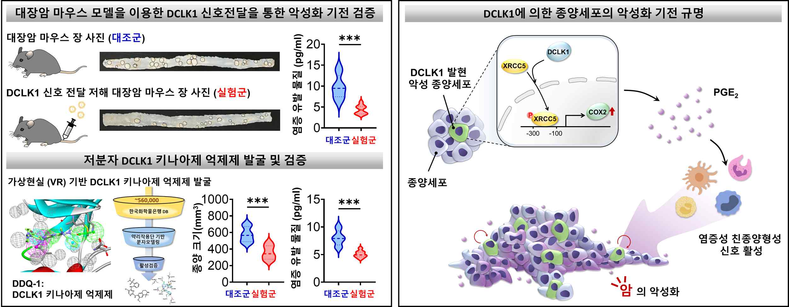
▲ Identification of the mechanism of cancer malignancy by DCLK1
Left) In a mouse model of colorectal cancer, the number of tumors formed when the expression of DCLK1 signaling mediators or kinase activity was inhibited decreased, and the secretion of pro-inflammatory substances (PGE2) was also decreased.
Right) DCLK1, which is expressed specifically for malignancy, phosphorylates XRCC5 and increases the expression of COX2, an inflammatory enzyme factor, to generate and secrete an inflammatory substance (PGE2), thereby activating an inflammatory pro-tumor formation signal in the tumor microenvironment. It was found to induce cancer malignancy.

The research team confirmed that DCLK1 binds to XRCC5 and increases the expression of the inflammatory enzyme factor COX2 to promote the synthesis of inflammatory substances (PGE2) and accelerate the malignancy of tumor cells by activating the pro-tumor signaling pathway* in the tumor microenvironment.

* examples: promotion of inflammation, polarization of macrophages, secretion of cytokines, immune tolerance (the non-responsiveness of the immune system to a specific antigen), etc.

Professor Jeong-Seok Nam said, "This study is significant in that it identified the inflammatory pro-tumor formation mechanism in the tumor microenvironment by DCLK1, which is specifically expressed in malignant tumors, and discovered a low-molecular compound that inhibits it. This is expected to contribute to the preparation of fundamental treatment strategies for intractable diseases in the future."

This research was led by Professor Jeong-Seok Nam and led by Ph.D. student Jee-Heun Kim and Dr. So-Yeon Park with support the National Research Foundation's mid-level researcher support project, new researcher support project, doctoral student research incentive support project, SRC leading research center support project, and GIST GRI project and was published online on July 4, 2022, in Theranostics, an authoritative journal that specializes in the top 4.62% of the medical field. In addition, a patent was applied for a pharmaceutical composition for inhibiting cancer metastasis or recurrence including a DCLK1 inhibitor.



