Quantum heat dissipation: opening a new horizon in semiconductor packaging

– Proposal of a quantum heat dissipation technique utilizing the wave nature of heat transfer acoustic phonons that exist immediately after heat generation

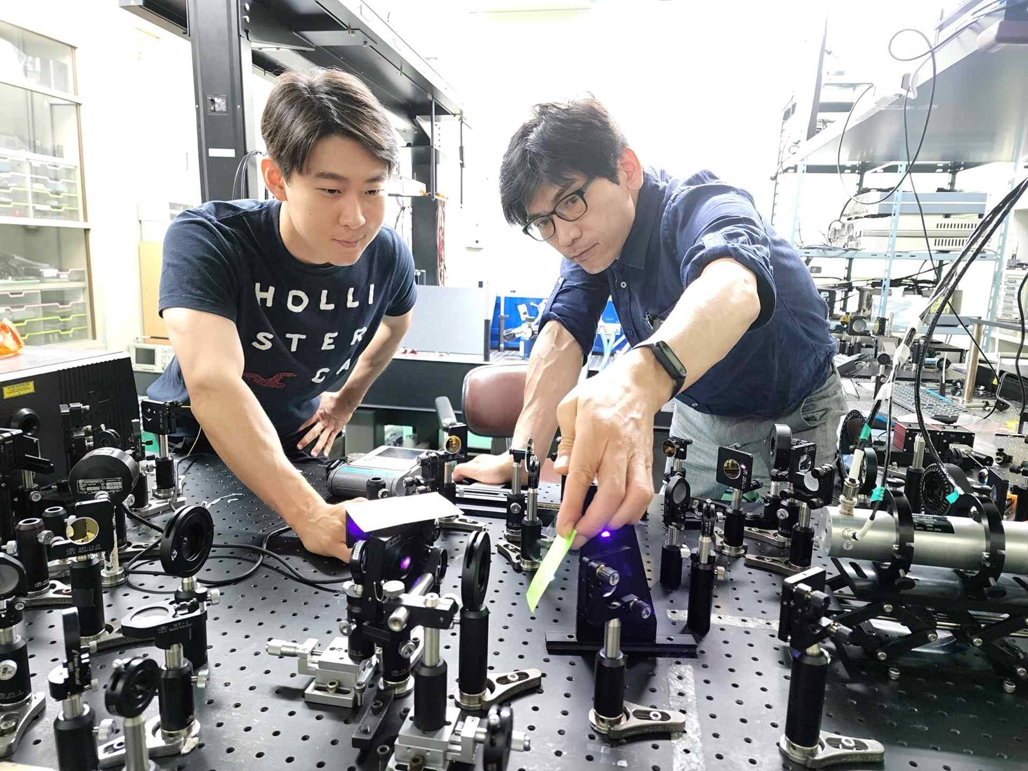
▲ (From left) Integrated student Sang-Hyuk Park and Professor Young-Dahl Jho

As semiconductor packaging becomes high-output and high-integration, the heat dissipation technique through structural design has reached its limit, and the appropriate driving temperature is frequently exceeded. While power consumption is reduced and performance is improved, the heating load of the chip in charge of calculation in this process causes problems such as malfunction.

In the related industry, air-cooled heat dissipation using a heat sink or combining a cooling fan to solve the heat load is familiar in real life. Recently, heat dissipation concepts including new nanomaterials such as graphene, thermoelectric (heat to electricity) phenomenon, and radiative cooling have appeared, and various efforts are being made to solve the heat dissipation problem.

Heat is transferred by conduction, convection, and radiation. Since semiconductors are stacked layer by layer with various materials, conduction has been treated as important in heat dissipation packaging.

A Korean research team has focused on the wave nature of acoustic phonon*, a heat carrier for many years, and recently discovered a new heat removal technique for semiconductors.

* acoustic phonon: A type of phonon that is a transmitter of sound and heat. Acoustic phonons with various frequencies exist in solids, and in particular, the terahertz frequency band determines heat conduction. Although it is a major heat exchanger, it is known that it cannot be converted to light because it does not intersect the light dispersion curve.

GIST (Gwangju Institute of Science and Technology) School of Electrical Engineering and Computer Science Professor Young-Dahl Jho's research team discovered the acoustic phonon radiation mechanism before thermal equilibrium and experimentally identified a new method of converting acoustic phonon waves into light in silicon, a core semiconductor material.

According to previous studies, radiative cooling deals with the generation of electromagnetic waves according to the movement of charges in the time band after thermal equilibrium, and it follows Planck's law of radiation. On the other hand, before thermal equilibrium, acoustic phonons, which are heat carriers, have wave properties that form constant curves like waves and have various frequency values like light.

When these acoustic phonon waves pass through an interface (eg, gallium nitride GaN/aluminum nitride AlN) with a difference in piezoelectric (electricity is produced when pressed), they interact with ions to radiate electromagnetic waves.

However, in semiconductors without a piezoelectric field such as silicon, the concept of radiation in which acoustic phonons are converted into light has not yet been elucidated. This is because, physically, the dispersion curve of acoustic phonons and the dispersion curve of light do not meet each other, thus violating the law of conservation of energy.

▲ Schematic diagram of acoustic phonon radiation by electron-acoustic phonon interaction based on strain potential. As the acoustic phonon moves and accelerates electrons, terahertz electromagnetic waves can be oscillated.

To overcome this limitation, the research team modulated the bandgap, which is the energy value of the solid, locally by acoustic phonons, a heat transferor. Accordingly, the so-called deformation potential* in which an electric field is generated was utilized.

In particular, by pre-accumulating electrons on a silicon substrate using a well-known doping technique in semiconductors, electron-acoustic phonon interactions were induced so that electromagnetic waves were radiated. This is a realistic implementation of the quantum heat dissipation concept utilizing the acoustic phonon wave properties immediately after heat generation.

* deformation potential: One of the material constants of a solid. The energy gap changes according to the deformation of the solid (change in the size or shape of the unit cell), which is their correlation coefficient.

▲ Measurement results of terahertz electromagnetic waves due to the electroacoustic phonon interaction measured in the heat generating layer/Si heterojunction structure. When the distance (d) between the heat generating layer and the electron layer is changed, the travel time of the acoustic phonon is different. Acoustic phonon radiation by electron-acoustic phonon interaction was demonstrated by confirming that the oscillation time of terahertz electromagnetic waves also changed.

Professor Young-Dahl Jho said, "In all high-tech industries such as artificial intelligence, mobile devices, displays, and electric vehicle batteries, heat removal is a key factor in improving the efficiency and lifespan of related semiconductor systems. The quantum heat dissipation concept in this study is expected to be used in industry through various research collaborations and to combine quantum heat dissipation and conventional heat dissipation techniques after thermal equilibrium through extensive processing of semiconductor substrates such as silicon in the future."

The lead author, Dr. Sang-Hyuk Park, said, "Efforts have been made to overcome the heat dissipation limit of opto/electronic devices, and the results are now starting to show."

This research, led by Professor Young-Dahl Jho and conducted by Dr. Sang-Hyuk Park as the lead author, was supported by the Ministry of Education and the Korea Electric Power Research Institute. In recognition of its achievements in the June issue of Optics Express, a major international academic journal in the field of optical technology, it was selected as the editor’s pick and published online on June 13.



