Proposed optimal ratio of water electrolysis ‘iron-nickel’ catalyst for green hydrogen production with artificial intelligence

– Deduction of the optimal ratio of non-precious metal catalyst (iron: nickel) of 8.7:91.3, expected to improve green hydrogen production efficiency
– Professor Jaeyoung Lee's team (School of Earth Sciences and Environmental Engineering) publishes paper in Journal of Materials Chemistry A

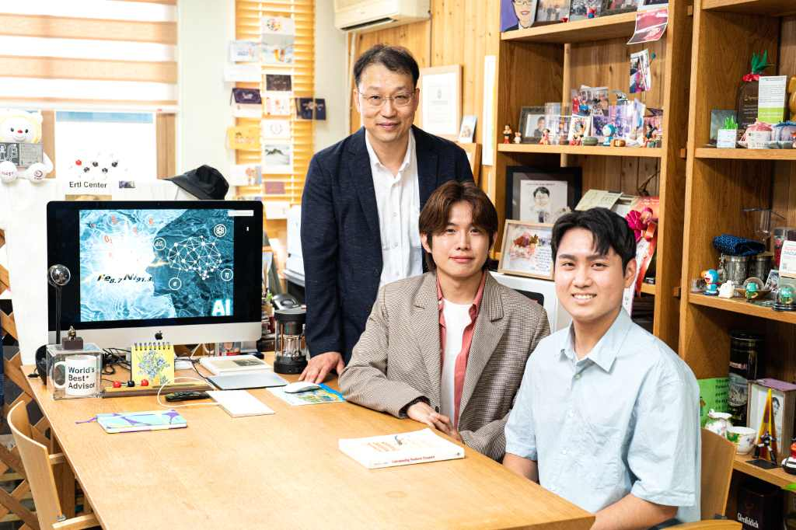
▲ (From left) Professor Jaeyoung Lee, Dr. Jihyeon Park, and researcher Sinwoo Kang

A Korean research team has succeeded in calculating the optimal ratio of non-noble metals (iron-nickel) in the water electrolysis catalyst required for green hydrogen production through the 'Deep Learning Algorithm'.

This is expected that by increasing the production efficiency of eco-friendly green hydrogen, it will help the distribution of mass transportation institutions such as trucks, trailers, and trains equipped with hydrogen fuel cell engines.

Water electrolysis, which is attracting attention as a method for producing hydrogen (green hydrogen) by electrolysis of water without greenhouse gas emission, requires applying a voltage higher than the theoretical potential (1.23V)* to generate hydrogen.

A voltage higher than the theoretical potential (overvoltage) will eventually consume a lot of energy, so lowering the overvoltage is a key technology to produce green hydrogen.

* theoretical potential: the theoretical potential for water to be electrolyzed

At this time, since the oxygen electrode (+ electrode) has an overvoltage about 5 to 10 times higher than that of the hydrogen electrode (-pole), it can be said that lowering the overvoltage of the oxygen electrode catalyst is a key technology for efficient green hydrogen production.

The iridium-based noble metal catalyst is effective in reducing the overvoltage of the oxygen electrode, but its high price is a hindrance to its practical use.

Although iron and nickel are representative non-precious metal electrocatalysts, they have low prices, abundant reserves, and high overvoltage for oxygen generation. Proper combination of the two catalysts can lower the overpotential due to a synergistic effect.

Studies to control the ratio of the two metals are being continuously attempted to lower the overvoltage even a little. Although it has been found that the overvoltage is low when the iron content is around 10% through previous studies, there is no research result that suggests a more precise ratio experimentally.

GIST (Gwangju Institute of Science and Technology) School of Earth Sciences and Environmental Engineering Professor Jaeyoung Lee's research team presented the optimal ratio of iron and nickel, a non-precious metal catalyst used in the water electrolysis system, through artificial intelligence deep learning.

The research team synthesized iron-nickel catalysts in various ratios and extracted their characteristics as variables to create a database, and through deep learning, presented a formula expressing overvoltage by summing up numerous variables of iron-nickel catalysts.

Through this formula, the optimal ratio of iron-nickel catalysts when the overvoltage is at the minimum value ‘Iron (Fe): Nickel (Ni) = 8.7 : 91.3’ was derived.

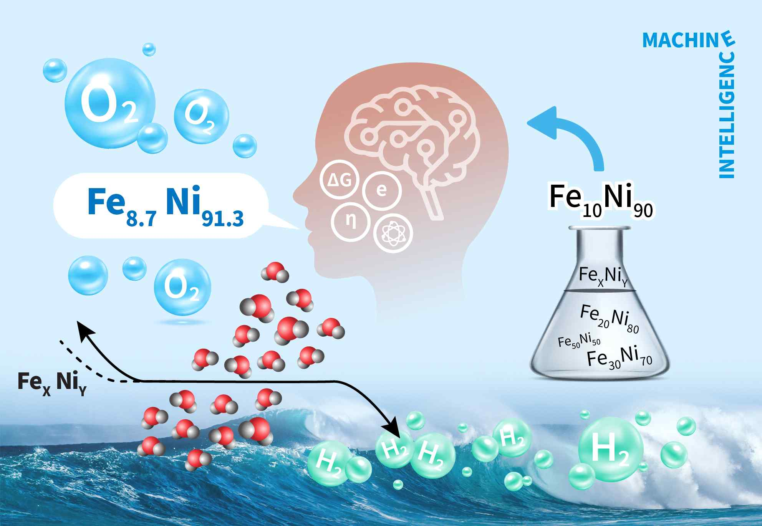
▲ Conceptual diagram of specifying the iron-nickel ratio through artificial intelligence in the water electrolysis process for green hydrogen production

Professor Jaeyoung Lee said, "The result of this research is that artificial intelligence suggested the direction that the water electrolysis catalyst to produce green hydrogen should go. The surprising result of the deep learning algorithm calculating the optimal ratio between the two metals as well as the natural properties of the catalyst."

This research, conducted by Professor Jaeyoung Lee's team at GIST, is based on GIST's <AI-based social problem solving convergence talent development support project> with the support of the National Research Foundation of Korea's <Overseas Outstanding Research Institutions Collaboration Hub Establishment Project> and was selected as a cover paper in the Journal of Materials Chemistry A, a world-renowned academic journal in the field of chemistry, and published online on July 15, 2022.



