Professor Young Min Song's joint research team develops an ultra-small amphibious camera capable of shooting 360 degrees

– Bio-mimicking the compound eye structure of fiddler crabs, manufacturing flat multi-microlenses and integrating them into a spherical device
– Youngmin Song (GIST) and Dae-Hyeong Kim (Seoul National University) research team, Nature Electronics... “Test success in water”

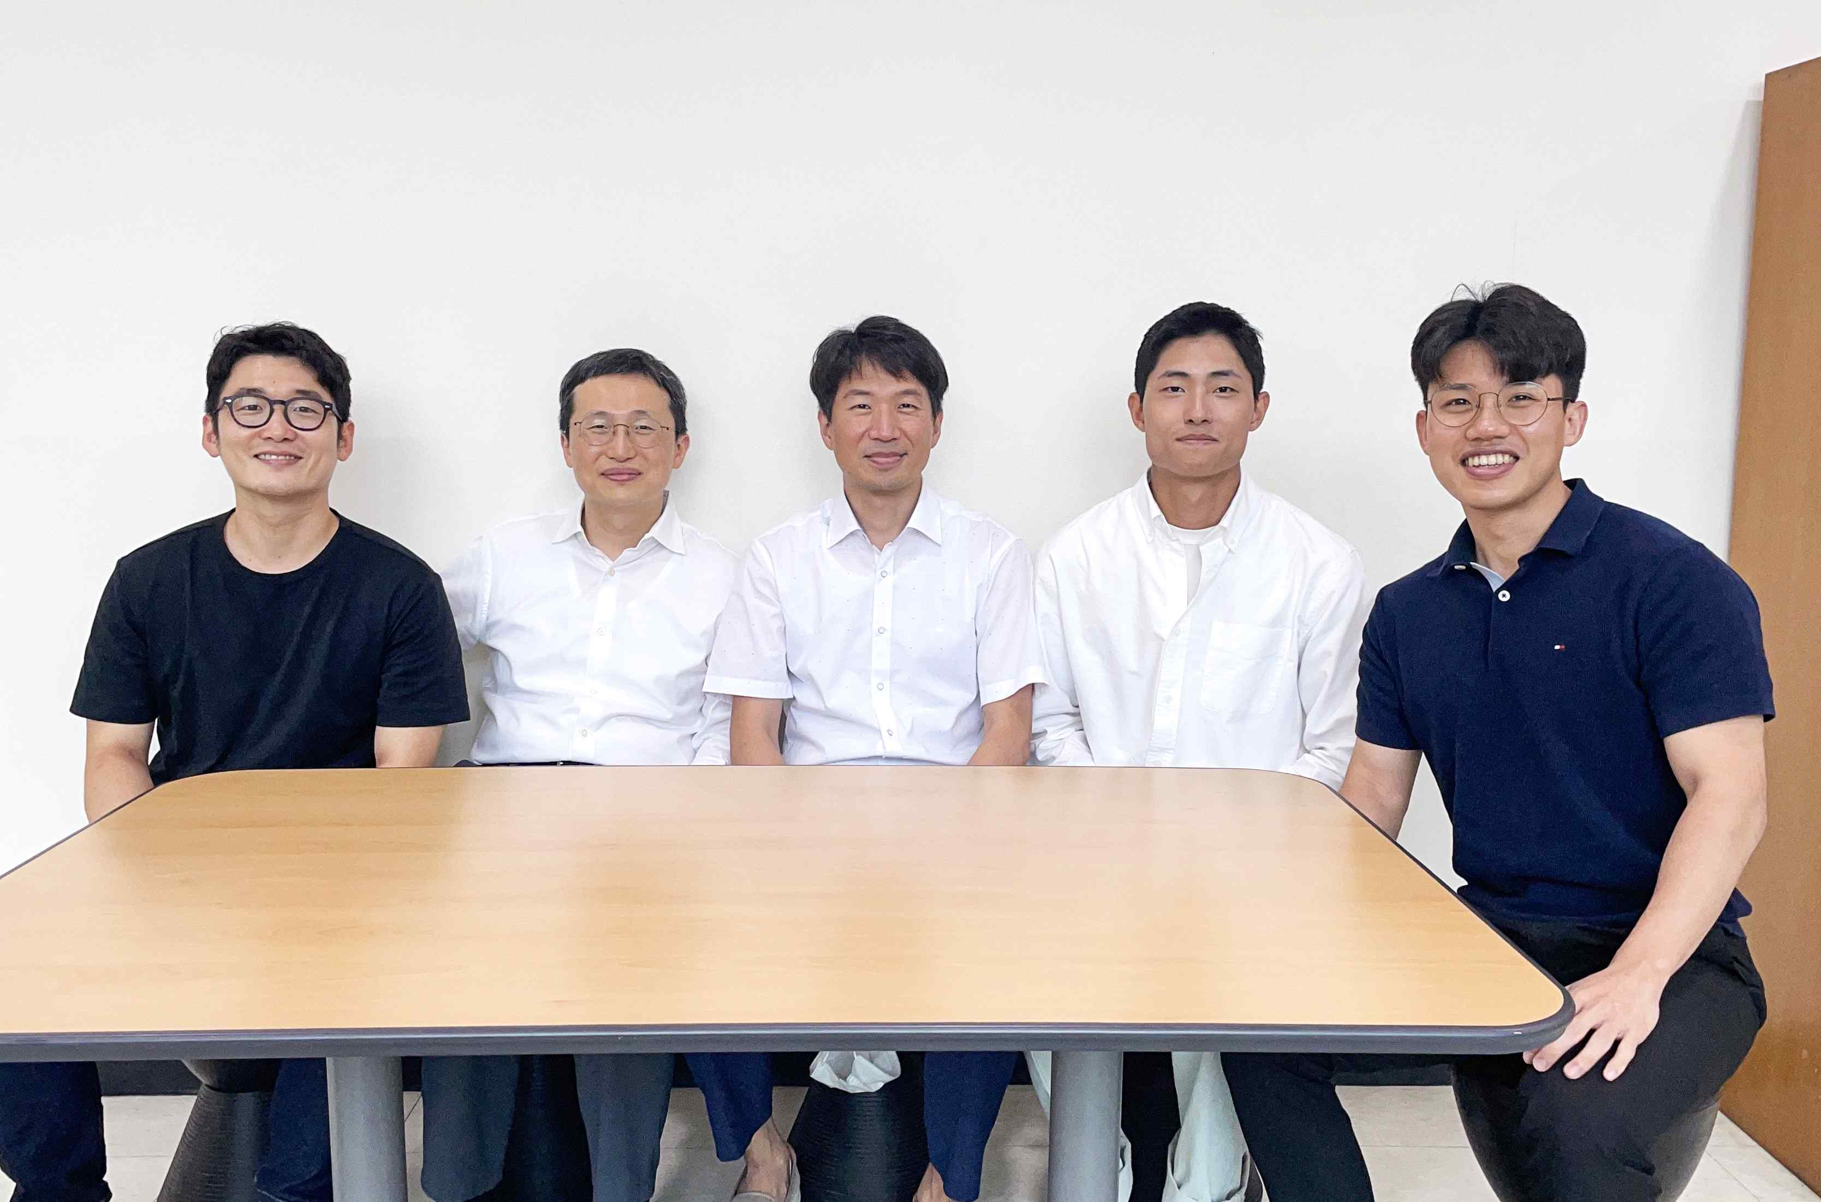
▲ (From left) Dr. Mincheol Lee (Seoul National University, co-first author), Professor Dae-Hyeong Kim (Seoul National University, co-corresponding author), Professor Young Min Song (GIST, co-corresponding author), researcher Hyuk Jae Jang (GIST, co-first author), and Professor Gil Ju Lee (Pusan National University, co-first author)

An ultra-compact amphibious camera that can take 360-degree photos and videos in and out of water without image distortion has been developed.

As a result of research obtained by biomimicking the structure of the compound eyes of a fiddler crab living in the intertidal zone*, the video tests were successfully completed while immersed in actual water, supplementing the limitations of the existing 360-degree camera and applying it to various video equipment such as VR devices.

GIST (Gwangju Institute of Science and Technology, President Kiseon Kim) School of Electrical Engineering and Computer Science Professor Young Min Song's joint research team with Seoul National University School of Chemical and Biological Engineering Professor Dae-Hyeong Kim published the results online on July 12, 2022 (Tuesday) 00:00 in Nature Electronics.

* Intertidal zone: A coastal area exposed above the water surface during low tide and submerged below the water surface during high tide when the sea level is the highest.

Currently, global companies such as Meta Platforms, which operates Facebook to produce 360-degree cameras, and Teledyne FLIR, a company specializing in the design of thermal imaging cameras and sensors, are conducting research and development. Existing products have the disadvantage that it is difficult to overcome the limitations of hardware for image distortion, and post-processing is required to connect the sensor information of each camera.

Usually, a lens with a curved surface is used in a camera. Due to the phenomenon of light refraction*, there is a limit to processing images in and out of water simultaneously in one optical system.

* light refraction: Depending on the degree of refraction (refractive index) of the image of an external object in the lens, the path of light changes and the position where the shape is formed on the image sensor changes.

In addition, in the case of a wide-angle camera with a wide field of view, a high refractive lens with a high degree of bending (high curvature) is used in order to form the image of the subject in the widest possible range on the image sensor. Due to this lens configuration, a difference in refraction occurs at the center and the outer angle of the lens, and a distorted image is projected on the image sensor.

The research team developed a camera that combines a flat microlens with an image sensor and integrates about 200 optical systems consisting of one microlens and one photodiode in a spherical spherical structure with a diameter of about 2 cm to achieve a wide angle without distortion.

The fiddler crab, which the research team got the idea from, is a species that inhabits the intertidal zone and must be able to secure visibility both in the water and out of the water. To this end, the lens of the dark crab has a flat surface and a gradual change in the graded refraction index below it. In addition, in order to effectively identify predators in flat tidal flats, the eyes of fiddler crabs are lensed in all directions.
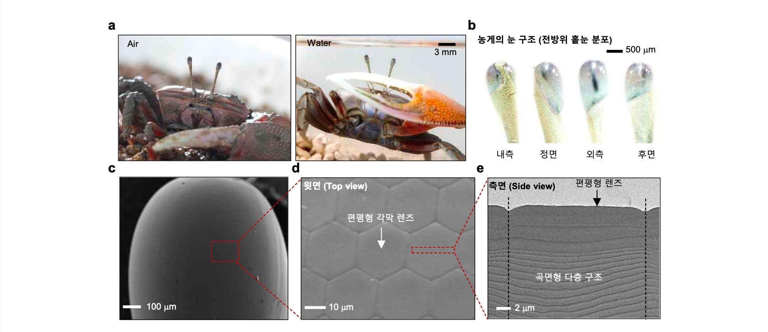
▲ Eye structure of fiddler crabs inhabiting intertidal zone: (a) Photo of sea bass living in intertidal zone (in water/out-of-water) (b) Omnidirectional photo of sea bass eye (c) Scanning electron micrograph of sea bass eye (d) Photo of sea bass eye Scanning electron micrograph (Top view) (e) Lateral transmission electron micrograph of a single eye (single corneal lens)

The research team placed about 200 photodiodes in a spherical shape. By placing a flat microlens on each photodiode, the problem of distortion caused by post-processing and optical lenses that connect each sensor information was solved.

In addition, a graded-index microlens composed of four lenses whose refractive index is continuously changed to improve the focusing power and correct aberrations, which is lowered when a flat microlens is placed, was manufactured. As a result, it was confirmed theoretically and experimentally that the image quality in and out of the water remains the same regardless of the external environment and image distortion is reduced compared to the existing wide-angle camera.
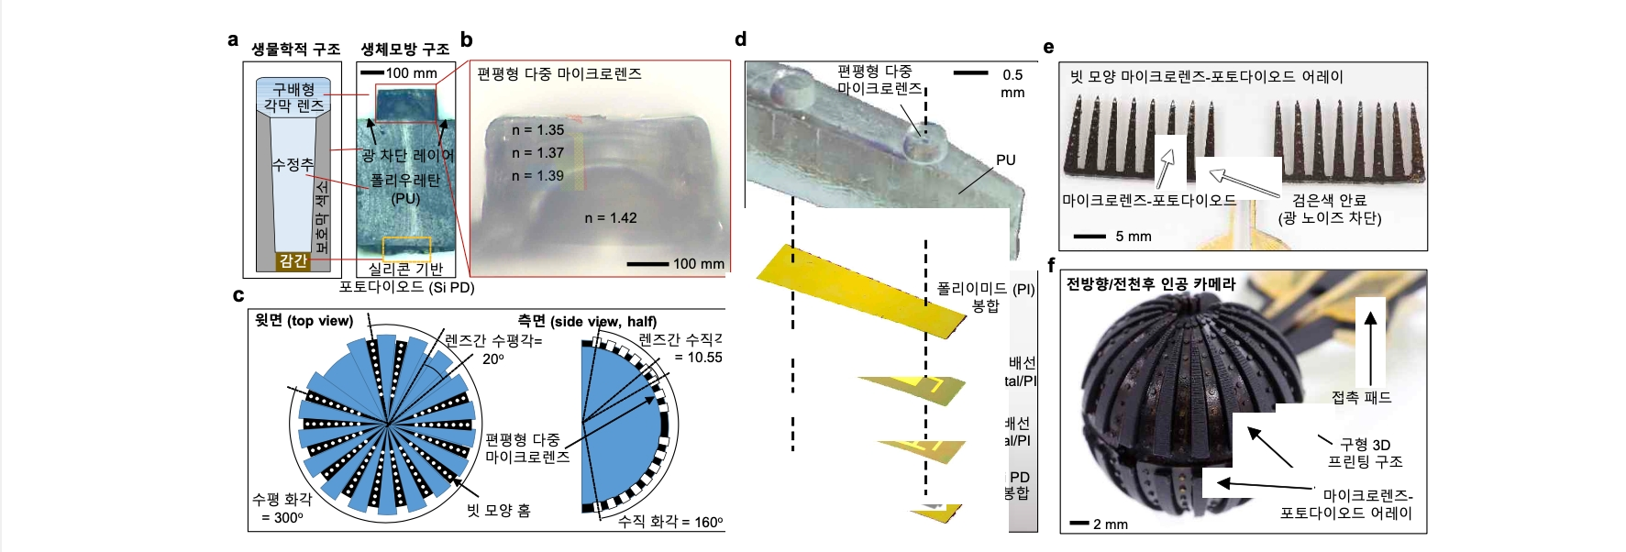
▲ Manufactured microlens-photodiode module and module-integrated camera: (a) Comparison of biological and biomimetic structures of peridots eye (b) Optical micrograph of flattened multi-microlenses (c) Layout diagram of biomimetic flat multi-microlens array (d) Flattened multi-microlens and photodiode configuration exploded view (e) Comb-shaped microlens-photodiode array photo (hemispheric region) (f) Comb-shaped array integrated omni-directional/all-weather artificial camera photo

Professor Young Min Song said, "The 360-degree camera developed this time is meaningful in that it presents a new concept that complements the existing limitations and at the same time successfully conducts actual image testing by collecting microlenses and photodiodes in a ball-shaped device. By improving the size limitations of photodiodes and microlenses and lens alignment that can be manufactured at the laboratory stage, we expect there will be a 360-degree camera with higher resolution and performance can be applied to a vision system of an autonomous vehicle or an existing 360-degree camera."

Professor Song also said, "In the future, we will lead research in the field of system semiconductors that are relatively weak in Korea through the development of new concept image sensors and cameras."
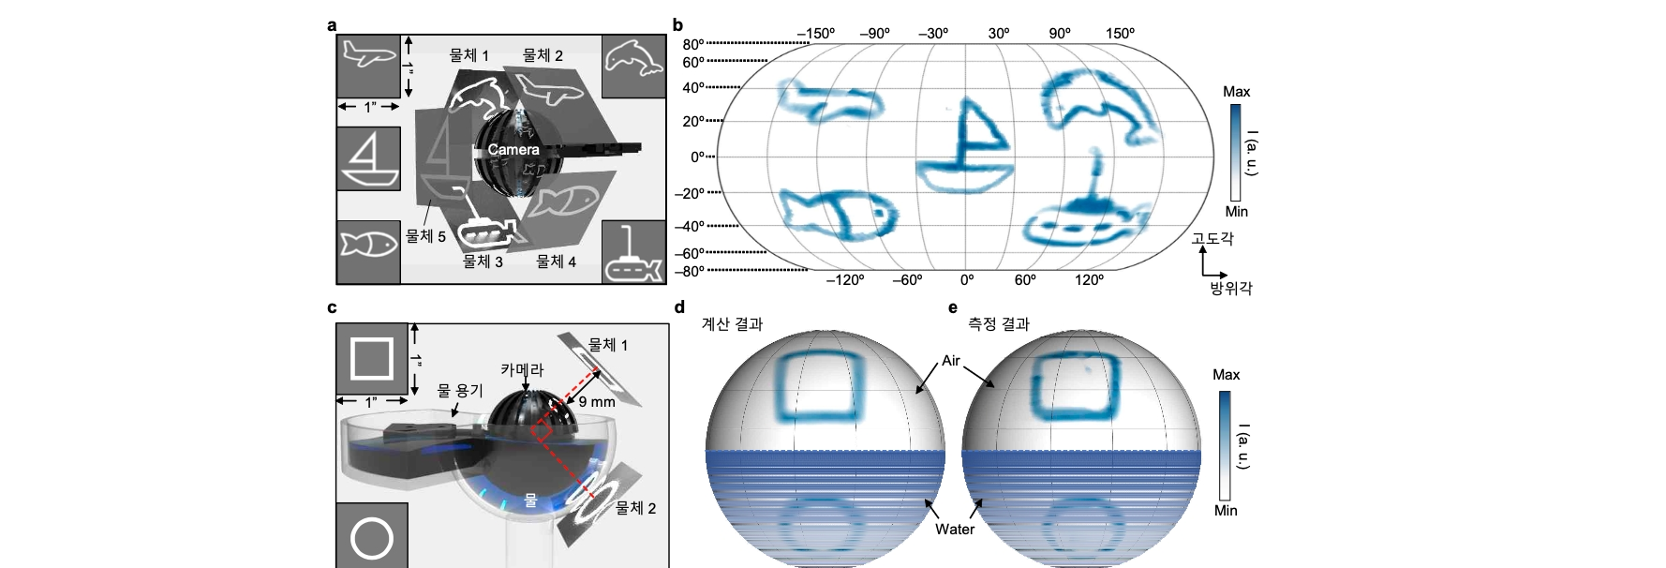
▲ All-weather camera image processing setup and results: (a) Omnidirectional image performance evaluation setup of the manufactured camera (b) Omnidirectional image processing result of the manufactured camera (c) All-weather image performance evaluation setup of the manufactured camera ( d) All-weather characteristic calculation result of the manufactured camera (e) All-weather image processing result of the manufactured camera

This research was carried out with the support of the Future Materials Discovery Project promoted by the National Research Foundation of Korea and the Future Generations Support Project in the Science and Engineering field, the Basic Science Research Center External Research Group of the Institute for Basic Science (IBS), and the GIST-MIT joint research project.

The joint research team of School of Electrical Engineering and Computer Science Professor Young Min Song included integrated student Hyuk Jae Jang (first author), Pusan National University Professor Gil Ju Lee, and Seoul National University School of Chemical and Biological Engineering Professor Dae-Hyeong Kim.

In addition, Professor Frédo Durand of MIT and Professor Nanshu Lu of Texas State University participated in the study as co-authors.



