Development of a drug to inhibit hepatitis B virus penetration that can be made more easily and with lower toxicity

– Synthesis of libraries based on cyclosporine O... Secured macrocyclic peptide derivatives
– Professor Jiwon Seo’s team published in Bioorganic and Medicinal Chemistry, "Expected to apply combination therapy"


▲ (From left) Professor Jiwon Seo and Ph.D. student Dongjae Lee

A GIST research team has developed a cyclic peptide**-based drug that blocks the hepatitis B* virus, which accounts for 70% of liver cancer, from invading hepatocytes.

The result of this research is to secure a cyclic peptide-based drug that has an inhibitory effect on the hepatitis B virus invasion. This is expected to contribute to presenting drugs optimized for various diseases through library-based structure-activity correlation analysis in the future.

* Hepatitis B: It is an inflammatory disease of the liver caused by infection with a hepatitis B virus. Chronic hepatitis B causes continuous inflammation of the liver, increasing the risk of cirrhosis and liver cancer. The cure rate of chronic hepatitis B patients, which is estimated to reach 400,000, is about 5%, and the development of new drugs is urgent because most of them require long-term treatment.

** cyclic peptide: A peptide with a cyclic structure. There is a form in which amino acids at both ends are linked, a form in which an amino acid at one end and a side branch are linked, or a form in which a side branch and a side branch are linked.

Recently, studies on combination therapy using multiple drugs that interfere with the activation of hepatitis B virus are being actively conducted. Combination therapy requires the development of drugs that can inhibit each stage of viral development.

Among them, drugs that interfere with hepatocyte invasion in the early stage of development of hepatitis B virus inhibit virus invasion by attaching to the sodium-taurocholic acid co-transport protein*, which is involved when hepatitis B virus invades hepatocytes. Among drugs approved by the U.S. Food and Drug Administration (FDA), cyclosporine A** had an inhibitory effect on the hepatitis B virus invasion.

However, cyclosporin A-based substances are fundamentally difficult to synthesize and does not solve the side effects and toxicity problems.

* sodium taurocholate cotransporting polypeptide (NTCP): A protein specifically expressed only on the surface of hepatocytes to transport taurocholic acid into cells. Hepatitis B virus infects hepatocytes via this protein.

** cyclosporin A: A natural cyclic peptide with immunosuppressive effects. It is used for diseases related to immunity, such as rheumatoid arthritis. As a result of screening through a recent drug re-creation strategy, an invasion-inhibiting effect against hepatitis B virus was confirmed.

GIST (Gwangju Institute of Science and Technology, President Kiseon Kim) Department of Chemistry Professor Jiwon Seo's joint research team synthesized a library based on 'cyclosporin O*,' a structural analogue of cyclosporin A, to overcome the problems of cyclosporin A.

In addition, the research team secured the ease of synthesis and structural diversity at the same time by introducing some amino acids as peptoids**.

* cyclosporin O: One of several natural structural analogues of cyclosporin A, the only analogue of which contains a natural amino acid at position 1.

** peptoid: One of the peptide mimetics, it is a structural isomer in which the side branch of the peptide is attached to the nitrogen atom instead of the carbon in the main chain.

Through this strategy, compared to cyclosporin A, the inhibitory effect of hepatitis B virus invasion was maintained at a similar level, and the difficulty of synthesis could be solved. In addition, a derivative that solved the side effects and toxicity problems of cyclosporin A was secured.

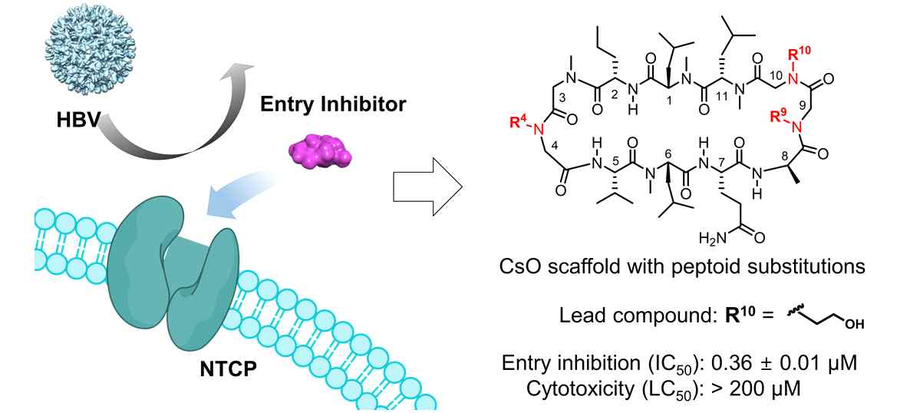
▲ Development of a cyclic peptide-based drug to inhibit invasion of hepatitis B virus: Hepatitis B virus penetrates through a protein (NTCP) specifically expressed on the surface of hepatocytes. Cyclosporine-based cyclic peptide material inhibits virus invasion by binding to the same site before hepatitis B virus binds to this protein. However, the existing cyclosporine was difficult to make and had toxicity problems. In this study, a peptoid was introduced instead of a peptide at position 10 of cyclosporine to discover a drug that has the same binding force as that of existing cyclosporine, has low toxicity and can be made more easily.

By introducing a peptoid into the cyclosporine O backbone, the drug could be discovered quickly, and based on this, it is expected that it will contribute to securing derivatives with improved hepatitis B virus invasion inhibitory effect through a large-scale structure-activity correlation study in the future.

Professor Jiwon Seo said, "Through this study, an important design principle was presented for the development of new drugs using cyclic peptides, which are important molecular platforms in the development of medium-molecular drugs. Using this cyclic peptide structure, we plan to continue research on the development of new drugs to treat infectious diseases such as antivirals."

This resesrach was carried out with support from the Ministry of Health and Welfare's health and medical technology R&D project, the Ministry of Science and ICT's mid-level researcher support project, and GIST's GRI project, and the research results were published online on June 6, 2022, in Bioorganic and Medicinal Chemistry, an international academic journal in the field of medicinal chemistry published by Elsevier.



