Successfully established and demonstrated the world's largest hand signal DB that stops autonomous vehicles

– Professor Yong Gu Lee's team DB construction of police and traffic safety guards, and 10,000 hand signal images, etc.
– Succeeded in suspension demonstration hosted by Information and Communication Planning and Evaluation Institute... 'Level 4 or higher autonomous driving and AI-related main DB role'

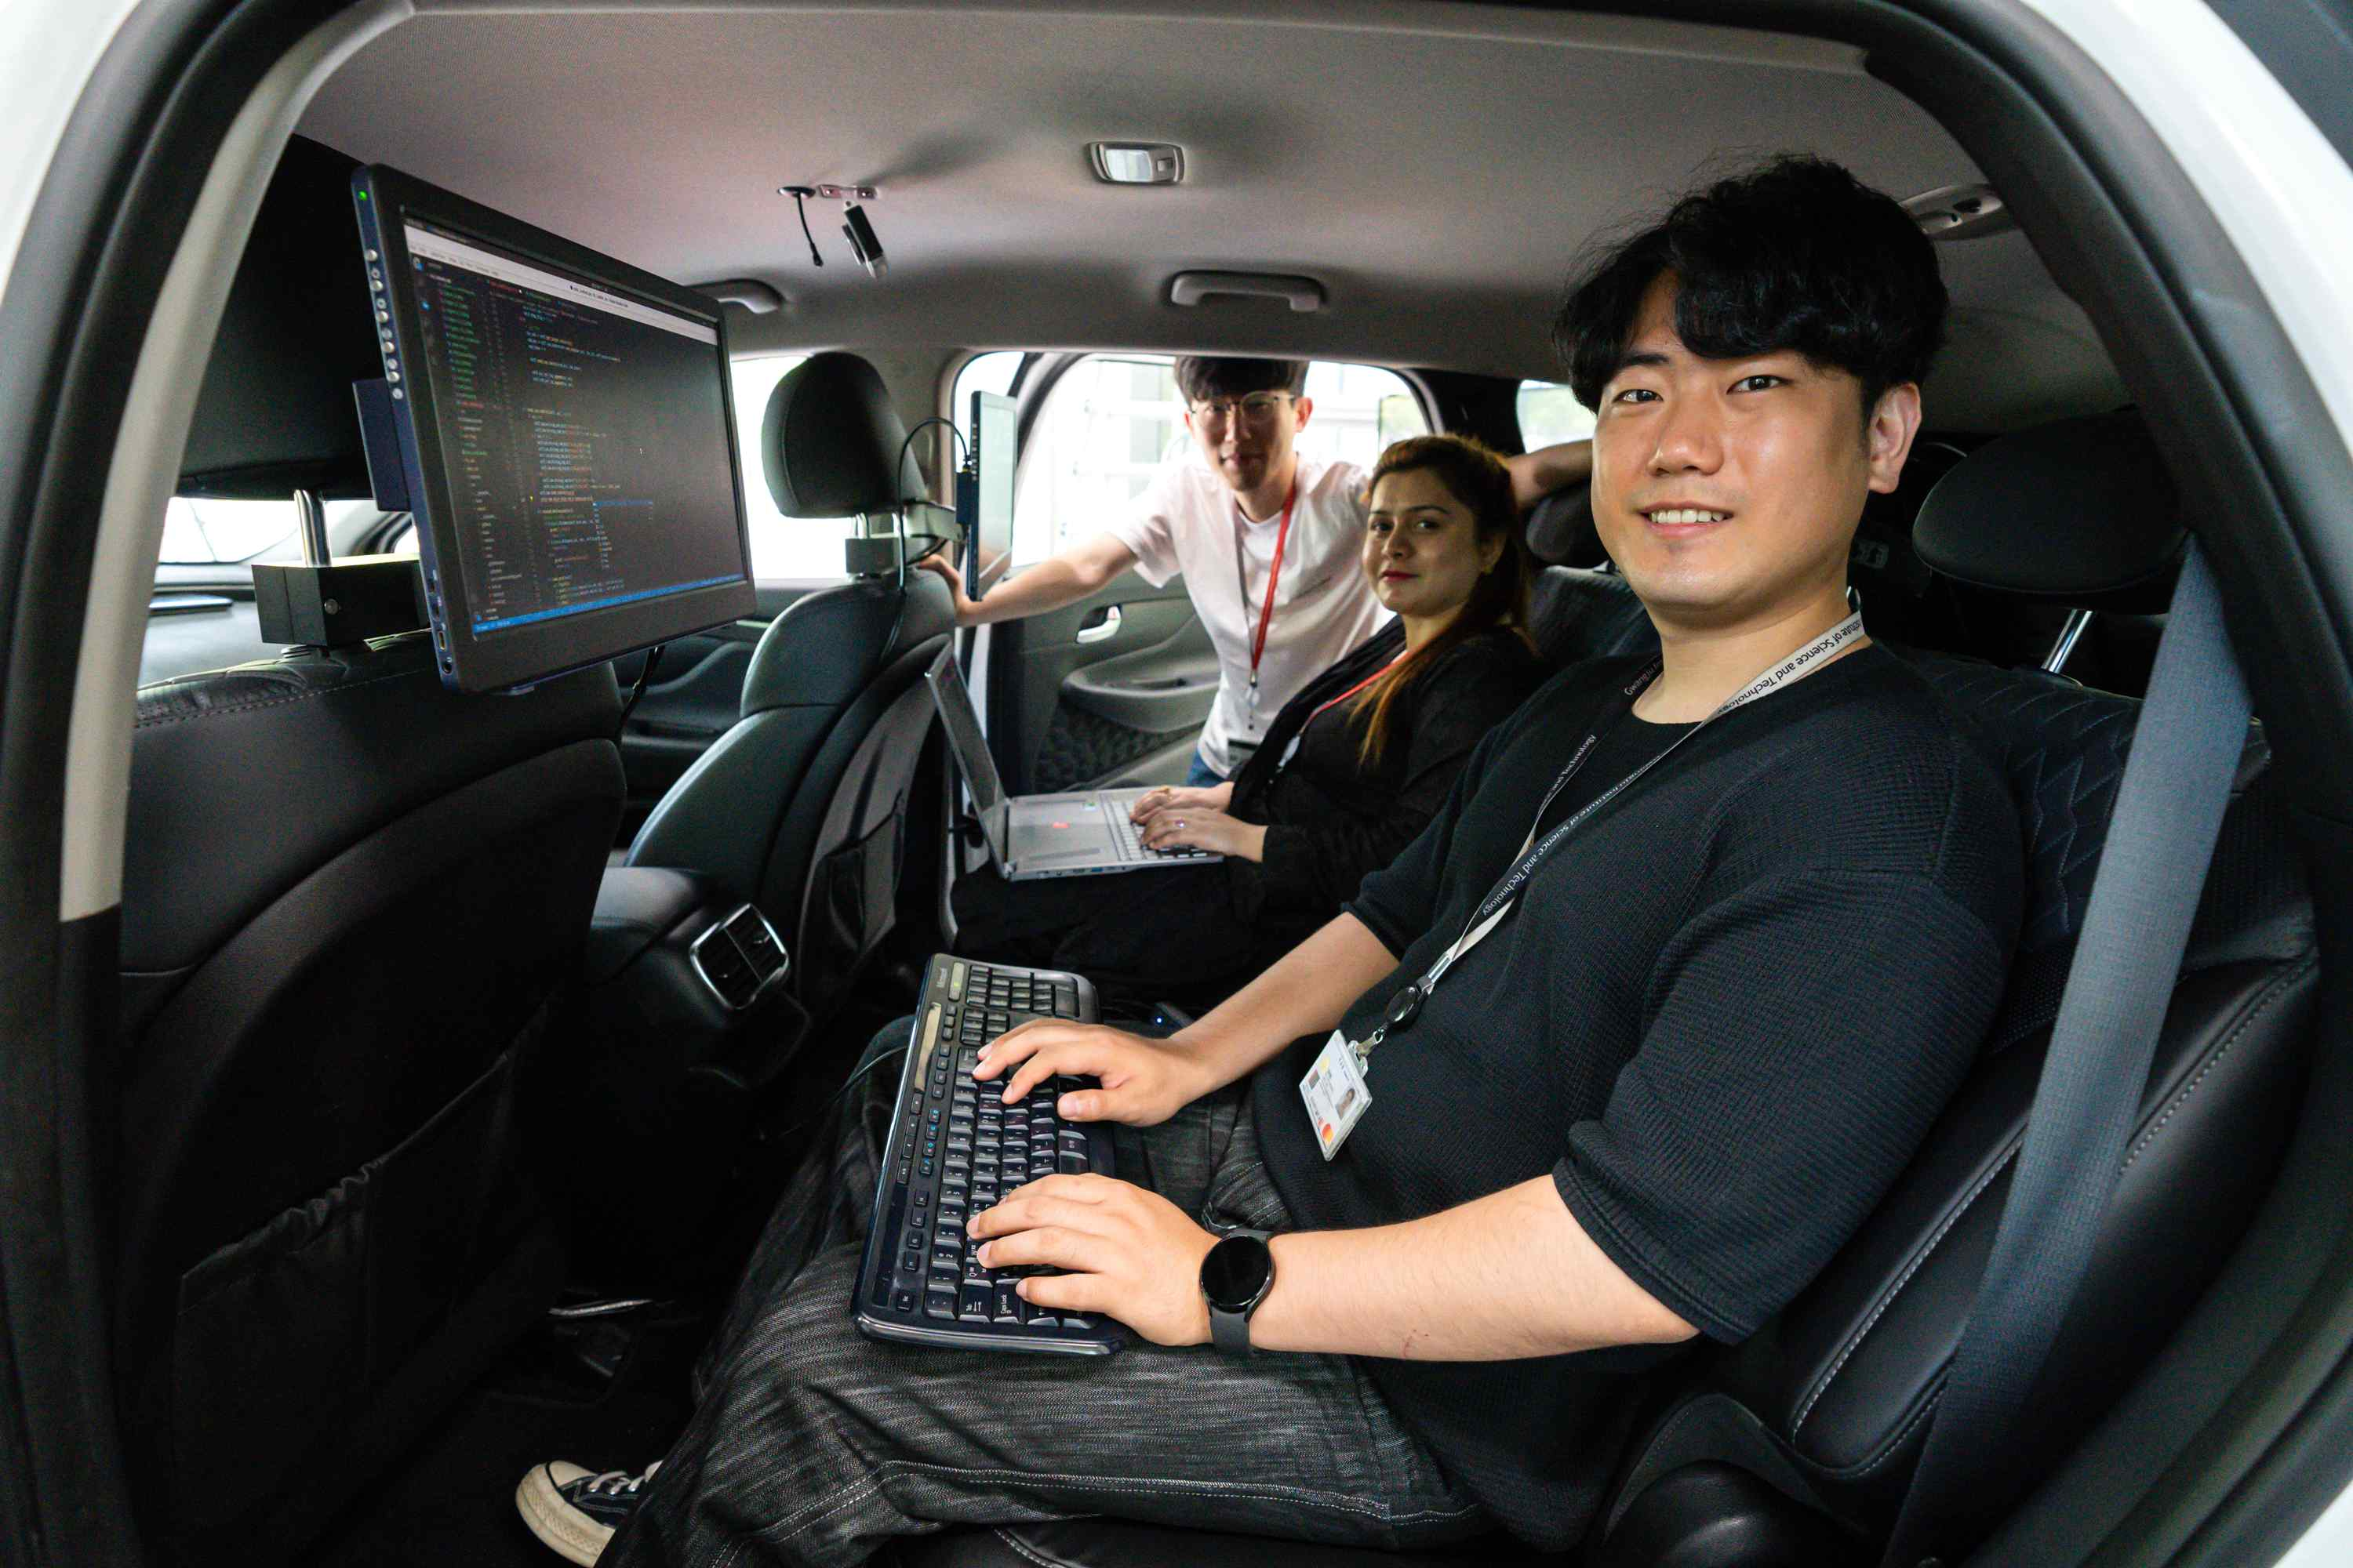
▲ Professor Yong Gu Lee's research team is conducting research using embedded boards in autonomous vehicles.

GIST (Gwangju Institute of Science and Technology, President Kiseon Kim) research team built the world's largest hand signal database (DB) for self-driving cars of Level 4* technology to recognize police hand signals or indicator rods on the road, and succeeded in demonstrating that the car recognizes and stops at the traffic signal.

The database of ▴ hand signals for police ▴ road driving images ▴ and images for tracking pedestrians and police officers, etc. built through this study is expected to lay the foundation for recognition of hand signals, which is an essential element for autonomous vehicles with level 4 or higher technology in the future.

* Level 4 or higher autonomous driving technology: Technology capable of monitoring the driving environment and responding to unexpected situations on its own within an area (level 4) or unrestricted conditions (level 5) designed to operate without driver or passenger manipulation. Recently, global companies such as Waymo, Google's autonomous driving affiliate, and General Motors (GM) of the US have shown successful cases in pilot operation of robotaxi, raising expectations for the commercialization of the autonomous driving industry with level 4 or higher.

With the support of the Information and Communication Planning Evaluation Institute (IITP), GIST School of Mechanical Engineering Professor Yong Gu Lee's research team has built a database to detect dynamic objects (pedestrians, police officers, traffic safety personnel, etc.) on and around roads that cannot be judged by static signals such as traffic lights for about four years since 2018.

The database constructed this time consists of 100,000 images of road driving for object detection, 200,000 images for tracking pedestrians and police officers, and 10,000 images of pointers and hand signals of police and traffic safety personnel.

The research team disclosed the data accumulated so far on the public data portal (www.data.go.kr) so that it can be used for research for the advancement of domestic autonomous driving technology.

Currently, the U.S. nuScenes Dataset is the only overseas database including types of traffic police and traffic safety personnel. In comparison, the data collected by the research team this time is about 40 times more for traffic police (750 vs 29,883) and 3.4 times for traffic safety personnel (9,200 vs 31,132).

In addition, the research team succeeded for the first time in Korea to demonstrate a vehicle in which an actual car recognizes a hand signal and stops while driving by using the collected hand signal recognition data.

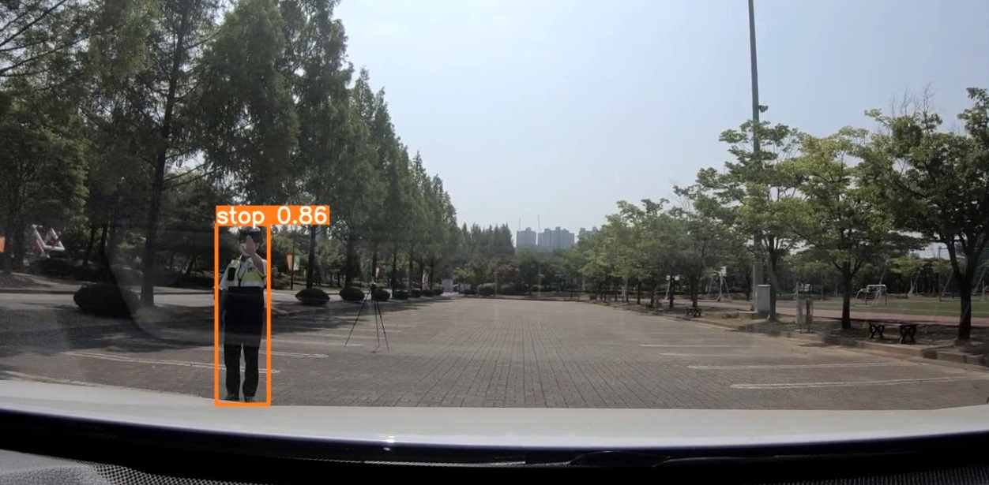
▲ Vehicle recognition of hand signal for traffic stop (front): Recognition of hand signal stop through vehicle camera equipped with hand signal recognition AI technology developed by the research team

The vehicle demonstration was conducted under the supervision of the Institute for Information and Communication Planning and Evaluation (IITP) during a scenario where the autonomous vehicle recognizes the police hand signal and stops.

Vision sensors (11 cameras) and GPS sensors were used in the autonomous vehicle used in the demonstration for real time traching. The vision sensor ▴ identifies the surrounding environment based on the autonomous driving vehicle ▴ recognizes hand signals from police officers that appear while driving, and the GPS sensor ▴ identifies the exact location of the vehicle and ▴ determines the route the autonomous vehicle travels to the destination.

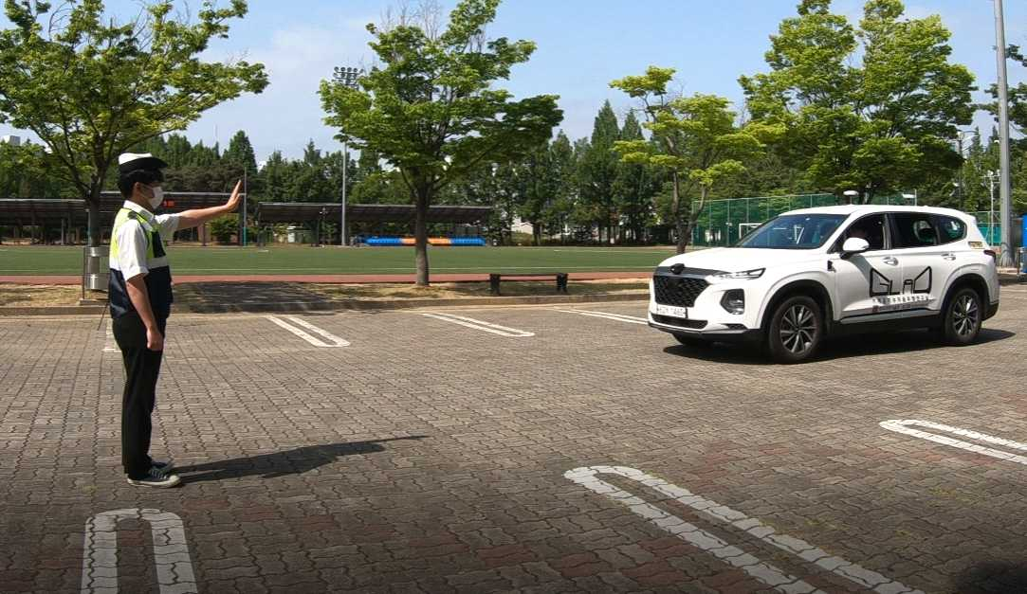
▲ Vehicle recognition of hand signal for traffic stop (side): The autonomous vehicle recognizes hand signal stop while driving to its destination and stops the vehicle

The vehicle recognized the police officer's hand signal motion through AI technology developed based on the vision sensor and then controlled the vehicle according to the hand signal motion.

Professor Yong Gu Lee said, "The traffic control hand signal information of traffic police and traffic safety personnel collected by the research team will serve as a guideline for future hand sign-equipped vehicles as a major database for autonomous driving and artificial intelligence industries. This is expected that the hand-signal object detection technology developed this time will serve as a cornerstone and accelerate the emergence and generalization of future automobiles."

Under the guidance of GIST Professor Yong Gu, researchers Seongjae Lee, Inwoo Hwang, Joon Oh Kim, and Taehyung Gil conducted this research with the support of the Information and Communication Planning and Evaluation Institute (IITP)'s 'Development of Open Dataset and Cognitive Processing Technology for Atypical Dynamic Characteristics Affecting Autonomous Driving.'



