Drugs that cause 'cardiotoxicity' are predicted by AI models!

– Predict the cardiac toxicity of early-stage drugs with high accuracy and reliability

– Professor Hojung Nam's team published in Briefings in Bioinformatics, an international journal of bioinformatics

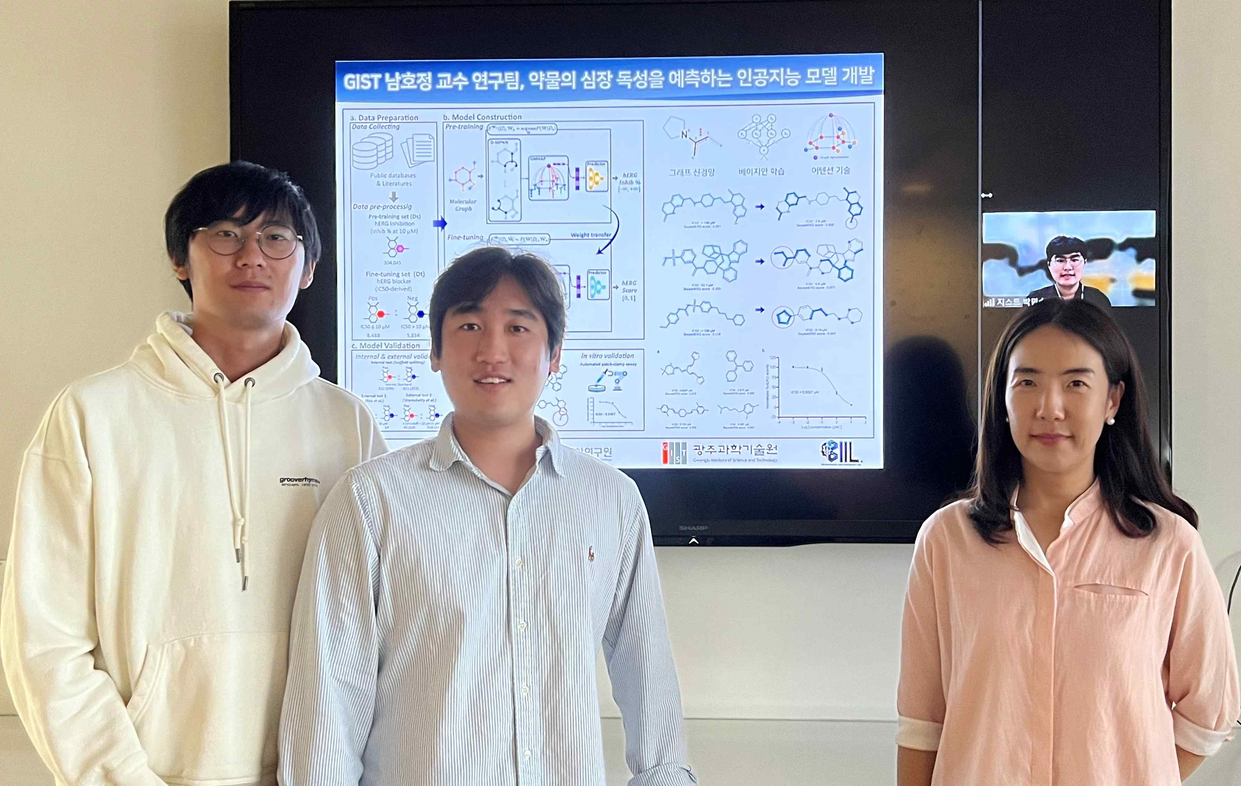
▲ (From left) Integrated student Ingoo Lee, integrated student Hyunho Kim, Professor Hojung Nam, and integrated student Minsu Park (screen)

When developing a new drug, an artificial intelligence (AI) model has been developed that can predict whether a drug will cause “cardiotoxicity”* in patients.

* Cardiotoxicity: When drugs such as anticancer drugs are administered to the body, there is a possibility or causes fatal side effects by disrupting the normal heartbeat system by interfering with the regulation of heart activity.

This is expected to contribute to dramatically reducing trial and error frequently occurring in the new drug development stage by more accurately predicting the probability of causing cardiac toxicity of a new drug under development.

GIST (Gwangju Institute of Science and Technology, President Kiseon Kim) School of Electrical Engineering and Computer Science Professor Hojung Nam's research team developed an artificial intelligence prediction technology that can identify drugs that interfere with the activity of the hERG* channel, a gene that controls heartbeat, at the development stage.

* hERG (human ether-à-go-go-related gene): A gene that regulates the heartbeat by regulating the flow of potassium (K+) ions in the heart. The hERG ion channel present in the cardiac cell membrane plays an important role in regulating cardiac activity, and drug inhibition of this channel activity may cause Torsades de pointes. Several drugs on the market have been withdrawn due to cardiac toxicity due to unintentional inhibition of the hERG channel.

Cardiotoxicity caused by drugs such as anticancer drugs is considered a major challenge in the development of new drugs. The best way to evaluate the potential for toxicity is to use human cells or tissues. In the case of the heart, surgery to cut a part is very rare, and it is very difficult to use it for toxicity evaluation because it is difficult to isolate and culture cells.

In addition, biological and chemical verification performed in the preclinical stage of the new drug development stage has the disadvantage of being time-consuming and costly.

The research team is developing an artificial intelligence technology for predicting 'hERG channel inhibitors' that can cause cardiac arrhythmias. Compared to the existing artificial intelligence model, it succeeded in securing high accuracy, reliability, and interpretability (3~18% improvement in balance accuracy compared to the comparative model).

The research team not only familiarizes themselves with various compound structures by pre-learning large amounts of data not used in previous hERG inhibitor prediction studies through artificial intelligence. By transferring the prior knowledge closely related to hERG inhibition to the model, they confirmed the significantly improved predictive performance compared to the existing predictive models.

In addition, the prediction probability is higher compared to other models to which Bayesian deep neural network technology* is not applied. Reliability and interpretability were verified by confirming that the newly developed model correctly focused on the partial structure related to hERG channel inhibition through attention technology**.

* Bayesian deep neural network technology: It refers to a technology that makes a general deep neural network into a probabilistic model based on Bayesian probability. The representative method and the technique used in this study is Monte-Carlo dropout. This technique is a method that can estimate the distribution of predicted values by activating dropout during validation as well as training.

** Attention technology: A learning technique that allows a model to learn by highlighting itself from input data to help predict information. It has the advantage of increasing interpretability and learning efficiency, which could not be expected from existing deep neural network models.

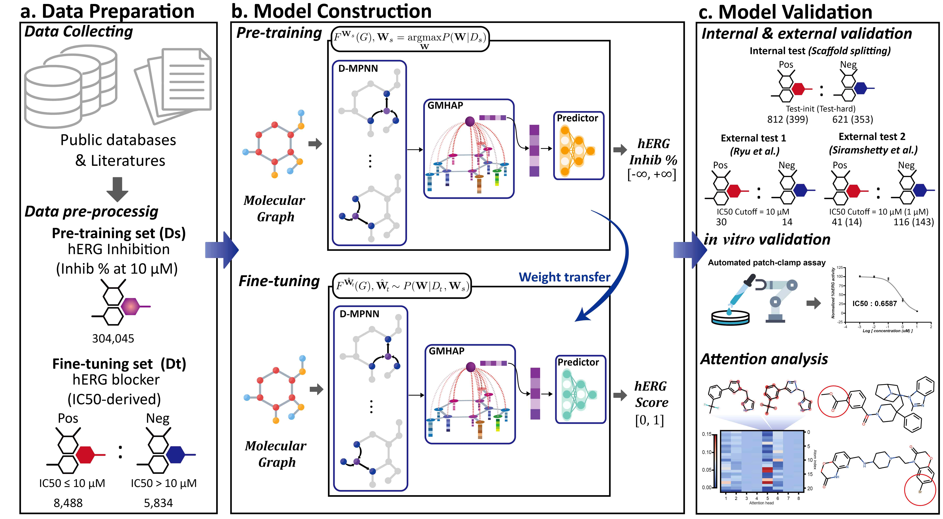
▲ An overview of the BayeshERG study. It comprehensively shows the data used in the study, the detailed structure of the model, and the evaluation and analysis methods.

It shows high prediction accuracy compared to various currently published AI models, and the reliability of the prediction score is 30% higher than that of the basic model. Also, there is a difference in that it can be interpreted by presenting the partial structure of the compound that causes toxicity.

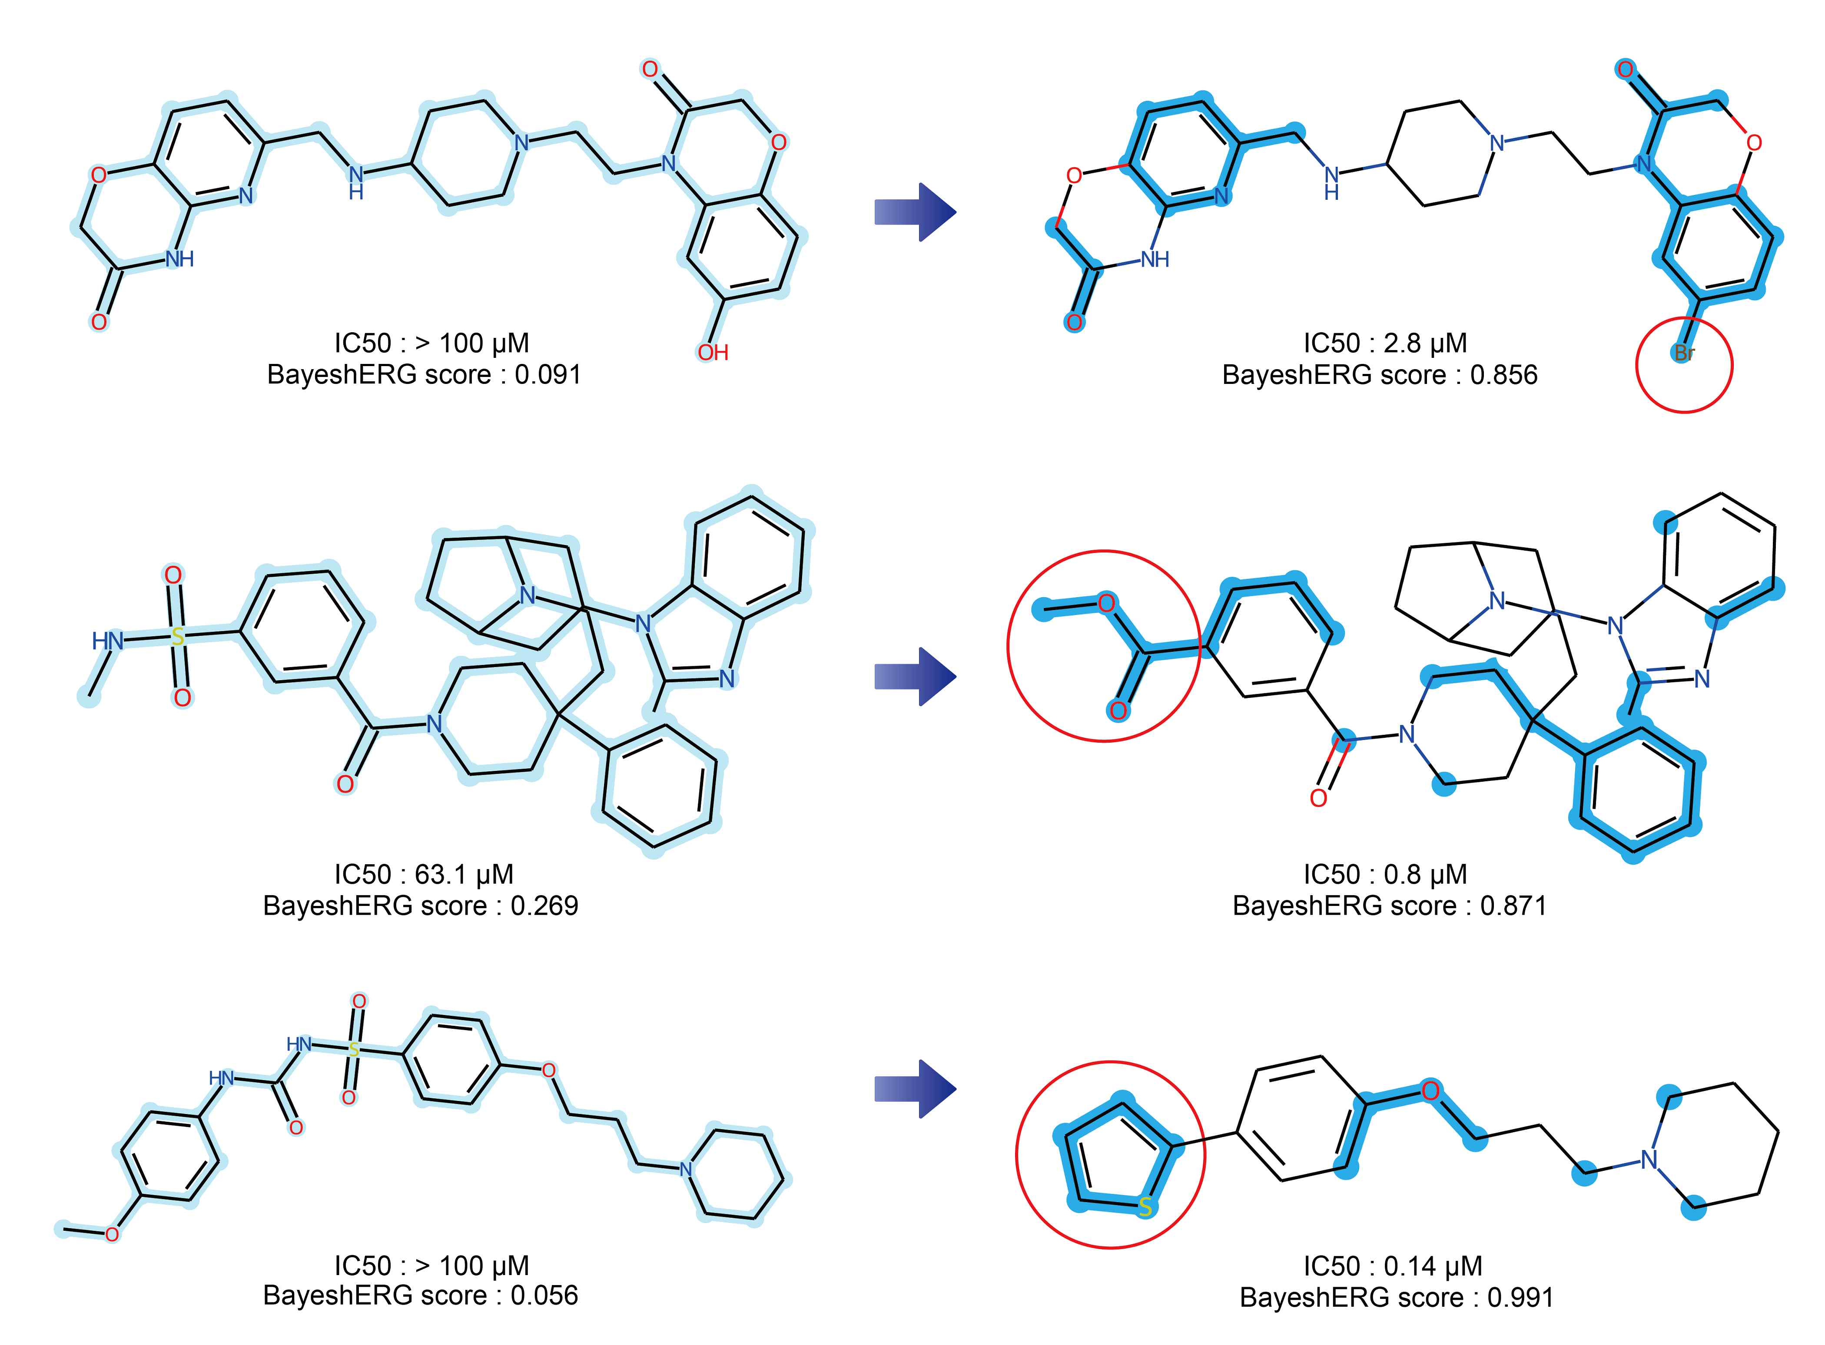
▲ The prediction and analysis results of the model. It can be seen that the model not only accurately predicts the prediction but also emphasizes and predicts the partial structures that made the difference in the actual hERG channel inhibition level.

Professor Hojung Nam said, "This is an important study that can greatly contribute to securing the efficiency and drug stability in the new drug development stage by predicting with high accuracy and reliability the potential of a drug to induce cardiac toxicity in the early stage of drug development."

This research was carried out with support from the National Research Foundation of Korea’s 'Development of a system for predicting toxicity and side effects of drug candidates based on explainable artificial intelligence' and was published online on June 17, 2022, in Briefings in Bioinformatics, a world-renowned academic journal in the field of bioinformatics.



