Development of organic semiconductor-based large-area module system for long-term and mass production of 'Green Hydrogen'

– Development of module with metal-encapsulated organic semiconductor photocathode that maintains performance for a long time
– "Confirmation of the possibility of mass production of eco-friendly hydrogen"... Prof. Sanghan Lee, cover paper for Journal of Materials Chemistry A


▲ (From left) Professor Sanghan Lee, Dr. Sehun Seo,
Dr. Jong-Hoon Lee, and integrated student Yejoon Kim

A Korean research team has developed a large-area module system that can produce hydrogen for a long time and in large quantities using a relatively inexpensive and efficient organic semiconductor*-based photoelectrode.

Eco-friendly photoelectrochemical water splitting** technology that efficiently produces hydrogen without carbon dioxide emission using solar heat is expected to contribute to advancing commercialization by improving the efficiency and stability of the so-called ‘green hydrogen’ production technology.

* organic semiconductor: A material made up of bonds between a polymer skeleton made of carbon bonds and hydrogen atoms or minor atoms such as nitrogen, sulfur and oxygen. Although it has insulator properties, it has semiconducting properties by adding impurities to the pi bond. Because it is relatively inexpensive and the production method is flexible and diverse, it is in the spotlight in various fields.

** photoelectrochemical water splitting: A representative method of converting solar energy into hydrogen, an eco-friendly energy source. When solar energy is supplied to the semiconductor photoelectrode, electron-hole pairs are generated. Through this, water is decomposed to generate oxygen from photogenerated holes at the photoanode and hydrogen from photogenerated electrons at the photocathode, which is environmentally friendly. can produce hydrogen.

Organic semiconductors are relatively inexpensive compared to other semiconductor materials and have a variety of process methods, so they are easy to produce on a large scale and large area and have high energy conversion efficiency, making them a promising photoelectrode material.

However, organic materials themselves are vulnerable to moisture, so for the practical use of hydrogen production through photoelectrochemical water decomposition, it is urgent to develop a technology that allows the organic semiconductor to be operated for a long time without significant deterioration in performance.

GIST (Gwangju Institute of Science and Technology) School of Materials Science and Engineering Professor Sanghan Lee's research team presented an organic semiconductor photoelectrode-based module system that enables the production of large amounts of hydrogen from solar energy.

The research team succeeded in maintaining the highest stability among organic semiconductor photocathodes reported so far by applying metal encapsulation* technology that prevents moisture from penetrating into the photoelectrode so that the organic semiconductor can be operated for a long time.

* metal encapsulation: A technology that guarantees the stability of materials by sealing materials that are vulnerable to moisture, such as organic semiconductors. The material to be sealed is completely blocked from penetration of external moisture by using liquid metal (indium-gallium alloy) and a protective layer (metal foil). In previous studies, it was introduced into an organometal halide perovskite-based photocathode and showed excellent performance.

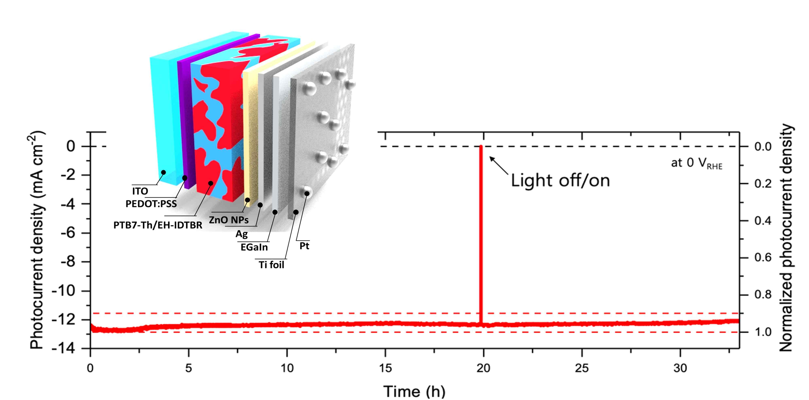
▲ Schematic diagram of a metal-encapsulated organic semiconductor photoelectrode. The photoelectrode fabricated in this way was maintained for more than 30 hours without significant degradation in performance, which shows the highest stability among organic semiconductor photoelectrodes reported to date.

Compared to the initial performance, the organic semiconductor photocathode of the research team maintained 95% or more of the performance for 30 hours or more and secured stability improved for at least 20 hours compared to the previous study. In addition, compared to the previous study's highest efficiency of 4.3%, this study achieved a high photocurrent of 12.3mA·cm-2 and a high half-cell efficiency of 5.3%.

The research team developed a photoelectrode module system that connects organic semiconductor photocathodes that can be driven for a long time, and operated it under actual sunlight. As a result, we confirmed the possibility of hydrogen production of a large-area organic semiconductor photocathode-based module system in the real environment beyond the laboratory unit.

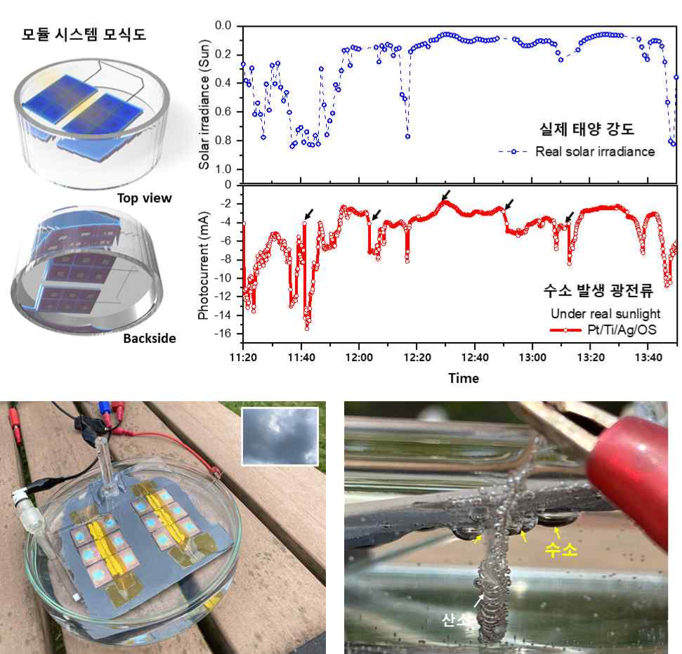
▲ Schematic diagram of the organic semiconductor photoelectrode-based module system developed by this research team. It was manufactured by connecting organic semiconductor photoelectrodes with high stability, and hydrogen production was carried out under actual sunlight through the manufactured module system.

Professor Sanghan Lee said, "Through this research, the stability problem, which is a big issue of organic semiconductor-based photoelectrodes, has been overcome, and the large-area photoelectrochemical module system developed based on this will greatly contribute to advancing the commercialization of eco-friendly hydrogen mass production technology."

This research was led by Professor Sanghan Lee and conducted by Dr. Sehun Seo (Lawrence Berkeley National Laboratory), Dr. Jong-Hoon Lee (University of Illinois Urbana-Champaign), and integrated GIST student Yejoon Kim with support from the Future Hydrogen Source Technology Development Project supported by the National Research Foundation of Korea, the Senior Researcher Project, and the GIST-MIT Joint Research Project and was selected as a cover paper in the Journal of Materials Chemistry A (IF=12.732), which is the top 7% paper in the energy field, and was published online on June 28, 2022.



