Professor Jae Young Lee's research team develops hydrogel with lower toxicity and higher conductivity through graphene three-dimensional structure

– Development of conductive hydrogel for various medical applications such as bioelectrodes and cell supports
– Professor Jae Young Lee's team published a thesis in Chemical Engineering Journal... “Expectation to replace metal bioelectrodes”

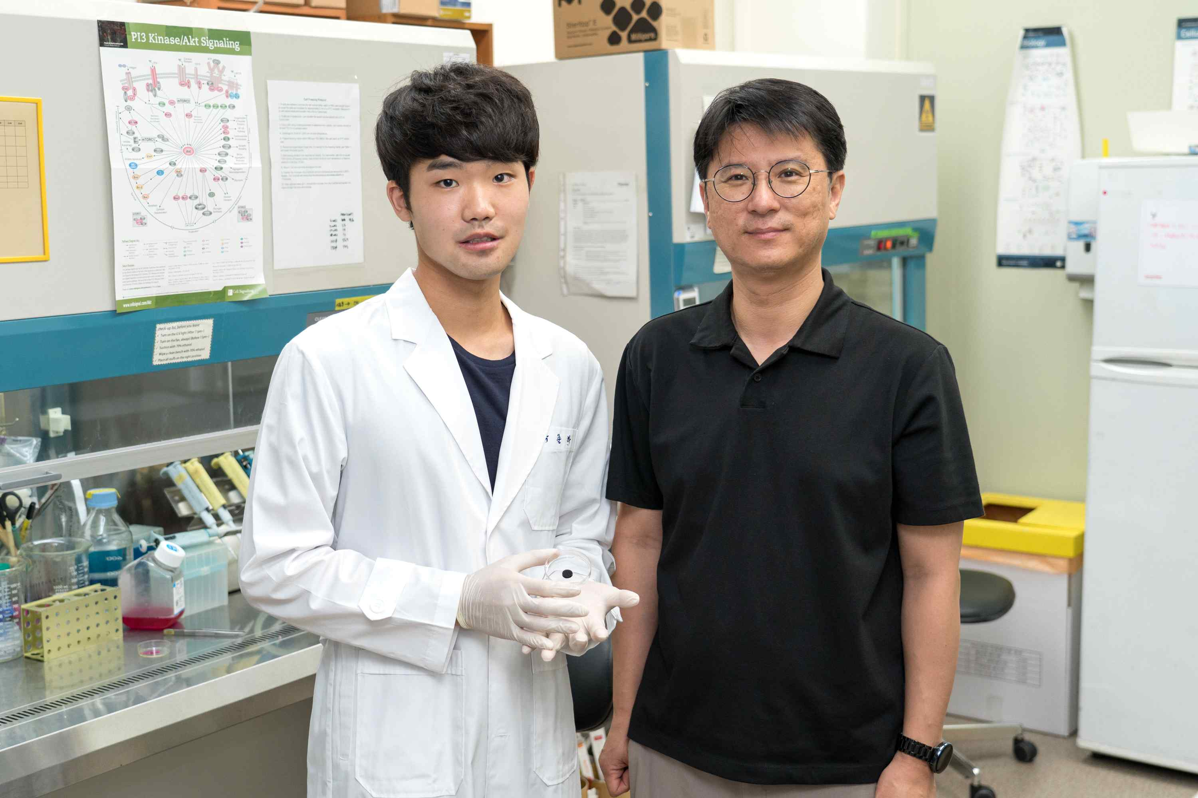
▲ Ph.D. student Junggeon Park (left) and Professor Lee Jae-young of the School of Materials Science and Engineering

A multifunctional hydrogel has been developed that lowers toxicity in the human body and improves electrical conductivity by three-dimensionally structuring graphene*, which is called the 'dream material.' In the future, it is expected that it can be applied to bioelectrodes and cell support (scaffolds)** that are more suitable and efficient for our body by replacing metal-based electrodes.

* graphene: A two-dimensional material composed of carbon atoms in the shape of a honeycomb. In theory, it has much higher strength than steel and has excellent thermal and electrical conductivity, so it is called a dream material. However, its use in biomedical engineering is limited due to problems such as the production of a three-dimensional structure or hydrophobicity by transferring it.

** bioelectrodes and cell support (scaffolds): Conductive biomaterials are widely used as electrodes for monitoring biosignals, electrodes for stimulation, or scaffolds targeting electroactive tissues such as muscles, nerves, and heart.

Conductive biomaterials can effectively mediate electrical signals with cells or tissues, so they are widely used in cell supports (scaffolds) and bioelectrodes for the regeneration of electrically active tissues in the human body, such as heart and muscle. However, since most of them are made of metal-based materials, there are limitations to their use as implantable biomaterials, such as causing inflammation or lowering contact efficiency when implanted in a living body.

Therefore, in recent years, development of a conductive hydrogel with excellent electrical properties, soft and flexible, has been in progress. A large amount of conductive material required to produce such a hydrogel induces biotoxicity, and studies are underway to overcome this by hardening the hydrogel.

GIST (Gwangju Institute of Science and Technology) Professor Jae Young Lee's research team developed a hydrogel manufacturing technology with a three-dimensional graphene network by controlling the arrangement and alignment of graphene for improved conductivity compared to the conductive material content in the hydrogel. Through this study, the usefulness of bioelectrical signal measurement, pressure/strain electrode, bioprinting ink, and cell support was suggested.

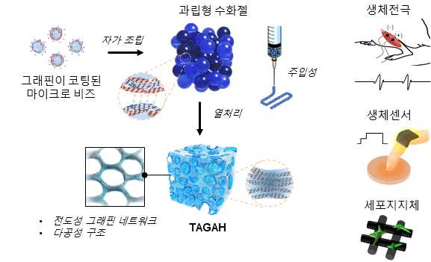
▲ Schematic diagram of the development of conductive hydrogels containing graphene networks and their applications in biomedical engineering

The research team coated graphene on microbeads (agarose* hydrogel with a diameter of about 30 μm) to form a three-dimensional network of graphene and induced interaction by surface charge to form particles by surface charge. A granular hydrogel was prepared by self-assembly by liver aggregation. A paste-like hydrogel was prepared by aggregation between particles by surface charge.

Then, when the dough-type hydrogel is heat-treated, the microbeads melt by heat and move between the graphene layers, and the graphene coated on the beads is connected to each other to form a three-dimensionally connected graphene network as a whole.

* agarose, agar: One of the polysaccharides, it is made by purifying agaropectin from agar made by extracting agar agar. It is soluble in warm water, and a solution of about 1% or more becomes a gel when cooled. Since this gel has a net-like structure and high molecular substances diffuse freely, it is used as a support for electrophoresis or as a filler for gel filtration.

The research team produced various types of conductive hydrogels through 3D printing and casting. The hydrogel produced in this way showed a high conductivity of 20 mS/cm* even with a very small amount of graphene equivalent to 0.15% of the total volume of the hydrogel compared to previous studies.

This is about 5 times higher conductivity value than the control that is not structured with the same amount of graphene. In addition, it was confirmed that it has an elasticity of 130 kPa, similar to that of the muscles of our body, and has mechanical flexibility suitable for use in the living body.

* S (Siemens): Siemens (symbol S) is the international unit for electrical conductance, equal to the reciprocal of ohms. 1 Siemens (S) is the conductivity that allows a current of 1 ampere (A) to pass when a voltage of 1 volt (V) is applied. 1 S/cm = 1,000 mS/cm (milli-siemens per centimeter)

Professor Jae Young Lee said, "By using a small amount of conductive material, the risk of toxicity was reduced, the conductivity and biocompatibility of the hydrogel were improved, and at the same time, a hydrogel was produced that had the same flexibility as human tissue. In the future, this is expected to be used as a biocompatible and more efficient electrode, sensor, and tissue engineering scaffold that can be used in the human body by replacing metal-based electrodes."

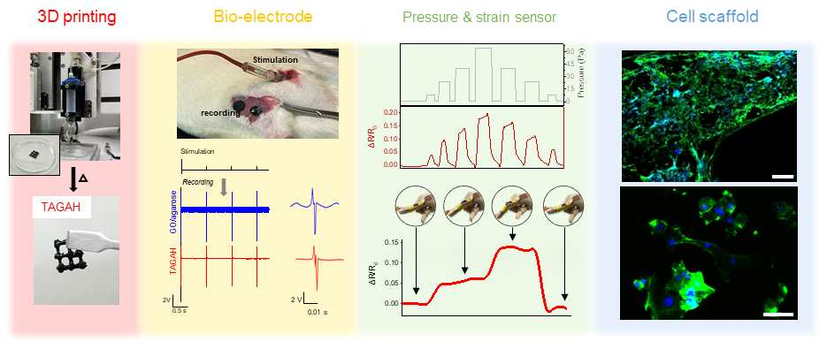
▲ Results applied to actual biomedical engineering applications (3D printing, bioelectrode, biosensor, cell support)

This research was conducted by Professor Jae Young Lee's team at GIST with support from the National Research Foundation's Basic Lab Project and the Nano and Material Technology Development Project and was published online on June 11, 2022, in the Chemical Engineering Journal, which is the top 2.45% paper in the field of chemical engineering.



