Professor Chang Wook Ahn's research team develops 'optimization algorithm' to increase quantum computer efficiency

– Identification of the unique morphology of quantum algorithms through a creative approach beyond the simple simulation of classical algorithms

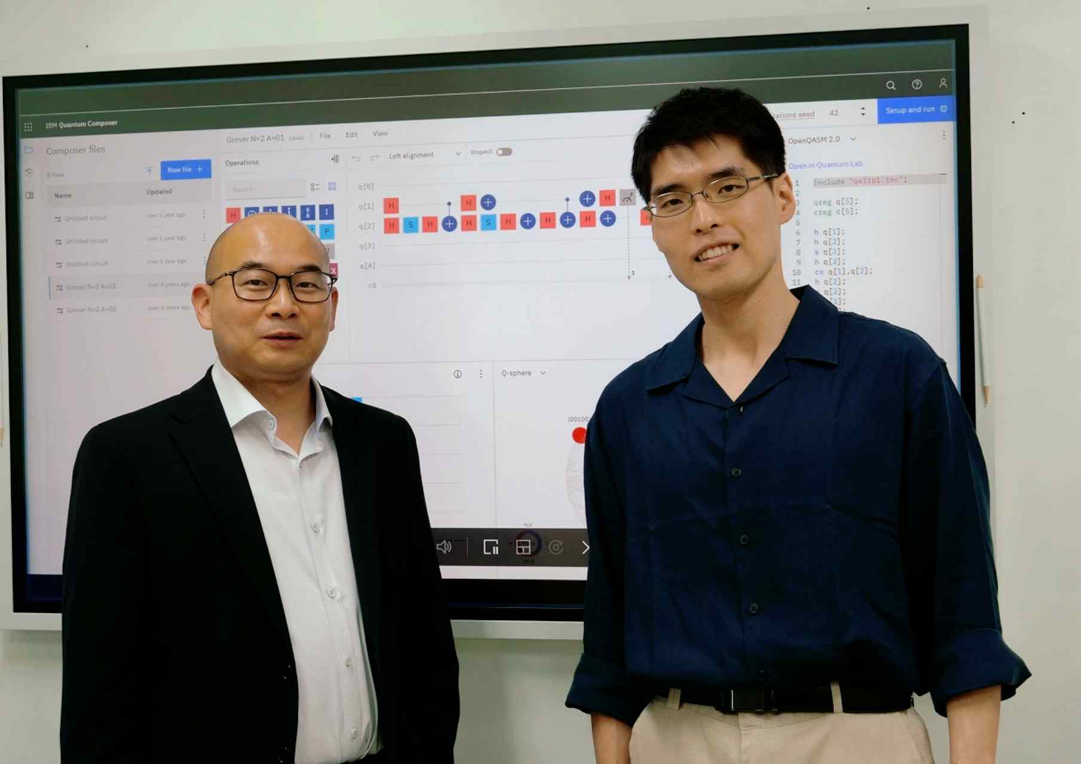
▲ (From left) GIST Professor Chang Wook Ahn and Ph.D. student Jun Suk Kim

The era of quantum computers, which surpasses the performance of supercomputers, is approaching. Quantum computers are expected to spur innovation in various industries as they are attracting attention as futuristic computers because they can perform high-speed calculations that are hundreds of millions of times faster than supercomputers. A Korean research team reported the results of a study that improved the structure of an optimization* algorithm suitable for quantum computers** more efficiently.

* optimization: A mathematical technique that finds the optimal value for a given problem.

** quantum computer: A high-tech futuristic computer that transcends the limits of supercomputers by using atoms, not semiconductors, as memory elements. Quantum computers process information by utilizing quantum mechanical phenomena such as superposition and entanglement. It is considered a next-generation technology because it can dramatically reduce the time required to process massive data as well as decrypt encryption.

GIST (Gwangju Institute of Science and Technology, President Kiseon Kim) Professor Chang Wook Ahn's research team announced that the structure of an algorithm has been improved to dramatically increase computational efficiency while maintaining the optimization performance of the existing semit-classical quantum genetic algorithm*.

* semi-classical quantum genetic algorithm: A quantum computer-specific optimization algorithm that is currently under continuous theoretical research. It aims to realize optimization through the Darwinian evolution process in a quantum computer.

This study is expected to serve as a stepping stone for practical quantum optimization algorithm research in the future by considering efficiency as a computational method that only quantum computers can do.

Quantum genetic algorithm is an attempt to reproduce technologies that have been proven in classical* computers, such as quantum neural networks and quantum reinforcement learning, on a quantum computer to implement a meta-heuristic** approach to ‘global optimization’ that finds the optimal solution in the entire search domain, which is the strength of genetic algorithms, in quantum computers.

* classical: As a concept in contrast to quantum computers, it refers to a general computer operating system that is widely used today.

** meta-heuristic: As one of the optimization strategies, it goes through the process of gradually finding an approximation of the optimal solution for an unspecified problem.

Wavefunction collapse*, which inevitably occurs in a quantum system, conflicts with the working principle of a genetic algorithm that finds a solution through iterative operations. Existing anti-classical quantum genetic algorithm studies have solved this problem by creating a large number of randomized individuals during population formation.

* wavefunction collapse: Refers to a phenomenon in which several quantum states formed by superposition converge to a single quantum state with a definite measurable quantity after observation.

This study hypothesized that these random entities hardly contribute to the optimization work of the algorithm and then attempted to improve the quantum circuit to minimize the generation of random entities while maintaining the Darwinian evolutionary structure of the algorithm.

Through this, when forming a population in each generation, a structure was designed to generate only individuals who fully or partially possess the genetic characteristics of the superior individuals obtained from the previous generation.

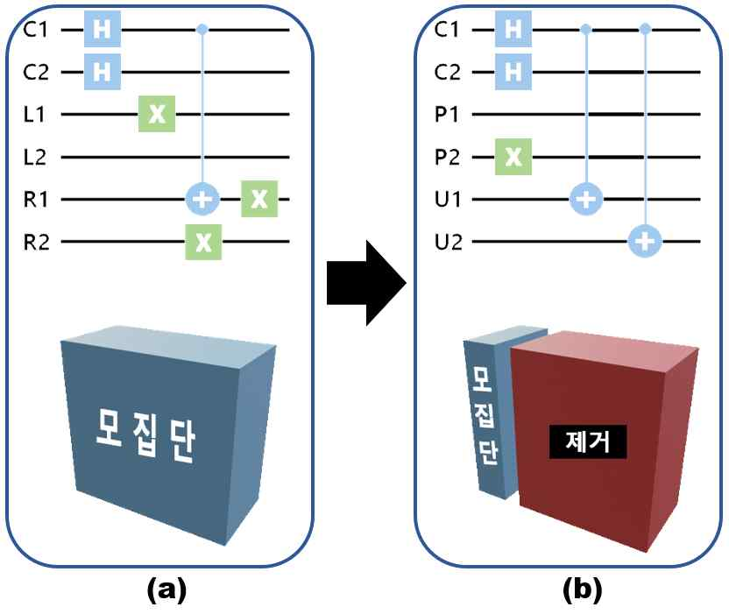
▲ semi-classical quantum genetic algorithm circuit improvement and consequent change in quantum population composition. (a) Existing circuits generate a large number of unnecessary entities that do not significantly affect the optimization task. (b) The improved circuit greatly reduces the computational amount of the genetic operator and improves the efficiency of the entire algorithm by removing these entities in advance.

An experiment was conducted to compare the performance of this improved algorithm by applying it to the optimization problem together with the previous algorithm. In fact, while achieving the same level of optimization as the previous algorithm, the total number of fitness evaluations was reduced from 2560 to 432, demonstrating a performance improvement that reduces the amount of computation required for each generation by up to 80%.

As a result, the researchers succeeded in increasing the computational efficiency of the algorithm by about 5 times by preventing the degradation of the original optimization performance of the algorithm and reducing the size of the population quadratic.

Professor Chang Wook Ahn said, "Quantum computers are expected to change the landscape of future industries and security ecosystems by quickly finding answers to optimization problems such as new drugs and energy development, semiconductor design, autonomous vehicles, and flight routes. This study has achieved practical performance improvement through a creative approach beyond the notion of classical computers and is expected to lead to the development of more effective quantum optimization algorithms in the future."

This research was led by GIST Professor Chang Wook Ahn and conducted by doctoral student Jun Suk Kim with support from the National Research Foundation of Korea. The research results were published online on May 20, 2022, in Future Generation Computer Systems, an international scientific journal in the field of computer science theory and methods.



