Identification of a new mechanism of cancer metastasis protein! Patent application for related peptide anticancer drug

– Identification of cell signal transduction mechanism through colorectal cancer mouse experiment... Discovering peptides that interfere with cancer cells

– Professor Jeong-Seok Nam's team published a thesis on Theranostics, an international medical journal


▲ (Counterclockwise from bottom left) student So-El Jeon, student Jee-Heun Kim, Professor Nam Jeongseok, student Choong-Jae Lee, student Jin-wook Han, student Tae-Young Jang, and student Hyeon-ji Yoon

A Korean research team proposes a new mechanism to promote cancer metastasis, which accounts for more than 90% of cancer deaths. They succeeded in discovering a peptide anticancer drug to suppress this.

The results of this study are expected to contribute to the preparation of new anticancer treatment strategies with fewer side effects in the future.

Cancer is a difficult disease to treat due to recurrence and metastasis. It is known that most of the deaths due to cancer are due to dysfunction of essential organs due to metastasis rather than 'primary' (which occurs for the first time in an organ).

To overcome cancer metastasis, it is necessary to identify specific mechanisms for cancer metastasis and establish a therapeutic strategy to control it.

GIST (Gwangju Institute of Science and Technology, President Kiseon Kim) School of Life Sciences Professor Jeong-Seok Nam's research team confirmed that 'dysadherin,' a cancer metastasis protein*, promotes cancer malignancy and metastasis through cell signal mechanotransduction** mechanism.

* cancer metastasis protein: Dysadherin is a cancer-specific protein that has been proven to have higher levels of expression, especially in invasive/transmissible cancers, and is classified as a dark metastatic protein in the U.S. National Institute of Human Genetics's disease genetic database.

** mechanotransduction: converting a physical or mechanical signal transmitted from outside the cell into a chemical signal

The research team verified that the expression of dysadherin was specifically higher in cancer tissues than in normal tissues of the same patient through tissue analysis of colorectal cancer patients. Based on this, inhibition of tumor formation and invasion was confirmed in dysadherin knockout mice* through a colorectal cancer mouse experiment.

* knockout mice: mice in which a specific gene is made to stop working

The research team found that dysadherin binds with fibronectin, a structural component of the extracellular matrix (ECM), to increase the physical force applied to cancer cells. As a result, it was confirmed that the protein* related to the cell signal mechanotransduction mechanism was activated, leading to cancer malignancy and metastasis.

* examples: Integrin, focal adhesion kinase (FAK), YAP, etc.

Based on this new understanding of the promotion of cancer metastasis, the research team revealed the amino acid sequence of the portion where disedherin binds to fibronectin and discovered a peptide that interferes with disedherin-fibronectin binding.

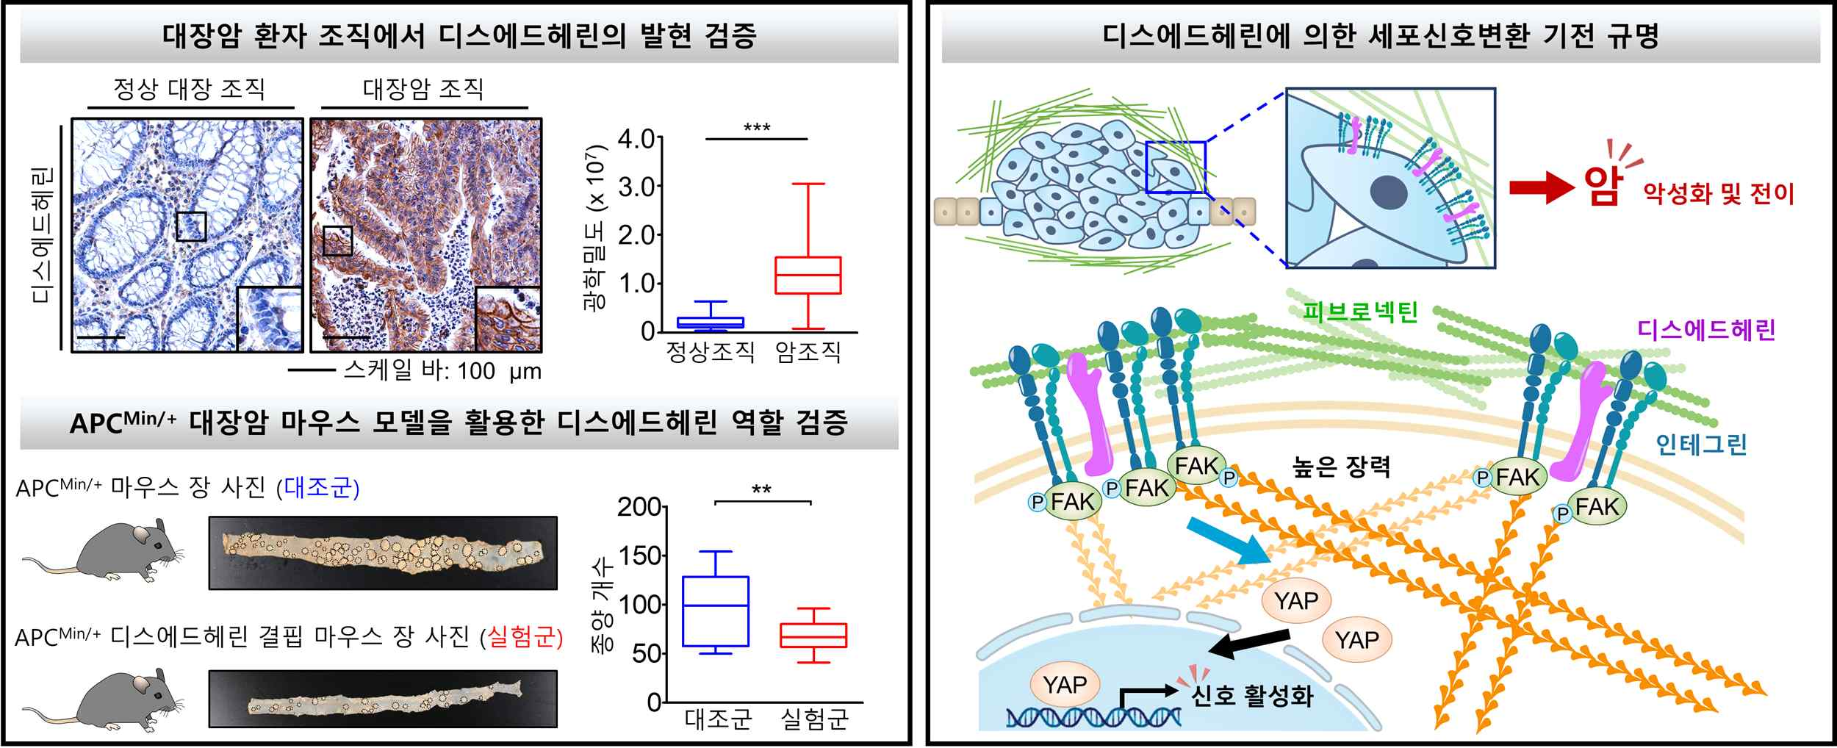
▲ Identification of cell signal mechanotransduction mechanism by dysadherin
Left) It was observed that the expression of disedherin was higher in cancer tissues than normal tissues of the patient, and it was confirmed that the number of tumors formed when disedherin expression was suppressed in the colorectal cancer mouse model decreased.
Right) It was found that disedherin binds to fibronectin and activates cell signal transduction mechanisms such as focal adhesion kinase and YAP, thereby causing cancer malignancy and metastasis.

The research team proved that the discovered peptide interferes with the survival of cancer cells by interfering with the binding of dysadherin-fibronectin. The experimental basis was presented to establish a new preventive and therapeutic technique for cancer metastasis.

Professor Jeong-Seok Nam said, "This study is significant in that it identified a mechanism that promotes cancer malignancy and metastasis by dysadherin, which is specifically expressed in cancer cells, and discovered a peptide that inhibits it. It is expected that it will become a possibility for a new treatment strategy with fewer side effects in the future."

This research was led by GIST Professor Jeong-Seok Nam and conducted by Dr. So-Yeon Park and Choong-Jae Lee, an integrated master's and doctoral student, and was carried out with support from the National Research Foundation's Senior Researcher Support Project, SRC Leading Research Center Support Project, and GIST GRI Project and was published online on May 21, 2022, in Theranostics, an authoritative magazine that specializes in the top 6.07% in the medical field. In addition, a patent was applied for a novel peptide and an anticancer composition comprising the same.



