'Energy Harvesting' technology to save friction electricity felt from doorknobs and hair

– Energy efficiency 40 times higher than before... Expected to be applied to wearable devices and IoT

– GIST and Chonnam National University joint research team publishes an internal cover paper in Small Methods in the field of materials


▲ (From left) GIST Professor Chanho Pak, Chonnam National University Professor Jong-Jin Park, GIST integrated student Jong Gyeong Kim, Chonnam National University master's student Seokjun Cha

A technology that converts triboelectric energy*, which is routinely discarded, into electrical energy with higher efficiency has been developed by a Korean research team.

It is a technology that improves the conversion efficiency of existing triboelectric energy by about 40 times, and it is expected to be used as a power source for wearable devices and the Internet of Things (IoT).

* triboelectric energy: When different substances rub against each other, they are separated into positive and negative charges due to the charging phenomenon, which causes it to usually sting when you touch the doorknob in winter or the phenomenon of hair floating caused by frictional charge.

To increase the storage efficiency of triboelectricity, it is important to prevent charge loss on the electrode surface and move the charge to the center of the electrode.

However, previous studies have overlooked the process of charge transfer or the interpretation of charge transfer and storage phenomena caused by the use of inorganic materials.

GIST (Gwangju Institute of Science and Technology, President Kiseon Kim) Graduate School of Energy Convergence Professor Chanho Pak's joint research team with Chonnam National University Department of Polymer Science and Engineering Professor Jong-Jin Park has developed a groundbreaking method to convert the friction surface into a state that can have more positive (+) and negative (-) electromotive force for efficient energy harvesting from materials that are discarded in daily life.

The research team uses the phenomenon that the larger the external specific surface area* of porous carbon**, the better the charge, and the smaller the charge, the faster the charge movement. The friction electricity storage efficiency was improved by stacking three types of porous carbon whose external specific surface area was changed to control the movement of charges.

* specific surface area: Specific surface area refers to the surface area of a material per unit weight. The external specific surface area refers to the surface area exposed to the outside, and the larger it is, the larger the space that can hold the charge.

** porous carbon: Porous carbon refers to a carbon material containing a large amount of pores. The more pores, the greater the surface area.

As a result, the conventional triboelectric generator that did not use porous carbon showed an output voltage of 15.2V. Using the method and materials of this study, it was possible to obtain an output voltage of 600V, which is about 40 times higher than that of the previous one.

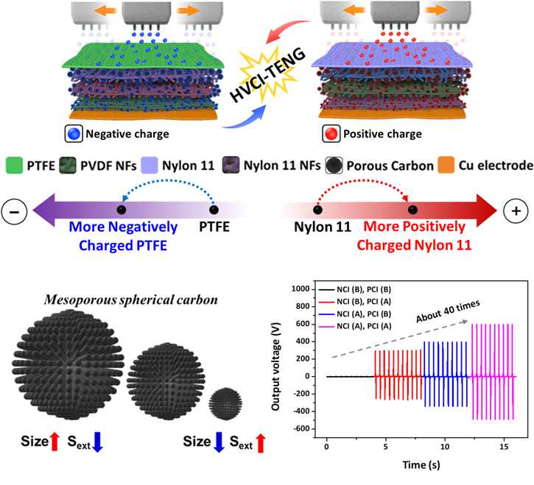
[Figure] Schematic diagram of injecting and storing electric charges in triboelectric electrodes (top) and the relationship between particle size and external specific surface area (larger particles, smaller external specific surface area, bottom left). Output voltage increase due to charge injection (NCI: negative charge injection, PCI: positive charge injection, A: injection, B: no injection, bottom right.

Whereas previous triboelectric energy harvesting* studies focused on simple changes in the surface chemical structure or improvement of physical surface area, this study used porous carbon to explain the charge transfer and storage inside the triboelectric generator material. In subsequent research, the possibility of developing various materials and material composition was opened.

* Energy Harvesting: A technology that generates electricity by collecting energy wasted around it. Energy generated from natural energy sources such as heat or vibration is converted into electrical energy and 'harvested.' Since it is possible to maintain the stability, security, and continuity of supply by collecting and utilizing clean energy that exists in nature or small energy that is normally ignored, it is in the spotlight as a new and renewable energy source technology. It also has the advantage of being eco-friendly because it does not use fossil fuels.

GIST Professor Chanho Pak said, "Using a porous carbon material, we developed a device that can harvest and use triboelectric or static electricity discarded from the surroundings. We plan to apply it to actual wearable devices through future material development."

Chonnam National University Professor Jong-Jin Park said, "The development of a porous material capable of supporting triboelectricity can be expected to result in high energy generation efficiency in various triboelectric-based energy harvesting systems. It is expected as a core material that can be applied as a self-generation material required for wearable devices."

This research was led by the two professors and conducted by GIST integrated student Jong Gyeong Kim and Chonnam National University master's student Seokjun Cha with the support of GIST GRI (GIST Researcher) project and the Industrial Technology Innovation project of the Ministry of Trade, Industry and Energy and was published on May 18th as an inside front cover in Small Methods, an internationally renowned academic journal in the field of materials.



