Independent development of 3D Magnetic Particle Imaging (MPI) device for taking bio-images of companion animals

– Securing a viewing angle up to 5 times higher than before at the same resolution... Expected to be used for treatment of intractable brain diseases

– Professor Jungwon Yoon's team published in IEEE Transactions on Industrial Electronics

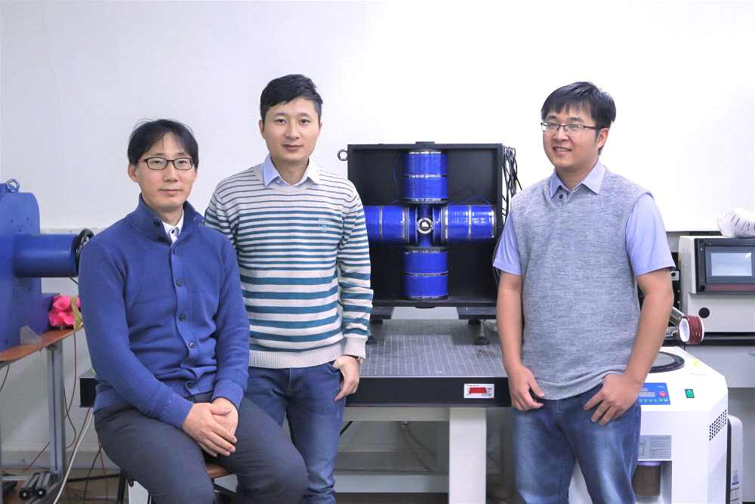
▲ (From left) Professor Jungwon Yoon, postdoctoral
researcher Tuan-Anh Le, and Ph.D. student Minh Phu Bui

A proprietary technology in Korea that can apply the MPI* device, a next-generation medical imaging technology that can only be used for small animals such as laboratory mice, to bioimaging of medium-sized animals such as dogs at veterinary hospitals, etc. was developed.

As a source technology that can develop MPI, it is expected to contribute to the development of patient-specific intractable brain disease treatments such as delivery of targeted drugs to the brain using nanoparticles, non-invasive brain stimulation, and brain tumor fever treatment.

* magnetic particle imaging (MPI): A non-invasive molecular imaging device that can image the concentration and location of iron oxide nanoparticles that are harmless to the living body. Because it can operate without radiation and can capture 3D distribution images in real time, it can be used in various medical fields such as cardiovascular and cerebrovascular diagnosis, cell labeling and tracking, and targeted drug delivery.

MPI technology is a next-generation medical imaging technology that has been developed only by some companies, such as the United States and Germany, which are advanced countries in the medical imaging field, and the commercialized equipment is sold for billions of won. Due to the limitations and physical characteristics of the gradient magnetic field*, only high-resolution medical imaging in small animals is possible.

It is necessary to secure a wide viewing angle in order to photograph a living body of a medium-sized animal or larger. If the bore size is increased to secure a wide viewing angle of the MPI, the gradient magnetic field* rapidly decreases and only low-resolution images can be obtained. Therefore, the development of an MPI medical device that provides high resolution while securing a wide viewing angle for expansion to clinical applications is the most urgent problem to be solved.

* magnetic gradient field: It can be defined as the change in magnetic field (ΔB) divided by the change in distance (Δs). In MPI, the magnetic nanoparticles respond to an excitation field and generate an electrical signal through the generation of a gradient magnetic field to generate a Field Free Point (FFP), which is reduced in size, so that image precision can be increased.

GIST (Gwangju Institute of Science and Technology, President Kiseon Kim) School of Integrated Technology Professor Jungwon Yoon's research team (Intelligent Medical Robotics Laboratory) used magnetic nanoparticles as tracers for medium-sized animals and succeeded in developing a three-dimensional magnetic particle imaging (MPI) device that can capture high-resolution biological images in real time.

The research team developed an MPI system that can be used for medium-sized animals with a bore size of 90 mm and a high gradient magnetic field of up to 4 T/m.

The developed Amplitude Modulation MPI method divides the drive coil required for image scanning and the excitation coil that generates signals from nanoparticles. It is possible to minimize the size, weight and power requirements of the MPI and to provide a high gradient magnetic field while lowering the risk of peripheral nerve stimulation (PNS) occurrence.

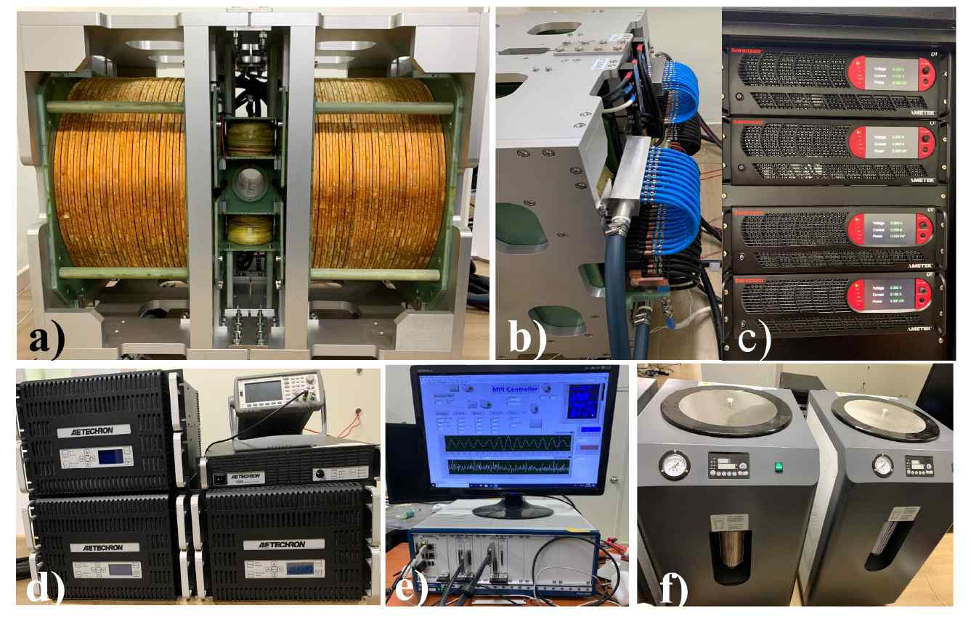
▲ AM-MPI09 device for middle animals: a) MPI front, b) MPI side, c) DC power supply, d) Function generator and power amplifier, e) computer interface device, f) cooling device

Therefore, the developed 3D MPI captures high-resolution (1mm) images at a high speed of 2Hz or higher and secures a viewing angle up to five times wider than that of the existing commercially available MPI device under the condition of a 2.5T/m gradient magnetic field.

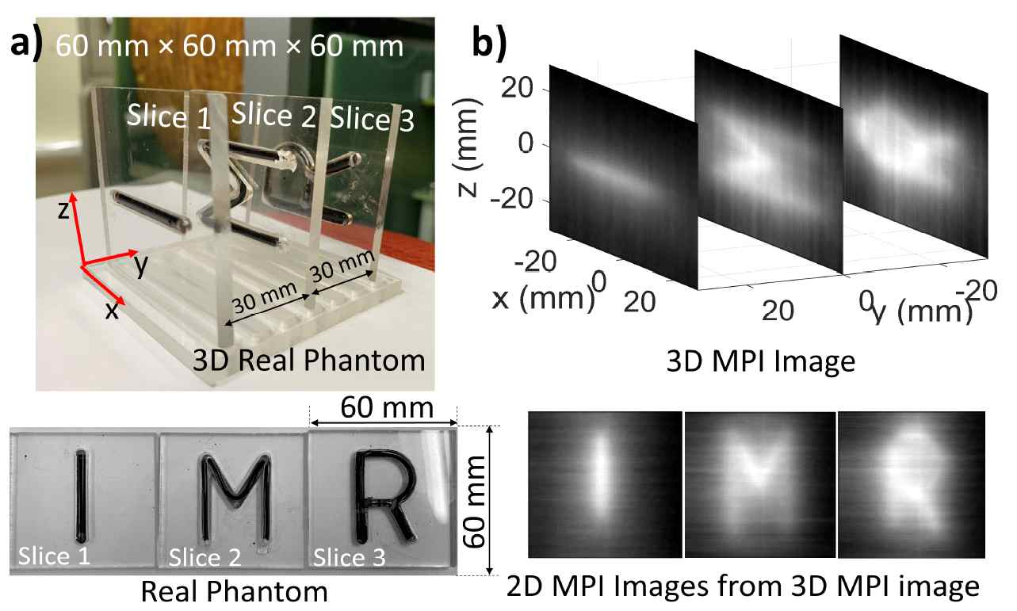
▲ 3D image measured with AM-MPI (a) Real 3D phantom and image (b) 3DMPI image and 2DMPI image (Gx = 2.5T/m/μ0 under gradient magnetic field condition)

Professor Jungwon Yoon said, "The technology developed this time can provide an overwhelmingly wide viewing angle while providing the same resolution as existing MPI devices, so it is expected that the range of use will be further increased than before. The localization of high-resolution 3D MPI devices is expected to contribute to maintaining the level of medical equipment and technology that is on par with those of advanced countries."

The research was carried out with the support of the Robot Industry Core Technology Development Project of the Ministry of Trade, Industry and Energy, the Human Plus Convergence Research and Development Challenge Project of the Ministry of Science and ICT, and the Micromedical Robot Commercialization Technology Development Project of the Ministry of Health and Welfare and was published in the online edition on April 29, 2022, in Transactions on Industrial Electronics (IEEE), the world's most authoritative journal in the field of measurement.



