Development of a new catalyst to lower the production price of 'clean hydrogen'

– Improving water electrolysis performance by using a manganese-based catalyst with conductive carbon introduced by Professor Jaeyoung Lee’s team

– Published in Journal of Energy Chemistry, "Expected to contribute to low-cost eco-friendly hydrogen production"

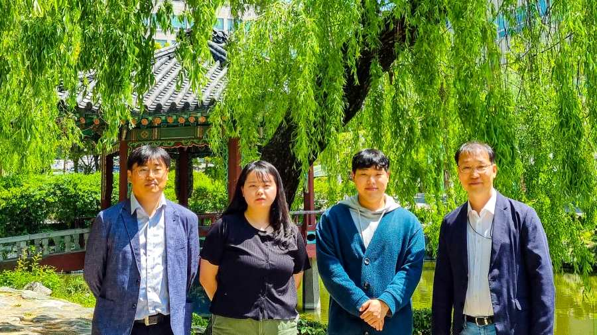
▲ (From left): Inha University Professor Kiyoung Lee, GIST Dr. Kahyun Ham, Inha University Ph.D. student Jaewon Lee, GIST Professor Jaeyoung Lee

Korean researchers have developed a new manganese-based catalyst that can lower the cost of producing high-purity hydrogen by electrolyzing water.

If it replaces the existing expensive precious metal catalyst, eco-friendly hydrogen can be produced at low cost, which is expected to contribute to advancing the hydrogen era.

The 'water electrolysis' method is an eco-friendly hydrogen production method that does not emit greenhouse gases, but the high cost of electricity is an obstacle to its practical use. To use hydrogen in a wider and more diversified way, the production cost must be significantly lowered. Therefore, the development of a high-performance catalyst capable of producing hydrogen with less energy is required.

Precious metals such as iridium and ruthenium are mainly used for water electrolysis as excellent catalysts for generating oxygen, but they have a disadvantage in that they are expensive. Therefore, it is important to develop an inexpensive and excellent transition metal-based (nickel, cobalt, iron) hydrogen/oxygen catalyst.

GIST (Gwangju Institute of Science and Technology, President Kiseon Kim) School of Earth Sciences and Environmental Engineering Professor Jaeyoung Lee's research team conducted a joint study with Inha University Department of Chemistry and Chemical Engineering Professor Kiyoung Lee's research team by using a manganese-based catalyst mixed with conductive carbon to control the electrical conductivity of the catalyst. It succeeded in improving the performance of water electrolysis.

Manganese-based metal oxide is a representative water decomposition catalyst that exists in nature, and many studies are being conducted to utilize it as a water electrolysis catalyst because of its structural diversity, abundant reserves, and non-toxicity.

It is known that the existing manganese oxide generally has low electrical conductivity and that the oxygenation reaction occurs well only in a specific structure (δ-MnO₂). For the formation of this specific structure, complete oxidation of manganese oxide during the oxygenation reaction is essential, and this requires sufficient electrical conductivity.

The research team introduced graphitized conductive carbon into the catalyst layer to secure electrical conductivity, and the oxygen evolution reaction performance of the catalyst layer was improved by the repeated electrochemical activation method.

As a result, the oxygen evolution reaction activity was increased more than 15 times. When applied to the 3rd generation anion exchange membrane water electrolysis method to determine the commercial applicability of the developed catalyst, it was confirmed that hydrogen production was possible at a current density 400% higher than that of the existing catalyst.

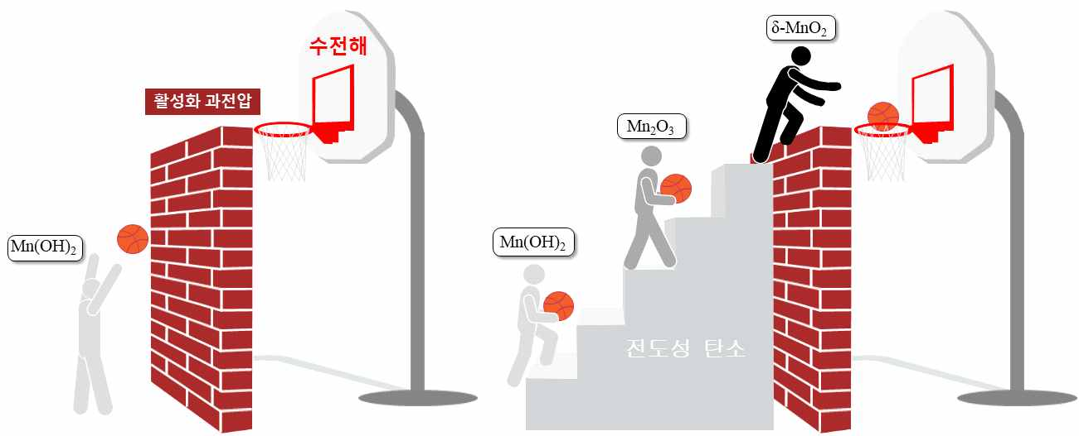
▲ Conceptual diagram of the meaning of forming δ-MnO₂ and overcoming the activation overvoltage through the introduction of conductive carbon

GIST Professor Jaeyoung Lee said, "It was possible to develop a catalyst capable of improving water electrolysis performance by increasing the catalytic active site by utilizing inexpensive manganese oxide. In particular, this research result is significant in a situation where the development of an alternative transition metal-based electrode catalyst is urgently needed due to the recent rise in the price of nickel."

Inha University Professor Kiyoung Lee said, "This catalyst technology is meaningful in that it has secured the original technology to commercialize manganese oxide as a water electrolysis catalyst. Manganese oxide produced through anodization technology is expected to contribute to the production of low-cost, eco-friendly hydrogen."

This research was led by School of Earth Sciences and Environmental Engineering Professor Jaeyoung Lee (corresponding author) and Inha University Department of Chemistry and Chemical Engineering Professor Kiyoung Lee (co-corresponding author) and conducted by Dr. Kahyun Ham (first author) and Ph.D. student Jaewon Lee (co-first author) with support from the National Research Foundation of Korea and the Korea Institute of Energy Technology Evaluation and was published online on April 25, 2022, in the Journal of Energy Chemistry, an international academic journal in the field of applied chemistry.



