Improved performance of implantable electrode by controlling surface properties

– A clue to alleviating inflammatory response in the body by controlling the surface roughness of biomimetic electrodes


▲ (From left) School of Materials Science and Engineering
Professor Jae Young Lee and Ph.D. student Sanghun Lee

Korean researchers have implemented a method to effectively alleviate the inflammatory response that occurs when medical electronic devices are implanted in the body by controlling the surface characteristics of implantable electrodes.

GIST (Gwangju Institute of Science and Technology, President Kiseon Kim) School of Materials Science and Engineering Professor Jae Young Lee's research team has developed a high-performance bioelectrode with excellent effects in relieving inflammation and maintaining long-term stability by controlling the surface roughness of a biomimetic polypyrrole/heparin bioelectrode.

※ polypyrrole (PPy): As a polymer of the monomer pyrrole, it is a type of electrically conductive polymer.

※ heparin: A biopolymer that exists in the human body and has anticoagulant and anti-inflammatory effects.

Bioelectrodes for implantation in the body are a core part of medical electronic devices used to record various biosignals, such as electrocardiogram and electroencephalogram, or to electrically stimulate a living body to diagnose health conditions and treat diseases.

However, due to the protective action of the human immune system, implanted materials in the body, including bioelectrodes, inevitably undergo a foreign body reaction*.

※ foreign body reaction: A self-defensive response of the human immune system, a series of immune responses in which the human body recognizes transplanted external substances as foreign substances and separates them from surrounding cell tissues.

Inflammation may occur around the material after transplantation, and, if it persists excessively, a thick wound tissue is formed and the performance of the material is greatly impaired.

To prevent degradation of the performance of the bioelectrode due to foreign body reaction, it is important to induce non-inflammatory polarization control by controlling the macrophage* response, which is responsible for the inflammatory response.

※ macrophage: A major immune cell responsible for innate immunity. Depending on the biological environment, inflammatory (M1) promoting inflammation and anti-inflammatory (M2) resolving inflammation show opposite characteristics. The change in their phenotype is called polarization of macrophages.

Accordingly, the research team devised a method to alleviate the inflammatory response of macrophages based on research of the interaction between immune macrophages and the surface properties of electrodes in direct contact with living tissue. A biomimetic polypyrrole/heparin bioelectrode was manufactured by coating heparin present in the human body together with polypyrrole on a gold electrode.

In the electrochemical synthesis process of polypyrrole/heparin thin films, the surface roughness of the electrodes is precisely controlled by controlling the charge density. This is to secure the optimal bioelectrode surface structure that can relieve inflammation.

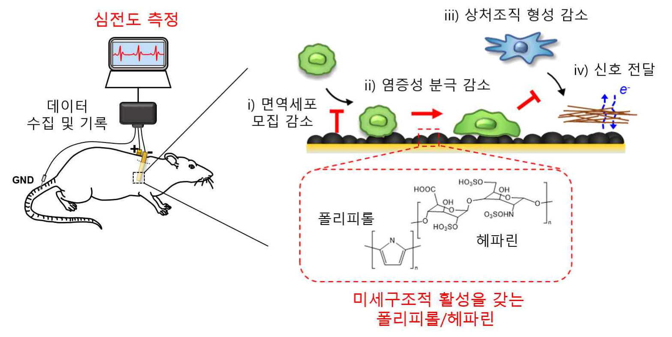
▲ Polypyrrole/heparin electrode with long-term stability as an electrode for signal measurement due to its ability to reduce macrophage recruitment, inflammatory polarization, and wound tissue formation
Polypyrrole/heparin bioelectrode with optimal surface microstructure is an immune-friendly high-performance bioelectrode that can maintain stability of bioelectrical signal transmission for a long time by effectively reducing the recruitment of immune cells, inflammatory polarization of macrophages, and formation of wound tissue.

As a result of implanting the fabricated bioelectrodes subcutaneously in mice, the polarization of macrophages to the inflammatory phenotype was greatly reduced.

Accordingly, as the inflammatory response to the bioelectrode was effectively alleviated, the formation of wound tissue around the electrode was reduced, and it was possible to record real-time ECG signals with high sensitivity and to measure stably for a long time.

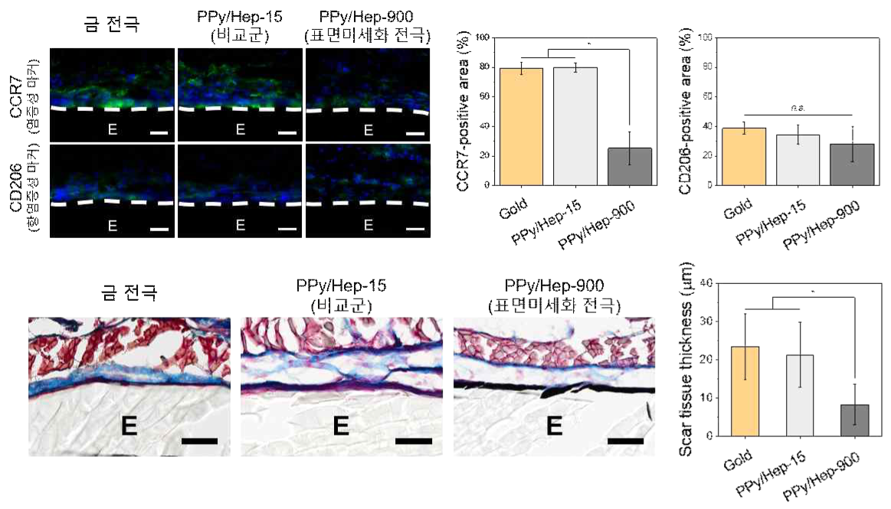
▲ Comparison of macrophage polarization and wound tissue thickness around electrodes after subcutaneous implantation in mice
Compared to the gold electrode not coated with the polypyrrole/heparin thin film and the control group (PPy/Hep-15) in which the surface roughness was not optimized, the surface miniaturization electrode (PPy/Hep-900) with high microstructural activity was observed around the macrophages. It was confirmed that inflammatory polarization and wound tissue thickness were effectively relieved.

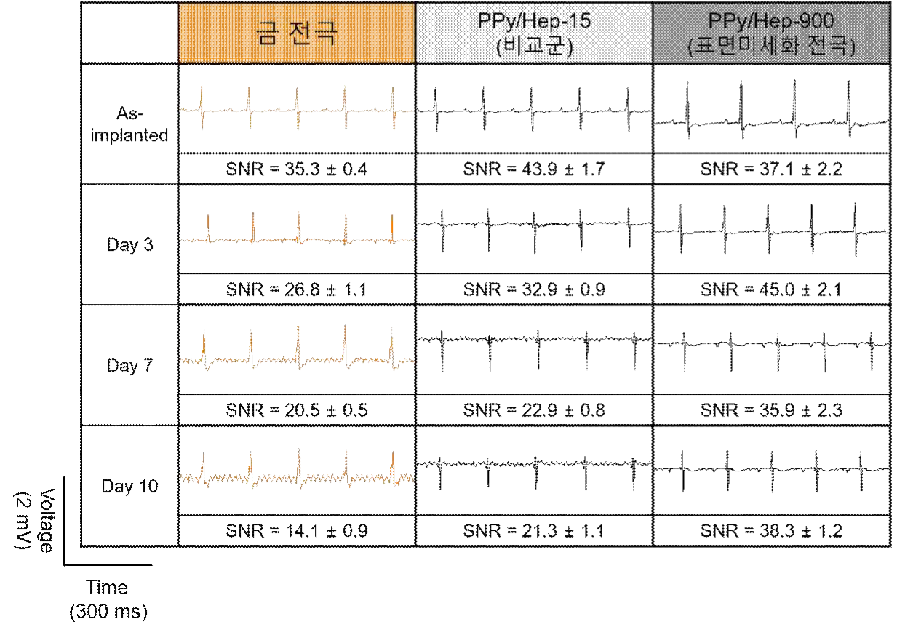
▲ Electrocardiogram measurement and signal-to-noise ratio (SNR) comparison after subcutaneous feeding in experimental rats
Compared to the gold electrode not coated with the polypyrrole/heparin thin film and the comparative group (PPy/Hep-15) in which the surface roughness is not optimized, the surface refinement electrode (PPy/Hep-900) with excellent structural activity is a signal measurement electrode. It was confirmed that high sensitivity is maintained stably for a long period of time.

Professor Jae Young Lee said, "It is expected that the developed bioelectrode technology will provide a clue to solve the foreign body reaction that occurs in various implantable biomedical materials. However, for practical use, it is necessary to ensure the safety and stability of the body through continuous research."

The results of this research conducted with support from the Ministry of Science and ICT and the National Research Foundation for mid-level research and basic laboratory support projects and was published on April 20, 2022, in ACS Nano, an international academic journal in the field of materials.



