A significant portion of
ultrafine dust is aging in the West Sea

– Prof. Kihong Park's team observed for a period of four years from a weather observation vessel... tracking the aging and mixing processes

– Presenting the potential effect for changes in aging on the human body and climate change on the Korean Peninsula

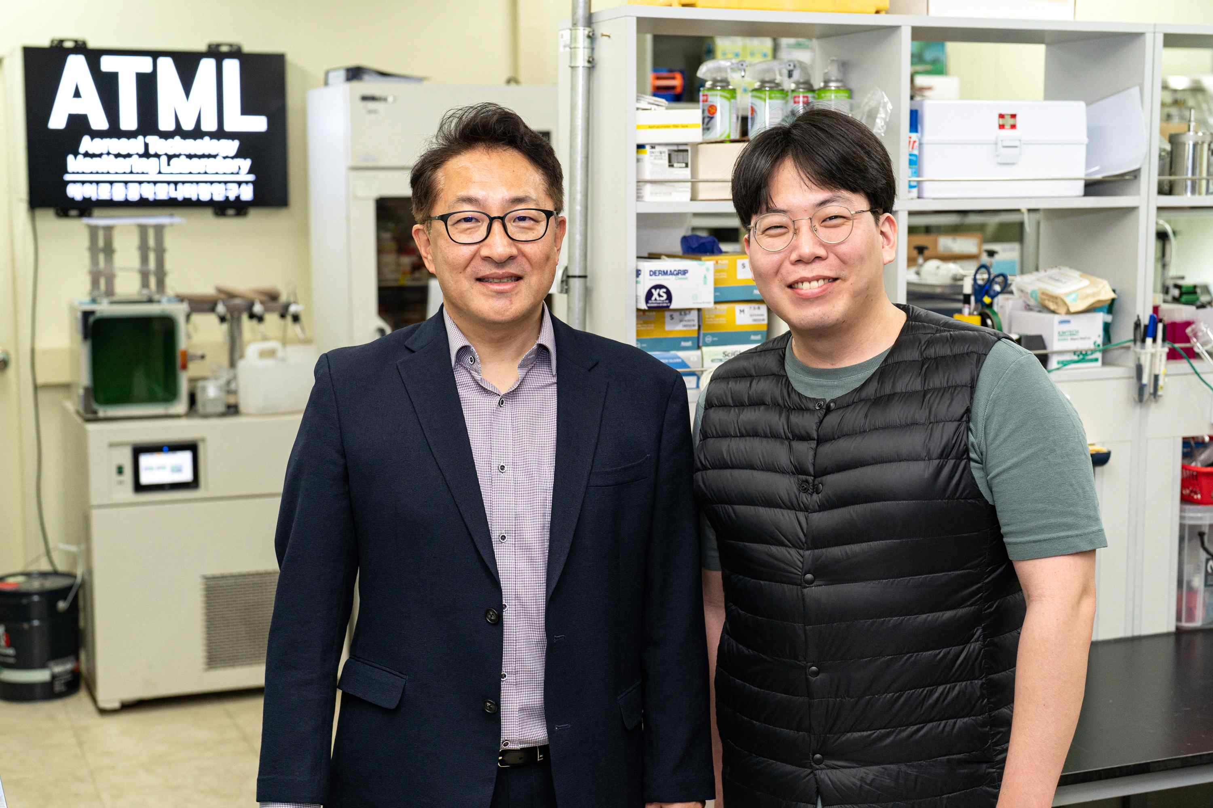
▲ (From left) Professor Kihong Park and Ph.D. student Haebum Lee

What are the characteristics of ultrafine dust observed over the West Sea? Through four years of observation in the West Sea, Korean researchers have identified for the first time in Korea the degree of aging by origin of various ultrafine dust single particles flowing from the west side of the Korean Peninsula, including China.

For the first time in Korea, the construction of a DB by observing marine ultrafine dust particles that are likely to flow into the Korean Peninsula is expected to contribute to more detailed identification of physicochemical changes due to the movement of ultrafine dust affecting public health and climate change.

The West Sea is an important gateway to long-distance traveling ultrafine dust with various origins before it enters the Korean Peninsula as it is where various mixing and aging processes of ultrafine dust occurs.

However, there have been many difficulties in understanding the characteristics and transformation process of ultrafine particulate matter in the West Sea due to difficult site access and continuous observation.

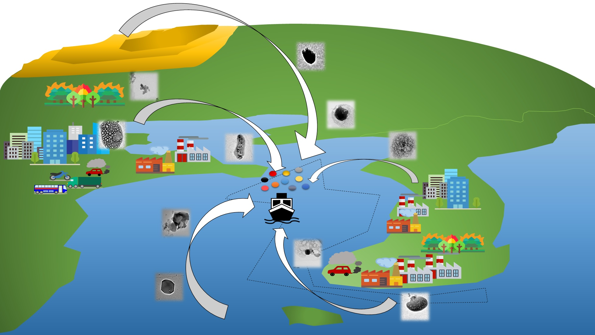▲ Classification of ultrafine dust types and DB establishment through observation of ships in the West Sea

GIST Professor Kihong Park's (School of Earth Sciences and Environmental Engineering, Director of Aerosol Technology Monitoring Laboratory) research team, together with the National Institute of Meteorological Sciences, used the Meteorological Observatory No. 1* for 4 years from 2015 to 2018 at the same time in the spring when (ultra) fine dust is on the rise (April-May) and succeeded in observing ultrafine dust in the West Sea along with various types of long-distance particles and changes in physicochemical properties according to their movement.

* Meteorological Observatory No. 1: A meteorological observation vessel equipped with 10 types of observation equipment that can comprehensively observe high-rise sea, ocean, and atmospheric environments.

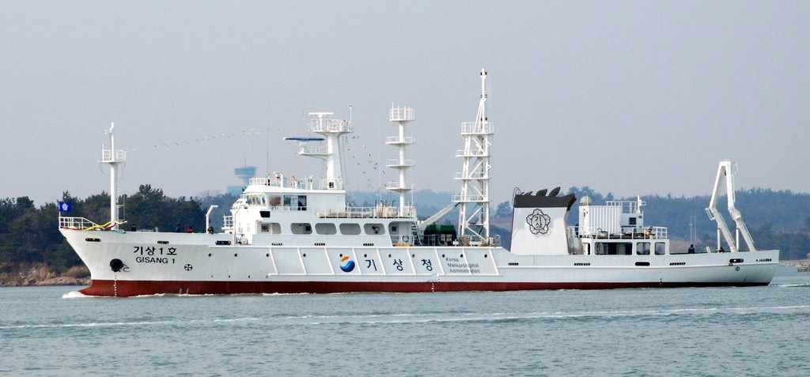
▲ Meteorological Observatory No.1: A meteorological observation vessel equipped with 10 types of observation equipment that can comprehensively observe high-rise sea, ocean, and atmospheric environments. (Source: Korea Meteorological Administration)

As a result of the study, when long-distance moving air masses generated in China and Mongolia were observed, mostly dust and sulfur oxide particle types increased. In the case of regional air masses originating from inland China or Korea near the West Sea, soot and fly ash particle types increased. Sea spray particles were mainly observed in the sea-origin air masses generated in the West Sea. This suggests that not only sea-origin particles but also particles of various migration paths exist in the West Sea.

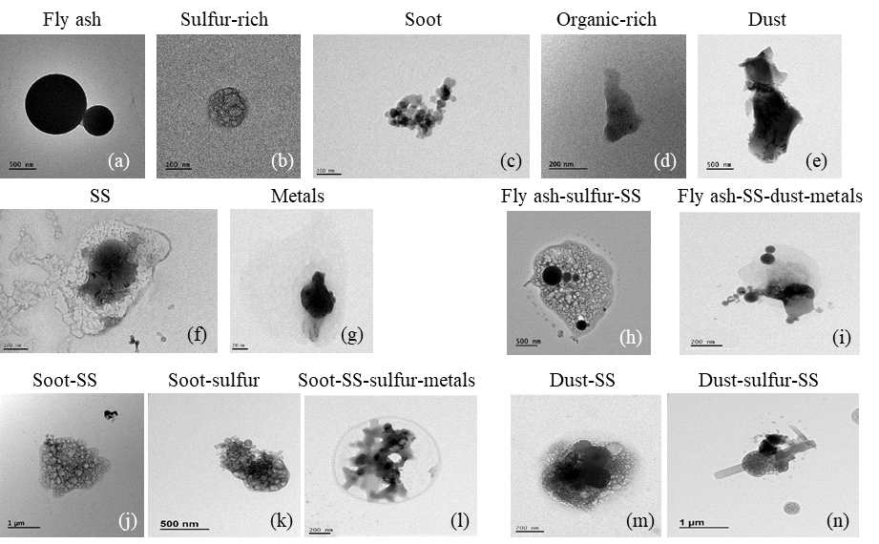
▲ Examples of particle types classified according to the shape of a single particle and chemical element composition: classified into spherical and non-spherical particles according to particle shape. For spherical particles, chemical element components are divided into fly ash and sulfur-rich particles.

The research team observed a number of changes in the shape and mixing of ultrafine dust particles and chemical components that undergo continuous aging and mixing processes in the West Sea, and the particles aged on the sea change in size, chemical composition, and optical properties compared to when they first occurred.

These aged particles have the potential to be more harmful to the human body due to the increased degree of oxidation, and it has the property of absorbing moisture from the atmosphere, which affects cloud formation and the Earth's radiative thermal equilibrium.

Professor Kihong Park said, "The results of this observation suggest that particle aging is progressing considerably in the West Sea, and that the external ultrafine dust can act completely differently on the health of the people and the impact of climate change. It is important to quickly and comprehensively understand the origins, various characteristics, and changes of fine dust entering the Korean Peninsula by establishing a more dense monitoring network for inflowing fine dust through continuous ship observation and various ground and air observations."

This research conducted by GIST Professor Kihong Park's team was supported by the National Research Foundation of Korea, the Ministry of Science and ICT, and by the Korea Meteorological Administration Research and Development Program and was published online on April 18, 2022, in Environmental Pollution (IF=8.071), which is the top 5.7% paper in the field of environmental science.



