Development of back-end process for 'silicon anode' to extend battery life of electric vehicles

– About 7 times longer than the existing lifespan while maintaining 93% capacity for 150 charge/discharge cycles

– When high energy density anode batteries are commercialized, electric vehicle mileage is expected to improve


▲ (From left) GIST Professor Hyeong-Jin Kim and Korea Institute
of Energy Research Dr. Jung-Je Woo and Dr. Jihun Kim

A technology that can improve the stability of the silicon anode*, which is attracting attention as a next-generation material to be used in electric vehicle batteries, about seven times compared to the existing lifespan was developed by GIST researchers.

GIST (Gwangju Institute of Science and Technology, President Kiseon Kim) Graduate School of Energy Convergence Professor Hyeong-Jin Kim's research team in conjunction with the Korea Institute of Energy Research developed a post-process that can significantly improve stability by applying graphene oxide and metal oxide to the finished silicon anode*.

* silicon anode: It is a next-generation anode with a theoretical capacity of up to 4,200 mAh/g per unit weight, which is more than 10 times the theoretical capacity of conventional graphite anodes.

The post-electrode-engineering developed by the research team can maintain 93% of capacity for 150 charge and discharge cycles, so this is expected to significantly increase the driving range of electric vehicles.

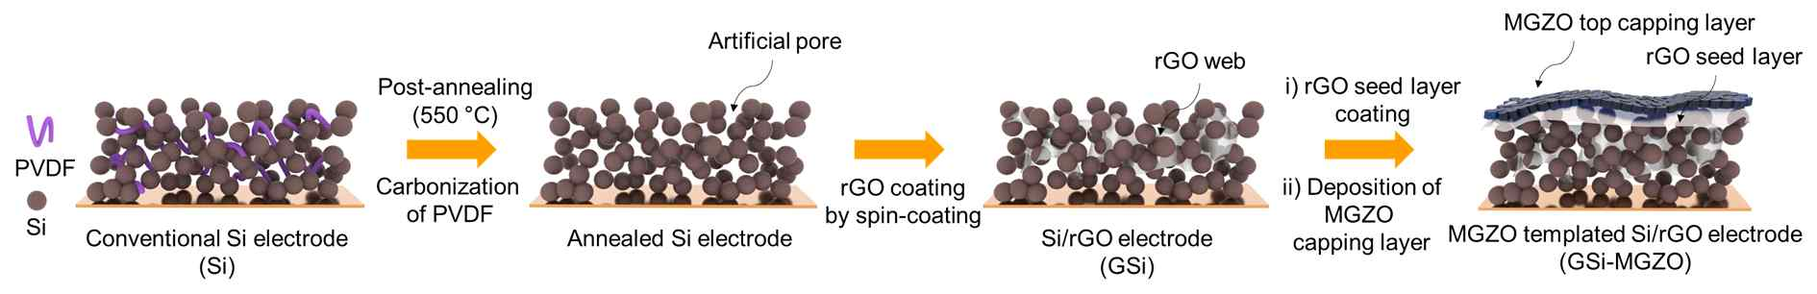
▲ Post-processing applied to silicon electrode. A porous electrode may be secured through heat treatment, and stability of the electrode may be improved through double treatment of graphene oxide and metal oxide.

Graphite is currently used as an anode material for lithium batteries to improve the mileage of electric vehicles. Theoretically, silicon anodes can store up to 10 times more electricity in the same volume than conventional graphite anodes, so it is being evaluated as a next-generation anode that will realize the development of high-energy-density batteries.

However, there is a disadvantage that the silicon anode expands about 4 times when charging the battery. Although the expanded cathode contracts again upon discharge, it does not return to its former shape. This threatens the stability of the battery and is an obstacle to commercialization as it can only be secured by investing a lot of time and money.

To solve the instability of silicon, the research team applied graphene oxide* as a solution process on a silicon anode, which was made porous through heat treatment, and coated a metal oxide** thin film through vacuum deposition.

* graphene oxide: A structure in which carbon atoms are bonded in a hexagonal honeycomb shape that is repeated on a plane with good mechanical strength and excellent current conduction characteristics, so it is being studied as an electronic material in the future.

** metal oxide: A compound in which a metal atom and an oxygen atom are combined. It can be formed into a thin film and is widely used in industry as a coating material due to its stable properties.

Graphene oxide acts as a bridge to improve electron conduction as it aggregates with silicon particles during charging and discharging and acts as a buffer to suppress volume expansion of silicon particles.

Here, to ensure the side reaction with electrolyte and the structural stability of the electrode, a metal oxide thin film with stable characteristics was deposited on the electrode to ensure high stability.

The silicon electrode developed by the research team through post-processing succeeded in 150 charge/discharge tests, which is seven times the lifespan of the existing silicon electrode. While the existing silicon electrode showed a low capacity retention rate (150 times, 1.3%) of 37% in 20 operations, the electrode developed through this study achieved 93% in 150 operations.

In the evaluation of the charge/discharge rate using a high current for charging within one hour, while the existing silicon electrode did not work normally in a high current environment, the silicon electrode developed through this study was able to charge 85% of its original capacity.

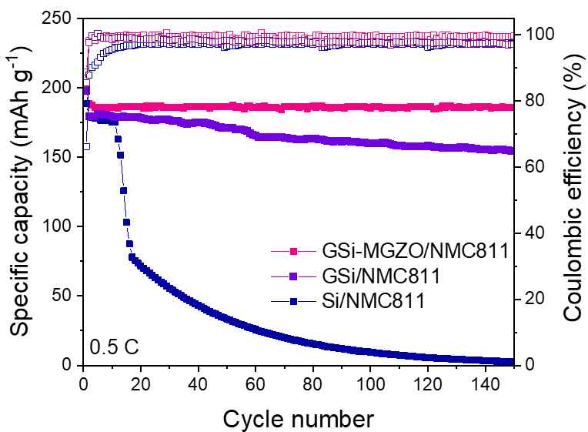
▲ Whole battery charge/discharge test result. It can be seen that the silicon anode fabricated through the post-process has the best operational stability.

In addition, this study identified for the first time the phenomenon that graphene oxide naturally forms a silicon-carbon composite through electrochemical aggregation with silicon particles during the charging and discharging process, thereby contributing to the improvement of the stability of silicon.

Professor Hyeong-Jin Kim said, "This study is most meaningful in that it provided a precedent for improving the stability of the anode, which is vulnerable to volume expansion, through post-processing. This is expected to contribute to the development of a new process that can accelerate the commercialization of high-energy-density cathodes in the future."

This research was led by Professor Hyeong-Jin Kim and conducted by Korea Institute of Energy Research Dr. Jung-Je Woo and Dr. Jihun Kim with support from the GIST Research Institute and the Research and Development Program of the Korea Institute of Energy Research and was published online in the March 21, 2022, issue of the Journal of Materials Chemistry A, an internationally renowned academic journal that ranks among the top (7%) in the energy and fuel field.



